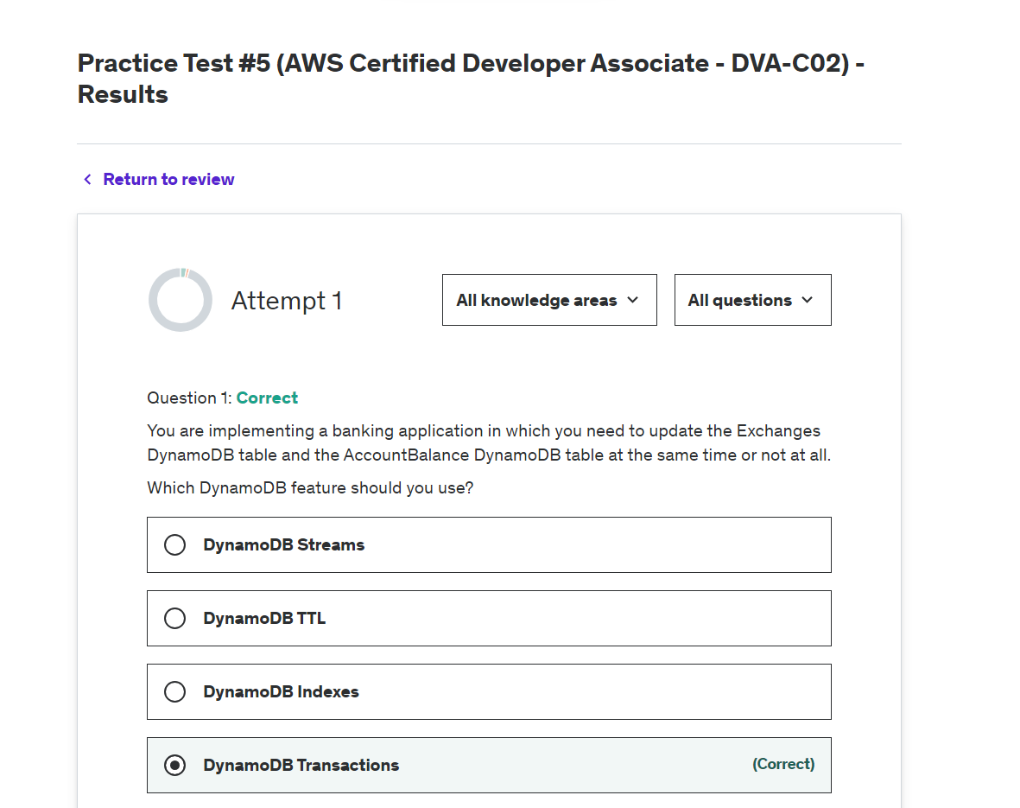

**Explanation**

Correct option:

**DynamoDB Transactions**

You can use DynamoDB transactions to make coordinated all-or-nothing changes to multiple items both within and across tables. Transactions provide atomicity, consistency, isolation, and durability (ACID) in DynamoDB, helping you to maintain data correctness in your applications.

DynamoDB Transactions Overview: 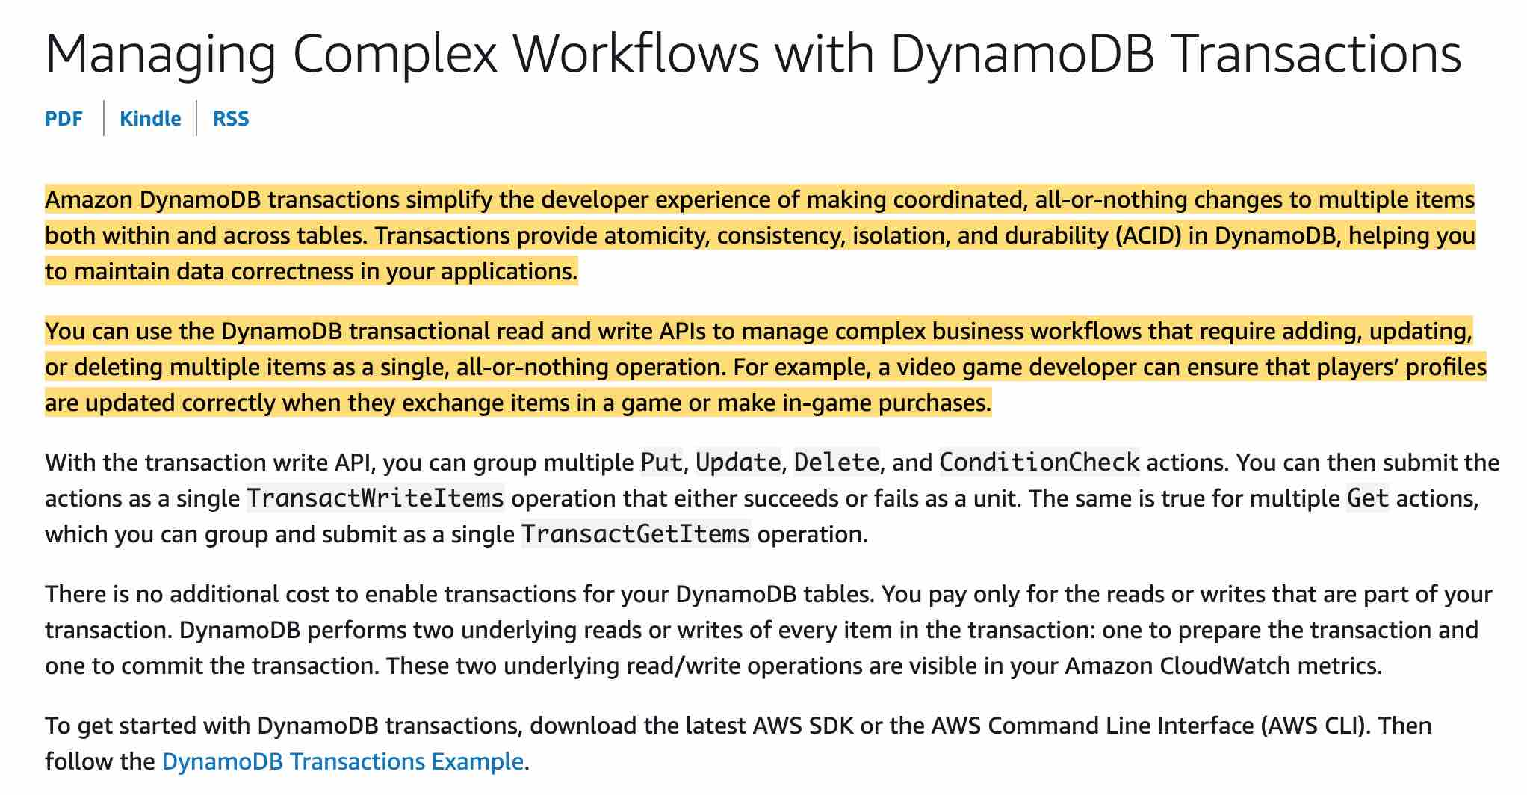 via - <https://docs.aws.amazon.com/amazondynamodb/latest/developerguide/transactions.html>

Incorrect options:

**DynamoDB TTL** - DynamoDB TTL allows you to expire data based on a timestamp, so this option is not correct.

**DynamoDB Streams** - DynamoDB Streams gives a changelog of changes that happened to your tables and then may even relay these to a Lambda function for further processing.

**DynamoDB Indexes** - GSI and LSI are used to allow you to query your tables using different partition/sort keys.

Reference:

<https://docs.aws.amazon.com/amazondynamodb/latest/developerguide/transactions.html>

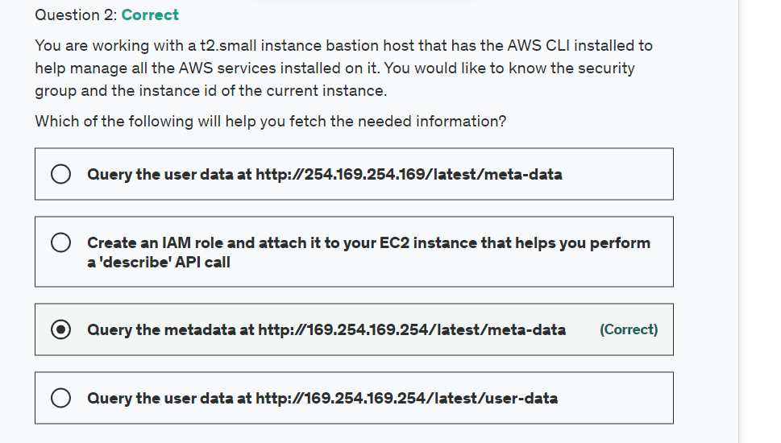

Explanation

Correct option:

**Query the metadata at http://169.254.169.254/latest/meta-data** - Because your instance metadata is available from your running instance, you do not need to use the Amazon EC2 console or the AWS CLI. This can be helpful when you're writing scripts to run from your instance. For example, you can access the local IP address of your instance from instance metadata to manage a connection to an external application. To view all categories of instance metadata from within a running instance, use the following URI - http://169.254.169.254/latest/meta-data/. The IP address 169.254.169.254 is a link-local address and is valid only from the instance. All instance metadata is returned as text (HTTP content type text/plain).

Incorrect options:

**Create an IAM role and attach it to your EC2 instance that helps you perform a 'describe' API call** - The AWS CLI has a describe-instances API call needs instance ID as an input. So, this will not work for the current use case wherein we do not know the instance ID.

**Query the user data at http://169.254.169.254/latest/user-data** - This address retrieves the user data that you specified when launching your instance.

**Query the user data at http://254.169.254.169/latest/meta-data** - The IP address specified is wrong.

References:

<https://docs.aws.amazon.com/AWSEC2/latest/UserGuide/instancedata-data-retrieval.html>

<https://awscli.amazonaws.com/v2/documentation/api/latest/reference/ec2/describe-instances.html>

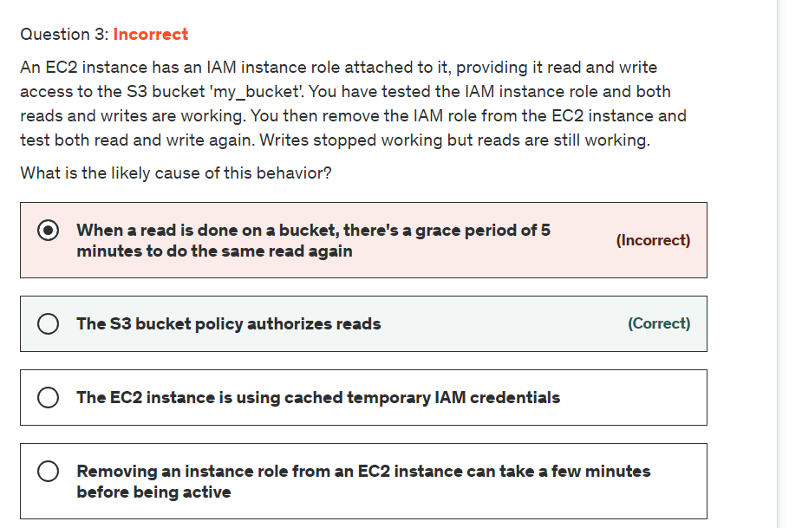

Explanation

Correct option:

**The S3 bucket policy authorizes reads**

When evaluating an IAM policy of an EC2 instance doing actions on S3, the least-privilege union of both the IAM policy of the EC2 instance and the bucket policy of the S3 bucket are taken into account.

For the given use-case, as IAM role has been removed, therefore only the S3 bucket policy comes into effect which authorizes reads.

Here is a great reference blog for understanding the various scenarios for using IAM policy vs S3 bucket policy - <https://aws.amazon.com/blogs/security/iam-policies-and-bucket-policies-and-acls-oh-my-controlling-access-to-s3-resources/>

Incorrect options:

**The EC2 instance is using cached temporary IAM credentials** - As the IAM instance role has been removed that wouldn't be the case

**Removing an instance role from an EC2 instance can take a few minutes before being active** - It is immediately active and even if it wasn't, it wouldn't make sense as we can still do reads but not writes.

**When a read is done on a bucket, there's a grace period of 5 minutes to do the same read again** - This is not true. Every single request is evaluated against IAM in the AWS model.

Reference:

<https://aws.amazon.com/blogs/security/iam-policies-and-bucket-policies-and-acls-oh-my-controlling-access-to-s3-resources/>

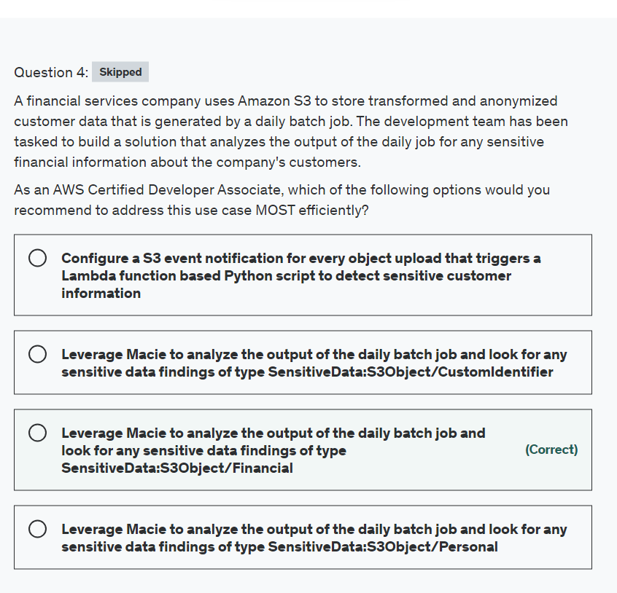

Explanation

Correct option:

**Leverage Macie to analyze the output of the daily batch job and look for any sensitive data findings of type SensitiveData:S3Object/Financial**

Amazon Macie is a data security service that discovers sensitive data by using machine learning and pattern matching, provides visibility into data security risks, and enables automated protection against those risks. To help you manage the security posture of your organization's Amazon Simple Storage Service (Amazon S3) data estate, Macie provides you with an inventory of your S3 buckets, and automatically evaluates and monitors the buckets for security and access control. If Macie detects a potential issue with the security or privacy of your data, such as a bucket that becomes publicly accessible, Macie generates a finding for you to review and remediate as necessary.

Macie also automates the discovery and reporting of sensitive data to provide you with a better understanding of the data that your organization stores in Amazon S3. To detect sensitive data, you can use built-in criteria and techniques that Macie provides, custom criteria that you define, or a combination of the two. If Macie detects sensitive data in an S3 object, Macie generates a finding to notify you of the sensitive data that Macie found.

Macie generates a sensitive data finding when it detects sensitive data in an S3 object that it analyzes to discover sensitive data. This includes analysis that Macie performs when you run a sensitive data discovery job and when it performs automated sensitive data discovery.

For the given use case, you can use Macie to analyze the output of the daily batch job and look for any sensitive data findings of type SensitiveData:S3Object/Financial which implies that the S3 object contains financial information, such as bank account numbers or credit card numbers.

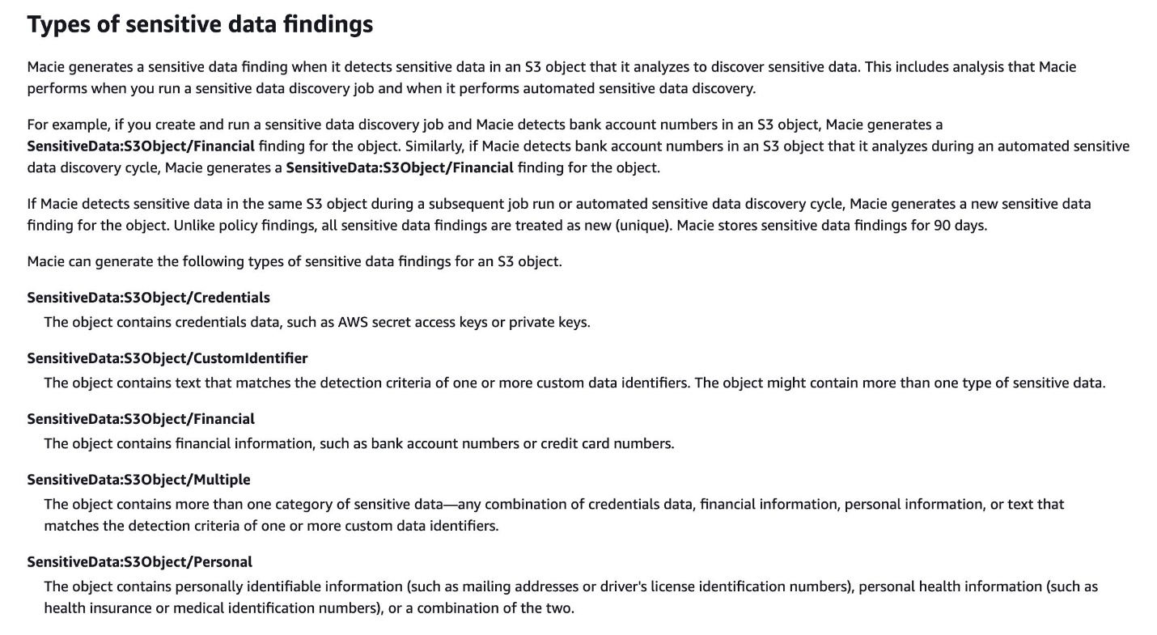 via - <https://docs.aws.amazon.com/macie/latest/user/findings-types.html>

Incorrect options:

**Leverage Macie to analyze the output of the daily batch job and look for any sensitive data findings of type SensitiveData:S3Object/Personal** - The object contains personally identifiable information (such as mailing addresses or driver's license identification numbers), personal health information (such as health insurance or medical identification numbers), or a combination of the two.

**Leverage Macie to analyze the output of the daily batch job and look for any sensitive data findings of type SensitiveData:S3Object/CustomIdentifier** - The object contains text that matches the detection criteria of one or more custom data identifiers. The object might contain more than one type of sensitive data.

As explained above, for the given use case, you need to look for any sensitive data findings of type SensitiveData:S3Object/Financial. So both these options are incorrect.

**Configure a S3 event notification for every object upload that triggers a Lambda function based custom application to detect sensitive customer information** - Maintaining a custom application to detect sensitive information would be highly inefficient as you need to consistently upgrade the application to handle new formats and types of financial information. This is better handled by leveraging Macie's Findings.

References:

<https://docs.aws.amazon.com/macie/latest/user/what-is-macie.html>

<https://docs.aws.amazon.com/macie/latest/user/findings-types.html>

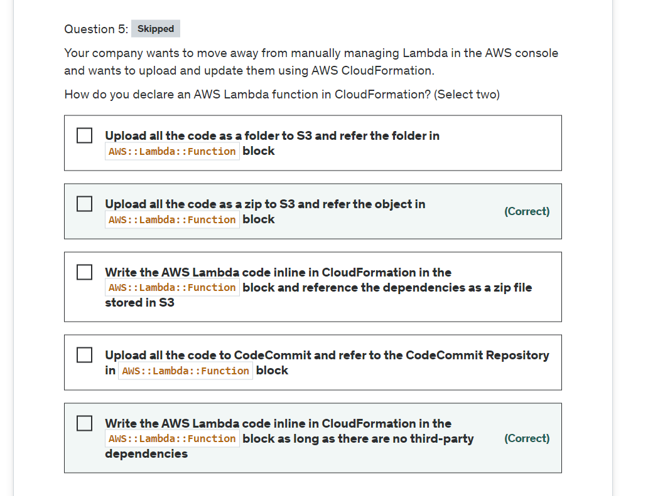

**Explanation**

Correct options:

AWS Lambda lets you run code without provisioning or managing servers. You pay only for the compute time you consume.

How Lambda function works: 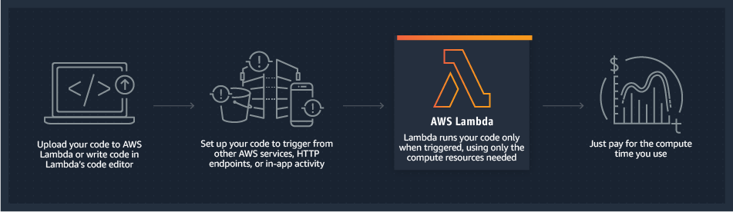 via - <https://aws.amazon.com/lambda/>

**Upload all the code as a zip to S3 and refer the object in AWS::Lambda::Function block**

You can upload all the code as a zip to S3 and refer the object in AWS::Lambda::Function block.

The AWS::Lambda::Function resource creates a Lambda function. To create a function, you need a deployment package and an execution role. The deployment package contains your function code.

**Write the AWS Lambda code inline in CloudFormation in the AWS::Lambda::Function block as long as there are no third-party dependencies**

The other option is to write the code inline for Node.js and Python as long as there are no dependencies for your code, besides the dependencies already provided by AWS in your Lambda Runtime (aws-sdk and cfn-response and many other AWS related libraries are preloaded via, for example, boto3 (python) in the lambda instances.)

YAML template for creating a Lambda function:

Type: AWS::Lambda::Function

Properties:

Code:

Code

DeadLetterConfig:

DeadLetterConfig

Description: String

Environment:

Environment

FileSystemConfigs:

- FileSystemConfig

FunctionName: String

Handler: String

KmsKeyArn: String

Layers:

- String

MemorySize: Integer

ReservedConcurrentExecutions: Integer

Role: String

Runtime: String

Tags:

- Tag

Timeout: Integer

TracingConfig:

TracingConfig

VpcConfig:

VpcConfig

Incorrect options:

**Upload all the code to CodeCommit and refer to the CodeCommit Repository in AWS::Lambda::Function block**

**Upload all the code as a folder to S3 and refer the folder in AWS::Lambda::Function block**

**Write the AWS Lambda code inline in CloudFormation in the AWS::Lambda::Function block and reference the dependencies as a zip file stored in S3**

These three options contradict the explanation provided earlier. So these are incorrect.

Reference:

<https://docs.aws.amazon.com/AWSCloudFormation/latest/UserGuide/aws-properties-lambda-function-code.html>

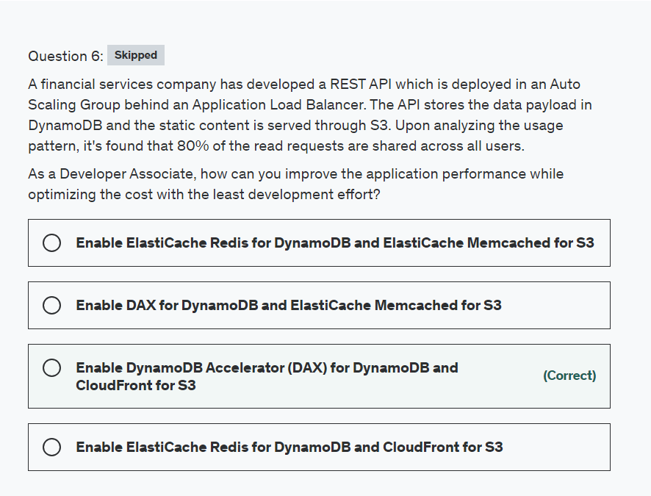

Explanation

Correct option:

**Enable DynamoDB Accelerator (DAX) for DynamoDB and CloudFront for S3**

DynamoDB Accelerator (DAX) is a fully managed, highly available, in-memory cache for Amazon DynamoDB that delivers up to a 10 times performance improvement—from milliseconds to microseconds—even at millions of requests per second.

DAX is tightly integrated with DynamoDB—you simply provision a DAX cluster, use the DAX client SDK to point your existing DynamoDB API calls at the DAX cluster, and let DAX handle the rest. Because DAX is API-compatible with DynamoDB, you don't have to make any functional application code changes. DAX is used to natively cache DynamoDB reads.

CloudFront is a content delivery network (CDN) service that delivers static and dynamic web content, video streams, and APIs around the world, securely and at scale. By design, delivering data out of CloudFront can be more cost-effective than delivering it from S3 directly to your users.

When a user requests content that you serve with CloudFront, their request is routed to a nearby Edge Location. If CloudFront has a cached copy of the requested file, CloudFront delivers it to the user, providing a fast (low-latency) response. If the file they’ve requested isn’t yet cached, CloudFront retrieves it from your origin – for example, the S3 bucket where you’ve stored your content.

So, you can use CloudFront to improve application performance to serve static content from S3.

Incorrect options:

**Enable ElastiCache Redis for DynamoDB and CloudFront for S3**

Amazon ElastiCache for Redis is a blazing fast in-memory data store that provides sub-millisecond latency to power internet-scale real-time applications. Amazon ElastiCache for Redis is a great choice for real-time transactional and analytical processing use cases such as caching, chat/messaging, gaming leaderboards, geospatial, machine learning, media streaming, queues, real-time analytics, and session store.

ElastiCache for Redis Overview: 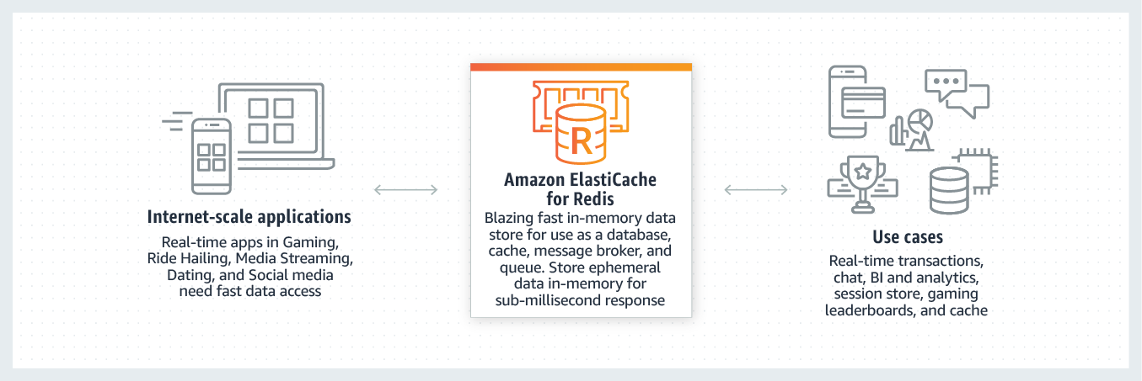 via - <https://aws.amazon.com/elasticache/redis/>

Although, you can integrate Redis with DynamoDB, it's much more involved from a development perspective. For the given use-case, you should use DAX which is a much better fit.

**Enable DAX for DynamoDB and ElastiCache Memcached for S3**

**Enable ElastiCache Redis for DynamoDB and ElastiCache Memcached for S3**

Amazon ElastiCache for Memcached is a Memcached-compatible in-memory key-value store service that can be used as a cache or a data store. Amazon ElastiCache for Memcached is a great choice for implementing an in-memory cache to decrease access latency, increase throughput, and ease the load off your relational or NoSQL database.

ElastiCache cannot be used as a cache to serve static content from S3, so both these options are incorrect.

References:

<https://aws.amazon.com/dynamodb/dax/>

<https://aws.amazon.com/blogs/networking-and-content-delivery/amazon-s3-amazon-cloudfront-a-match-made-in-the-cloud/>

<https://aws.amazon.com/elasticache/redis/>

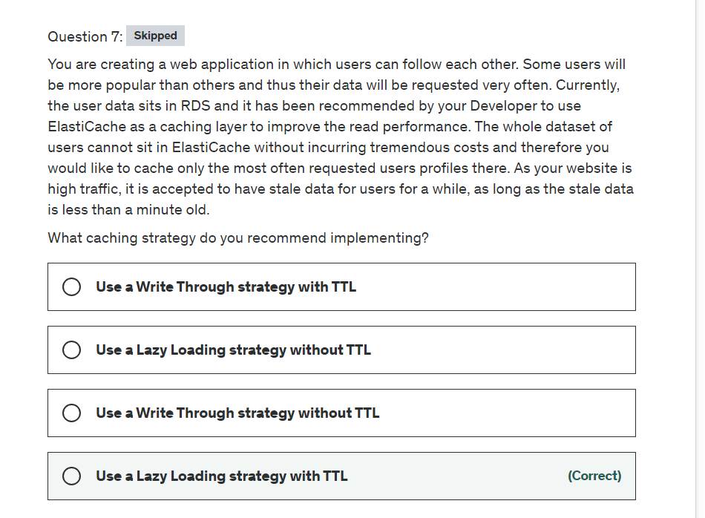

Explanation

Correct option

**Use a Lazy Loading strategy with TTL**

Lazy loading is a caching strategy that loads data into the cache only when necessary. Whenever your application requests data, it first requests the ElastiCache cache. If the data exists in the cache and is current, ElastiCache returns the data to your application. If the data doesn't exist in the cache or has expired, your application requests the data from your data store. Your datastore then returns the data to your application.

In this case, data that is actively requested by users will be cached in ElastiCache, and thanks to the TTL, we can expire that data after a minute to limit the data staleness.

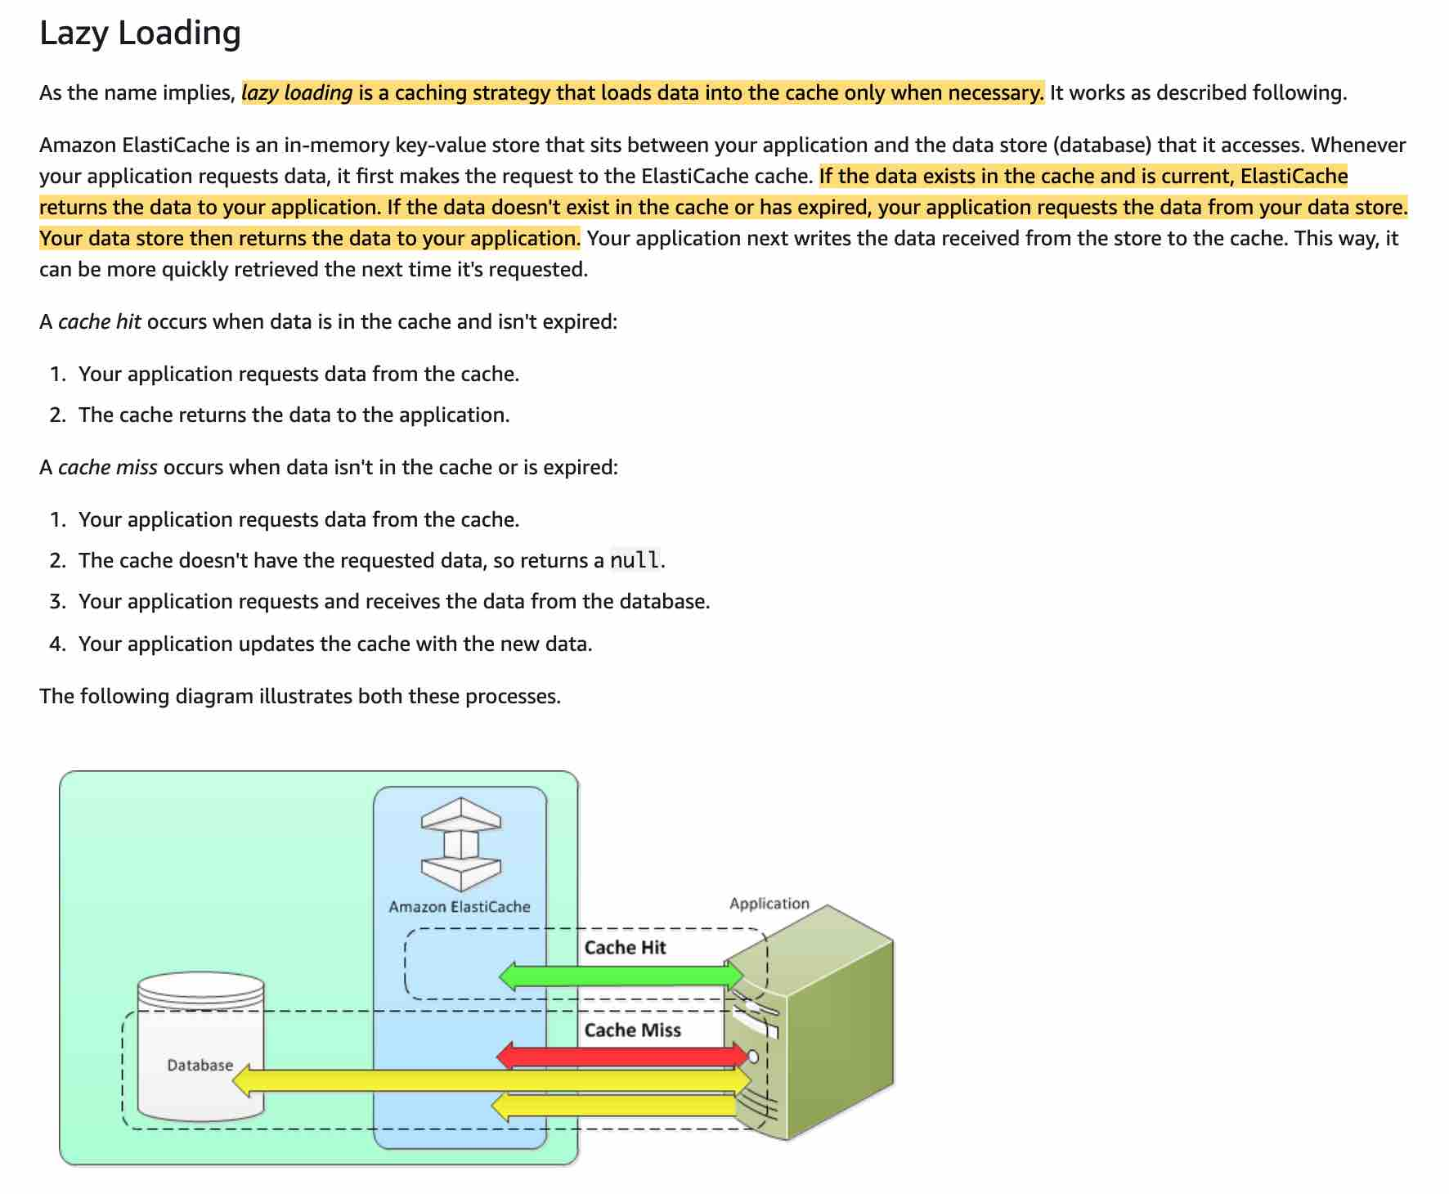 via - <https://docs.aws.amazon.com/AmazonElastiCache/latest/mem-ug/Strategies.html#Strategies.LazyLoading>

Incorrect option:

**Use a Lazy Loading strategy without TTL** - This fits the read requirements, but won't help expiring stale data, so we need TTL.

**Use a Write Through strategy with TTL**

**Use a Write Through strategy without TTL**

The problem with these two options for the write-through strategy is that we would fill up the cache with unnecessary data and as mentioned in the question we don't have enough space in the cache to fit all the dataset. Therefore we can't use a write-through strategy.

Reference:

<https://docs.aws.amazon.com/AmazonElastiCache/latest/mem-ug/Strategies.html#Strategies.LazyLoading>

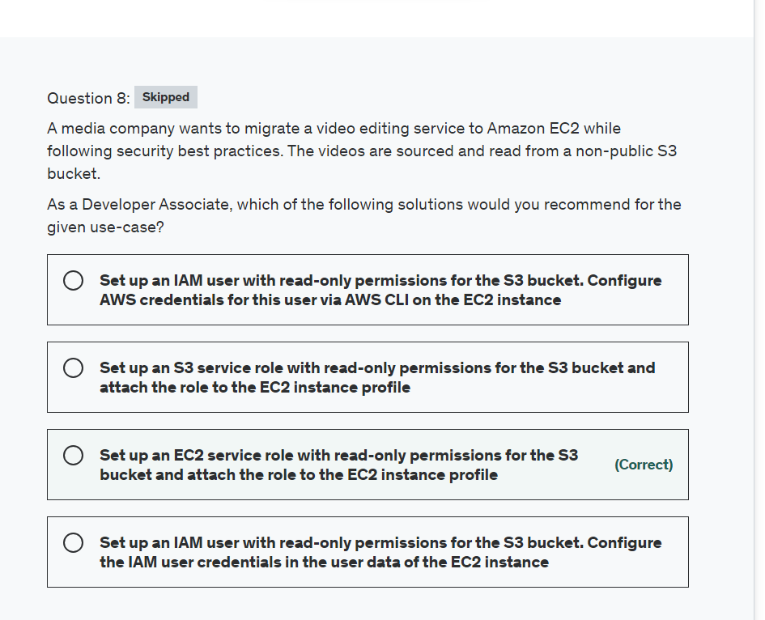

Explanation

Correct option:

**Set up an EC2 service role with read-only permissions for the S3 bucket and attach the role to the EC2 instance profile**

As an AWS security best practice, you should not create an IAM user and pass the user's credentials to the application or embed the credentials in the application. Instead, create an IAM role that you attach to the EC2 instance to give temporary security credentials to applications running on the instance. When an application uses these credentials in AWS, it can perform all of the operations that are allowed by the policies attached to the role.

So for the given use-case, you should create an IAM role with read-only permissions for the S3 bucket and apply it to the EC2 instance profile.

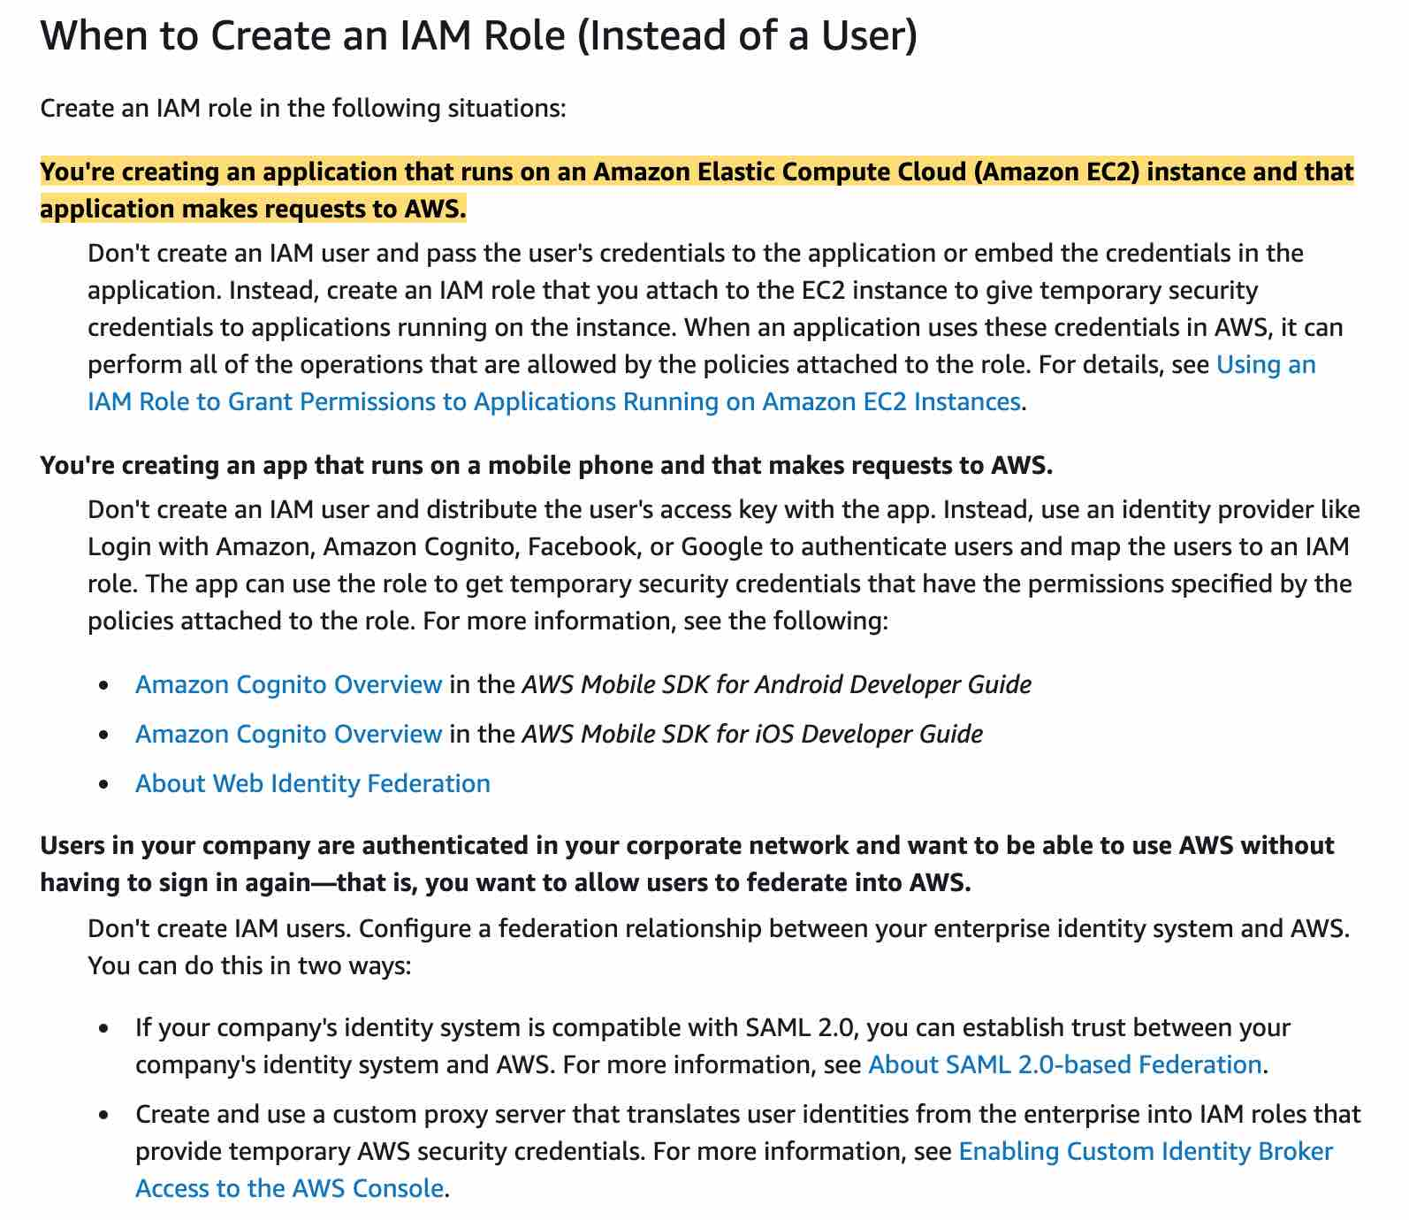 via - <https://docs.aws.amazon.com/IAM/latest/UserGuide/id.html>

Incorrect options:

**Set up an IAM user with read-only permissions for the S3 bucket. Configure AWS credentials for this user via AWS CLI on the EC2 instance**

**Set up an IAM user with read-only permissions for the S3 bucket. Configure the IAM user credentials in the user data of the EC2 instance**

As mentioned in the explanation above, it is dangerous to pass an IAM user's credentials to the application or embed the credentials in the application or even configure these credentials in the user data of the EC2 instance. So both these options are incorrect.

**Set up an S3 service role with read-only permissions for the S3 bucket and attach the role to the EC2 instance profile** - As the application is running on EC2 instances, therefore you need to set up an EC2 service role, not an S3 service role.

Reference:

<https://docs.aws.amazon.com/IAM/latest/UserGuide/id.html>

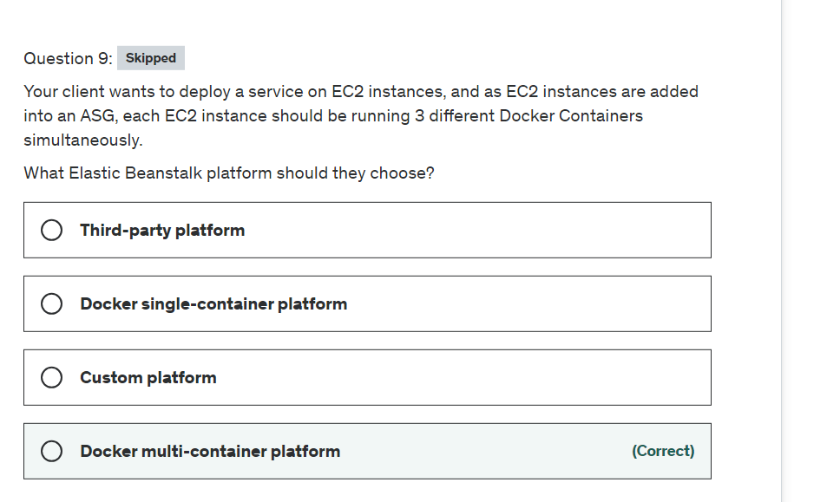

Explanation

Correct option:

**Docker multi-container platform**

Docker is a container platform that allows you to define your software stack and store it in an image that can be downloaded from a remote repository. Use the Multicontainer Docker platform if you need to run multiple containers on each instance. The Multicontainer Docker platform does not include a proxy server. Elastic Beanstalk uses Amazon Elastic Container Service (Amazon ECS) to coordinate container deployments to multi-container Docker environments.

Incorrect options:

**Docker single-container platform** - Docker is a container platform that allows you to define your software stack and store it in an image that can be downloaded from a remote repository. Use the Single Container Docker platform if you only need to run a single Docker container on each instance in your environment. The single container platform includes an Nginx proxy server.

**Custom Platform** - Elastic Beanstalk supports custom platforms. A custom platform provides more advanced customization than a custom image in several ways. A custom platform lets you develop an entirely new platform from scratch, customizing the operating system, additional software, and scripts that Elastic Beanstalk runs on platform instances. This flexibility enables you to build a platform for an application that uses a language or other infrastructure software, for which Elastic Beanstalk doesn't provide a managed platform. Compare that to custom images, where you modify an Amazon Machine Image (AMI) for use with an existing Elastic Beanstalk platform, and Elastic Beanstalk still provides the platform scripts and controls the platform's software stack. Besides, with custom platforms, you use an automated, scripted way to create and maintain your customization, whereas with custom images you make the changes manually over a running instance.

**Third Party Platform** - This is a made-up option.

Reference:

<https://docs.aws.amazon.com/elasticbeanstalk/latest/platforms/platforms-supported.html#platforms-supported.mcdocker>

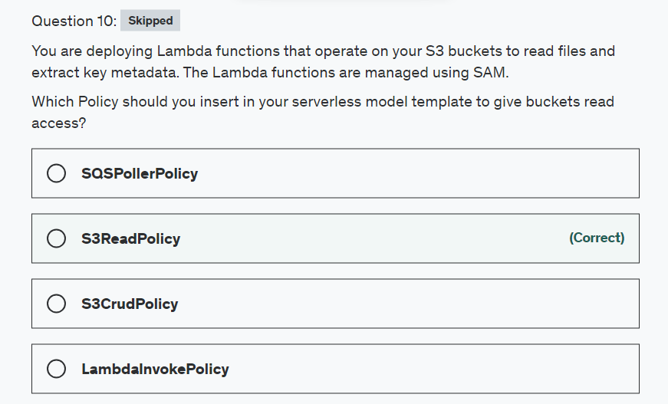

Explanation

Correct option:

**S3ReadPolicy**

The AWS Serverless Application Model (AWS SAM) is an open-source framework that you can use to build serverless applications on AWS.

A serverless application is a combination of Lambda functions, event sources, and other resources that work together to perform tasks. Note that a serverless application is more than just a Lambda function—it can include additional resources such as APIs, databases, and event source mappings.

AWS SAM allows you to choose from a list of policy templates to scope the permissions of your Lambda functions to the resources that are used by your application.

AWS SAM applications in the AWS Serverless Application Repository that use policy templates don't require any special customer acknowledgments to deploy the application from the AWS Serverless Application Repository.

S3ReadPolicy => Gives read-only permission to objects in an Amazon S3 bucket.

S3CrudPolicy => Gives create, read, update, and delete permission to objects in an Amazon S3 bucket.

SQSPollerPolicy => Permits to poll an Amazon SQS Queue.

LambdaInvokePolicy => Permits to invoke a Lambda function, alias, or version.

Incorrect options:

**SQSPollerPolicy**

**S3CrudPolicy**

**LambdaInvokePolicy**

These three options contradict the explanation provided earlier. So these are incorrect.

Reference:

<https://docs.aws.amazon.com/serverless-application-model/latest/developerguide/serverless-policy-templates.html>

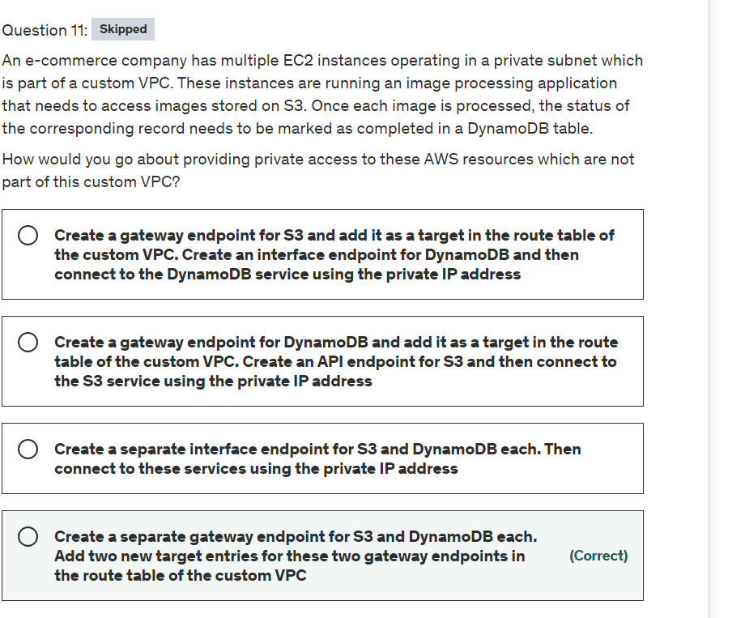

Explanation

Correct option:

**Create a separate gateway endpoint for S3 and DynamoDB each. Add two new target entries for these two gateway endpoints in the route table of the custom VPC**

Endpoints are virtual devices. They are horizontally scaled, redundant, and highly available VPC components. They allow communication between instances in your VPC and services without imposing availability risks or bandwidth constraints on your network traffic.

A VPC endpoint enables you to privately connect your VPC to supported AWS services and VPC endpoint services powered by AWS PrivateLink without requiring an internet gateway, NAT device, VPN connection, or AWS Direct Connect connection. Instances in your VPC do not require public IP addresses to communicate with resources in the service. Traffic between your VPC and the other service does not leave the Amazon network.

There are two types of VPC endpoints: interface endpoints and gateway endpoints. An interface endpoint is an elastic network interface with a private IP address from the IP address range of your subnet that serves as an entry point for traffic destined to a supported service.

A gateway endpoint is a gateway that you specify as a target for a route in your route table for traffic destined to a supported AWS service. The following AWS services are supported:

Amazon S3

DynamoDB

You should note that S3 now supports both gateway endpoints as well as the interface endpoints.

Incorrect options:

**Create a gateway endpoint for S3 and add it as a target in the route table of the custom VPC. Create an interface endpoint for DynamoDB and then connect to the DynamoDB service using the private IP address**

**Create a separate interface endpoint for S3 and DynamoDB each. Then connect to these services using the private IP address**

DynamoDB does not support interface endpoints, so these two options are incorrect.

**Create a gateway endpoint for DynamoDB and add it as a target in the route table of the custom VPC. Create an API endpoint for S3 and then connect to the S3 service using the private IP address** - There is no such thing as an API endpoint for S3. API endpoints are used with AWS API Gateway. This option has been added as a distractor.

References:

<https://docs.aws.amazon.com/vpc/latest/userguide/vpc-endpoints.html>

<https://docs.aws.amazon.com/AmazonS3/latest/userguide/privatelink-interface-endpoints.html>

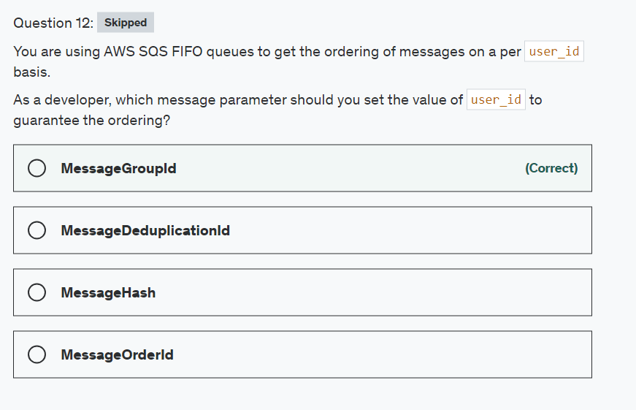

Explanation

Correct option:

AWS FIFO queues are designed to enhance messaging between applications when the order of operations and events has to be enforced.

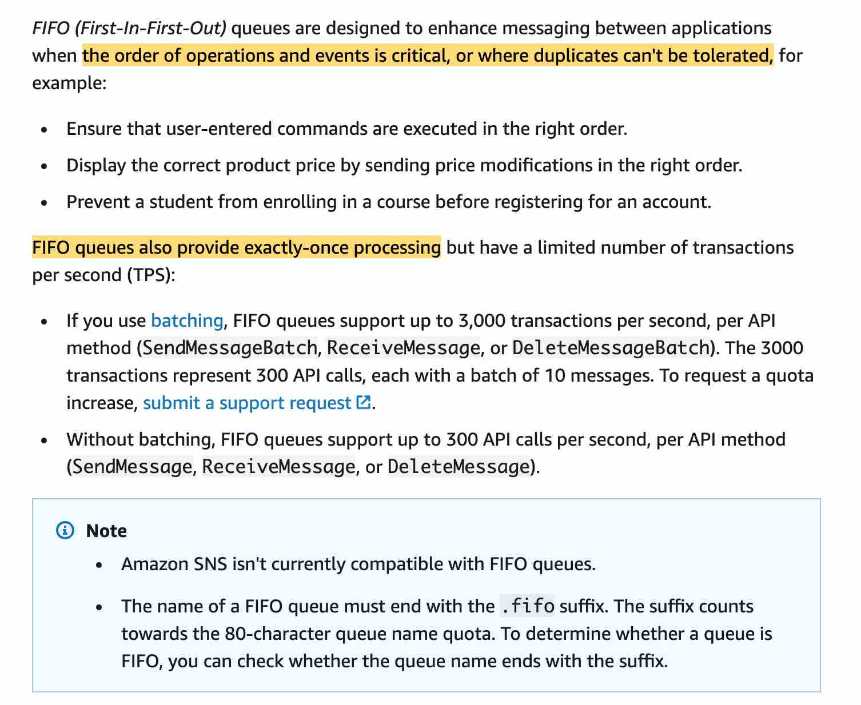 via - <https://docs.aws.amazon.com/AWSSimpleQueueService/latest/SQSDeveloperGuide/FIFO-queues.html>

**MessageGroupId**

The message group ID is the tag that specifies that a message belongs to a specific message group. Messages that belong to the same message group are always processed one by one, in a strict order relative to the message group (however, messages that belong to different message groups might be processed out of order).

Incorrect options:

**MessageDeduplicationId** - The message deduplication ID is the token used for the deduplication of sent messages. If a message with a particular message deduplication ID is sent successfully, any messages sent with the same message deduplication ID are accepted successfully but aren't delivered during the 5-minute deduplication interval.

**MessageOrderId** - This is a made-up option and has been added as a distractor.

**MessageHash** - This is a made-up option and has been added as a distractor.

References:

<https://docs.aws.amazon.com/AWSSimpleQueueService/latest/SQSDeveloperGuide/FIFO-queues.html>

<https://docs.aws.amazon.com/AWSSimpleQueueService/latest/SQSDeveloperGuide/using-messagegroupid-property.html>

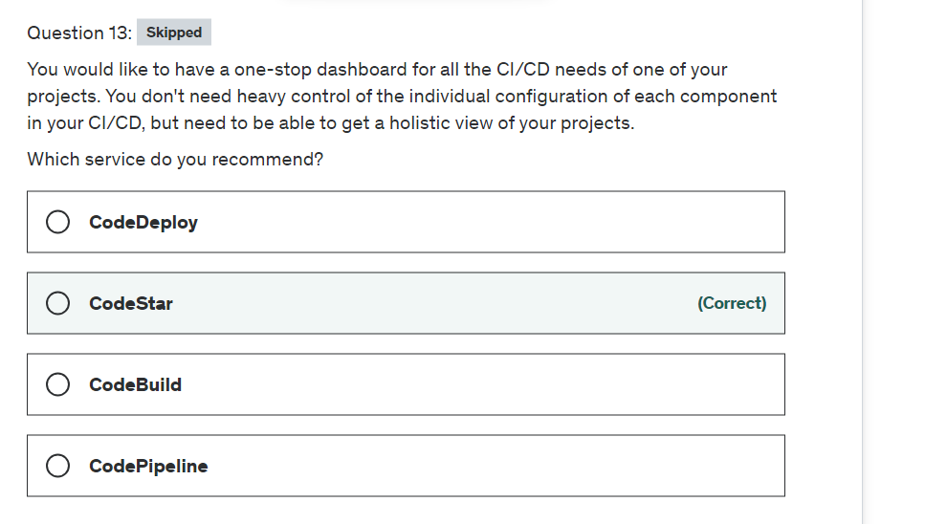

Explanation

Correct option:

**CodeStar**

AWS CodeStar enables you to quickly develop, build, and deploy applications on AWS. AWS CodeStar provides a unified user interface, enabling you to easily manage your software development activities in one place. With AWS CodeStar, you can set up your entire continuous delivery toolchain in minutes, allowing you to start releasing code faster. AWS CodeStar makes it easy for your whole team to work together securely, allowing you to easily manage access and add owners, contributors, and viewers to your projects. Each AWS CodeStar project comes with a project management dashboard, including an integrated issue tracking capability powered by Atlassian JIRA Software. With the AWS CodeStar project dashboard, you can easily track progress across your entire software development process, from your backlog of work items to teams’ recent code deployments.

Incorrect options:

**CodeBuild**

**CodeDeploy**

**CodePipeline**

All these options are individual services encompassed by CodeStar when you deploy a project. They have to be used individually and don't provide a unified "project" view.

Reference:

<https://aws.amazon.com/codestar/>

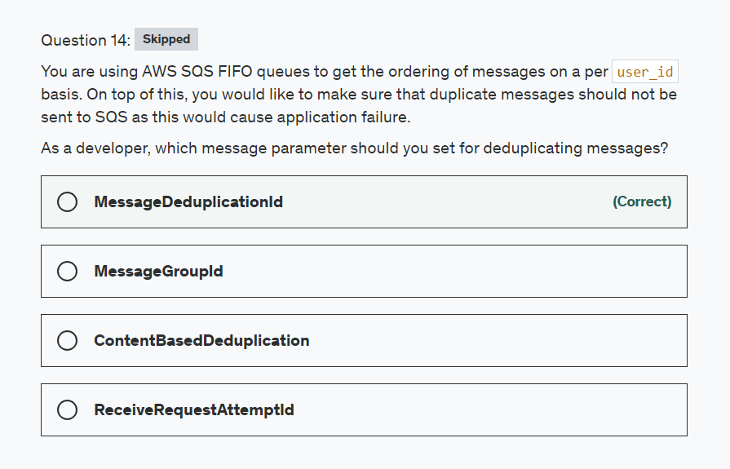

Explanation

Correct option:

AWS FIFO queues are designed to enhance messaging between applications when the order of operations and events has to be enforced.

 via - <https://docs.aws.amazon.com/AWSSimpleQueueService/latest/SQSDeveloperGuide/FIFO-queues.html>

**MessageDeduplicationId**

The message deduplication ID is the token used for the deduplication of sent messages. If a message with a particular message deduplication ID is sent successfully, any messages sent with the same message deduplication ID are accepted successfully but aren't delivered during the 5-minute deduplication interval.

Incorrect options:

**MessageGroupId** - The message group ID is the tag that specifies that a message belongs to a specific message group. Messages that belong to the same message group are always processed one by one, in a strict order relative to the message group (however, messages that belong to different message groups might be processed out of order).

**ReceiveRequestAttemptId** - This parameter applies only to FIFO (first-in-first-out) queues. The token is used for deduplication of ReceiveMessage calls. If a networking issue occurs after a ReceiveMessage action, and instead of a response you receive a generic error, you can retry the same action with an identical ReceiveRequestAttemptId to retrieve the same set of messages, even if their visibility timeout has not yet expired.

**ContentBasedDeduplication** - This is not a message parameter, but a queue setting. Enable content-based deduplication to instruct Amazon SQS to use an SHA-256 hash to generate the message deduplication ID using the body of the message - but not the attributes of the message.

Reference:

<https://docs.aws.amazon.com/AWSSimpleQueueService/latest/SQSDeveloperGuide/using-messagededuplicationid-property.html>

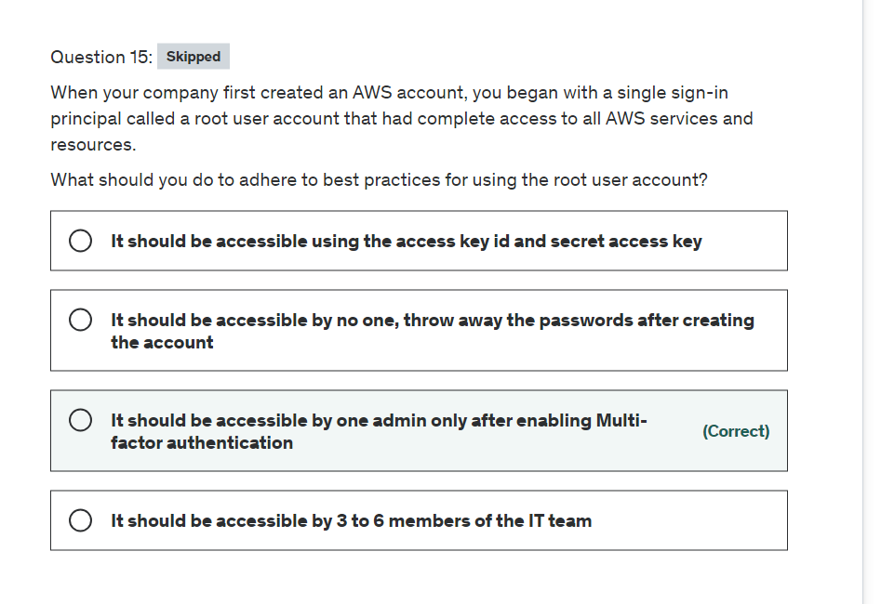

Explanation

Correct option:

**It should be accessible by one admin only after enabling Multi-factor authentication**

AWS Root Account Security Best Practices:  via - <https://docs.aws.amazon.com/IAM/latest/UserGuide/best-practices.html#lock-away-credentials>

If you continue to use the root user credentials, we recommend that you follow the security best practice to enable multi-factor authentication (MFA) for your account. Because your root user can perform sensitive operations in your account, adding a layer of authentication helps you to better secure your account. Multiple types of MFA are available.

Incorrect options:

**It should be accessible by 3 to 6 members of the IT team** - Only the owner of the AWS account should have access to the root account credentials. You should create an IT group with admin permissions via IAM and then assign a few users to this group.

**It should be accessible using the access key id and secret access key** - AWS recommends that you should not use the access key id and secret access key for the AWS account root user.

**It should be accessible by no one, throw away the passwords after creating the account** - You will still need to store the password somewhere for your root account.

Reference:

<https://docs.aws.amazon.com/IAM/latest/UserGuide/best-practices.html#lock-away-credentials>

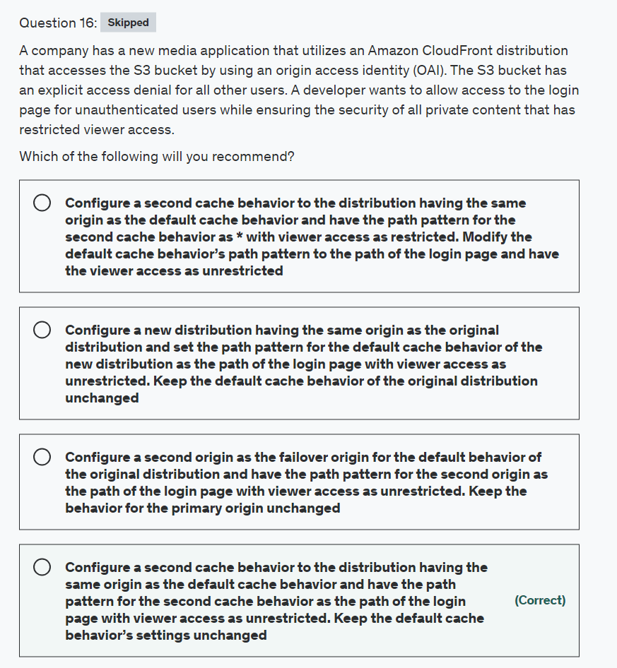

Explanation

Correct option:

**Configure a second cache behavior to the distribution having the same origin as the default cache behavior and have the path pattern for the second cache behavior as the path of the login page with viewer access as unrestricted. Keep the default cache behavior’s settings unchanged**

Cache behavior describes how CloudFront processes requests. You must create at least as many cache behaviors (including the default cache behavior) as you have origins if you want CloudFront to serve objects from all of the origins. Each cache behavior specifies the one origin from which you want CloudFront to get objects. If you have two origins and only the default cache behavior, the default cache behavior will cause CloudFront to get objects from one of the origins, but the other origin is never used.

The pattern (for example, images/*.jpg) specifies which requests to apply the behavior to. When CloudFront receives a viewer request, the requested path is compared with path patterns in the order in which cache behaviors are listed in the distribution. The path pattern for the default cache behavior is * and cannot be changed. If the request for an object does not match the path pattern for any cache behaviors, CloudFront applies the behavior in the default cache behavior.

For the given use case, you need to add a second cache behavior to the distribution having the same origin as the default cache behavior and list it above the default cache behavior in the distribution. The second cache behavior should have the path pattern as the path of the login page with viewer access set as unrestricted. This would allow access to the login page for unauthenticated users. Since the default cache behavior’s settings remain unchanged, it ensures the security of all private content that continues to have restricted viewer access.

Incorrect options:

**Configure a second cache behavior to the distribution having the same origin as the default cache behavior and have the path pattern for the second cache behavior as * with viewer access as restricted. Modify the default cache behavior’s path pattern to the path of the login page and have the viewer access as unrestricted** - This option is incorrect since the path pattern for the default cache behavior is always * and cannot be changed.

**Configure a new distribution having the same origin as the original distribution and set the path pattern for the default cache behavior of the new distribution as the path of the login page with viewer access as unrestricted. Keep the default cache behavior of the original distribution unchanged** - If you have two origins and only the default cache behavior, the default cache behavior will cause CloudFront to get objects from one of the origins, but the other origin is never used. So this option is incorrect.

**Configure a second origin as the failover origin for the default behavior of the original distribution and have the path pattern for the second origin as the path of the login page with viewer access as unrestricted. Keep the behavior for the primary origin unchanged** - You can set up CloudFront with origin failover for scenarios that require high availability. To get started, you create an origin group with two origins: a primary and a secondary. If the primary origin is unavailable or returns specific HTTP response status codes that indicate a failure, CloudFront automatically switches to the secondary origin. To set up origin failover, you must have a distribution with at least two origins. Next, you create an origin group for your distribution that includes two origins, setting one as the primary. Finally, you create or update a cache behavior to use the origin group.

This option is incorrect since the failover kicks in only when the primary is unavailable. Therefore, access to the login page and the rest of the content will never work together.

References:

<https://docs.aws.amazon.com/cloudfront/latest/APIReference/API_CacheBehavior.html>

<https://docs.aws.amazon.com/AmazonCloudFront/latest/DeveloperGuide/high_availability_origin_failover.html>

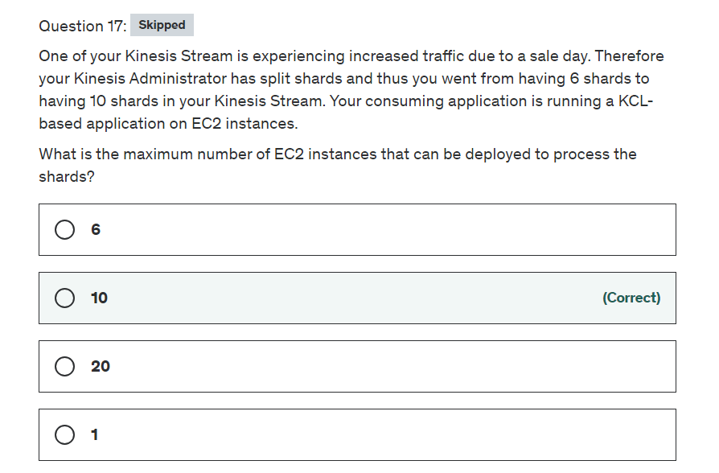

Explanation

Correct option:

**10**

Amazon Kinesis Data Streams enables you to build custom applications that process or analyze streaming data for specialized needs.

A Kinesis data stream is a set of shards. A shard is a uniquely identified sequence of data records in a stream. A stream is composed of one or more shards, each of which provides a fixed unit of capacity.

Kinesis Data Streams Overview: 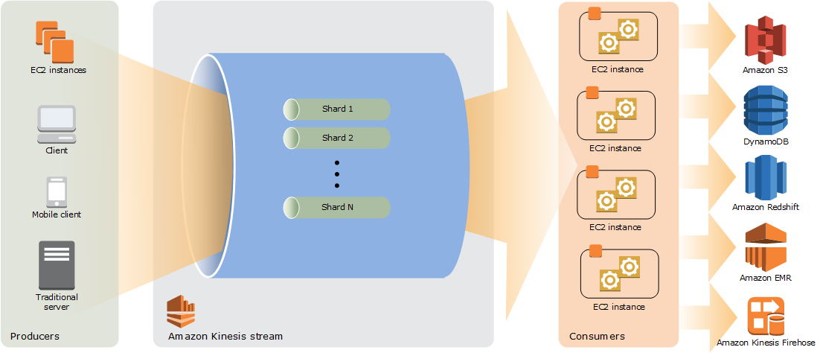 via - <https://docs.aws.amazon.com/streams/latest/dev/key-concepts.html>

Each KCL consumer application instance uses "workers" to process data in Kinesis shards. At any given time, each shard of data records is bound to a particular worker via a lease. For the given use-case, an EC2 instance acts as the worker for the KCL application. You can have at most one EC2 instance per shard in Kinesis for the given application. As we have 10 shards, the max number of EC2 instances is 10.

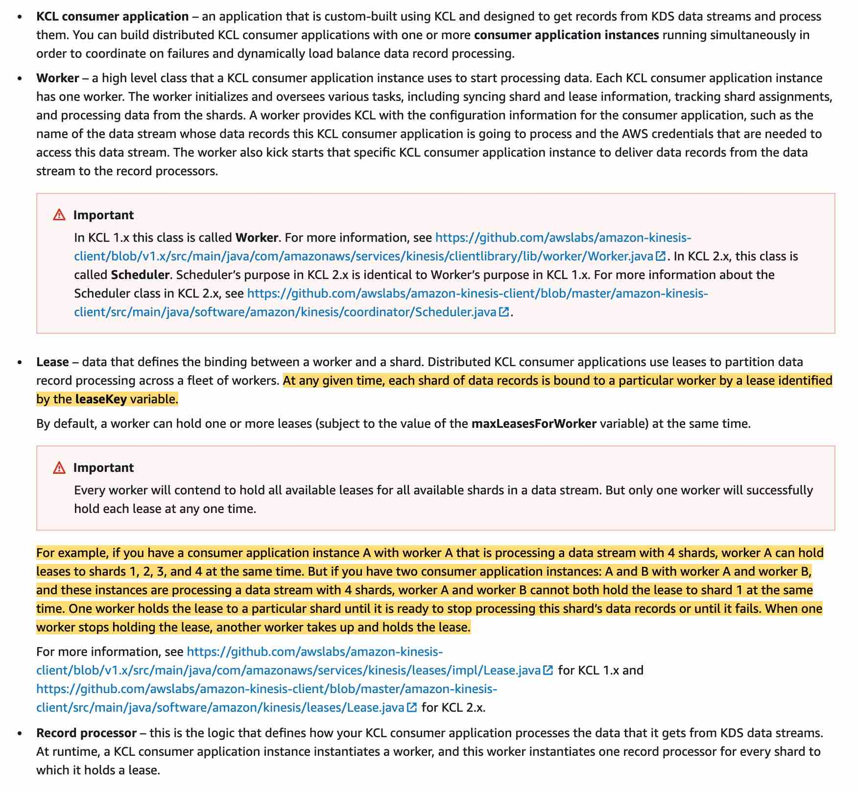 via - <https://docs.aws.amazon.com/streams/latest/dev/shared-throughput-kcl-consumers.html>

Incorrect options:

**1**

**6**

**20**

These three options contradict the explanation provided earlier. So these are incorrect.

Reference:

<https://docs.aws.amazon.com/streams/latest/dev/developing-consumers-with-kcl.html>

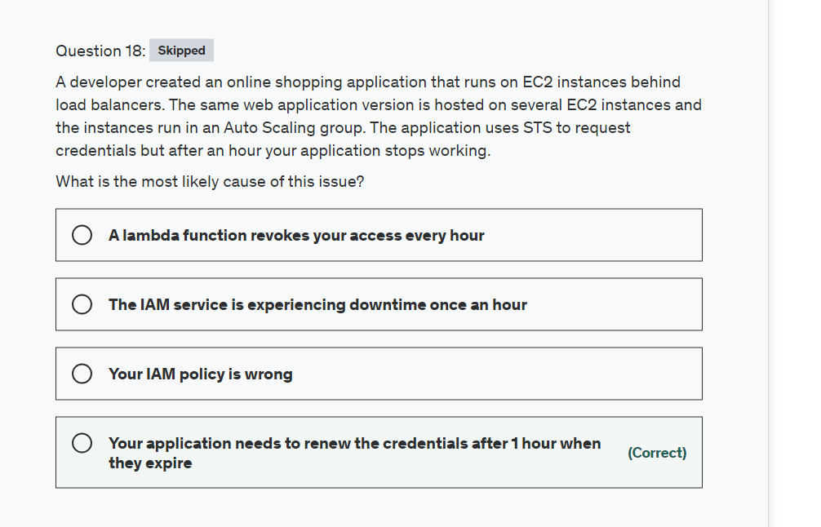

Explanation

Correct option:

**Your application needs to renew the credentials after 1 hour when they expire**

AWS Security Token Service (AWS STS) is a web service that enables you to request temporary, limited-privilege credentials for AWS Identity and Access Management (IAM) users or for users that you authenticate (federated users). By default, AWS Security Token Service (STS) is available as a global service, and all AWS STS requests go to a single endpoint at https://sts.amazonaws.com.

Credentials that are created by using account credentials can range from 900 seconds (15 minutes) up to a maximum of 3,600 seconds (1 hour), with a default of 1 hour. Hence you need to renew the credentials post expiry.

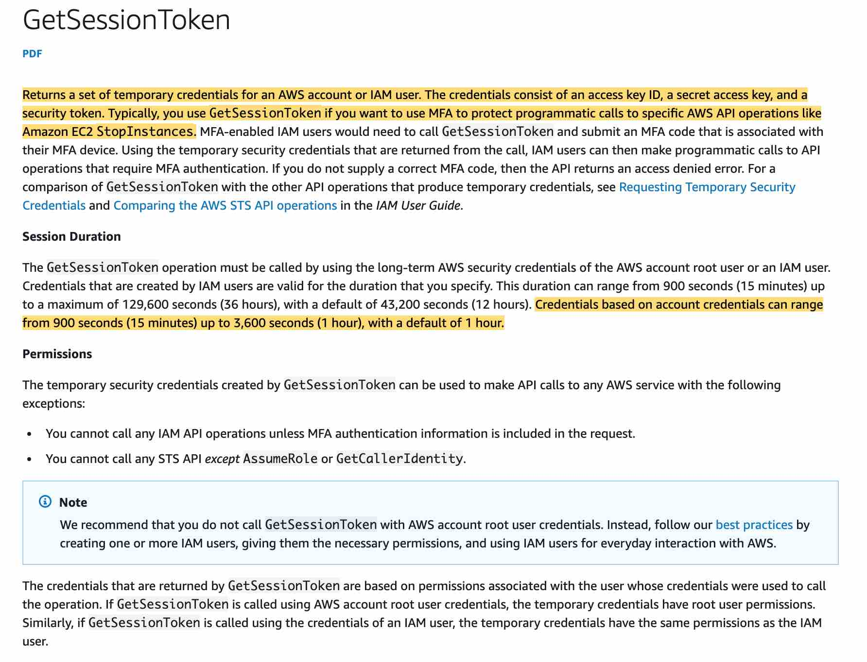 via - <https://docs.aws.amazon.com/STS/latest/APIReference/API_GetSessionToken.html>

Incorrect options:

**Your IAM policy is wrong** - If your policy was wrong, a reboot would not solve the issue.

**A lambda function revokes your access every hour** - Revoking can be done by an IAM policy. Lambda function cannot revoke access.

**The IAM service is experiencing downtime once an hour** - The IAM service is reliable as it's managed by AWS.

Reference:

<https://docs.aws.amazon.com/STS/latest/APIReference/API_GetSessionToken.html>

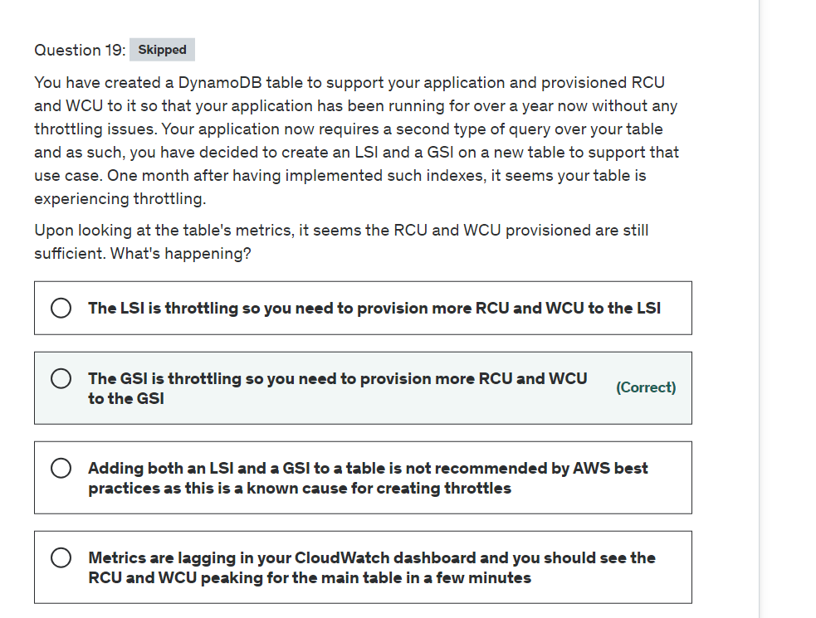

Explanation

Correct option:

**The GSI is throttling so you need to provision more RCU and WCU to the GSI**

DynamoDB supports two types of secondary indexes:

Global secondary index — An index with a partition key and a sort key that can be different from those on the base table. A global secondary index is considered "global" because queries on the index can span all of the data in the base table, across all partitions. A global secondary index is stored in its own partition space away from the base table and scales separately from the base table.

Local secondary index — An index that has the same partition key as the base table, but a different sort key. A local secondary index is "local" in the sense that every partition of a local secondary index is scoped to a base table partition that has the same partition key value.

Differences between GSI and LSI: 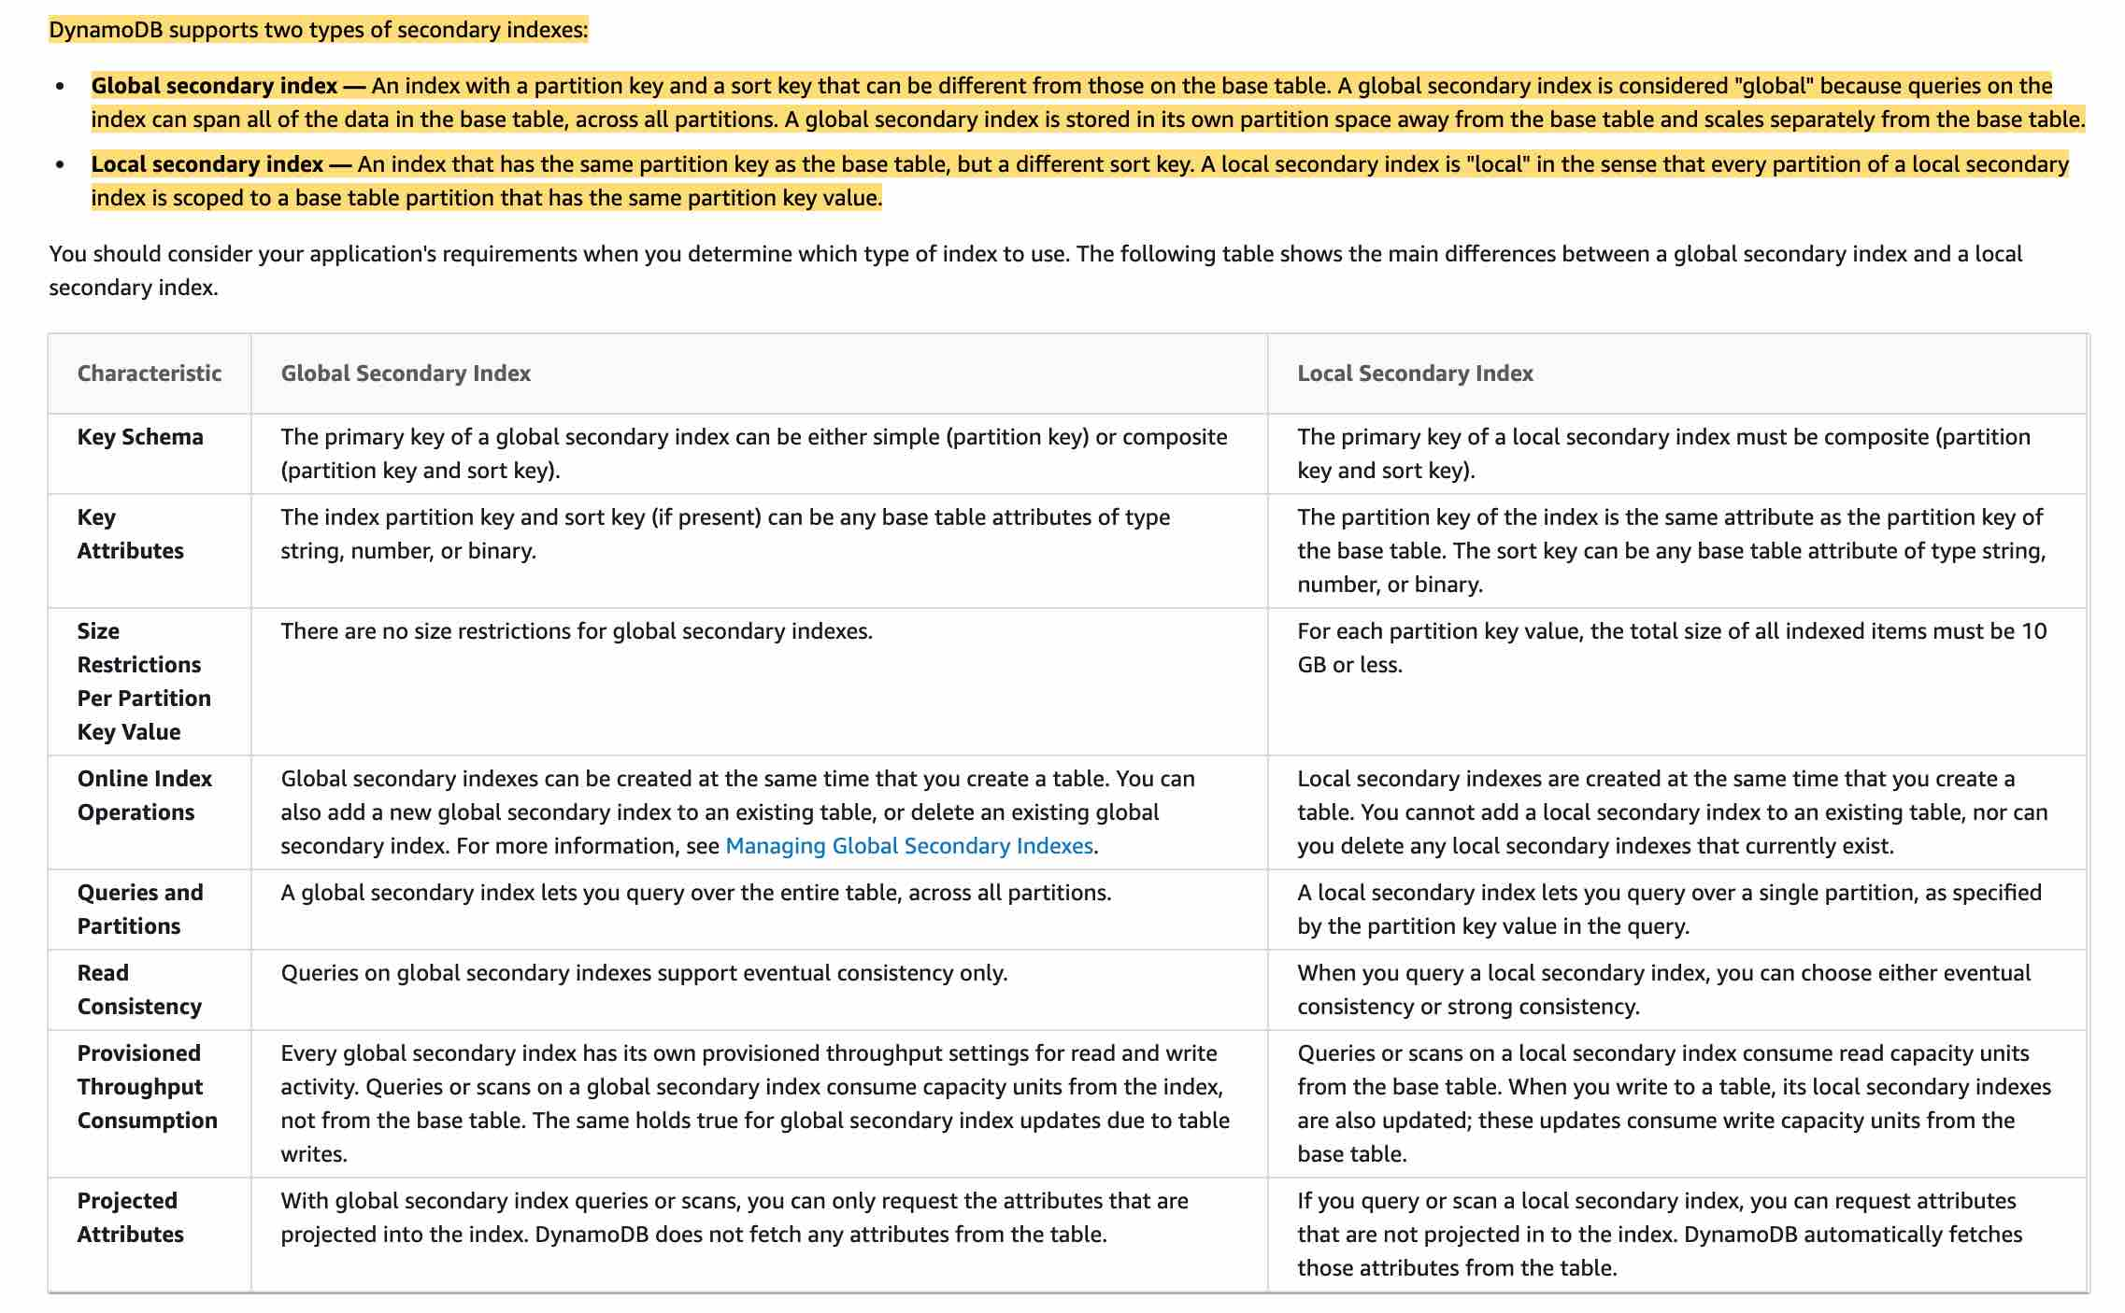 via - <https://docs.aws.amazon.com/amazondynamodb/latest/developerguide/SecondaryIndexes.html>

If you perform heavy write activity on the table, but a global secondary index on that table has insufficient write capacity, then the write activity on the table will be throttled. To avoid potential throttling, the provisioned write capacity for a global secondary index should be equal or greater than the write capacity of the base table since new updates will write to both the base table and global secondary index.

Incorrect options

**The LSI is throttling so you need to provision more RCU and WCU to the LSI** - LSI use the RCU and WCU of the main table, so you can't provision more RCU and WCU to the LSI.

**Adding both an LSI and a GSI to a table is not recommended by AWS best practices as this is a known cause for creating throttles** - This option has been added as a distractor. It is fine to have LSI and GSI together.

**Metrics are lagging in your CloudWatch dashboard and you should see the RCU and WCU peaking for the main table in a few minutes** - This could be a reason, but in this case, the GSI is at fault as the application has been running fine for months.

References:

<https://docs.aws.amazon.com/amazondynamodb/latest/developerguide/SecondaryIndexes.html>

<https://docs.aws.amazon.com/amazondynamodb/latest/developerguide/GSI.html#GSI.ThroughputConsiderations>

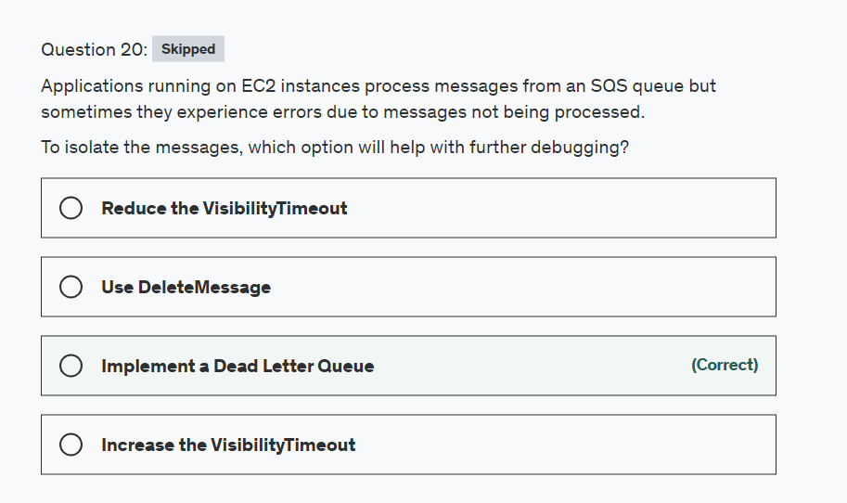

Explanation

Correct option:

**Implement a Dead Letter Queue**

Dead-letter queues can be used by other queues (source queues) as a target for messages that can't be processed (consumed) successfully. Dead-letter queues are useful for debugging your application or messaging system because they let you isolate problematic messages to determine why their processing doesn't succeed.

Sometimes, messages can’t be processed because of a variety of possible issues, such as when a user comments on a story but it remains unprocessed because the original story itself is deleted by the author while the comments were being posted. In such a case, the dead-letter queue can be used to handle message processing failures.

How do dead-letter queues work? 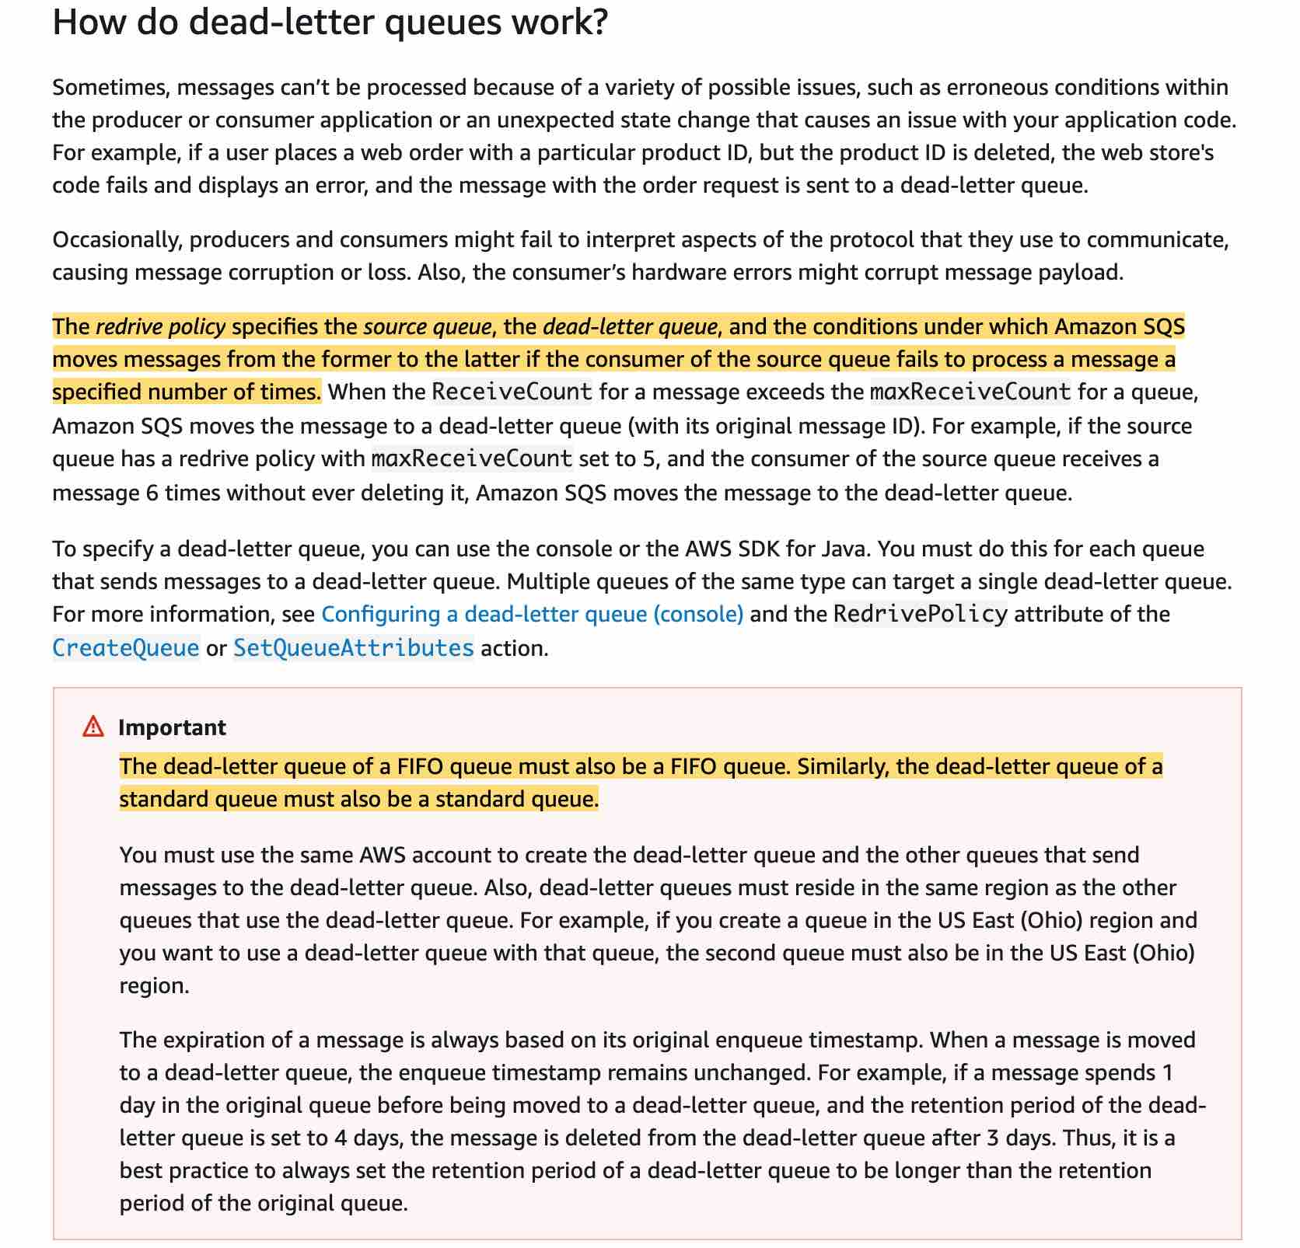 via - <https://docs.aws.amazon.com/AWSSimpleQueueService/latest/SQSDeveloperGuide/sqs-dead-letter-queues.html>

Use-cases for dead-letter queues: 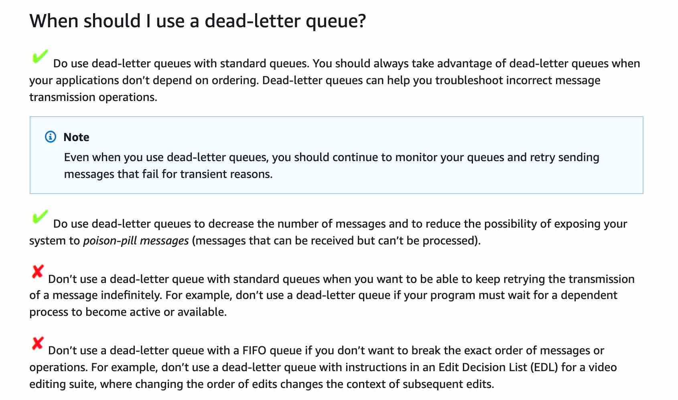 via - <https://docs.aws.amazon.com/AWSSimpleQueueService/latest/SQSDeveloperGuide/sqs-dead-letter-queues.html>

Amazon SQS supports dead-letter queues, which other queues (source queues) can target for messages that cannot be processed (consumed) successfully. Dead-letter queues are useful for debugging your application or messaging system because they let you isolate problematic messages to determine why their processing doesn't succeed.

Incorrect:

**Use DeleteMessage** - This API call deletes the message in the queue but does not help you find the issue.

**Reduce the VisibilityTimeout** - Amazon SQS uses a visibility timeout to prevent other consumers from receiving and processing the same message. The default visibility timeout for a message is 30 seconds. The minimum is 0 seconds. The maximum is 12 hours. If you reduce the VisibilityTimeout, more consumers will get the failed message

**Increase the VisibilityTimeout** - It won't help because you don't need more time but rather an isolated place to debug.

Reference:

<https://docs.aws.amazon.com/AWSSimpleQueueService/latest/SQSDeveloperGuide/sqs-dead-letter-queues.html>

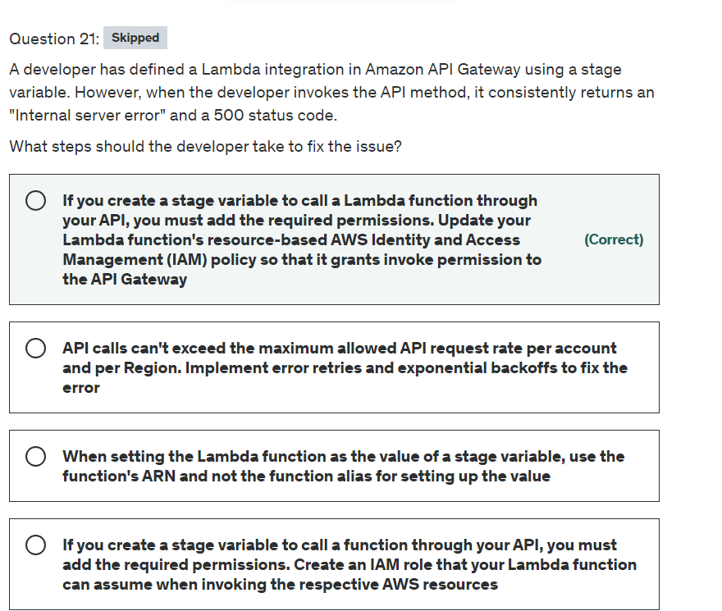

Explanation

Correct option:

**If you create a stage variable to call a Lambda function through your API, you must add the required permissions. Update your Lambda function's resource-based AWS Identity and Access Management (IAM) policy so that it grants invoke permission to the API Gateway**

If your Lambda function's resource-based policy doesn't include permissions for your API to invoke the function, API Gateway returns an Internal server error message.

If you create a stage variable to call a function through your API, you must add the required permissions by doing one of the following:

Update your Lambda function's resource-based AWS Identity and Access Management (IAM) policy so that it grants invoke permission to API Gateway.

OR

Create an IAM role that API Gateway can assume to invoke your Lambda function.

If you build an API Gateway API with standard Lambda integration using the API Gateway console, the console adds the required permissions automatically.

Example resource-based policy that grants invoke permission to API Gateway: 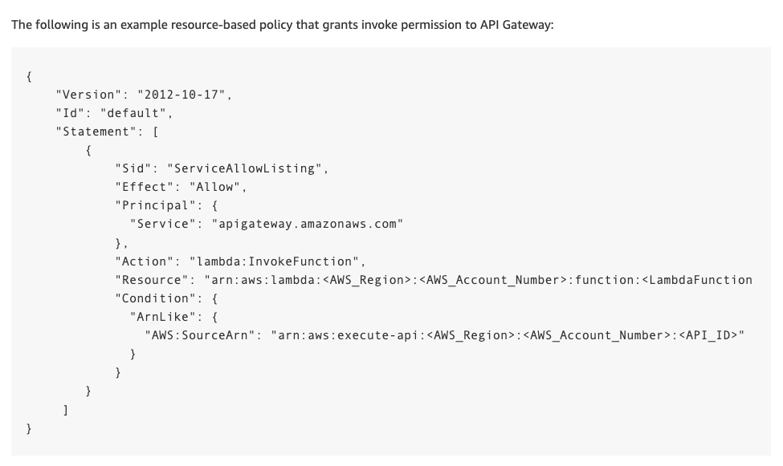 via - <https://aws.amazon.com/premiumsupport/knowledge-center/api-gateway-lambda-stage-variable-500/>

Incorrect options:

**API calls can't exceed the maximum allowed API request rate per account and per Region. Implement error retries and exponential backoffs to fix the error** - When API calls exceed the maximum allowed API request rate per account and per Region, the error received is a "Rate Exceeded" error and not an "Internal server error". Hence, this option is irrelevant to the given use case.

**If you create a stage variable to call a function through your API, you must add the required permissions. Create an IAM role that your Lambda function can assume when invoking the respective AWS resources** - This option is incorrect. However, creating an IAM role that API Gateway can assume to invoke the Lambda function is another solution to fix the given problem.

**When setting the Lambda function as the value of a stage variable, use the function's ARN and not the function alias for setting up the value** - This statement is incorrect. When setting a Lambda function as the value of a stage variable, use the function's local name, possibly including its alias or version specification. Do not use the function's ARN. The API Gateway console assumes the stage variable value for a Lambda function as the unqualified function name and expands the given stage variable into an ARN.

References:

<https://docs.aws.amazon.com/lambda/latest/dg/services-apigateway.html>

<https://docs.aws.amazon.com/apigateway/latest/developerguide/how-to-set-stage-variables-aws-console.html>

<https://aws.amazon.com/premiumsupport/knowledge-center/api-gateway-lambda-stage-variable-500/>

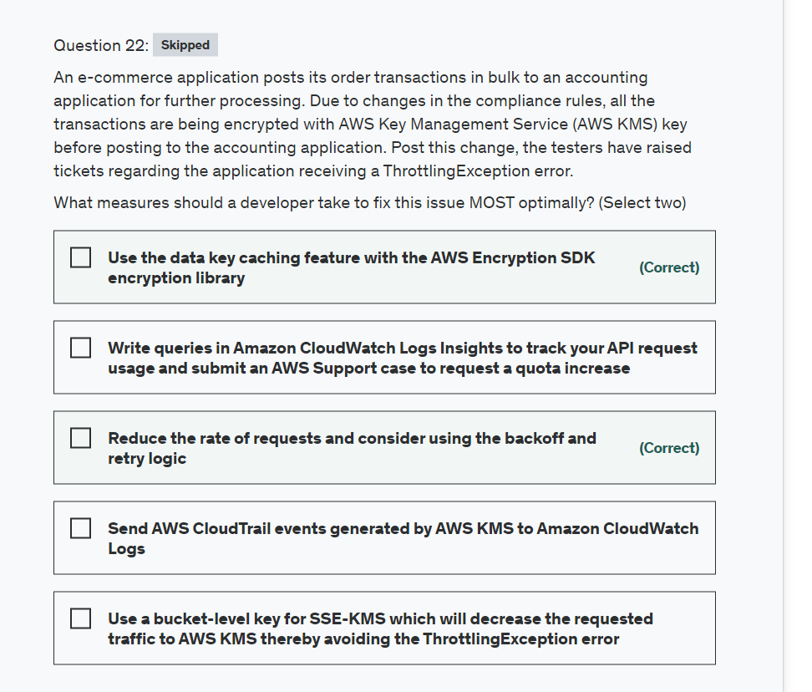

Explanation

Correct options:

**Reduce the rate of requests and consider using the backoff and retry logic**

Each AWS SDK implements automatic retry logic. The AWS SDK for Java automatically retries requests, and you can configure the retry settings. In addition to simple retries, each AWS SDK implements an exponential backoff algorithm for better flow control. The idea behind exponential backoff is to use progressively longer waits between retries for consecutive error responses. You should implement a maximum delay interval, as well as a maximum number of retries. The maximum delay interval and the maximum number of retries are not necessarily fixed values and should be set based on the operation being performed, as well as other local factors, such as network latency.

**Use the data key caching feature with the AWS Encryption SDK encryption library**

Data key caching stores data keys and related cryptographic material in a cache. When you encrypt or decrypt data, the AWS Encryption SDK looks for a matching data key in the cache. If it finds a match, it uses the cached data key rather than generating a new one. Data key caching can improve performance, reduce cost, and help you stay within service limits as your application scales.

Your application can benefit from data key caching if: 1. It can reuse data keys. 2. It generates numerous data keys. 3. Your cryptographic operations are unacceptably slow, expensive, limited, or resource-intensive.

Data key caching is an optional feature of the AWS Encryption SDK that you should use cautiously. By default, the AWS Encryption SDK generates a new data key for every encryption operation. This technique supports cryptographic best practices, which discourage excessive reuse of data keys. In general, use data key caching only when it is required to meet your performance goals. Then, use the data key caching security thresholds to ensure that you use the minimum amount of caching required to meet your cost and performance goals.

Best practices to troubleshoot ThrottlingException errors: 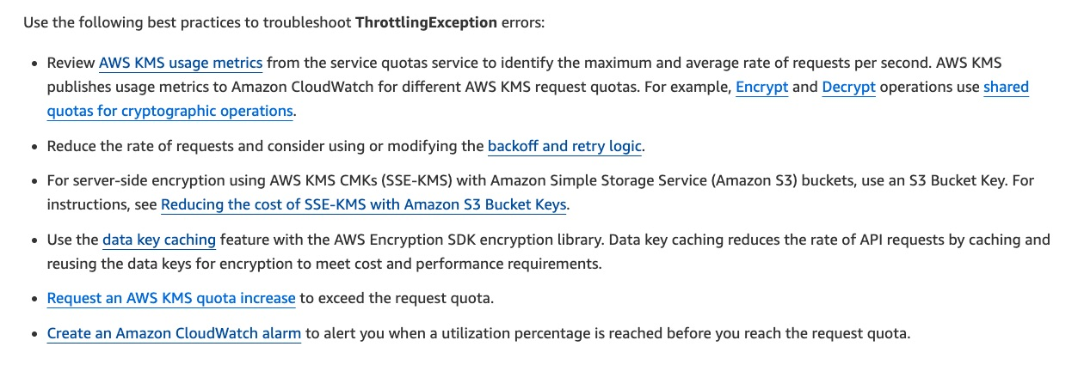 via - <https://aws.amazon.com/premiumsupport/knowledge-center/kms-throttlingexception-error/>

Incorrect options:

**Send AWS CloudTrail events generated by AWS KMS to Amazon CloudWatch Logs** - Deeper analysis of CloudTrail data sent to CloudWatch logs can help spot throttled API calls. While it is certainly possible to track API usage using CloudTrail data, it is not an optimal way to fix the ThrottlingException error.

**Write queries in Amazon CloudWatch Logs Insights to track your API request usage and submit an AWS Support case to request a quota increase** - Historically, to understand how close to a request rate quota you were, you had to perform three tasks: (i) send AWS CloudTrail events generated by AWS KMS to Amazon CloudWatch Logs; (ii) write queries in Amazon CloudWatch Logs Insights to track your API request usage; and (iii) submit an AWS Support case to request a quota increase. Now, you can view your AWS KMS API usage and request quota increases within the AWS Service Quotas console itself without doing any special configuration.

**Use a bucket-level key for SSE-KMS which will decrease the requested traffic to AWS KMS thereby avoiding the ThrottlingException error** - Amazon S3 bucket has not been mentioned in the given use case and hence this option is irrelevant.

References:

<https://docs.aws.amazon.com/general/latest/gr/api-retries.html>

<https://docs.aws.amazon.com/encryption-sdk/latest/developer-guide/data-key-caching.html>

<https://aws.amazon.com/blogs/security/manage-your-aws-kms-api-request-rates-using-service-quotas-and-amazon-cloudwatch/>

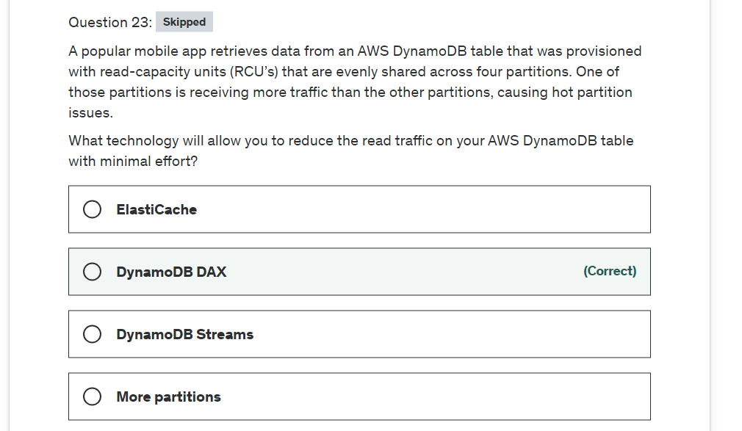

Explanation

Correct option:

**DynamoDB DAX**

Amazon DynamoDB Accelerator (DAX) is a fully managed, highly available, in-memory cache for DynamoDB that delivers up to a 10x performance improvement: from milliseconds to microseconds: even at millions of requests per second.

Incorrect options:

**DynamoDB Streams** - A stream record contains information about a data modification to a single item in a DynamoDB table. This is not the correct option for the given use-case.

**ElastiCache** - ElastiCache can cache the results from anything but you will need to modify your code to check the cache before querying the main query store. As the given use-case mandates minimal effort, so this option is not correct.

**More partitions** - This option has been added as a distractor as DynamoDB handles that for you automatically.

Reference:

<https://aws.amazon.com/dynamodb/dax/>

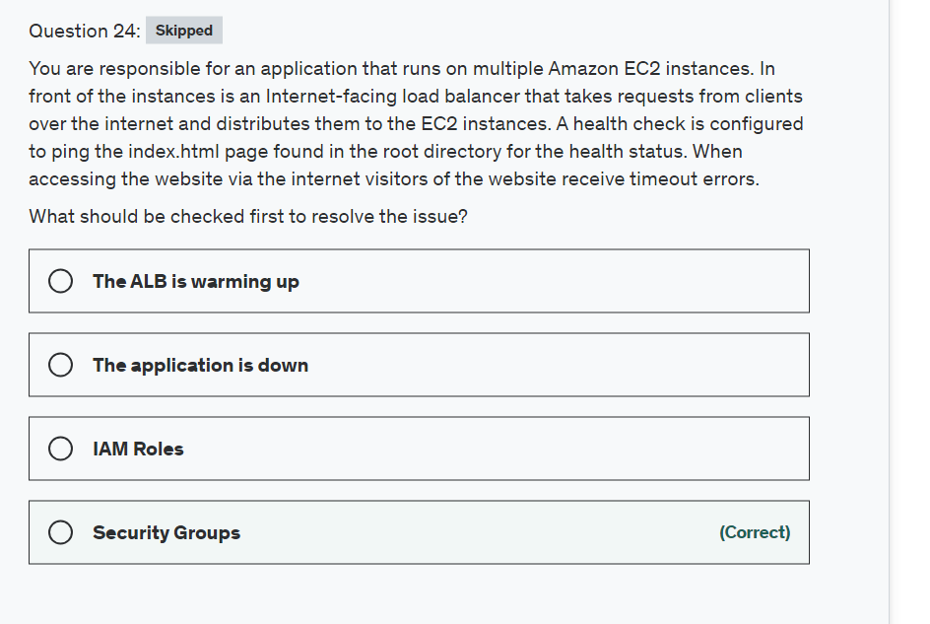

Explanation

Correct option:

**Security Groups**

A security group acts as a virtual firewall for your EC2 instances to control incoming and outgoing traffic. Inbound rules control the incoming traffic to your instance, and outbound rules control the outgoing traffic from your instance.

Check the security group rules of your EC2 instance. You need a security group rule that allows inbound traffic from your public IPv4 address on the proper port.

Incorrect options:

**IAM Roles** - Usually you run into issues with authorization of APIs with roles but not for timeout, so this option does not fit the given use-case.

**The application is down** - Although you can set a health check for application ping or HTTP, timeouts are usually caused by blocked firewall access.

**The ALB is warming up** - ALB has a slow start mode which allows a warm-up period before being able to respond to requests with optimal performance. So this is not the issue.

Reference:

<https://docs.aws.amazon.com/AWSEC2/latest/UserGuide/TroubleshootingInstancesConnecting.html#TroubleshootingInstancesConnectionTimeout>

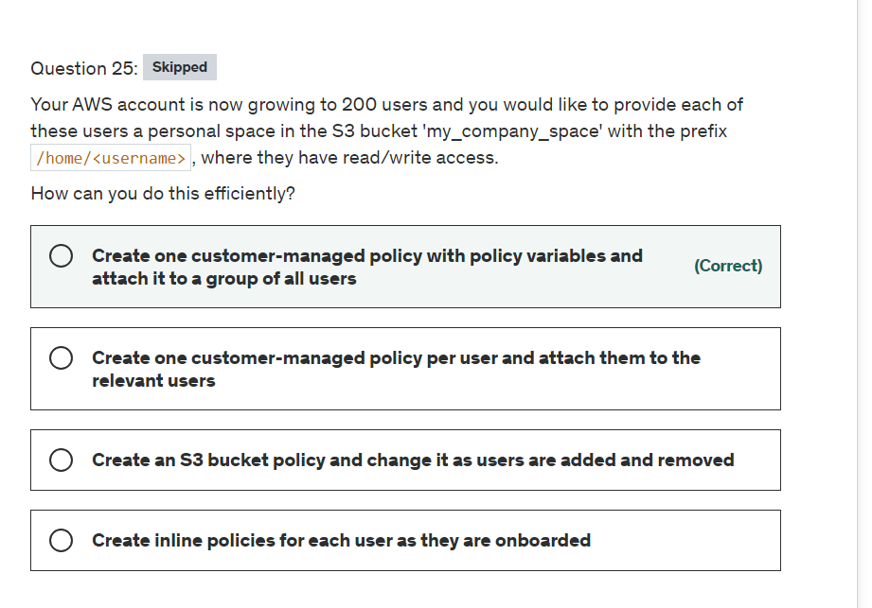

Explanation

Correct option:

**Create one customer-managed policy with policy variables and attach it to a group of all users**

You can assign access to "dynamically calculated resources" by using policy variables, a feature that lets you specify placeholders in a policy. When the policy is evaluated, the policy variables are replaced with values that come from the context of the request itself.

This is ideal when you want want to generalize the policy so it works for many users without having to make a unique copy of the policy for each user. For example, consider writing a policy to allow each user to have access to his or her own objects in an Amazon S3 bucket, as in the previous example. But don't create a separate policy for each user that explicitly specifies the user's name as part of the resource. Instead, create a single group policy that works for any user in that group.

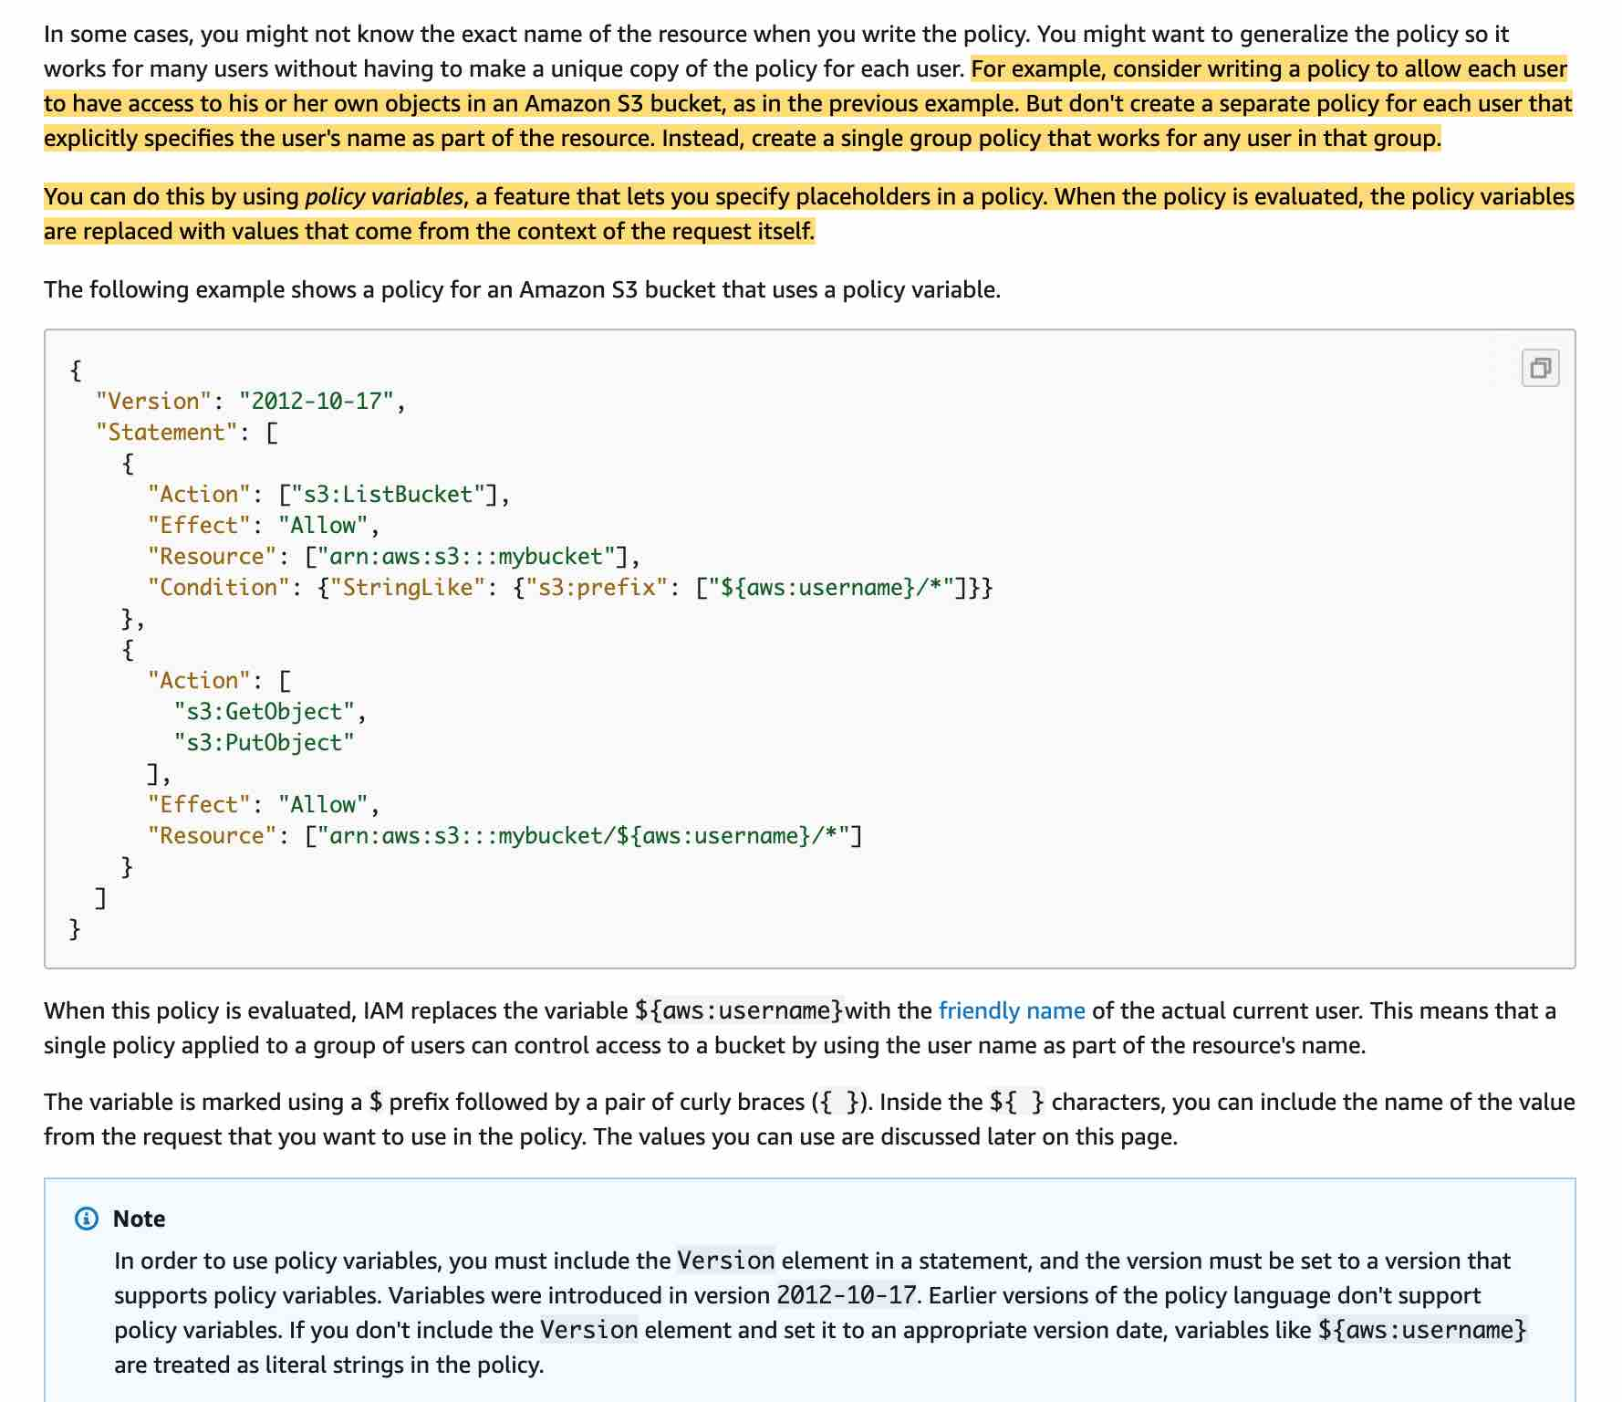 via - <https://docs.aws.amazon.com/IAM/latest/UserGuide/reference_policies_variables.html>

Incorrect options:

**Create an S3 bucket policy and change it as users are added and removed**

This doesn't scale and the S3 bucket policy size may be maxed out. The IAM policies bump up against a size limit (up to 2 kb for users, 5 kb for groups, and 10 kb for roles). S3 supports bucket policies of up 20 kb.

**Create inline policies for each user as they are onboarded**: This would work but doesn't scale and it's inefficient.

**Create one customer-managed policy per user and attach them to the relevant users**: This would work but doesn't scale and would be a nightmare to manage.

Reference:

<https://docs.aws.amazon.com/IAM/latest/UserGuide/reference_policies_variables.html>

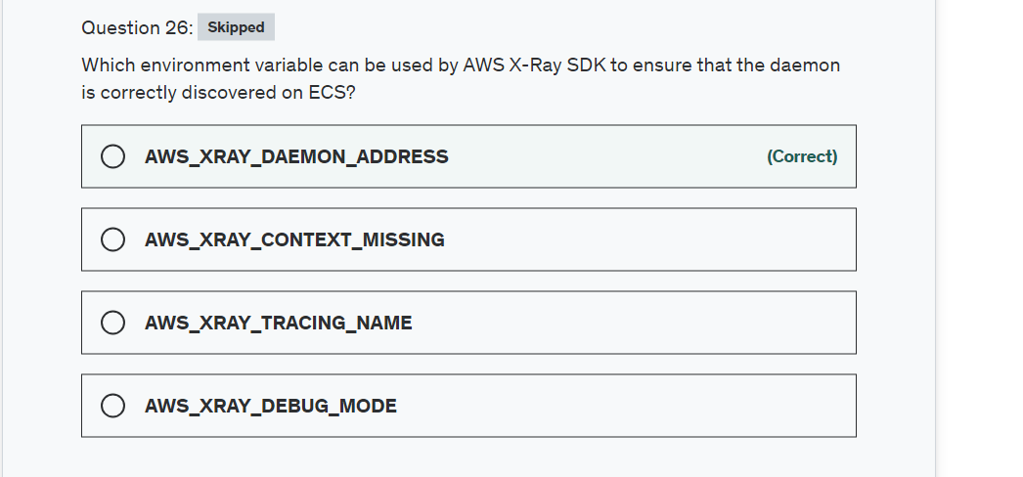

Explanation

Correct option:

**AWS_XRAY_DAEMON_ADDRESS**

Set the host and port of the X-Ray daemon listener. By default, the SDK uses 127.0.0.1:2000 for both trace data (UDP) and sampling (TCP). Use this variable if you have configured the daemon to listen on a different port or if it is running on a different host.

Incorrect options:

**AWS_XRAY_TRACING_NAME** - This sets a service name that the SDK uses for segments.

**AWS_XRAY_CONTEXT_MISSING** - This should be set to LOG_ERROR to avoid throwing exceptions when your instrumented code attempts to record data when no segment is open.

**AWS_XRAY_DEBUG_MODE** - This should be set to TRUE to configure the SDK to output logs to the console, instead of configuring a logger.

Reference:

<https://docs.aws.amazon.com/xray/latest/devguide/xray-sdk-nodejs-configuration.html>

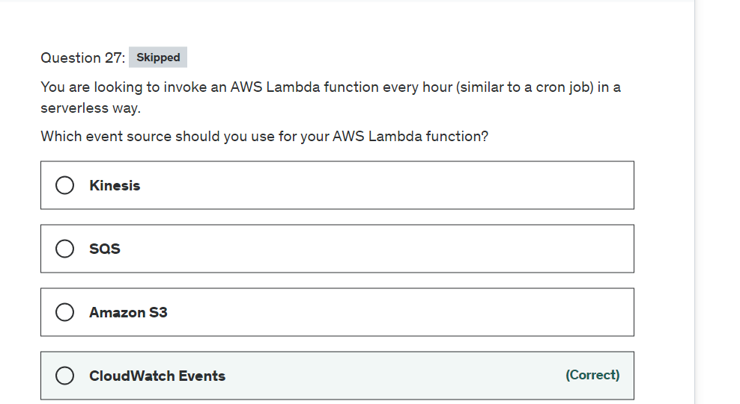

Explanation

Correct option:

**CloudWatch Events**

You can create a Lambda function and direct CloudWatch Events to execute it on a regular schedule. You can specify a fixed rate (for example, execute a Lambda function every hour or 15 minutes), or you can specify a Cron expression.

CloudWatch Events Key Concepts: 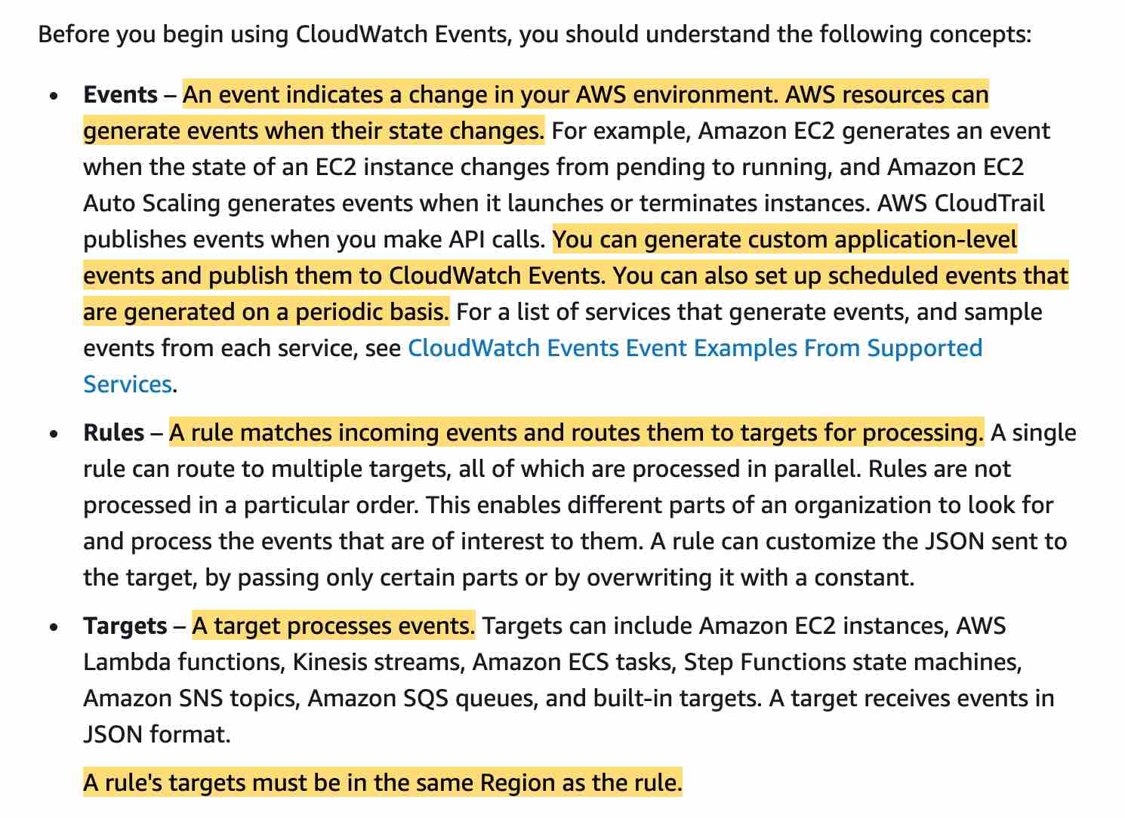 via - <https://docs.aws.amazon.com/AmazonCloudWatch/latest/events/WhatIsCloudWatchEvents.html>

Schedule Expressions for CloudWatch Events Rules: 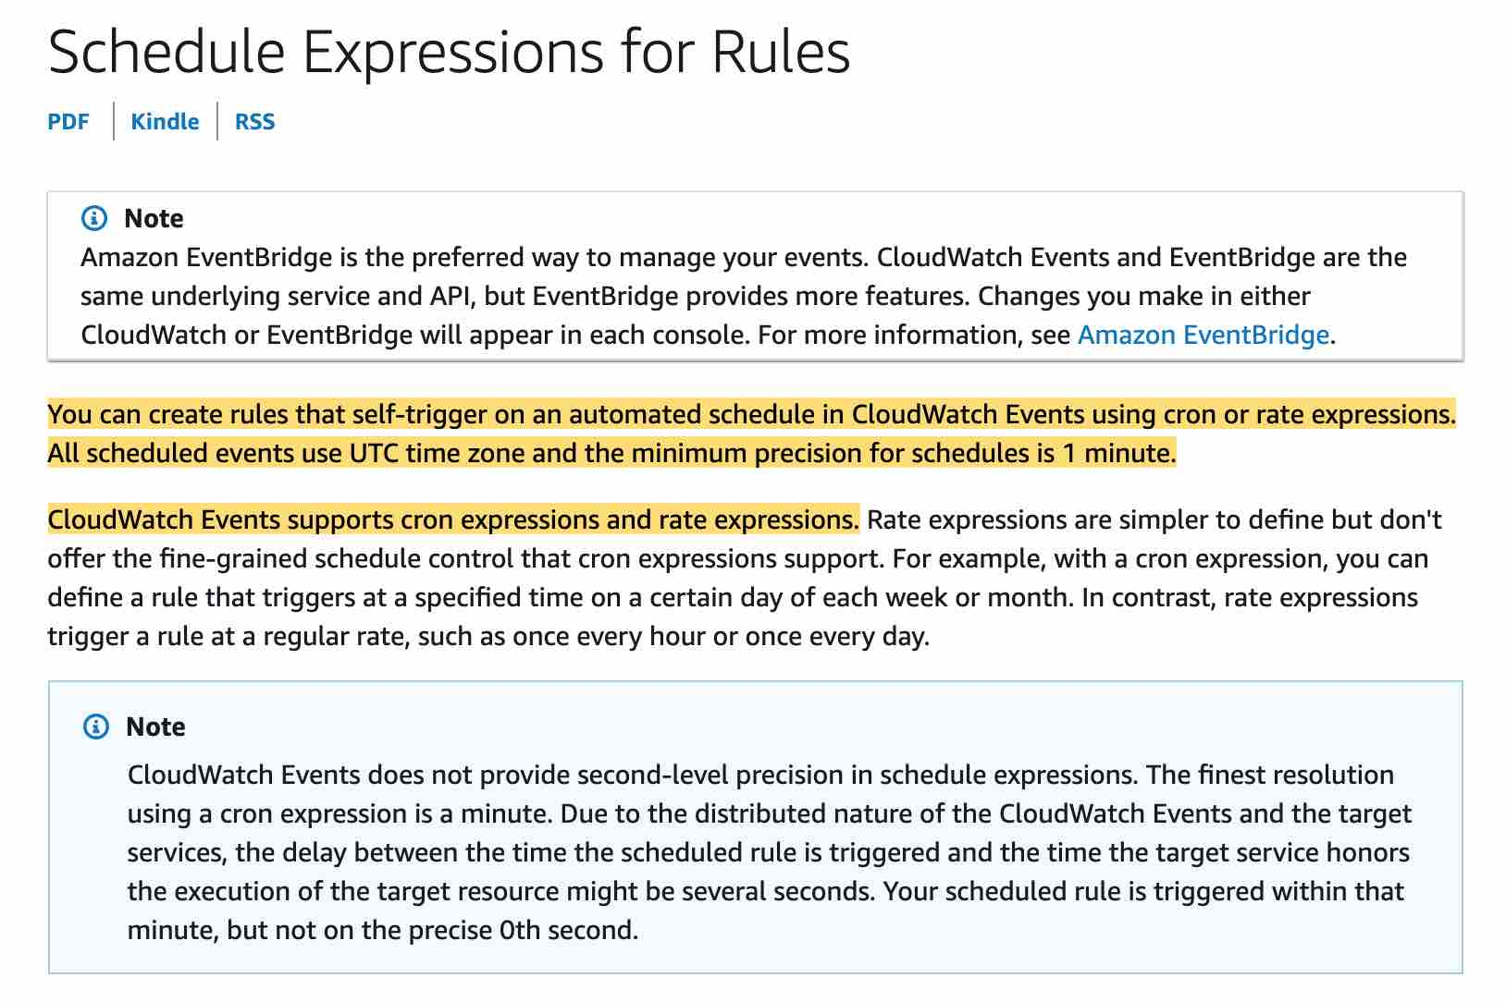 via - <https://docs.aws.amazon.com/AmazonCloudWatch/latest/events/ScheduledEvents.html>

Incorrect options:

**Amazon S3**

**SQS**

**Kinesis**

These three AWS services don't have cron capabilities, so these options are incorrect.

References:

<https://docs.aws.amazon.com/AmazonCloudWatch/latest/events/WhatIsCloudWatchEvents.html>

<https://docs.aws.amazon.com/lambda/latest/dg/with-scheduled-events.html>

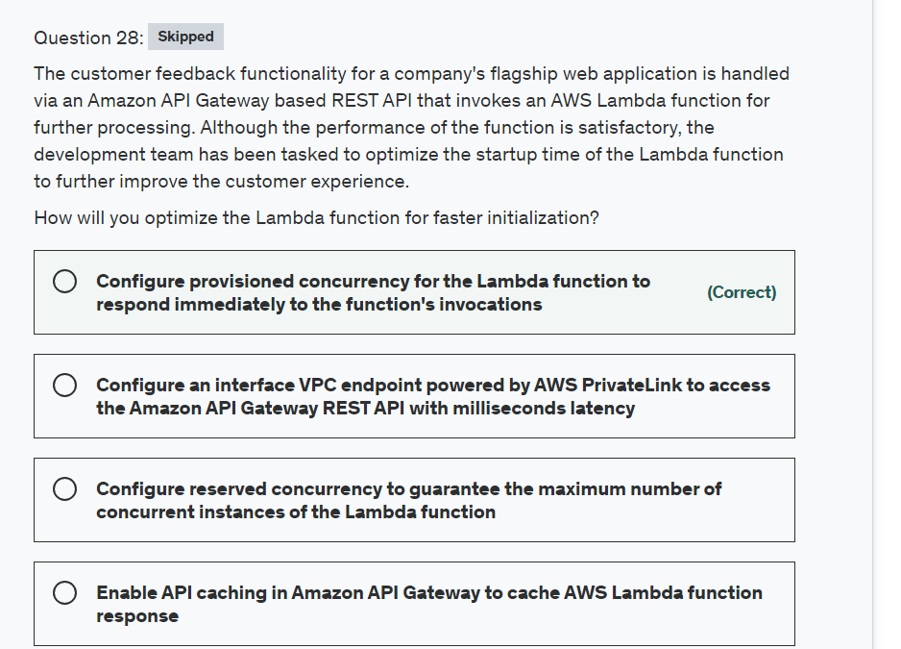

Explanation

Correct option:

**Configure provisioned concurrency for the Lambda function to respond immediately to the function's invocations**

When Lambda allocates an instance of your function, the runtime loads your function's code and runs the initialization code that you define outside of the handler. If your code and dependencies are large, or you create SDK clients during initialization, this process can take some time. When your function has not been used for some time, needs to scale up, or when you update a function, Lambda creates new execution environments. This causes the portion of requests that are served by new instances to have higher latency than the rest, otherwise known as a cold start.

By allocating provisioned concurrency before an increase in invocations, you can ensure that all requests are served by initialized instances with low latency. Lambda functions configured with provisioned concurrency run with consistent start-up latency, making them ideal for building interactive mobile or web backends, latency-sensitive microservices, and synchronously invoked APIs.

Functions with Provisioned Concurrency differ from on-demand functions in some important ways:

Initialization code does not need to be optimized. Since this happens long before the invocation, lengthy initialization does not impact the latency of invocations. If you are using runtimes that typically take longer to initialize, like Java, the performance of these can benefit from using Provisioned Concurrency.

Initialization code is run more frequently than the total number of invocations. Since Lambda is highly available, for every one unit of Provisioned Concurrency, there are a minimum of two execution environments prepared in separate Availability Zones. This is to ensure that your code is available in the event of a service disruption. As environments are reaped and load balancing occurs, Lambda over-provisions environments to ensure availability. You are not charged for this activity. If your code initializer implements logging, you will see additional log files anytime that this code is run, even though the main handler is not invoked.

Provisioned Concurrency cannot be used with the $LATEST version. This feature can only be used with published versions and aliases of a function. If you see cold starts for functions configured to use Provisioned Concurrency, you may be invoking the $LATEST version, instead of the version or alias with Provisioned Concurrency configured.

Reducing cold starts with Provisioned Concurrency: 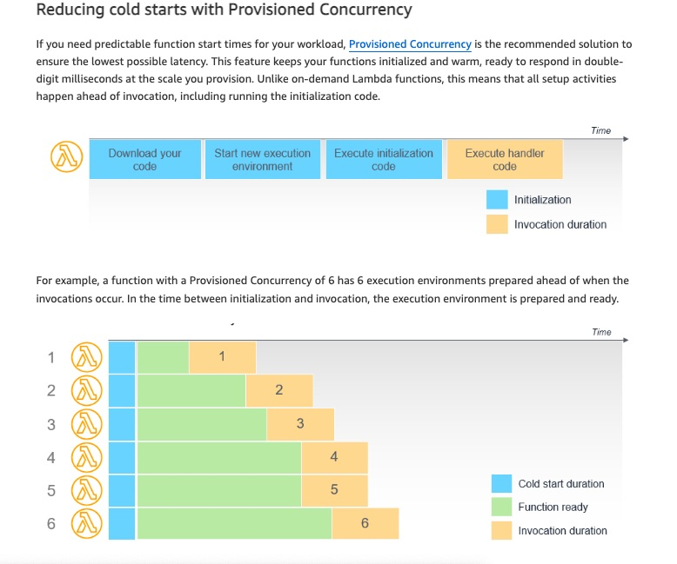 via - <https://aws.amazon.com/blogs/compute/operating-lambda-performance-optimization-part-1/>

Incorrect options:

**Configure reserved concurrency to guarantee the maximum number of concurrent instances of the Lambda function** - Reserved concurrency guarantees the maximum number of concurrent instances for the function. When a function has reserved concurrency, no other function can use that concurrency. There is no charge for configuring reserved concurrency for a function. Whereas, provisioned concurrency initializes a requested number of execution environments so that they are prepared to respond immediately to your function's invocations.

**Configure an interface VPC endpoint powered by AWS PrivateLink to access the Amazon API Gateway REST API with milliseconds latency** - An interface VPC endpoint can be used to connect your VPC resources to the AWS Lambda function without crossing the public internet. VPC endpoint is irrelevant to the current discussion.

**Enable API caching in Amazon API Gateway to cache AWS Lambda function response** - With caching, you can reduce the number of calls made to your AWS Lambda function and also improve the latency of requests to your API. Caching is best-effort and applications making frequent API calls to retrieve static data can benefit from a caching layer. Caching does not reduce the initialization time Lambda takes and hence is not an optimal solution for this use case.

References:

<https://docs.aws.amazon.com/lambda/latest/dg/provisioned-concurrency.html>

<https://aws.amazon.com/blogs/compute/operating-lambda-performance-optimization-part-1/>

<https://docs.aws.amazon.com/apigateway/latest/developerguide/api-gateway-caching.html>

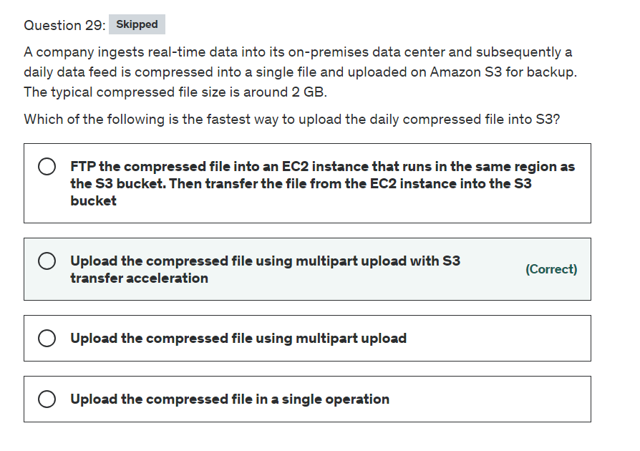

Explanation

Correct option:

**Upload the compressed file using multipart upload with S3 transfer acceleration**

Amazon S3 Transfer Acceleration enables fast, easy, and secure transfers of files over long distances between your client and an S3 bucket. Transfer Acceleration takes advantage of Amazon CloudFront’s globally distributed edge locations. As the data arrives at an edge location, data is routed to Amazon S3 over an optimized network path.

Multipart upload allows you to upload a single object as a set of parts. Each part is a contiguous portion of the object's data. You can upload these object parts independently and in any order. If transmission of any part fails, you can retransmit that part without affecting other parts. After all parts of your object are uploaded, Amazon S3 assembles these parts and creates the object. If you're uploading large objects over a stable high-bandwidth network, use multipart uploading to maximize the use of your available bandwidth by uploading object parts in parallel for multi-threaded performance. If you're uploading over a spotty network, use multipart uploading to increase resiliency to network errors by avoiding upload restarts.

Incorrect options:

**Upload the compressed file in a single operation** - In general, when your object size reaches 100 MB, you should consider using multipart uploads instead of uploading the object in a single operation. Multipart upload provides improved throughput - you can upload parts in parallel to improve throughput. Therefore, this option is not correct.

**Upload the compressed file using multipart upload** - Although using multipart upload would certainly speed up the process, combining with S3 transfer acceleration would further improve the transfer speed. Therefore just using multipart upload is not the correct option.

**FTP the compressed file into an EC2 instance that runs in the same region as the S3 bucket. Then transfer the file from the EC2 instance into the S3 bucket** - This is a roundabout process of getting the file into S3 and added as a distractor. Although it is technically feasible to follow this process, it would involve a lot of scripting and certainly would not be the fastest way to get the file into S3.

References:

<https://docs.aws.amazon.com/AmazonS3/latest/dev/transfer-acceleration.html>

<https://docs.aws.amazon.com/AmazonS3/latest/dev/uploadobjusingmpu.html>

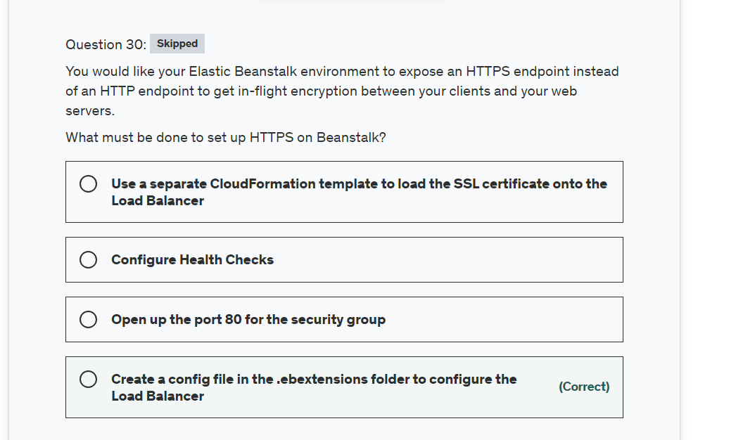

Explanation

Correct option:

The simplest way to use HTTPS with an Elastic Beanstalk environment is to assign a server certificate to your environment's load balancer. When you configure your load balancer to terminate HTTPS, the connection between the client and the load balancer is secure. Backend connections between the load balancer and EC2 instances use HTTP, so no additional configuration of the instances is required.

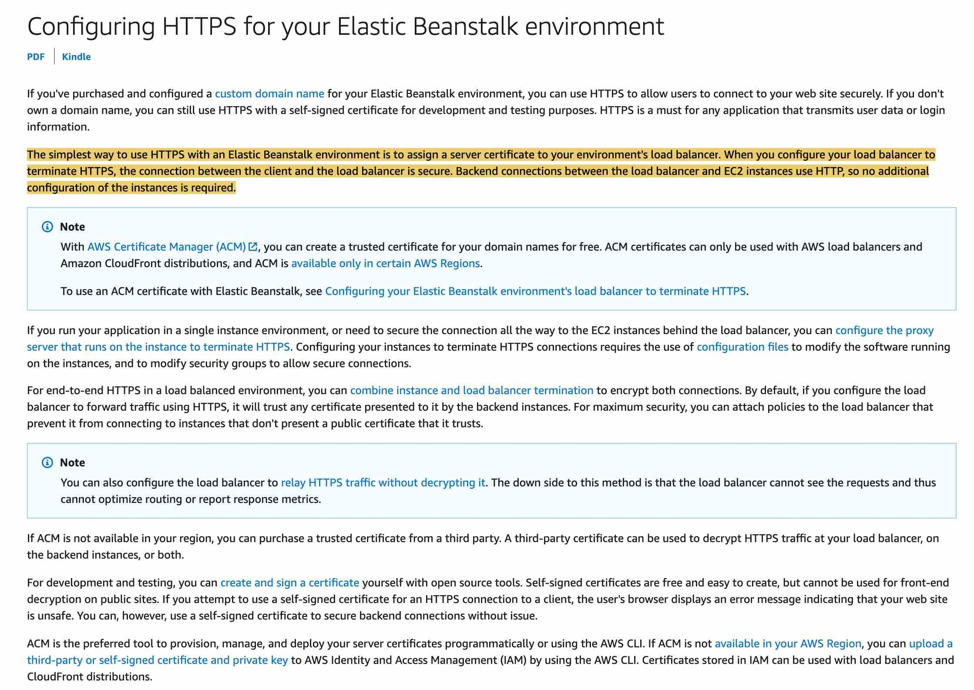 via - <https://docs.aws.amazon.com/elasticbeanstalk/latest/dg/configuring-https.html>

**Create a config file in the .ebextensions folder to configure the Load Balancer**

To update your AWS Elastic Beanstalk environment to use HTTPS, you need to configure an HTTPS listener for the load balancer in your environment. Two types of load balancers support an HTTPS listener: Classic Load Balancer and Application Load Balancer.

Example .ebextensions/securelistener-alb.config

Use this example when your environment has an Application Load Balancer. The example uses options in the aws:elbv2:listener namespace to configure an HTTPS listener on port 443 with the specified certificate. The listener routes traffic to the default process.

option_settings:

aws:elbv2:listener:443:

ListenerEnabled: 'true'

Protocol: HTTPS

SSLCertificateArns: arn:aws:acm:us-east-2:1234567890123:certificate/####################################

Incorrect options:

**Use a separate CloudFormation template to load the SSL certificate onto the Load Balancer** - A separate CloudFormation template won't be able to mutate the state of a Load Balancer managed by Elastic Beanstalk, so this option is incorrect.

**Open up the port 80 for the security group** - Port 80 is for HTTP traffic, so this option is incorrect.

**Configure Health Checks** - Health Checks are not related to SSL certificates, so this option is ruled out.

References:

<https://docs.aws.amazon.com/elasticbeanstalk/latest/dg/configuring-https-elb.html>

<https://docs.aws.amazon.com/elasticbeanstalk/latest/dg/configuring-https.html>

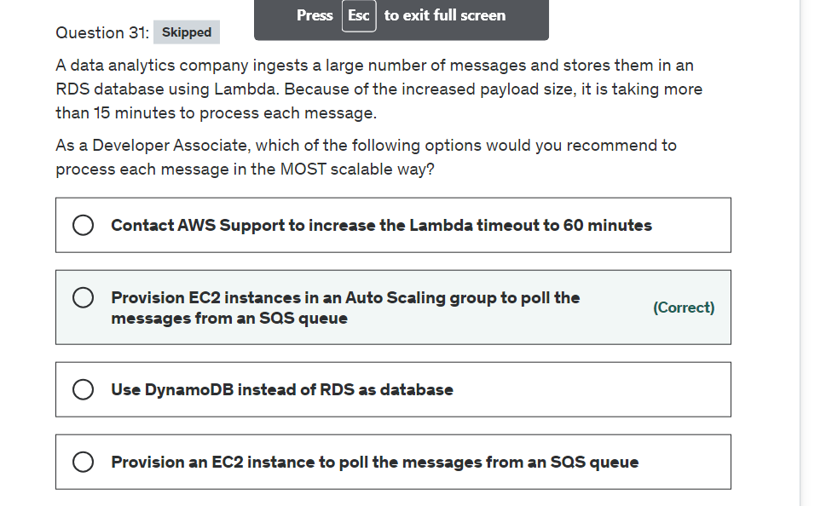

Explanation

Correct option:

**Provision EC2 instances in an Auto Scaling group to poll the messages from an SQS queue**

As each message takes more than 15 minutes to process, therefore the development team cannot use Lambda for message processing. To build a scalable solution, the EC2 instances must be provisioning via an Auto Scaling group to handle variations in the message processing workload.

Amazon EC2 Auto Scaling Overview: 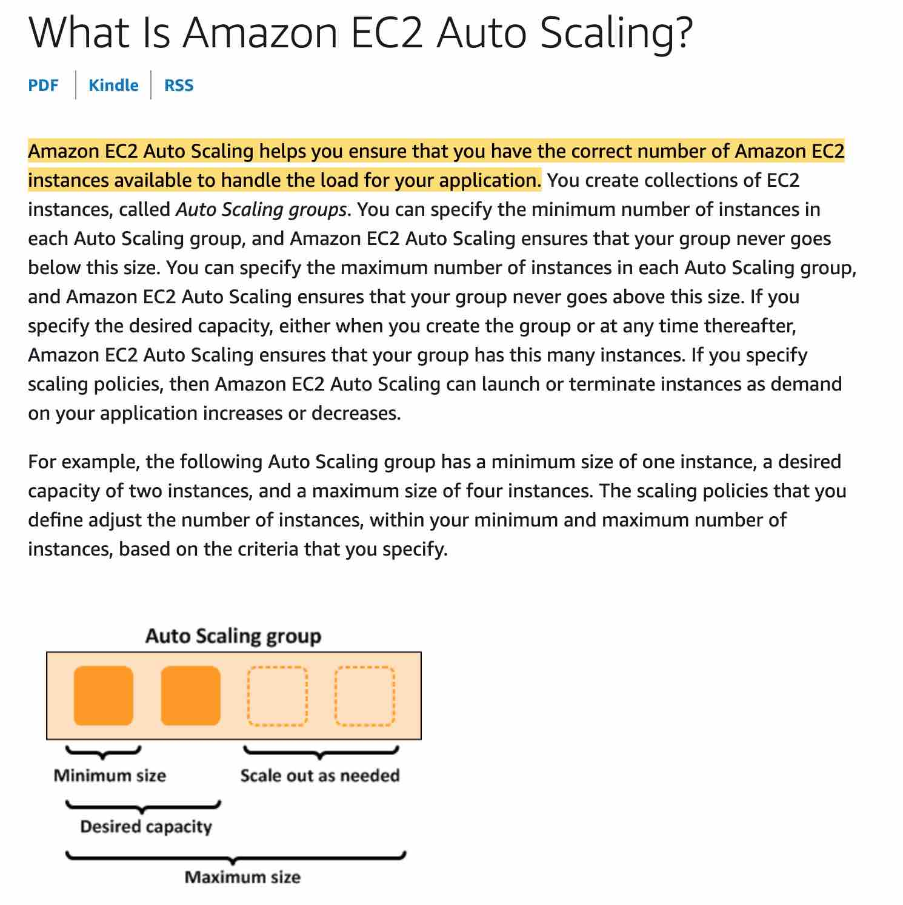 via - <https://docs.aws.amazon.com/autoscaling/ec2/userguide/what-is-amazon-ec2-auto-scaling.html>

Incorrect options:

**Provision an EC2 instance to poll the messages from an SQS queue** - Just using a single EC2 instance may not be sufficient to handle a sudden spike in the number of incoming messages.

**Contact AWS Support to increase the Lambda timeout to 60 minutes** - AWS Support cannot increase the Lambda timeout upper limit.

**Use DynamoDB instead of RDS as database** - This option has been added as a distractor, as changing the database would have no impact on the Lambda timeout while processing the message.

Reference:

<https://docs.aws.amazon.com/autoscaling/ec2/userguide/what-is-amazon-ec2-auto-scaling.html>

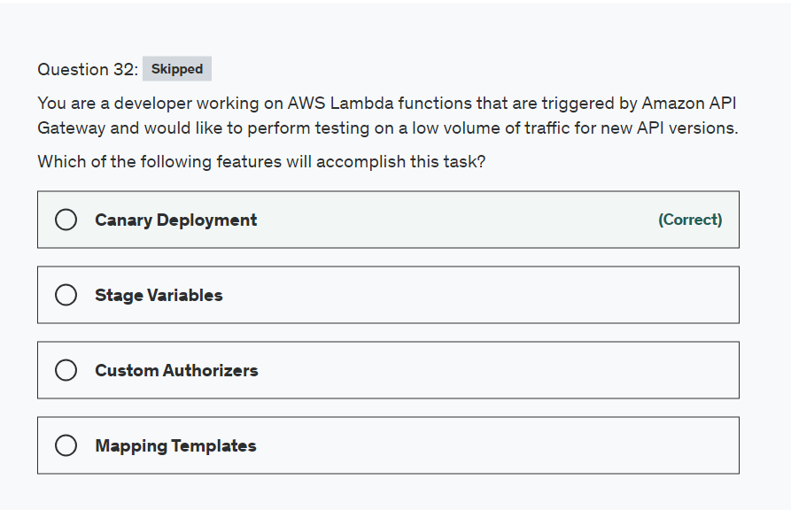

Explanation

Correct option:

**Canary Deployment**

In a canary release deployment, total API traffic is separated at random into a production release and a canary release with a preconfigured ratio. Typically, the canary release receives a small percentage of API traffic and the production release takes up the rest. The updated API features are only visible to API traffic through the canary. You can adjust the canary traffic percentage to optimize test coverage or performance.

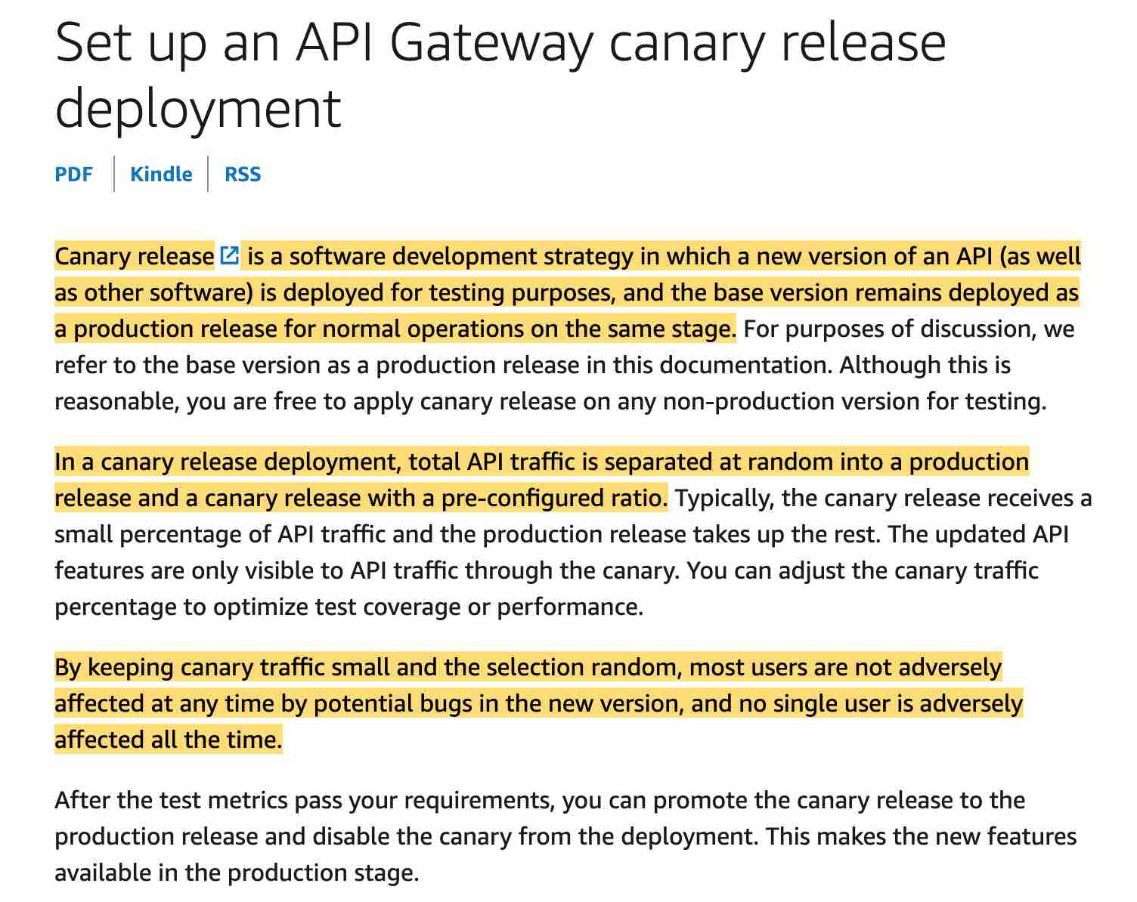 via - <https://docs.aws.amazon.com/apigateway/latest/developerguide/canary-release.html>

Incorrect options:

**Stage Variables** - They act like environment variables and can be used in your API setup.

**Mapping Templates** - Its a script to map the payload from a method request to the corresponding integration request and also maps the integration response to the corresponding method response.

**Custom Authorizers** - Used for authentication purposes and must return AWS Identity and Access Management (IAM) policies.

Reference:

<https://docs.aws.amazon.com/apigateway/latest/developerguide/canary-release.html>

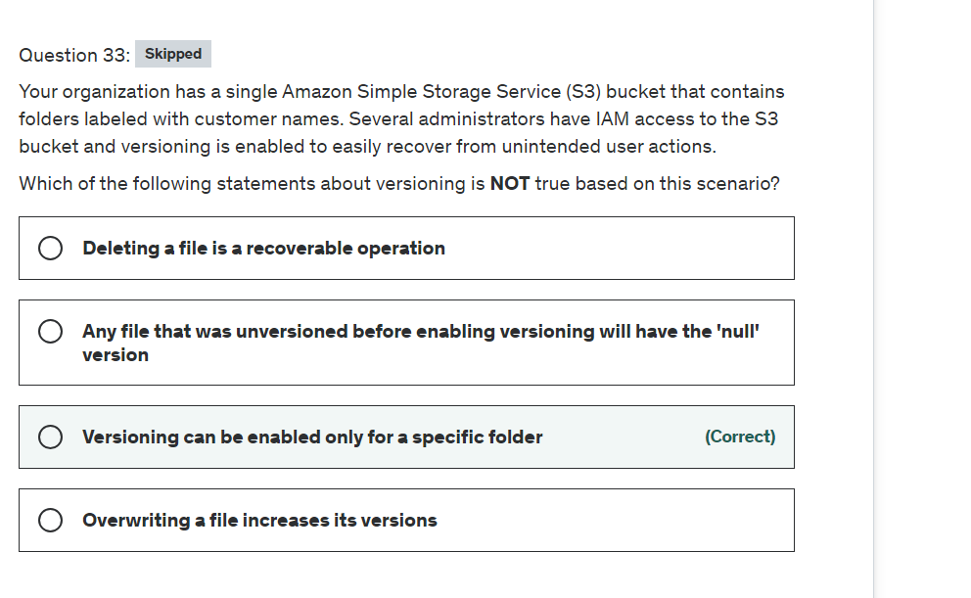

Explanation

Correct option:

**Versioning can be enabled only for a specific folder**

The versioning state applies to all (never some) of the objects in that bucket. The first time you enable a bucket for versioning, objects in it are thereafter always versioned and given a unique version ID.

Versioning Overview: 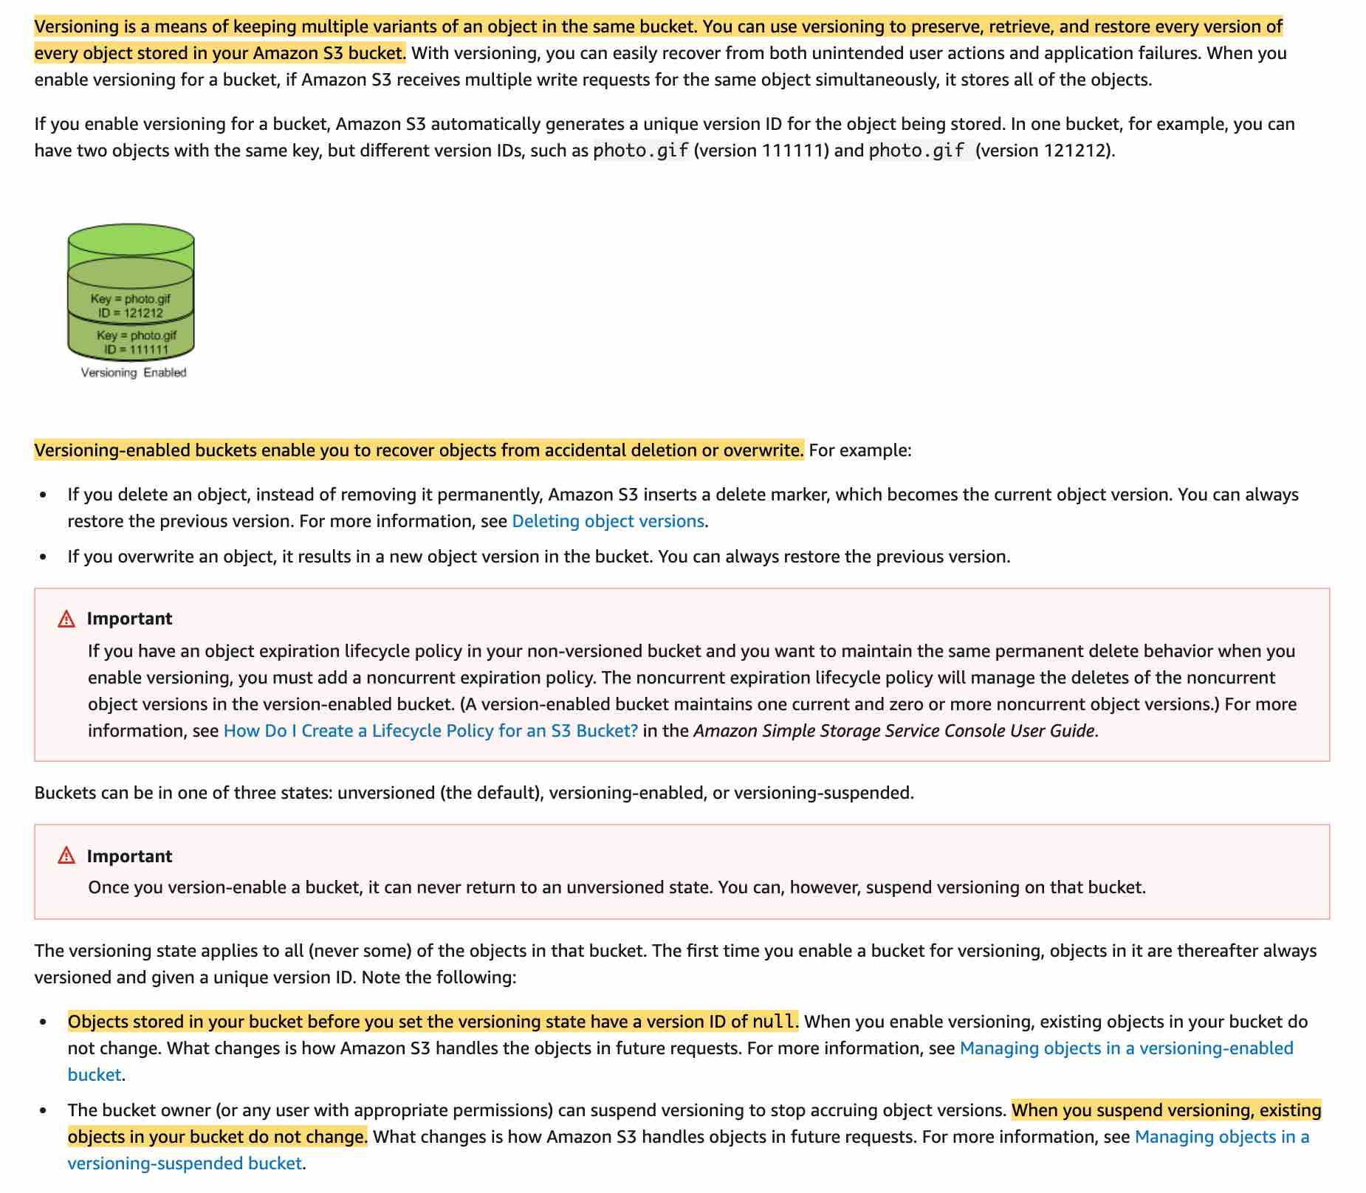 via - <https://docs.aws.amazon.com/AmazonS3/latest/dev/Versioning.html>

Incorrect options:

**Overwriting a file increases its versions** - If you overwrite an object (file), it results in a new object version in the bucket. You can always restore the previous version.

**Deleting a file is a recoverable operation** - Correct, when you delete an object (file), Amazon S3 inserts a delete marker, which becomes the current object version and you can restore the previous version.

**Any file that was unversioned before enabling versioning will have the 'null' version** - Objects stored in your bucket before you set the versioning state have a version ID of null. Those existing objects in your bucket do not change.

Reference:

<https://docs.aws.amazon.com/AmazonS3/latest/dev/Versioning.html>

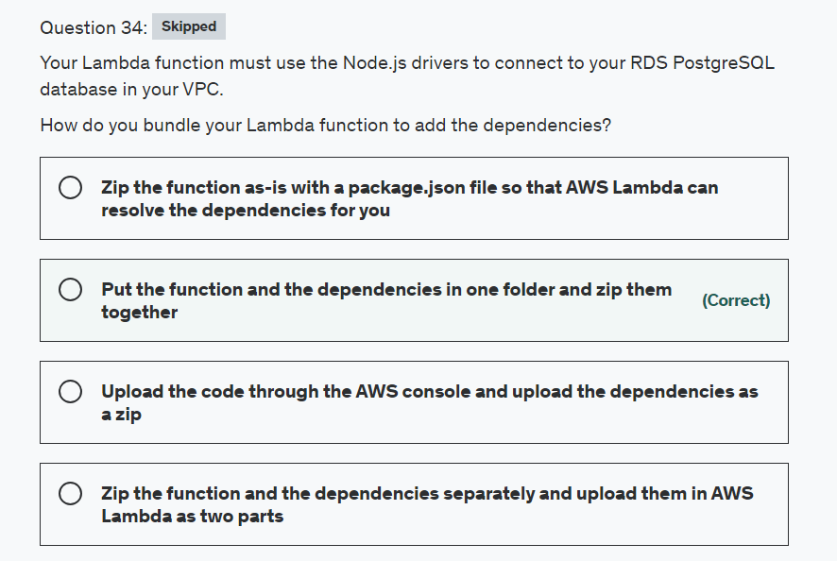

Explanation

Correct option:

AWS Lambda lets you run code without provisioning or managing servers. You pay only for the compute time you consume.

How Lambda function works:  via - <https://aws.amazon.com/lambda/>

**Put the function and the dependencies in one folder and zip them together**

A deployment package is a ZIP archive that contains your function code and dependencies. You need to create a deployment package if you use the Lambda API to manage functions, or if you need to include libraries and dependencies other than the AWS SDK. You can upload the package directly to Lambda, or you can use an Amazon S3 bucket, and then upload it to Lambda. If the deployment package is larger than 50 MB, you must use Amazon S3. This is the standard way of packaging Lambda functions.

Incorrect options:

**Zip the function as-is with a package.json file so that AWS Lambda can resolve the dependencies for you**

**Upload the code through the AWS console and upload the dependencies as a zip**

**Zip the function and the dependencies separately and upload them in AWS Lambda as two parts**

These three options are incorrect as there's only one way of deploying a Lambda function, which is to provide the zip file with all dependencies that it'll need.

Reference:

<https://docs.aws.amazon.com/lambda/latest/dg/nodejs-create-deployment-pkg.html>

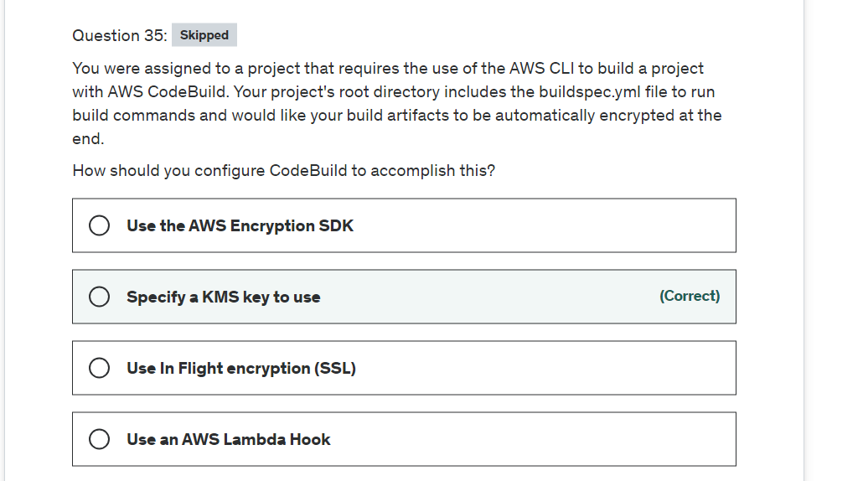

Explanation

Correct option:

**Specify a KMS key to use**

AWS Key Management Service (KMS) makes it easy for you to create and manage cryptographic keys and control their use across a wide range of AWS services and in your applications.

For AWS CodeBuild to encrypt its build output artifacts, it needs access to an AWS KMS customer master key (CMK). By default, AWS CodeBuild uses the AWS-managed CMK for Amazon S3 in your AWS account. The following environment variable provides these details:

CODEBUILD_KMS_KEY_ID: The identifier of the AWS KMS key that CodeBuild is using to encrypt the build output artifact (for example, arn:aws:kms:region-ID:account-ID:key/key-ID or alias/key-alias).

Incorrect options:

**Use an AWS Lambda Hook** - Code hook is used for integration with Lambda and is not relevant for the given use-case.

**Use the AWS Encryption SDK** - The SDK just makes it easier for you to implement encryption best practices in your application and is not relevant for the given use-case.

**Use In-Flight encryption (SSL)** - SSL is usually for internet traffic which in this case will be using internal traffic through AWS and is not relevant for the given use-case.

References:

<https://docs.aws.amazon.com/codebuild/latest/userguide/build-env-ref-env-vars.html>

<https://docs.aws.amazon.com/codebuild/latest/userguide/setting-up.html>

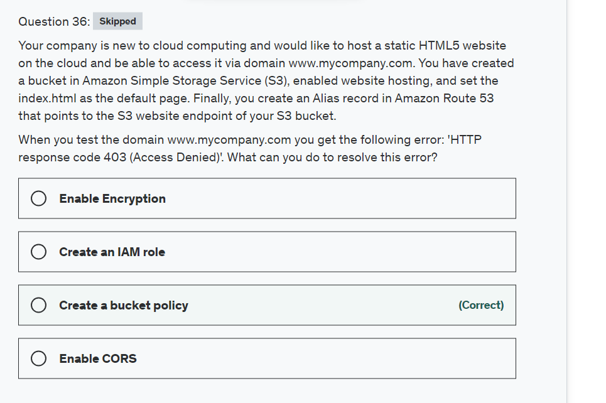

Explanation

Correct answer

**Create a bucket policy**

Bucket policy is an access policy option available for you to grant permission to your Amazon S3 resources. It uses JSON-based access policy language.

If you want to configure an existing bucket as a static website that has public access, you must edit block public access settings for that bucket. You may also have to edit your account-level block public access settings.

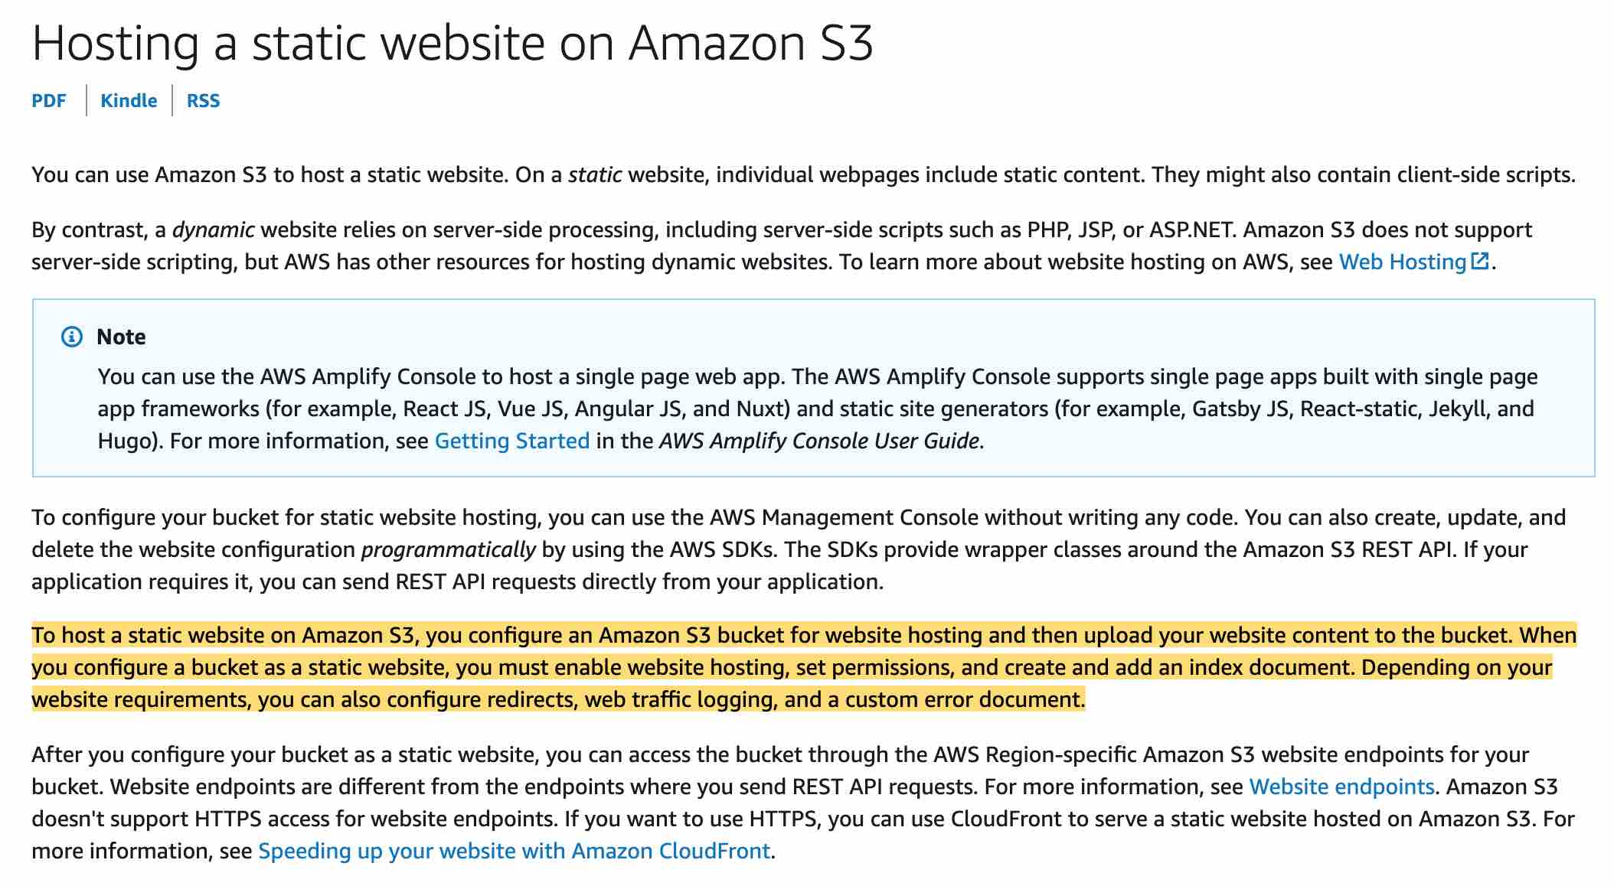 via - <https://docs.aws.amazon.com/AmazonS3/latest/dev/WebsiteHosting.html>

Incorrect:

**Create an IAM role** - This will not help because IAM roles are attached to services and in this case, we have public users.

**Enable CORS** - CORS defines a way for client web applications that are loaded in one domain to interact with resources in a different domain. Here we are not dealing with cross domains.

**Enable Encryption** - For the most part, encryption does not have an effect on access denied/forbidden errors. On the website endpoint, if a user requests an object that doesn't exist, Amazon S3 returns HTTP response code 404 (Not Found). If the object exists but you haven't granted read permission on it, the website endpoint returns HTTP response code 403 (Access Denied).

References:

<https://docs.aws.amazon.com/AmazonS3/latest/dev/WebsiteHosting.html>

<https://docs.aws.amazon.com/AmazonS3/latest/dev/WebsiteAccessPermissionsReqd.html>

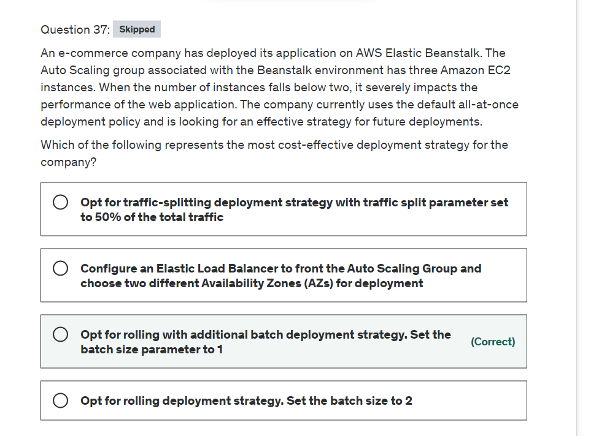

Explanation

Correct option:

**Opt for rolling with additional batch deployment strategy. Set the batch size parameter to 1**

With rolling deployments, Elastic Beanstalk splits the environment's Amazon EC2 instances into batches and deploys the new version of the application to one batch at a time. It leaves the rest of the instances in the environment running the old version of the application. During a rolling deployment, some instances serve requests with the old version of the application, while instances in completed batches serve other requests with the new version.

To maintain full capacity during deployments, you can configure your environment to launch a new batch of instances before taking any instances out of service. This option is known as a rolling deployment with an additional batch. When the deployment completes, Elastic Beanstalk terminates the additional batch of instances.

For the rolling and rolling with additional batch deployment policies, you can configure Batch size – The size of the set of instances to deploy in each batch. Choose Percentage to configure a percentage of the total number of EC2 instances in the Auto Scaling group (up to 100 percent), or choose Fixed to configure a fixed number of instances (up to the maximum instance count in your environment's Auto Scaling configuration).

Example configuration for rolling With additional batch: 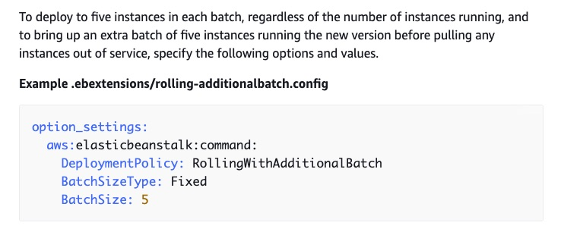 via - <https://docs.aws.amazon.com/elasticbeanstalk/latest/dg/using-features.rolling-version-deploy.html#environments-cfg-rollingdeployments-method>

Incorrect options:

**Opt for a traffic-splitting deployment strategy with a traffic split parameter set to 50% of the total traffic** - Traffic-splitting deployments let you perform canary testing as part of your application deployment. In a traffic-splitting deployment, Elastic Beanstalk launches a full set of new instances just like during an immutable deployment. It then forwards a specified percentage of incoming client traffic to the new application version for a specified evaluation period. This turns out to be a costly solution for the given use case.

**Configure an Elastic Load Balancer to front the Auto Scaling Group and choose two different Availability Zones (AZs) for deployment** - Adding AZs makes the entire configuration resilient for failures post-deployment. However, it does not represent a valid deployment strategy for the given use case. This option has been added as a distractor.

**Opt for a rolling deployment strategy. Set the batch size to 2** - As already discussed, with rolling deployments, Elastic Beanstalk splits the environment's Amazon EC2 instances into batches and deploys the new version of the application to one batch at a time. With a batch size set to 2, only 1 instance will be left for traffic during deployment, impacting the performance of the e-commerce application. Hence, this option is incorrect.

References:

<https://docs.aws.amazon.com/elasticbeanstalk/latest/dg/using-features.rolling-version-deploy.html>

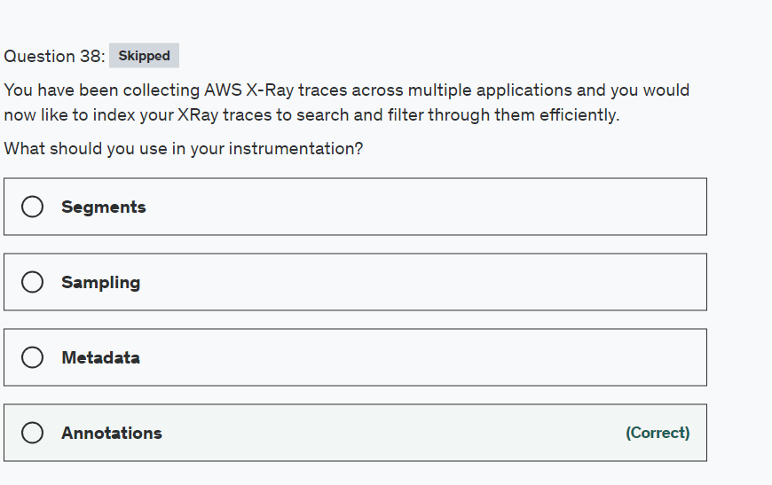

Explanation

Correct option:

**Annotations**

AWS X-Ray helps developers analyze and debug production, distributed applications, such as those built using a microservices architecture. With X-Ray, you can understand how your application and its underlying services are performing to identify and troubleshoot the root cause of performance issues and errors. X-Ray provides an end-to-end view of requests as they travel through your application, and shows a map of your application’s underlying components.

You can use X-Ray to collect data across AWS Accounts. The X-Ray agent can assume a role to publish data into an account different from the one in which it is running. This enables you to publish data from various components of your application into a central account.

How X-Ray Works: 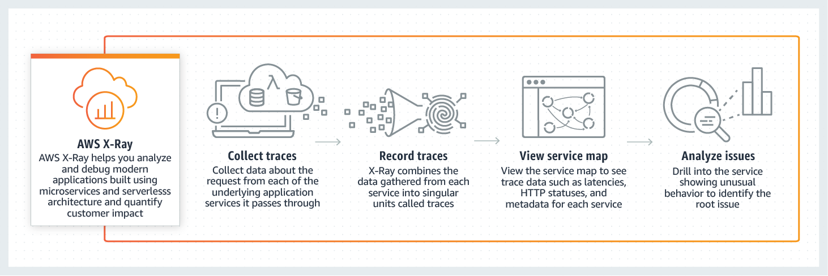 via - <https://aws.amazon.com/xray/>

Annotations are simple key-value pairs that are indexed for use with filter expressions. Use annotations to record data that you want to use to group traces in the console, or when calling the GetTraceSummaries API.

X-Ray indexes up to 50 annotations per trace.

Incorrect options:

**Metadata** - Metadata are key-value pairs with values of any type, including objects and lists, but that is not indexed. Use metadata to record data you want to store in the trace but don't need to use for searching traces.

**Segments** - The computing resources running your application logic send data about their work as segments. A segment provides the resource's name, details about the request, and details about the work done.

**Sampling** - To ensure efficient tracing and provide a representative sample of the requests that your application serves, the X-Ray SDK applies a sampling algorithm to determine which requests get traced. By default, the X-Ray SDK records the first request each second, and five percent of any additional requests.

Reference:

<https://docs.aws.amazon.com/xray/latest/devguide/xray-concepts.html>

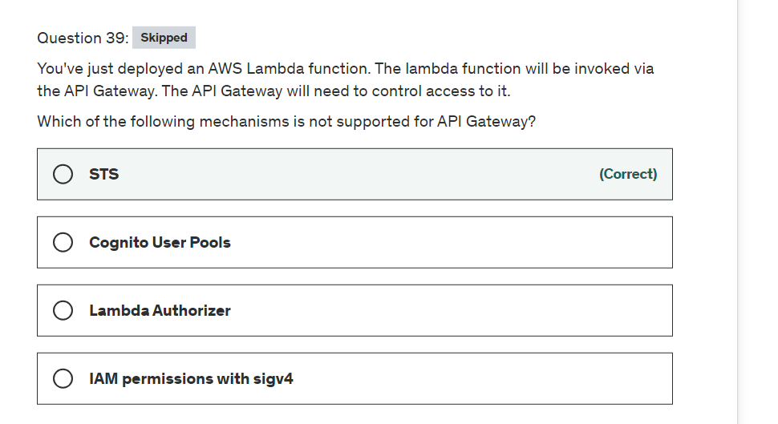

Explanation

Correct option:

Amazon API Gateway is an AWS service for creating, publishing, maintaining, monitoring, and securing REST, HTTP, and WebSocket APIs at any scale. API developers can create APIs that access AWS or other web services, as well as data stored in the AWS Cloud.

How API Gateway Works: 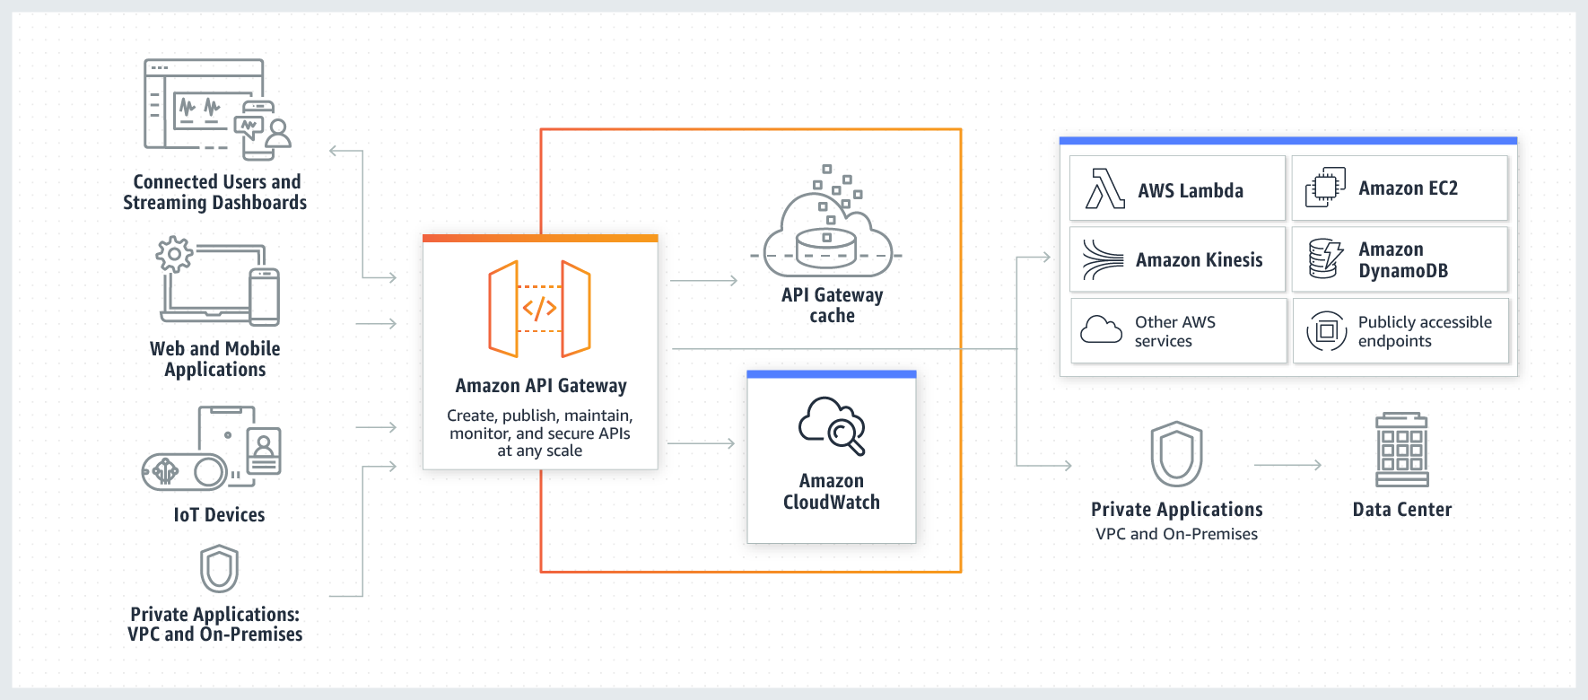 via - <https://aws.amazon.com/api-gateway/>

**STS**

The AWS Security Token Service (STS) is a web service that enables you to request temporary, limited-privilege credentials for AWS Identity and Access Management (IAM) users or for users that you authenticate (federated users). However, is not supported at the time with API Gateway.

Incorrect options:

**IAM permissions with sigv4** - They can be applied to an entire API or individual methods.

**Lambda Authorizer** - Control access to REST API methods using bearer token authentication as well as information described by headers, paths, query strings, stage variables, or context variables request parameter.

**Cognito User Pools** - Use Cognito User Pools to create customizable authentication and authorization solutions for your REST APIs.

Reference:

<https://aws.amazon.com/api-gateway/>

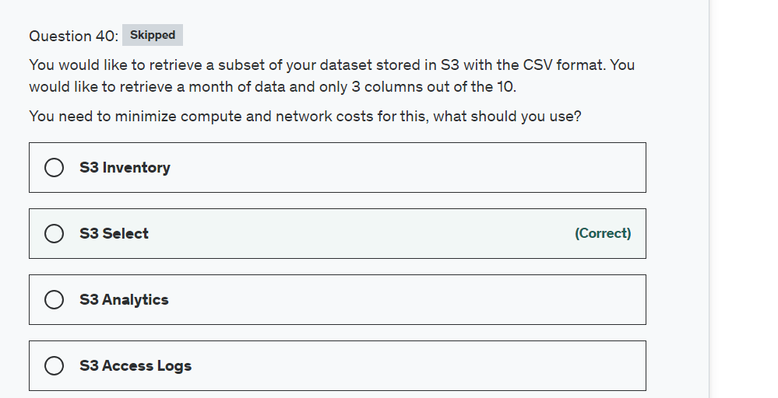

Explanation

Correct option:

**S3 Select**

S3 Select enables applications to retrieve only a subset of data from an object by using simple SQL expressions. By using S3 Select to retrieve only the data needed by your application, you can achieve drastic performance increases in many cases you can get as much as a 400% improvement.

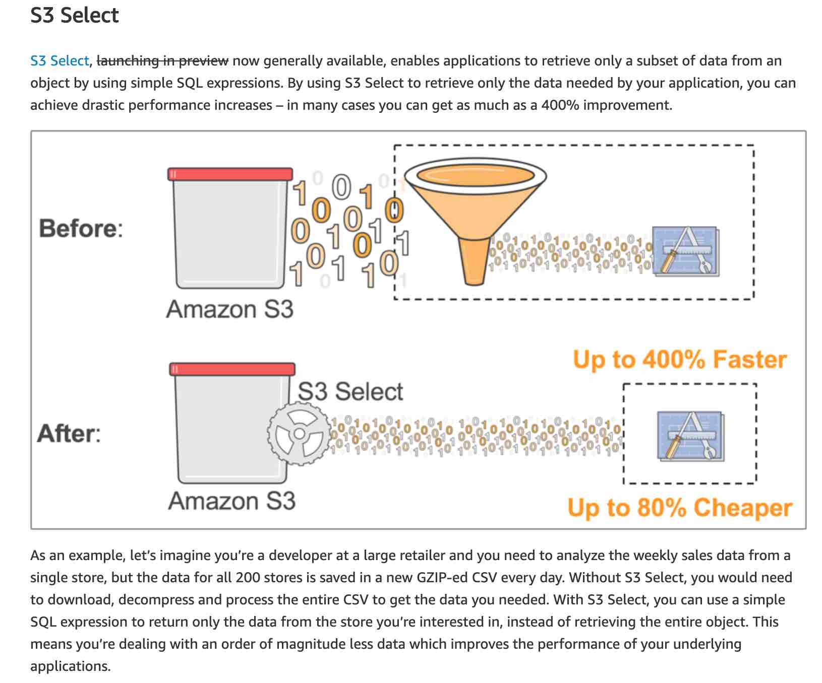 via - <https://aws.amazon.com/blogs/aws/s3-glacier-select/>

Incorrect options:

**S3 Inventory** - Amazon S3 inventory is one of the tools Amazon S3 provides to help manage your storage. You can use it to audit and report on the replication and encryption status of your objects for business, compliance, and regulatory needs.

**S3 Analytics** - By using Amazon S3 analytics storage class analysis you can analyze storage access patterns to help you decide when to transition the right data to the right storage class. This new Amazon S3 analytics feature observes data access patterns to help you determine when to transition less frequently accessed STANDARD storage to the STANDARD_IA (IA, for infrequent access) storage class.

**S3 Access Logs** - Server access logging provides detailed records for the requests that are made to a bucket. Server access logs are useful for many applications. For example, access log information can be useful in security and access audits. It can also help you learn about your customer base and understand your Amazon S3 bill.

Reference:

<https://aws.amazon.com/blogs/aws/s3-glacier-select/>

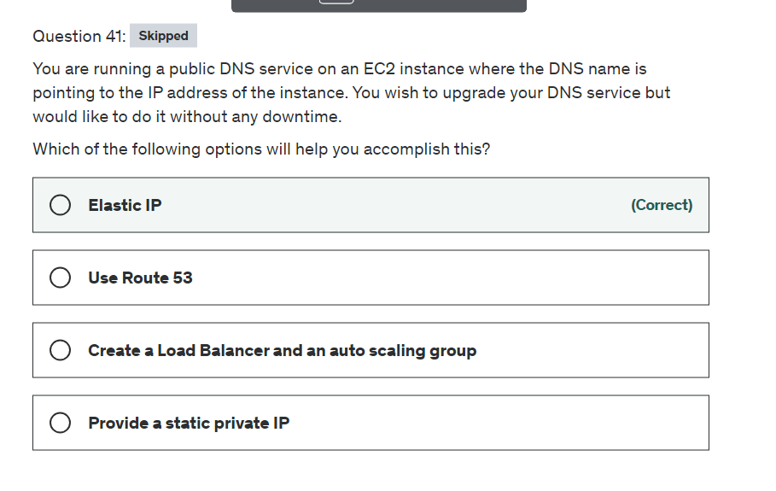

Explanation

Correct option:

Route 53 is a DNS managed by AWS, but nothing prevents you from running your own DNS (it's just a software) on an EC2 instance. The trick of this question is that it's about EC2, running some software that needs a fixed IP, and not about Route 53 at all.

**Elastic IP**

DNS services are identified by a public IP, so you need to use Elastic IP.

Incorrect options:

**Create a Load Balancer and an auto-scaling group** - Load balancers do not provide an IP, instead they provide a DNS name, so this option is ruled out.

**Provide a static private IP** - If you provide a private IP it will not be accessible from the internet, so this option is incorrect.

**Use Route 53** - Route 53 is a DNS service from AWS but the use-case talks about offering a DNS service using an EC2 instance, so this option is incorrect.

Reference:

<https://docs.aws.amazon.com/AWSEC2/latest/UserGuide/elastic-ip-addresses-eip.html#using-instance-addressing-eips-associating-different>

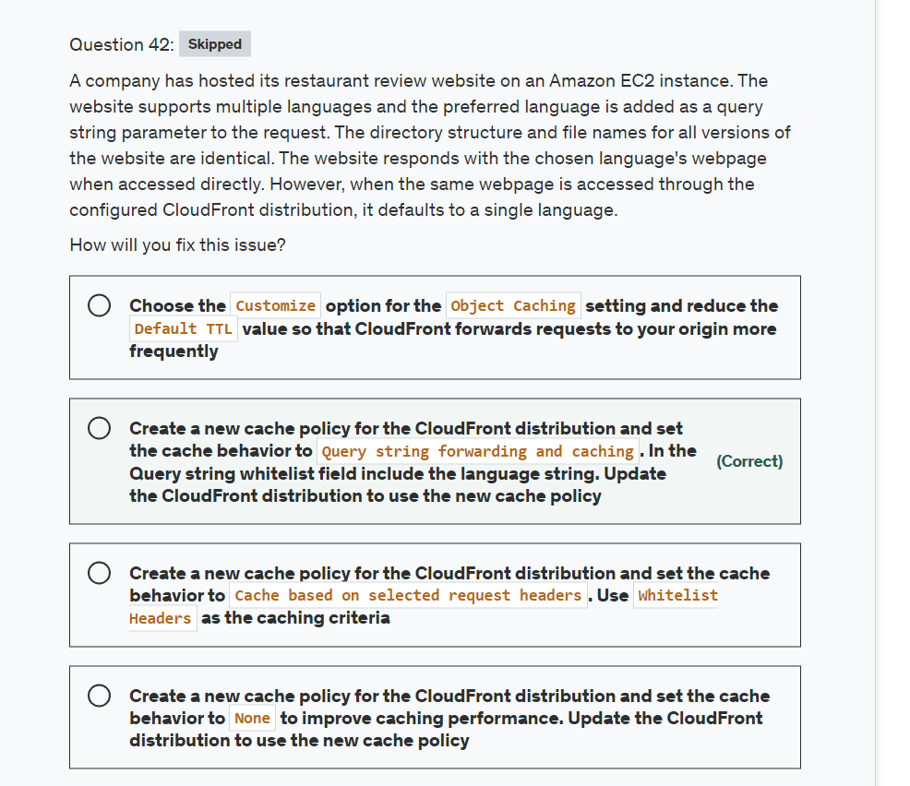

Explanation

Correct option:

**Create a new cache policy for the CloudFront distribution and set the cache behavior to Query string forwarding and caching. In the Query string whitelist field include the language string. Update the CloudFront distribution to use the new cache policy**

CloudFront can cache different versions of your content based on the values of query string parameters. Forward all, cache based on whitelist option should be chosen if your origin server returns different versions of your objects based on one or more query string parameters. Then specify the parameters that you want CloudFront to use as a basis for caching in the Query string whitelist field.

Incorrect options:

**Create a new cache policy for the CloudFront distribution and set the cache behavior to None to improve caching performance. Update the CloudFront distribution to use the new cache policy** - None improves Caching. Choose this option if your origin returns the same version of an object regardless of the values of query string parameters. This increases the likelihood that CloudFront can serve a request from the cache, which improves performance and reduces the load on your origin.

**Create a new cache policy for the CloudFront distribution and set the cache behavior to Cache based on selected request headers. Use Whitelist Headers as the caching criteria** - Cache based on selected request headers is not a valid option since the use case mentions using query string parameters.

**Choose the Customize option for the Object Caching setting and reduce the Default TTL value so that CloudFront forwards requests to your origin more frequently** - Default TTL specifies the default amount of time, in seconds, that you want objects to stay in CloudFront caches before CloudFront forwards another request to your origin to determine whether the object has been updated. This option is irrelevant for the current use case since the response returned defaulting to the same language is not a TTL issue.

References:

<https://docs.aws.amazon.com/AmazonCloudFront/latest/DeveloperGuide/distribution-web-values-specify.html#DownloadDistValuesQueryString>

<https://docs.aws.amazon.com/AmazonCloudFront/latest/DeveloperGuide/distribution-web-values-specify.html#DownloadDistValuesQueryStringWhiteList>

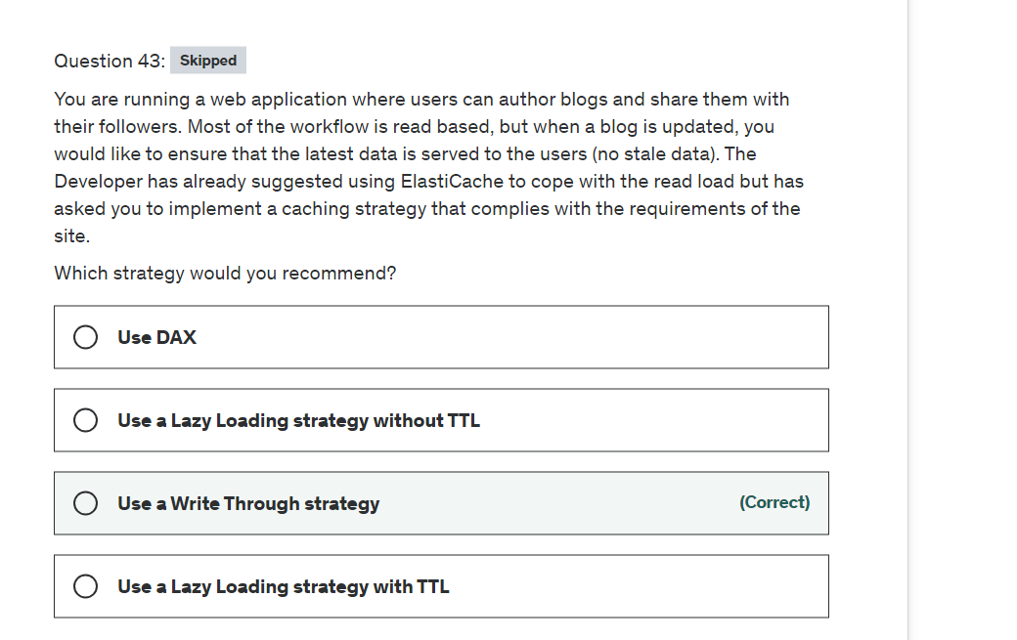

Explanation

Correct option:

**Use a Write Through strategy**

The write-through strategy adds data or updates data in the cache whenever data is written to the database.

In a Write Through strategy, any new blog or update to the blog will be written to both the database layer and the caching layer, thus ensuring that the latest data is always served from the cache.

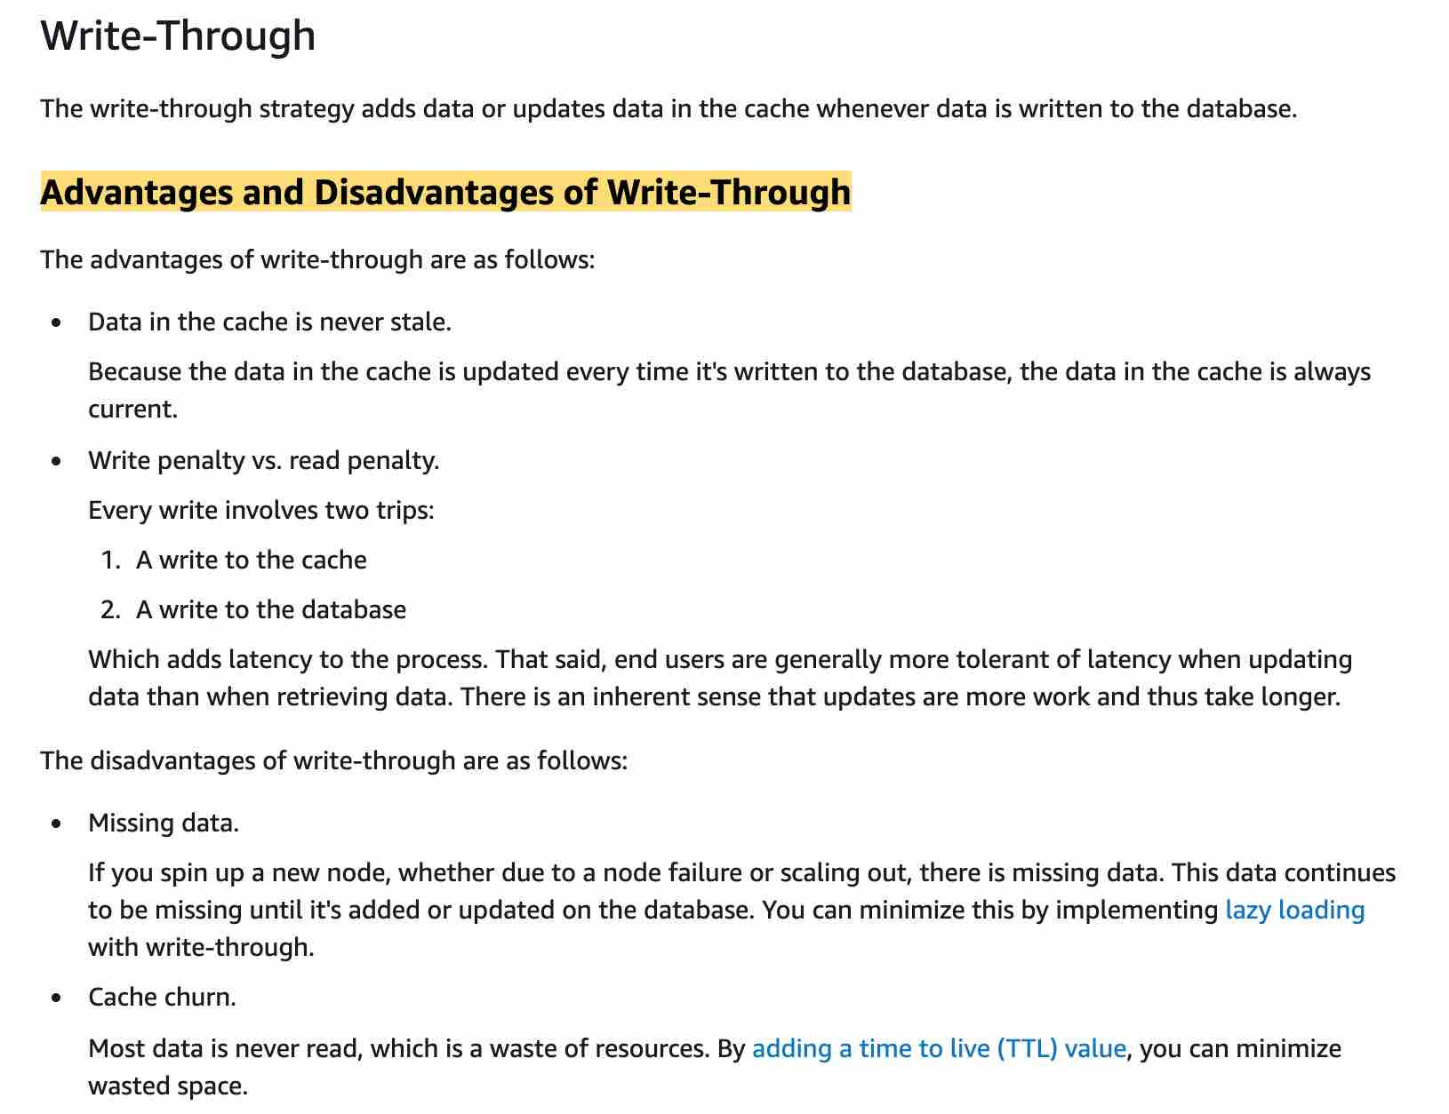 via - <https://docs.aws.amazon.com/AmazonElastiCache/latest/mem-ug/Strategies.html>

Incorrect options:

**Use a Lazy Loading strategy without TTL**

Lazy Loading is a caching strategy that loads data into the cache only when necessary. Whenever your application requests data, it first requests the ElastiCache cache. If the data exists in the cache and is current, ElastiCache returns the data to your application. If the data doesn't exist in the cache or has expired, your application requests the data from your data store.

**Use a Lazy Loading strategy with TTL**

In the case of Lazy Loading, the data is loaded onto the cache whenever the data is missing from the cache. In case the blog gets updated, it won't be updated from the cache unless that cache expires (in case you used a TTL). Time to live (TTL) is an integer value that specifies the number of seconds until the key expires. When an application attempts to read an expired key, it is treated as though the key is not found. The database is queried for the key and the cache is updated. Therefore, for a while, old data will be served to users which is a problem from a requirements perspective as we don't want any stale data.

**Use DAX** - This is a cache for DynamoDB based implementations, but in this question, we are considering ElastiCache. Therefore this option is not relevant.

Reference:

<https://docs.aws.amazon.com/AmazonElastiCache/latest/mem-ug/Strategies.html>

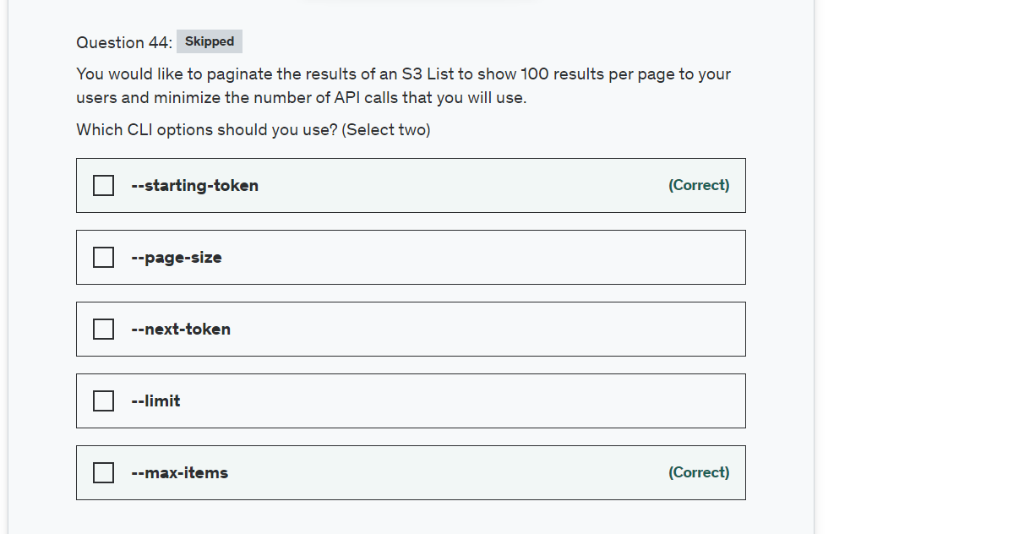

Explanation

Correct options:

**--max-items**

**--starting-token**

For commands that can return a large list of items, the AWS Command Line Interface (AWS CLI) has three options to control the number of items included in the output when the AWS CLI calls a service's API to populate the list.

--page-size

--max-items

--starting-token

By default, the AWS CLI uses a page size of 1000 and retrieves all available items. For example, if you run aws s3api list-objects on an Amazon S3 bucket that contains 3,500 objects, the AWS CLI makes four calls to Amazon S3, handling the service-specific pagination logic for you in the background and returning all 3,500 objects in the final output.

Here's an example: aws s3api list-objects --bucket my-bucket --max-items 100 --starting-token eyJNYXJrZXIiOiBudWxsLCAiYm90b190cnVuY2F0ZV9hbW91bnQiOiAxfQ==

Incorrect options:

"--page-size" - You can use the --page-size option to specify that the AWS CLI requests a smaller number of items from each call to the AWS service. The CLI still retrieves the full list but performs a larger number of service API calls in the background and retrieves a smaller number of items with each call.

"--next-token" - This is a made-up option and has been added as a distractor.

"--limit" - This is a made-up option and has been added as a distractor.

Reference:

<https://docs.aws.amazon.com/cli/latest/userguide/cli-usage-pagination.html>

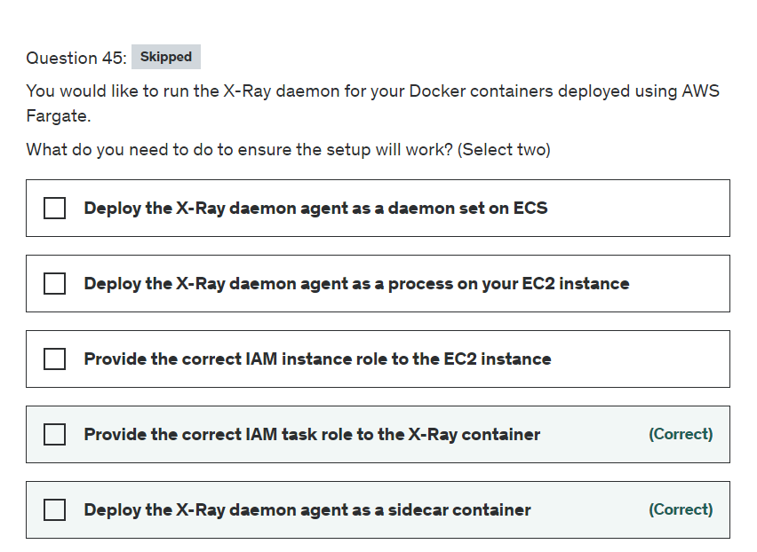

Explanation

Correct options:

**Deploy the X-Ray daemon agent as a sidecar container**

In Amazon ECS, create a Docker image that runs the X-Ray daemon, upload it to a Docker image repository, and then deploy it to your Amazon ECS cluster. You can use port mappings and network mode settings in your task definition file to allow your application to communicate with the daemon container.

As we are using AWS Fargate, we do not have control over the underlying EC2 instance and thus we can't deploy the agent on the EC2 instance or run an X-Ray agent container as a daemon set (only available for ECS classic).

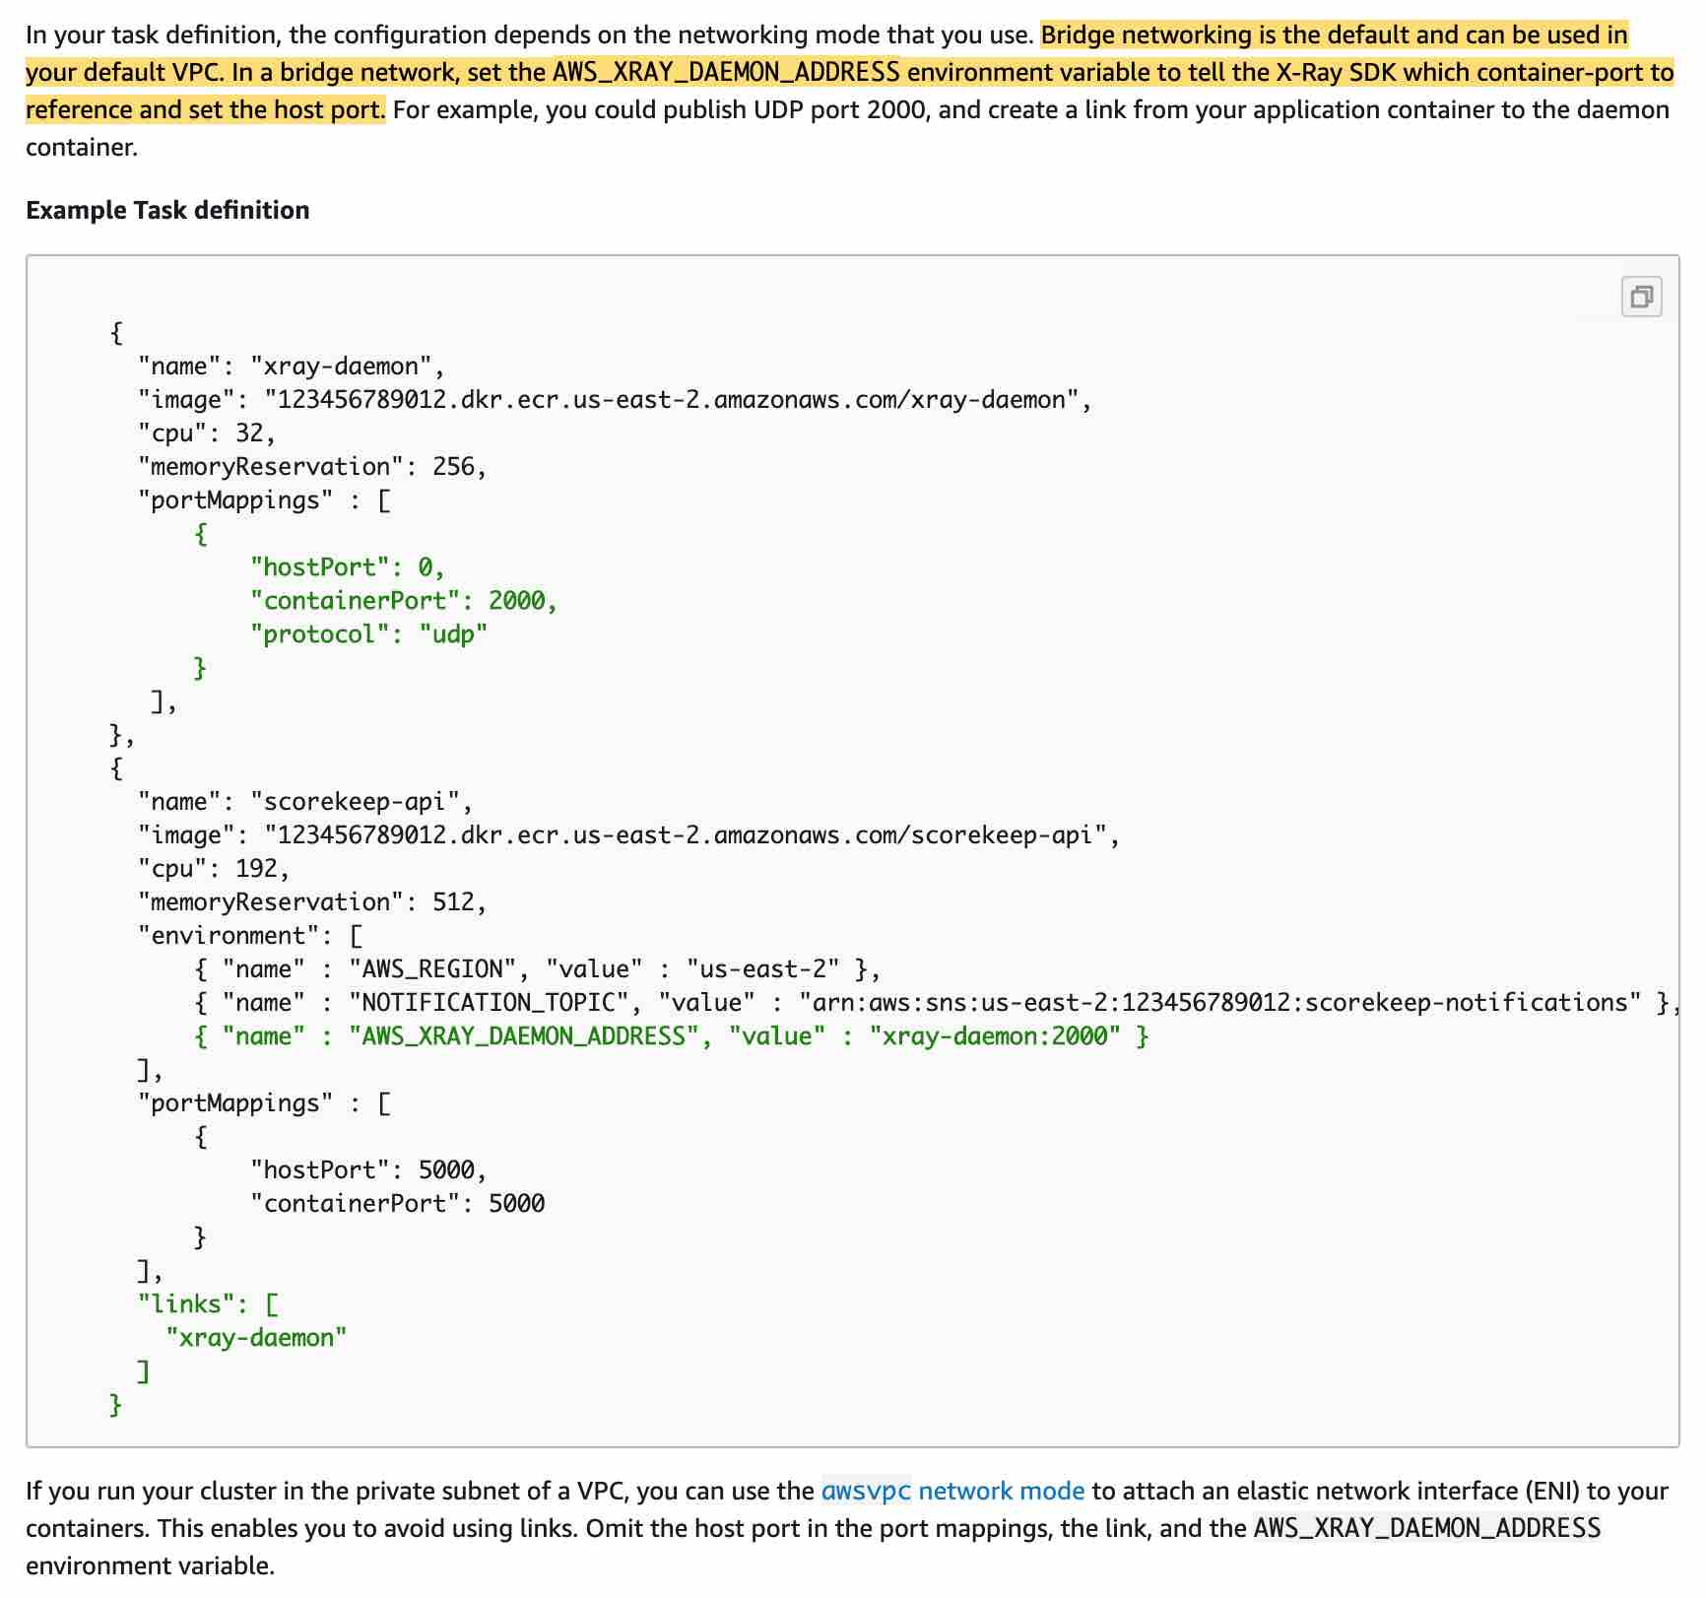 via - <https://docs.aws.amazon.com/xray/latest/devguide/xray-daemon-ecs.html>

**Provide the correct IAM task role to the X-Ray container**

For Fargate, we can only provide IAM roles to tasks, which is also the best security practice should we use EC2 instances.

Incorrect options:

**Deploy the X-Ray daemon agent as a daemon set on ECS** - As explained above, since we are using AWS Fargate, we do not have control over the underlying EC2 instance and thus we can't run an X-Ray agent container as a daemon set.

**Deploy the X-Ray daemon agent as a process on your EC2 instance**

**Provide the correct IAM instance role to the EC2 instance**

As we are using AWS Fargate, we do not have control over the underlying EC2 instance, so both these options are incorrect.

Reference:

<https://docs.aws.amazon.com/xray/latest/devguide/xray-daemon-ecs.html>

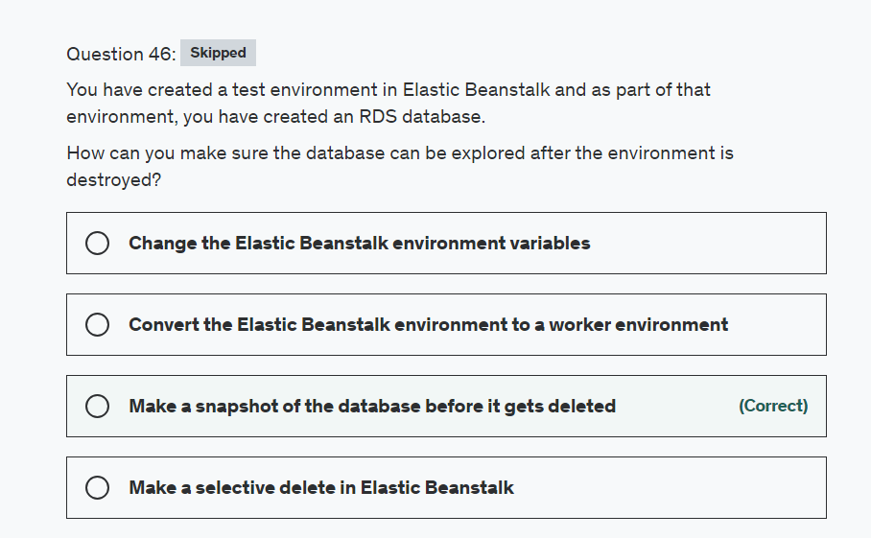

Explanation

Correct option:

**Make a snapshot of the database before it gets deleted**

Use an Elastic Beanstalk blue (environment A)/green (environment B) deployment to decouple an RDS DB instance from environment.

Create a new Elastic Beanstalk environment (environment B) with the necessary information to connect to the RDS DB instance.

Note: An RDS DB instance attached to an Elastic Beanstalk environment is ideal for development and testing environments. However, it's not ideal for production environments because the lifecycle of the database instance is tied to the lifecycle of your application environment. If you terminate the environment, then you lose your data because the RDS DB instance is deleted by the environment. For more information, see Using Elastic Beanstalk with Amazon RDS.

This is the only way to recover the database data before it gets deleted by Elastic Beanstalk.

Please review this excellent document that addresses this use-case :

<https://aws.amazon.com/premiumsupport/knowledge-center/decouple-rds-from-beanstalk/>

Incorrect options:

**Make a selective delete in Elastic Beanstalk** - This is not a feature in Elastic Beanstalk.

**Change the Elastic Beanstalk environment variables** - Environment variables won't help with the provisioned RDS database.

**Convert the Elastic Beanstalk environment to a worker environment** - You can't convert Elastic Beanstalk environments, you can only change their settings.

Reference:

<https://aws.amazon.com/premiumsupport/knowledge-center/decouple-rds-from-beanstalk/>

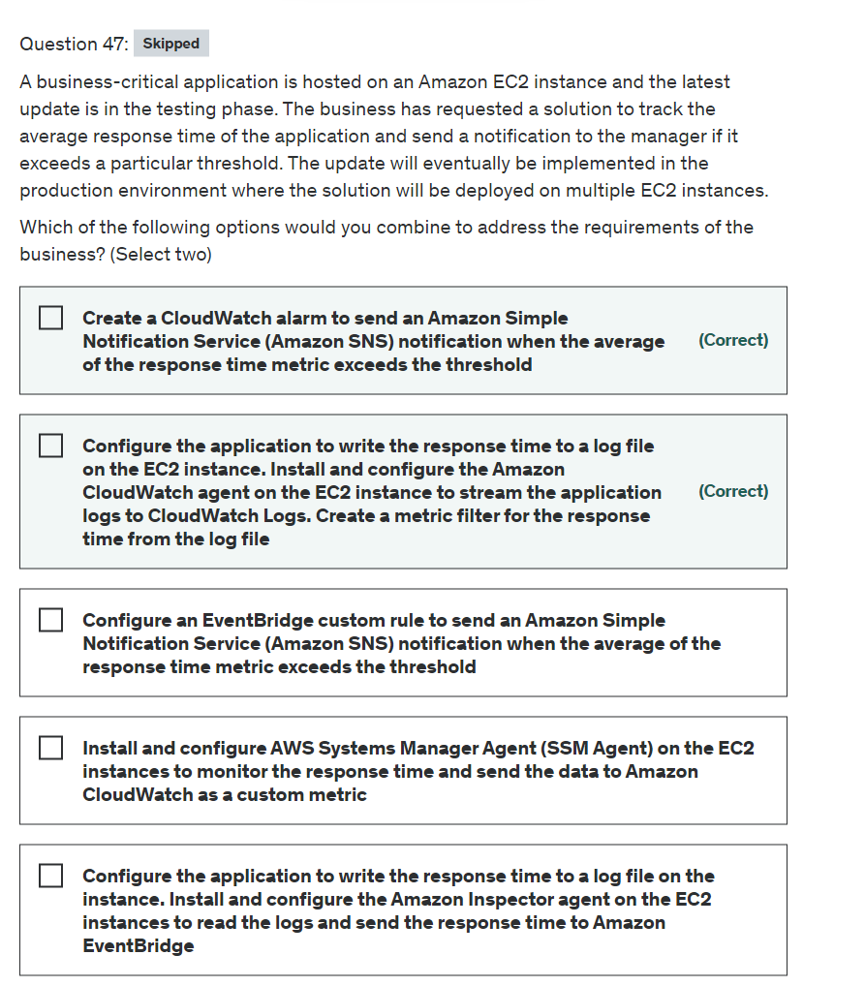

Explanation

Correct options:

**Configure the application to write the response time to a log file on the EC2 instance. Install and configure the Amazon CloudWatch agent on the EC2 instance to stream the application logs to CloudWatch Logs. Create a metric filter for the response time from the log file**

**Create a CloudWatch alarm to send an Amazon Simple Notification Service (Amazon SNS) notification when the average of the response time metric exceeds the threshold**

You can collect metrics and logs from Amazon EC2 instances and on-premises servers with the CloudWatch agent. The unified CloudWatch agent enables you to do the following:

Collect internal system-level metrics from Amazon EC2 instances across operating systems. The metrics can include in-guest metrics, in addition to the metrics for EC2 instances.

Collect system-level metrics from on-premises servers. These can include servers in a hybrid environment as well as servers not managed by AWS.

Retrieve custom metrics from your applications or services using the StatsD and collectd protocols. StatsD is supported on both Linux servers and servers running Windows Server. collectd is supported only on Linux servers.

Collect logs from Amazon EC2 instances and on-premises servers, running either Linux or Windows Server.

You can store and view the metrics that you collect with the CloudWatch agent in CloudWatch just as you can with any other CloudWatch metrics. The default namespace for metrics collected by the CloudWatch agent is CWAgent, although you can specify a different namespace when you configure the agent.

A metric alarm watches a single CloudWatch metric or the result of a math expression based on CloudWatch metrics. The alarm performs one or more actions based on the value of the metric or expression relative to a threshold over a number of time periods. The action can be sending a notification to an Amazon SNS topic, performing an Amazon EC2 action or an Amazon EC2 Auto Scaling action, or creating an OpsItem or incident in Systems Manager. For this use case, we will configure the metric alarm action to send an SNS notification when the alarm is in an ALARM state.

Incorrect options:

**Configure the application to write the response time to a log file on the instance. Install and configure the Amazon Inspector agent on the EC2 instances to read the logs and send the response time to Amazon EventBridge** - This statement is incorrect. Amazon Inspector is an automated vulnerability management service that continually scans Amazon Elastic Compute Cloud (EC2), AWS Lambda functions, and container workloads for software vulnerabilities and unintended network exposure. Inspector is not a log-collecting agent.

**Configure an EventBridge custom rule to send an Amazon Simple Notification Service (Amazon SNS) notification when the average of the response time metric exceeds the threshold** - Amazon EventBridge integrates with Amazon CloudWatch so that when CloudWatch alarms are triggered, a matching EventBridge rule can execute targets. So we are using CloudWatch alarms in this scenario too and hence a straightforward way would be to use CloudWatch alarm.

**Install and configure AWS Systems Manager Agent (SSM Agent) on the EC2 instances to monitor the response time and send the data to Amazon CloudWatch as a custom metric** - This statement is incorrect. AWS Systems Manager Agent (SSM Agent) is Amazon software that runs on Amazon Elastic Compute Cloud (Amazon EC2) instances, edge devices, on-premises servers, and virtual machines (VMs). SSM Agent makes it possible for the Systems Manager to update, manage, and configure these resources. SSM agent is required on each instance that needs to be managed from the Systems Manager service. SSM agents cannot collect log data and push it to CloudWatch logs. However, Systems Manager can be used to automate the task of CloudWatch agent installation on the instances.

References:

<https://docs.aws.amazon.com/AmazonCloudWatch/latest/monitoring/Install-CloudWatch-Agent.html>

<https://docs.aws.amazon.com/AmazonCloudWatch/latest/monitoring/AlarmThatSendsEmail.html>

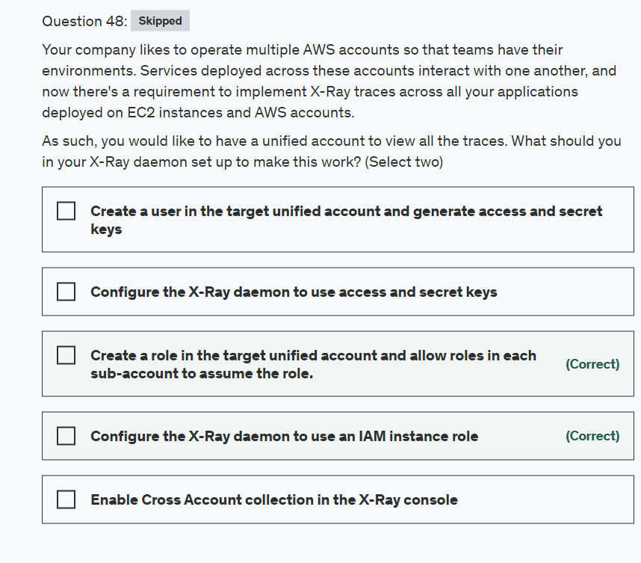

Explanation

Correct option:

AWS X-Ray helps developers analyze and debug production, distributed applications, such as those built using a microservices architecture. With X-Ray, you can understand how your application and its underlying services are performing to identify and troubleshoot the root cause of performance issues and errors. X-Ray provides an end-to-end view of requests as they travel through your application, and shows a map of your application’s underlying components.

How X-Ray Works:  via - <https://aws.amazon.com/xray/>

**Create a role in the target unified account and allow roles in each sub-account to assume the role**

**Configure the X-Ray daemon to use an IAM instance role**

The X-Ray agent can assume a role to publish data into an account different from the one in which it is running. This enables you to publish data from various components of your application into a central account.

X-Ray can also track requests flowing through applications or services across multiple AWS Regions.

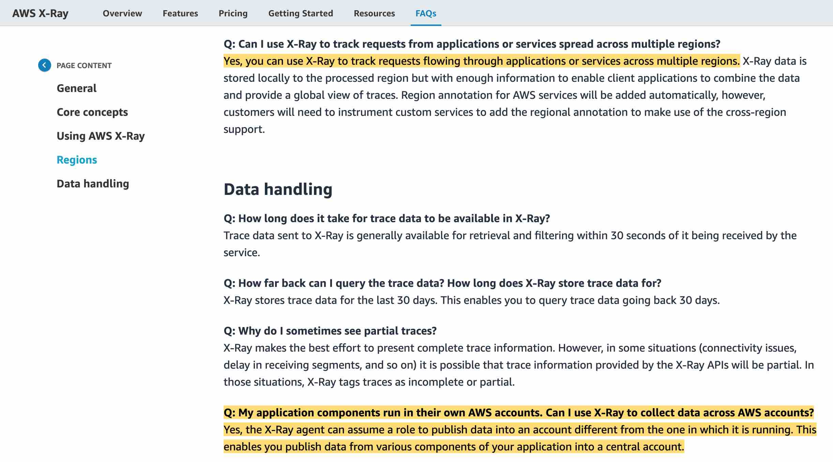 via - <https://aws.amazon.com/xray/faqs/>

You can create the necessary configurations for cross-account access via this reference documentation - <https://docs.aws.amazon.com/xray/latest/devguide/xray-daemon-configuration.html>

Incorrect options:

**Create a user in the target unified account and generate access and secret keys**

**Configure the X-Ray daemon to use access and secret keys**

These two options combined together would work but wouldn't be a best-practice security-wise. Therefore these are not correct.

**Enable Cross Account collection in the X-Ray console** - This is a made-up option and has been added as a distractor.

References:

<https://aws.amazon.com/xray/faqs/>

<https://docs.aws.amazon.com/xray/latest/devguide/xray-daemon-configuration.html>

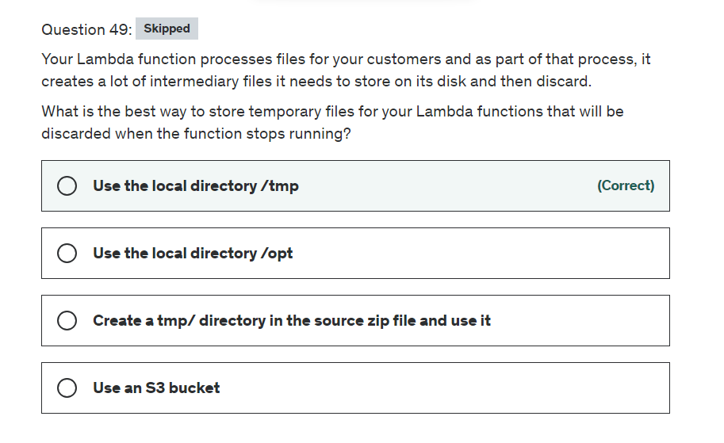

Explanation

Correct option:

**Use the local directory /tmp**

This is 512MB of temporary space you can use for your Lambda functions.

Incorrect options:

**Create a tmp/ directory in the source zip file and use it** - This option has been added as a distractor, as you can't access a directory within a zip file.

**Use the local directory /opt** - This option has been added as a distractor. This path is not accessible.

**Use an S3 bucket** - This won't be temporary after the Lambda function is deleted, so this option is incorrect.

Reference:

<https://docs.aws.amazon.com/lambda/latest/dg/limits.html>

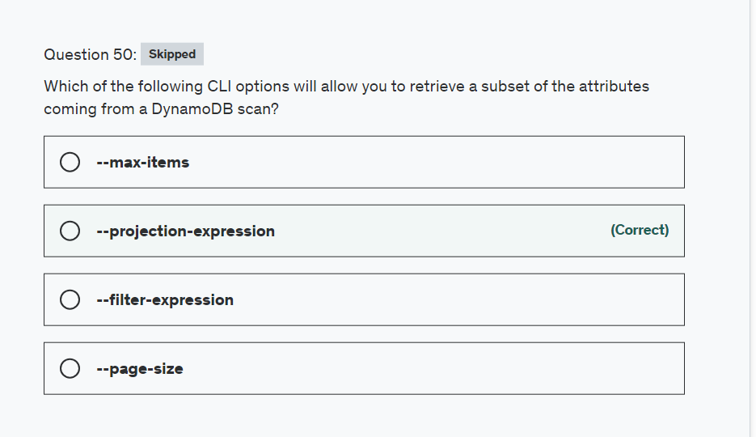

Explanation

Correct option:

**--projection-expression**

A projection expression is a string that identifies the attributes you want. To retrieve a single attribute, specify its name. For multiple attributes, the names must be comma-separated.

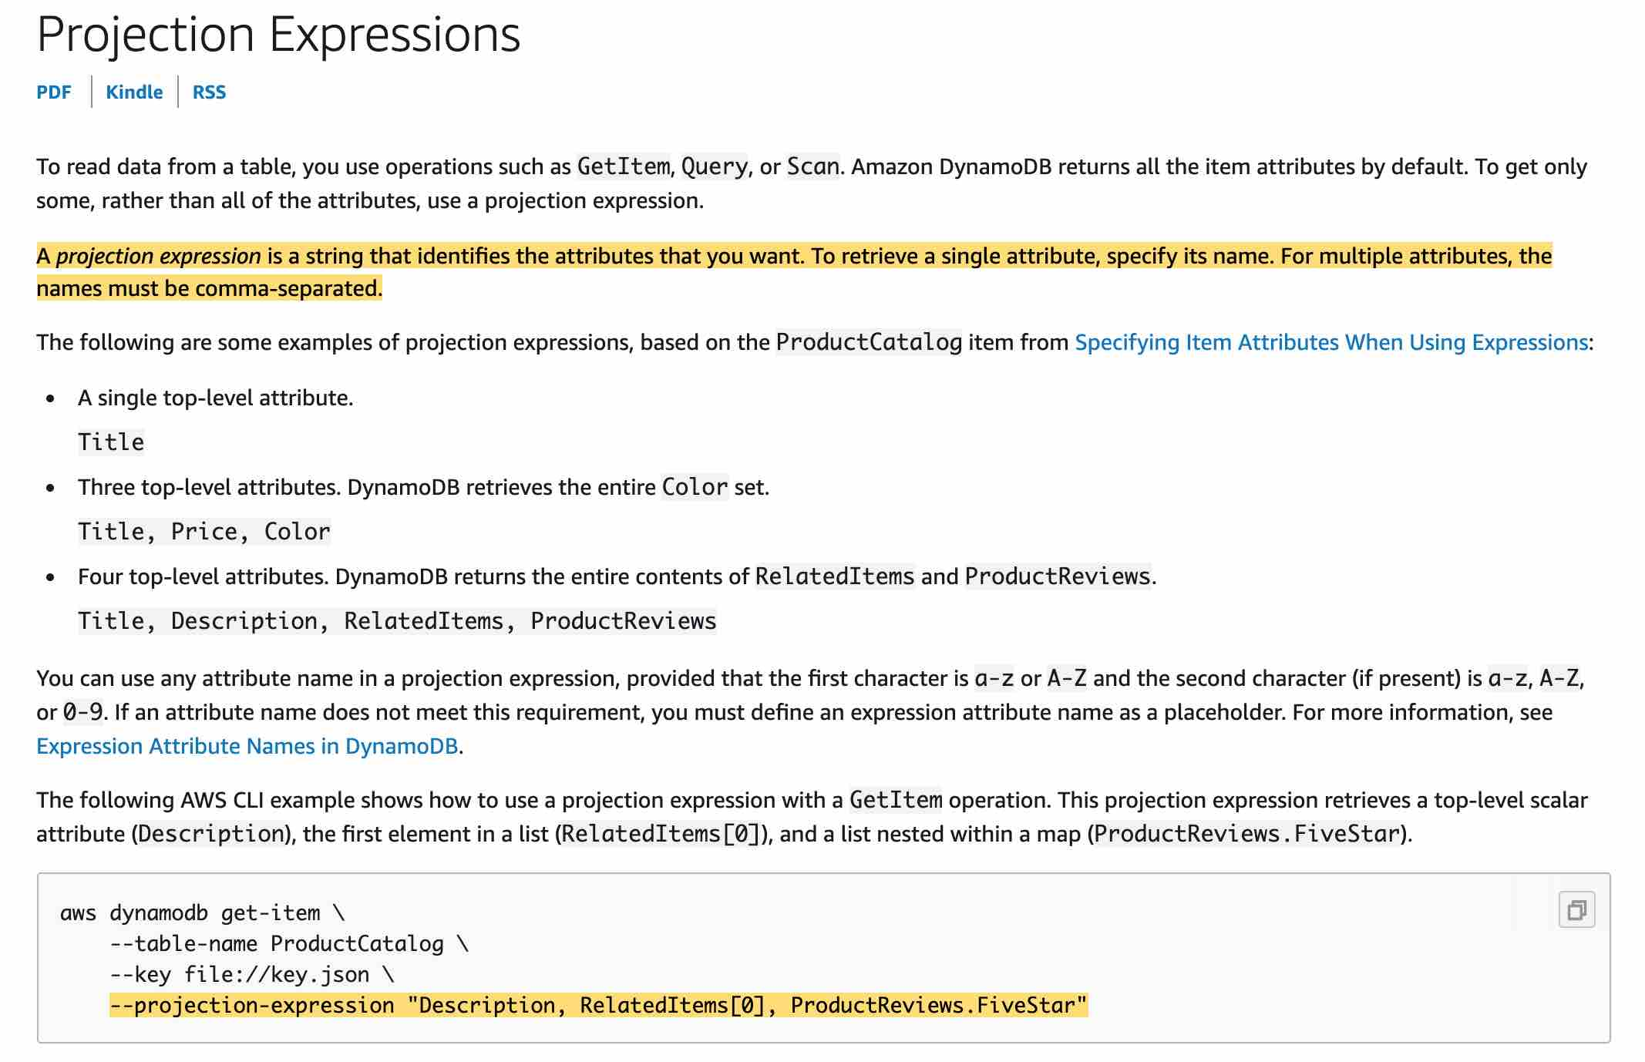 via - <https://docs.aws.amazon.com/amazondynamodb/latest/developerguide/Expressions.ProjectionExpressions.html>

To read data from a table, you use operations such as GetItem, Query, or Scan. DynamoDB returns all of the item attributes by default. To get just some, rather than all of the attributes, use a projection expression.

Incorrect options:

**--filter-expression** - If you need to further refine the Query results, you can optionally provide a filter expression. A filter expression determines which items within the Query results should be returned to you. All of the other results are discarded. A filter expression is applied after Query finishes, but before the results are returned. Therefore, a Query will consume the same amount of read capacity, regardless of whether a filter expression is present.

**--page-size** - You can use the --page-size option to specify that the AWS CLI requests a smaller number of items from each call to the AWS service. The CLI still retrieves the full list but performs a larger number of service API calls in the background and retrieves a smaller number of items with each call.

**--max-items** - To include fewer items at a time in the AWS CLI output, use the --max-items option. The AWS CLI still handles pagination with the service as described above, but prints out only the number of items at a time that you specify.

Reference:

<https://docs.aws.amazon.com/amazondynamodb/latest/developerguide/Expressions.ProjectionExpressions.html>

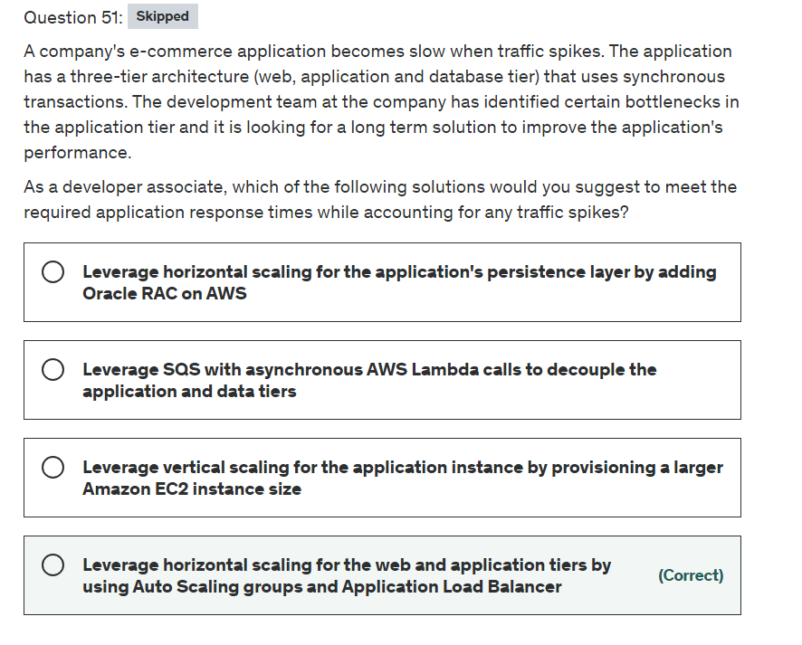

Explanation

Correct option:

**Leverage horizontal scaling for the web and application tiers by using Auto Scaling groups and Application Load Balancer** - A horizontally scalable system is one that can increase capacity by adding more computers to the system. This is in contrast to a vertically scalable system, which is constrained to running its processes on only one computer; in such systems, the only way to increase performance is to add more resources into one computer in the form of faster (or more) CPUs, memory or storage.

Horizontally scalable systems are oftentimes able to outperform vertically scalable systems by enabling parallel execution of workloads and distributing those across many different computers.

Elastic Load Balancing is used to automatically distribute your incoming application traffic across all the EC2 instances that you are running. You can use Elastic Load Balancing to manage incoming requests by optimally routing traffic so that no one instance is overwhelmed.

To use Elastic Load Balancing with your Auto Scaling group, you attach the load balancer to your Auto Scaling group to register the group with the load balancer. Your load balancer acts as a single point of contact for all incoming web traffic to your Auto Scaling group.

When you use Elastic Load Balancing with your Auto Scaling group, it's not necessary to register individual EC2 instances with the load balancer. Instances that are launched by your Auto Scaling group are automatically registered with the load balancer. Likewise, instances that are terminated by your Auto Scaling group are automatically deregistered from the load balancer.

This option will require fewer design changes, it's mostly configuration changes and the ability for the web/application tier to be able to communicate across instances. Hence, this is the right solution for the current use case.

Incorrect options:

**Leverage SQS with asynchronous AWS Lambda calls to decouple the application and data tiers** - This is incorrect as it uses asynchronous AWS Lambda calls and the application uses synchronous transactions. The question says there should be no change in the application architecture.

**Leverage horizontal scaling for the application's persistence layer by adding Oracle RAC on AWS** - The issue is not with the persistence layer at all. This option has only been used as a distractor.

You can deploy scalable Oracle Real Application Clusters (RAC) on Amazon EC2 using Amazon Machine Images (AMI) on AWS Marketplace. Oracle RAC is a shared-everything database cluster technology from Oracle that allows a single database (a set of data files) to be concurrently accessed and served by one or many database server instances.

**Leverage vertical scaling for the application instance by provisioning a larger Amazon EC2 instance size** - Vertical scaling is just a band-aid solution and will not work long term.

References:

<https://docs.aws.amazon.com/autoscaling/ec2/userguide/autoscaling-load-balancer.html>

<https://aws.amazon.com/blogs/compute/operating-lambda-understanding-event-driven-architecture-part-1/>

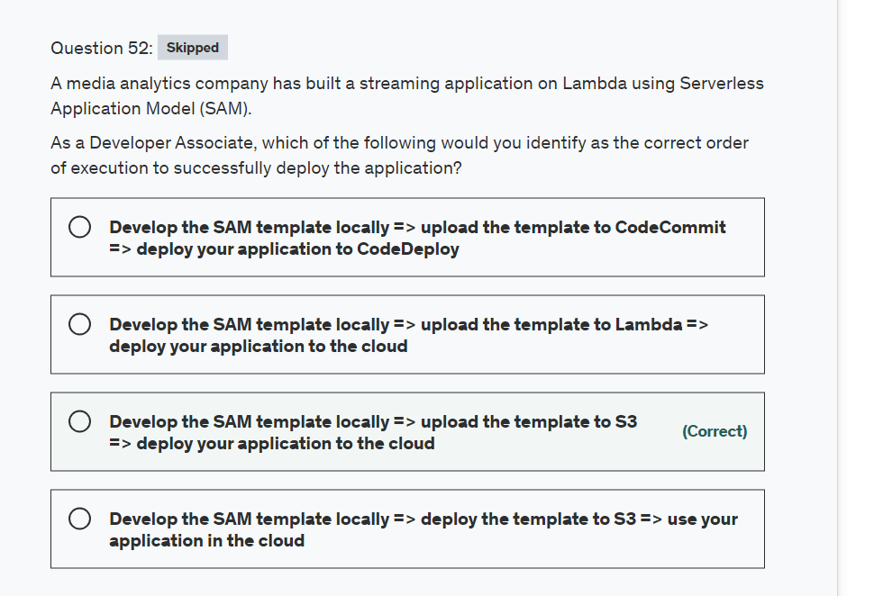

Explanation

Correct option:

**Develop the SAM template locally => upload the template to S3 => deploy your application to the cloud**

The AWS Serverless Application Model (SAM) is an open-source framework for building serverless applications. It provides shorthand syntax to express functions, APIs, databases, and event source mappings. With just a few lines per resource, you can define the application you want and model it using YAML.

You can develop and test your serverless application locally, and then you can deploy your application by using the sam deploy command. The sam deploy command zips your application artifacts, uploads them to Amazon Simple Storage Service (Amazon S3), and deploys your application to the AWS Cloud. AWS SAM uses AWS CloudFormation as the underlying deployment mechanism.

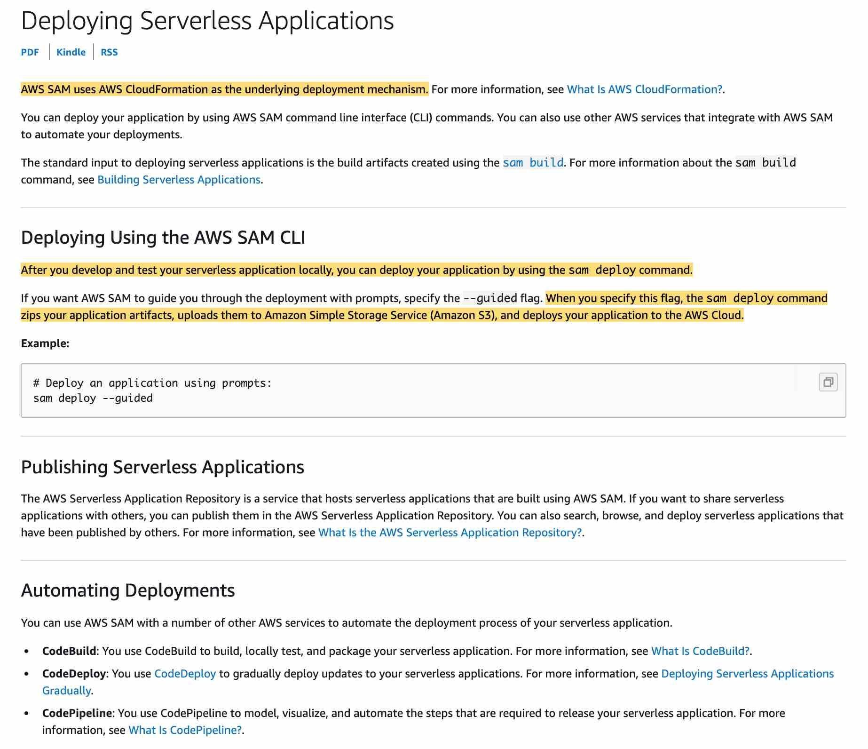 via - <https://docs.aws.amazon.com/serverless-application-model/latest/developerguide/serverless-deploying.html>

Incorrect options:

**Develop the SAM template locally => upload the template to Lambda => deploy your application to the cloud**

**Develop the SAM template locally => upload the template to CodeCommit => deploy your application to CodeDeploy**

**Develop the SAM template locally => deploy the template to S3 => use your application in the cloud**

These three options contradict the details provided in the explanation above, so these are incorrect.

Reference:

<https://docs.aws.amazon.com/serverless-application-model/latest/developerguide/serverless-deploying.html>

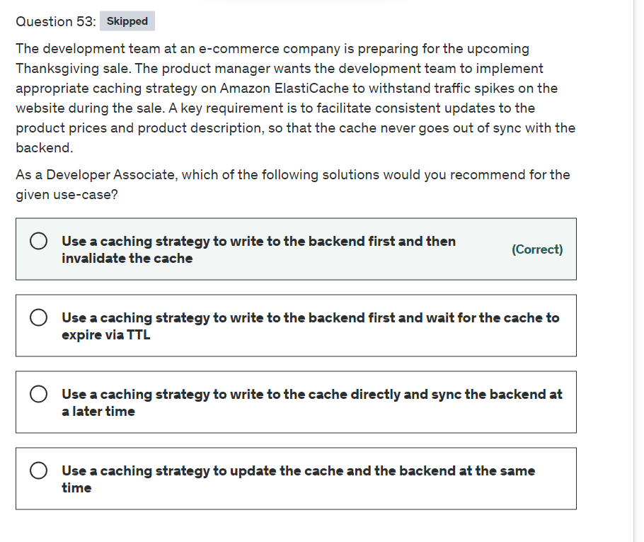

Explanation

Correct option:

Amazon ElastiCache allows you to seamlessly set up, run, and scale popular open-Source compatible in-memory data stores in the cloud. Build data-intensive apps or boost the performance of your existing databases by retrieving data from high throughput and low latency in-memory data stores. Amazon ElastiCache is a popular choice for real-time use cases like Caching, Session Stores, Gaming, Geospatial Services, Real-Time Analytics, and Queuing.

Broadly, you can set up two types of caching strategies:

Lazy Loading

Write-Through

 via - <https://docs.aws.amazon.com/AmazonElastiCache/latest/mem-ug/Strategies.html>

 via - <https://docs.aws.amazon.com/AmazonElastiCache/latest/mem-ug/Strategies.html>

**Use a caching strategy to write to the backend first and then invalidate the cache**

This option is similar to the write-through strategy wherein the application writes to the backend first and then invalidate the cache. As the cache gets invalidated, the caching engine would then fetch the latest value from the backend, thereby making sure that the product prices and product description stay consistent with the backend.

Incorrect options:

**Use a caching strategy to update the cache and the backend at the same time** - The cache and the backend cannot be updated at the same time via a single atomic operation as these are two separate systems. Therefore this option is incorrect.

**Use a caching strategy to write to the backend first and wait for the cache to expire via TTL** - This strategy could work if the TTL is really short. However, for the duration of this TTL, the cache would be out of sync with the backend, hence this option is not correct for the given use-case.

**Use a caching strategy to write to the cache directly and sync the backend at a later time** - This option is given as a distractor as this strategy is not viable to address the given use-case. The product prices and description on the cache must always stay consistent with the backend. You cannot sync the backend at a later time.

Reference:

<https://docs.aws.amazon.com/AmazonElastiCache/latest/mem-ug/Strategies.html>

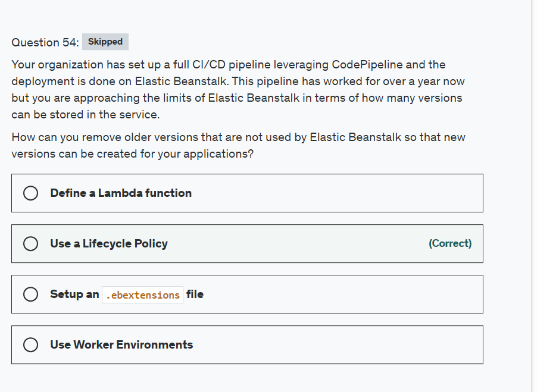

Explanation

Correct option:

**Use a Lifecycle Policy**

Each time you upload a new version of your application with the Elastic Beanstalk console or the EB CLI, Elastic Beanstalk creates an application version. If you don't delete versions that you no longer use, you will eventually reach the application version limit and be unable to create new versions of that application.

You can avoid hitting the limit by applying an application version lifecycle policy to your applications. A lifecycle policy tells Elastic Beanstalk to delete old application versions or to delete application versions when the total number of versions for an application exceeds a specified number.

Elastic Beanstalk applies an application's lifecycle policy each time you create a new application version and deletes up to 100 versions each time the lifecycle policy is applied. Elastic Beanstalk deletes old versions after creating the new version and does not count the new version towards the maximum number of versions defined in the policy.

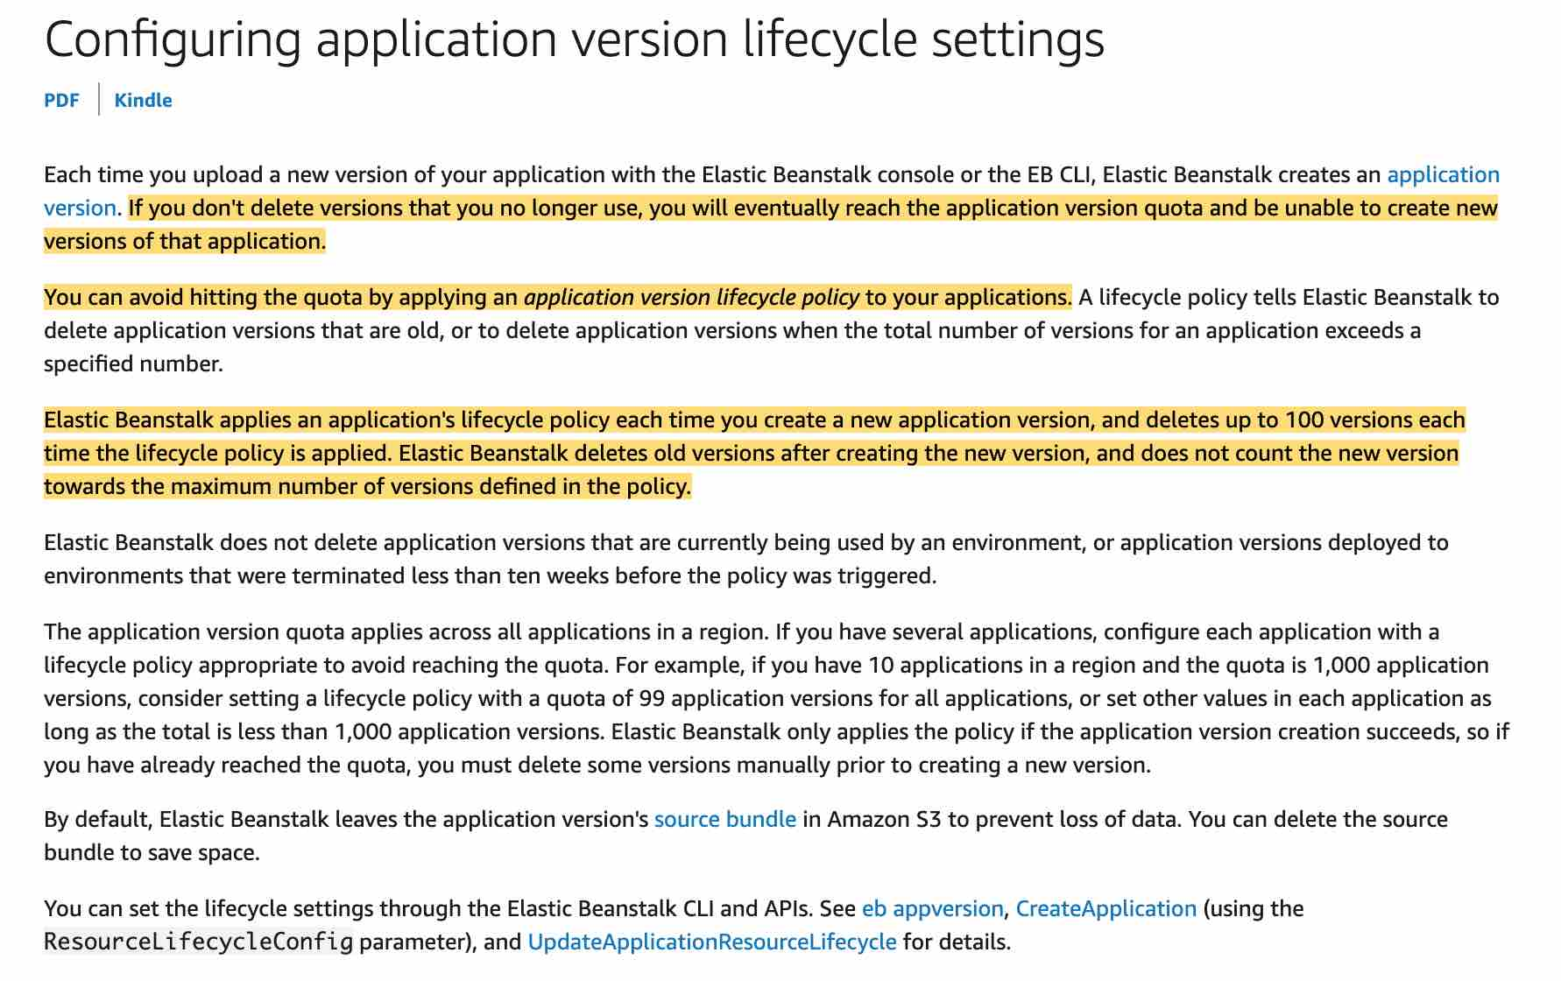 via - <https://docs.aws.amazon.com/elasticbeanstalk/latest/dg/applications-lifecycle.html>

Incorrect options: **Setup an .ebextensions files** - You can add AWS Elastic Beanstalk configuration files (.ebextensions) to your web application's source code to configure your environment and customize the AWS resources that it contains. This does not help with managing versions.

**Define a Lambda function** - This could work but would require a lot of manual scripting, to achieve the same desired effect as the Lifecycle Policy EB feature.

**Use Worker Environments** - This won't help. If your application performs operations or workflows that take a long time to complete, you can offload those tasks to a dedicated worker environment. Decoupling your web application front end from a process that performs blocking operations is a common way to ensure that your application stays responsive under load.

Reference:

<https://docs.aws.amazon.com/elasticbeanstalk/latest/dg/applications-lifecycle.html>

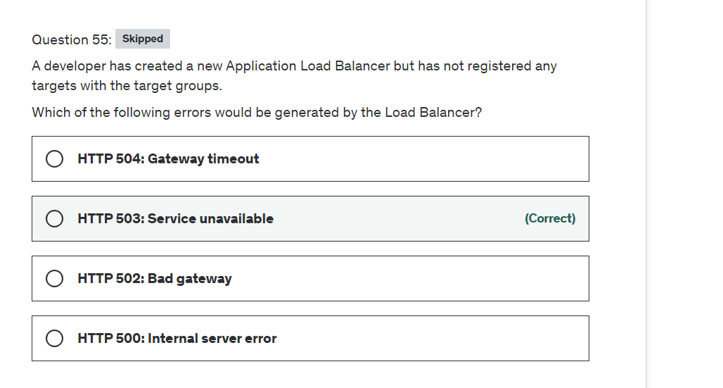

Explanation

Correct option:

**HTTP 503: Service unavailable**

The Load Balancer generates the HTTP 503: Service unavailable error when the target groups for the load balancer have no registered targets.

Incorrect options:

**HTTP 500: Internal server error**

**HTTP 502: Bad gateway**

**HTTP 504: Gateway timeout**

Here is a summary of the possible causes for these error types:

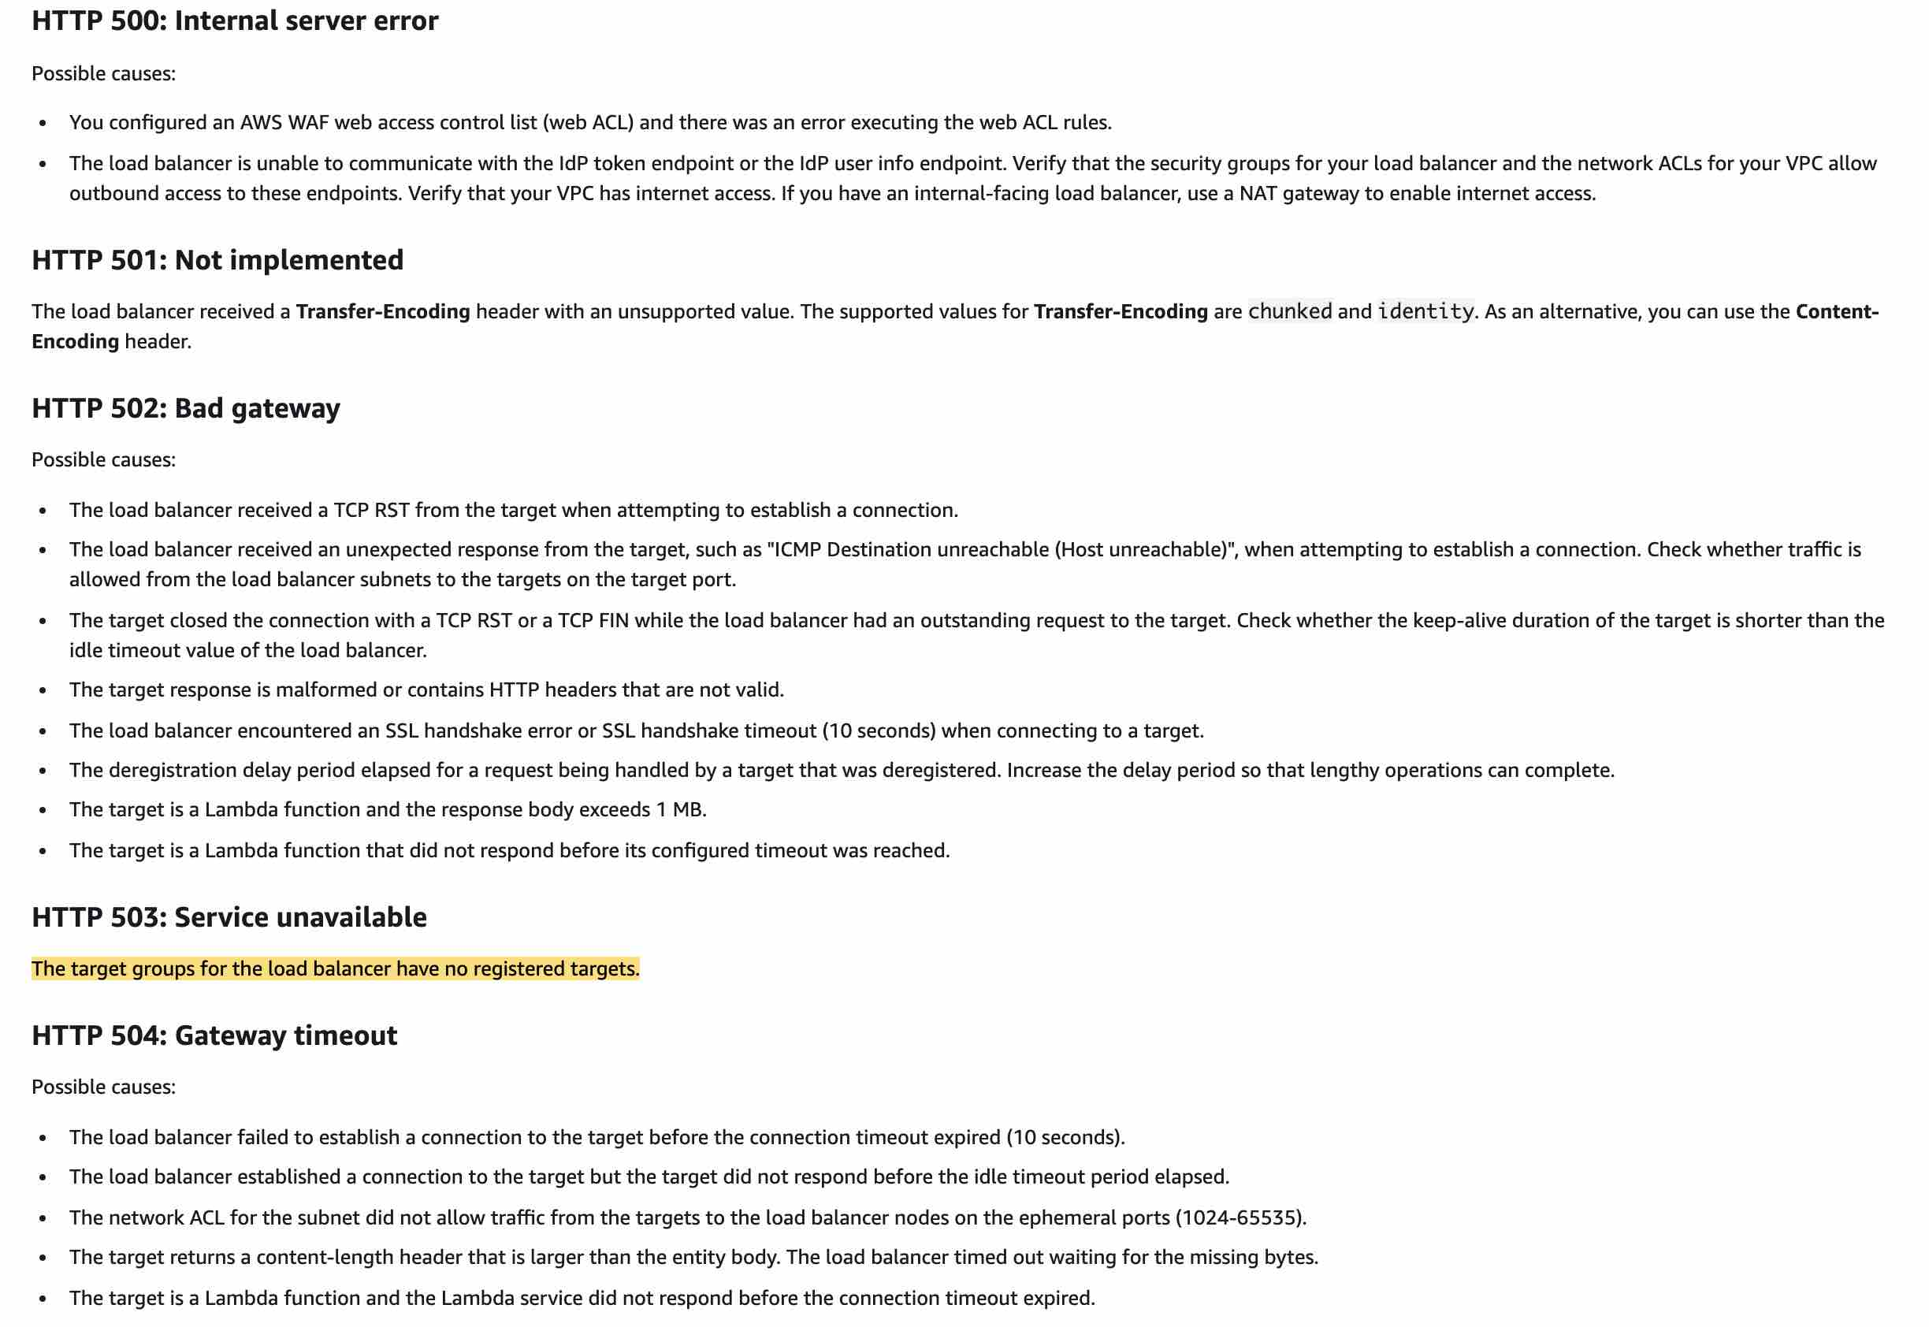 via - <https://docs.aws.amazon.com/elasticloadbalancing/latest/application/load-balancer-troubleshooting.html>

Reference:

<https://docs.aws.amazon.com/elasticloadbalancing/latest/application/load-balancer-troubleshooting.html>

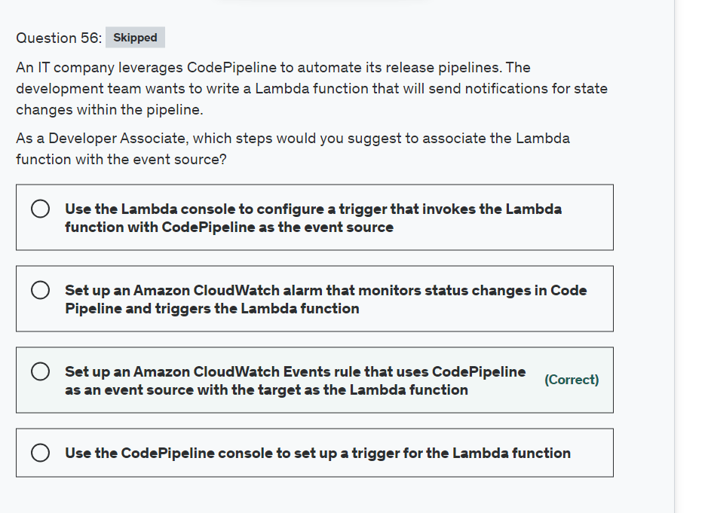

Explanation

Correct option:

Amazon CloudWatch Events delivers a near real-time stream of system events that describe changes in Amazon Web Services (AWS) resources. Using simple rules that you can quickly set up, you can match events and route them to one or more target functions or streams.

CloudWatch Events Key Concepts:  via - <https://docs.aws.amazon.com/AmazonCloudWatch/latest/events/WhatIsCloudWatchEvents.html>

**Set up an Amazon CloudWatch Events rule that uses CodePipeline as an event source with the target as the Lambda function**

You can use Amazon CloudWatch Events to detect and react to changes in the state of a pipeline, stage, or action. Then, based on rules you create, CloudWatch Events invokes one or more target actions when a pipeline, stage, or action enters the state you specify in a rule. For the given use-case, you can set up a rule that detects pipeline changes and invokes an AWS Lambda function.

Amazon CloudWatch Events With CodePipeline: 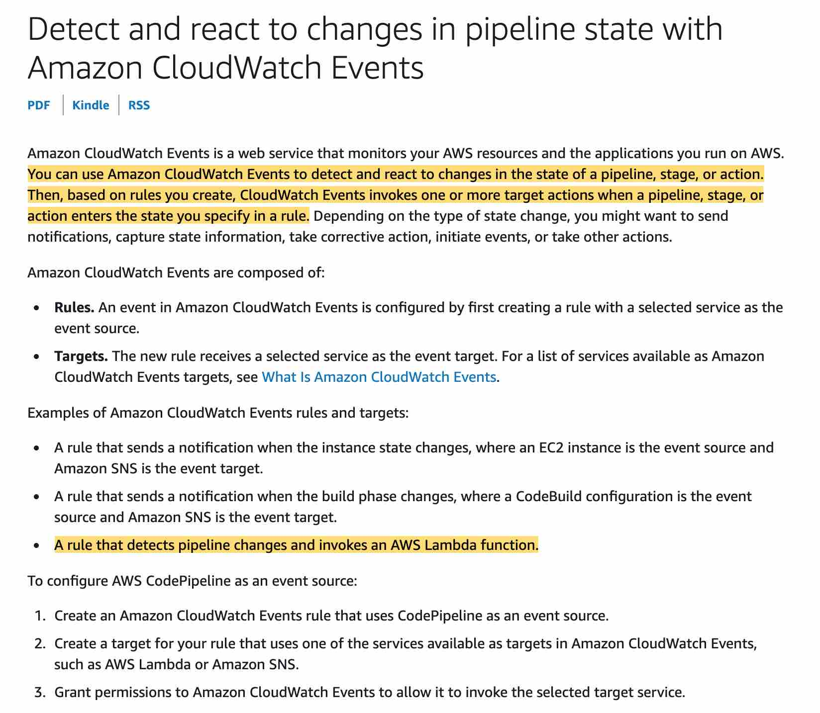 <https://docs.aws.amazon.com/codepipeline/latest/userguide/detect-state-changes-cloudwatch-events.html>

Incorrect options:

**Set up an Amazon CloudWatch alarm that monitors status changes in Code Pipeline and triggers the Lambda function** - As mentioned in the explanation above, you need to use a CloudWatch event and not CloudWatch alarm for this use-case.

**Use the Lambda console to configure a trigger that invokes the Lambda function with CodePipeline as the event source** - You cannot create a trigger with CodePipeline as the event source via the Lambda Console.

**Use the CodePipeline console to set up a trigger for the Lambda function** - CodePipeline console cannot be used to configure a trigger for a Lambda function.

References:

<https://docs.aws.amazon.com/AmazonCloudWatch/latest/events/WhatIsCloudWatchEvents.html>

<https://docs.aws.amazon.com/codepipeline/latest/userguide/detect-state-changes-cloudwatch-events.html>

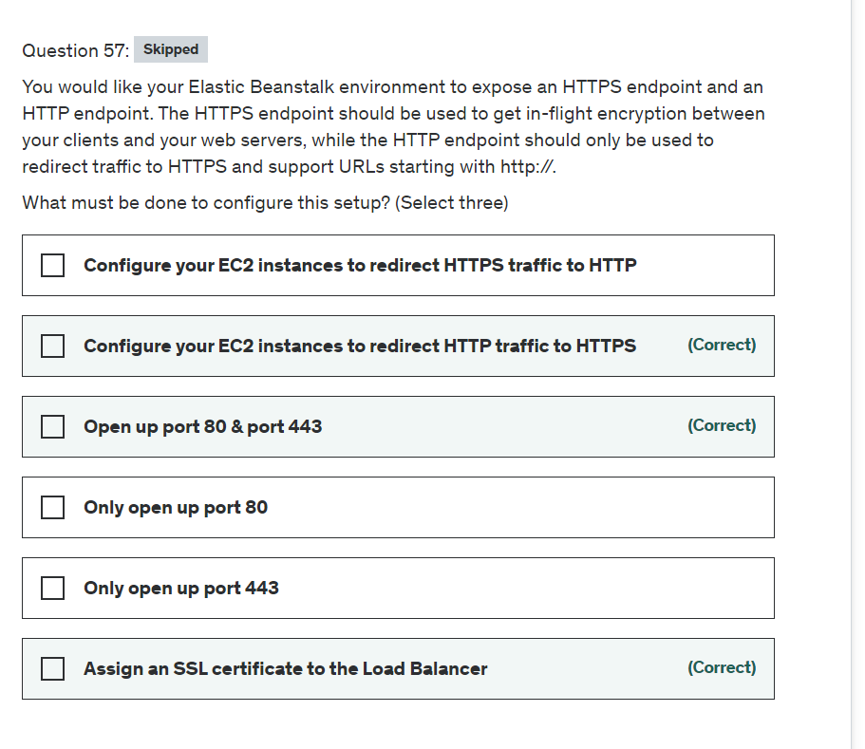

Explanation

Correct options:

**Assign an SSL certificate to the Load Balancer**

This ensures that the Load Balancer can expose an HTTPS endpoint.

**Open up port 80 & port 443**

This ensures that the Load Balancer will allow both the HTTP (80) and HTTPS (443) protocol for incoming connections

**Configure your EC2 instances to redirect HTTP traffic to HTTPS**

This ensures traffic originating from HTTP onto the Load Balancer forces a redirect to HTTPS by the EC2 instances before being correctly served, thus ensuring the traffic served is fully encrypted.

Incorrect options:

**Only open up port 80** - This is not correct as it would not allow HTTPS traffic (port 443).

**Only open up port 443** - This is not correct as it would not allow HTTP traffic (port 80).

**Configure your EC2 instances to redirect HTTPS traffic to HTTP** - This is not correct as it would force HTTP traffic, instead of HTTPS.

References:

<https://docs.aws.amazon.com/elasticbeanstalk/latest/dg/configuring-https-httpredirect.html>

<https://docs.aws.amazon.com/elasticbeanstalk/latest/dg/configuring-https-elb.html>

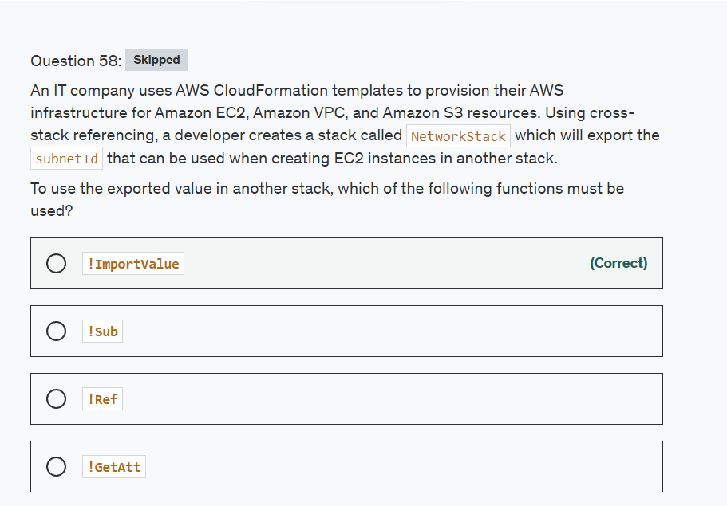

Explanation

Correct option:

**!ImportValue**

The intrinsic function Fn::ImportValue returns the value of an output exported by another stack. You typically use this function to create cross-stack references.

Incorrect options:

**!Ref** - Returns the value of the specified parameter or resource.

**!GetAtt** - Returns the value of an attribute from a resource in the template.

**!Sub** - Substitutes variables in an input string with values that you specify.

Reference:

<https://docs.aws.amazon.com/AWSCloudFormation/latest/UserGuide/intrinsic-function-reference-importvalue.html>

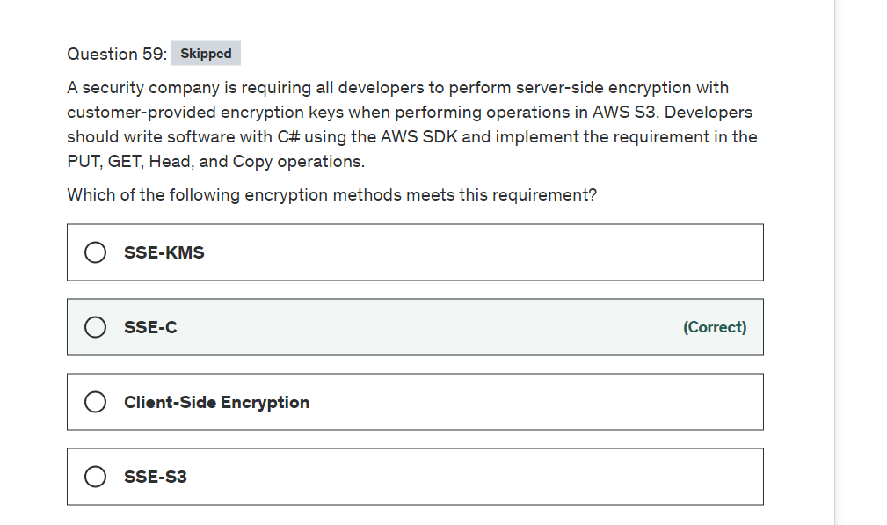

Explanation

Correct option:

**SSE-C**

You have the following options for protecting data at rest in Amazon S3:

Server-Side Encryption – Request Amazon S3 to encrypt your object before saving it on disks in its data centers and then decrypt it when you download the objects.

Client-Side Encryption – Encrypt data client-side and upload the encrypted data to Amazon S3. In this case, you manage the encryption process, the encryption keys, and related tools.

For the given use-case, the company wants to manage the encryption keys via its custom application and let S3 manage the encryption, therefore you must use Server-Side Encryption with Customer-Provided Keys (SSE-C).

Using server-side encryption with customer-provided encryption keys (SSE-C) allows you to set your encryption keys. With the encryption key you provide as part of your request, Amazon S3 manages both the encryption, as it writes to disks, and decryption, when you access your objects.

Please review these three options for Server Side Encryption on S3: 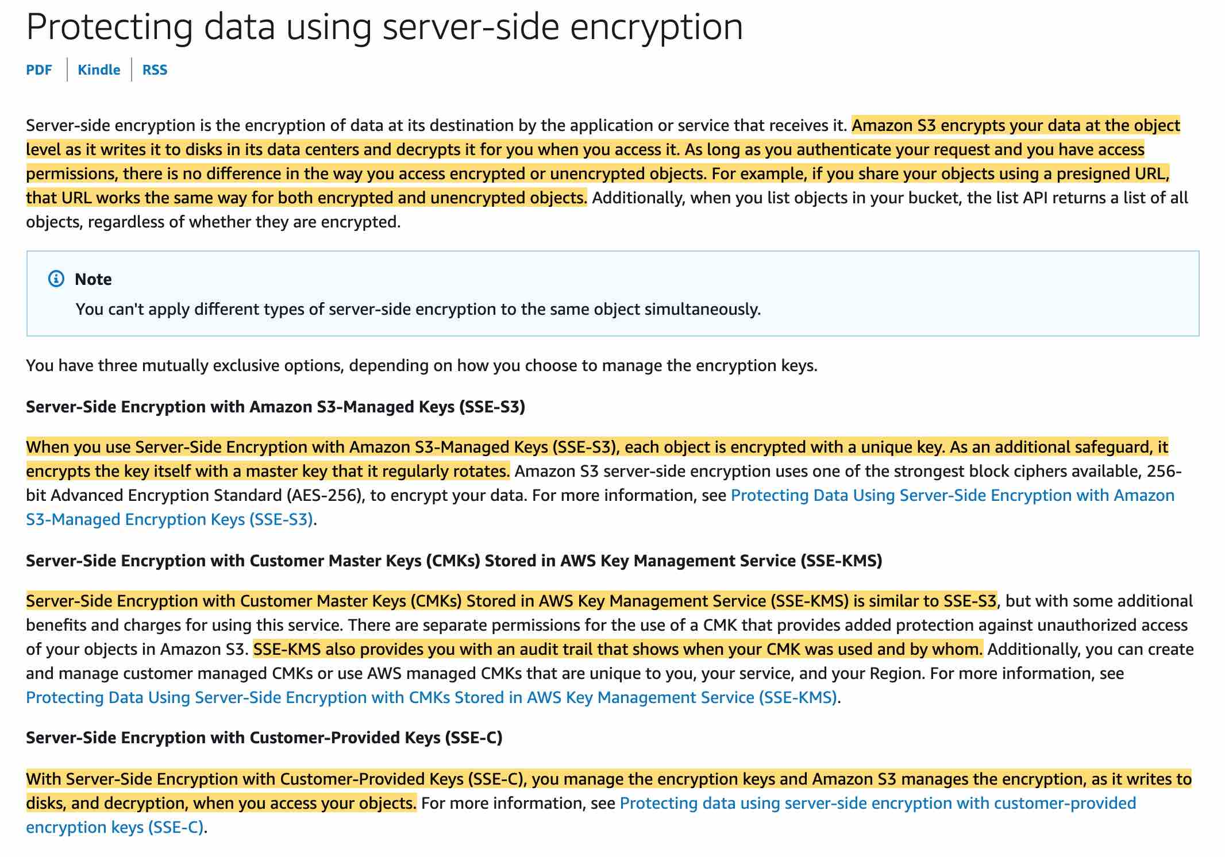 via - <https://docs.aws.amazon.com/AmazonS3/latest/dev/serv-side-encryption.html>

Incorrect options:

**SSE-KMS** - Server-Side Encryption with Customer Master Keys (CMKs) stored in AWS Key Management Service (SSE-KMS) is similar to SSE-S3. SSE-KMS provides you with an audit trail that shows when your CMK was used and by whom. Additionally, you can create and manage customer-managed CMKs or use AWS managed CMKs that are unique to you, your service, and your Region.

**Client-Side Encryption** - You can encrypt the data client-side and upload the encrypted data to Amazon S3. In this case, you manage the encryption process, the encryption keys, and related tools.

**SSE-S3** - When you use Server-Side Encryption with Amazon S3-Managed Keys (SSE-S3), each object is encrypted with a unique key. As an additional safeguard, it encrypts the key itself with a master key that it regularly rotates. So this option is incorrect.

Reference:

<https://docs.aws.amazon.com/AmazonS3/latest/dev/serv-side-encryption.html>

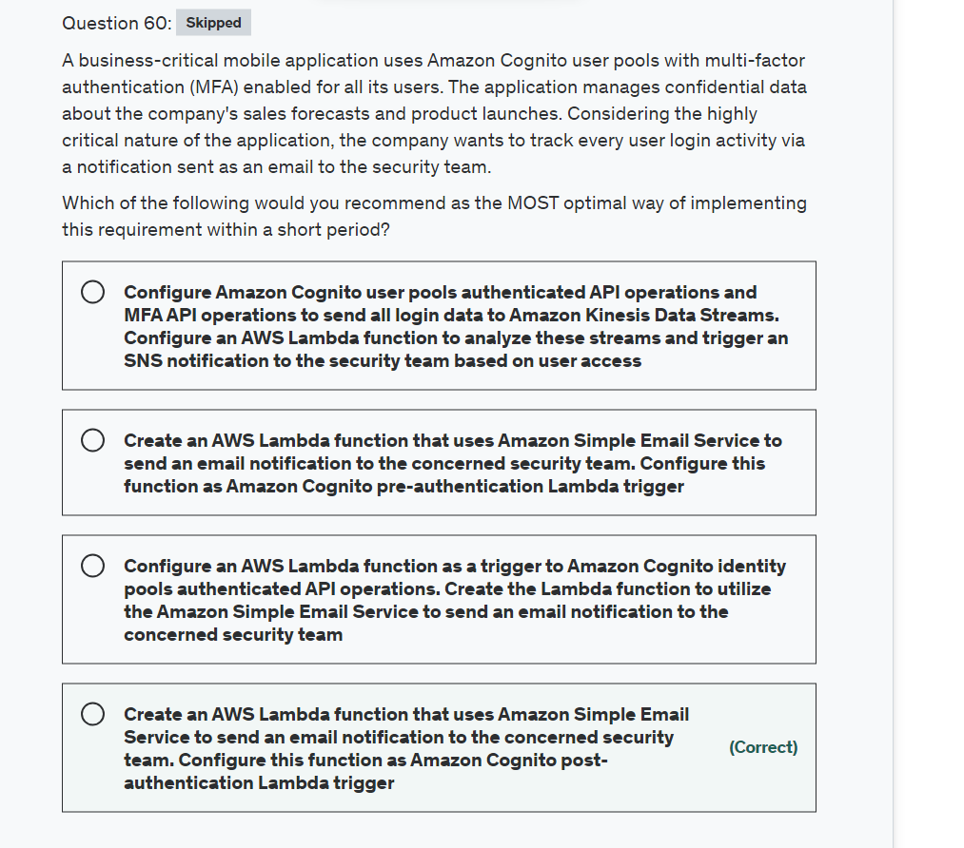

Explanation

Correct option:

**Create an AWS Lambda function that uses Amazon Simple Email Service to send an email notification to the concerned security team. Configure this function as Amazon Cognito post-authentication Lambda trigger**

Amazon Cognito invokes Post authentication Lambda trigger after signing in a user, you can add custom logic after Amazon Cognito authenticates the user.

Post-authentication Lambda flows: 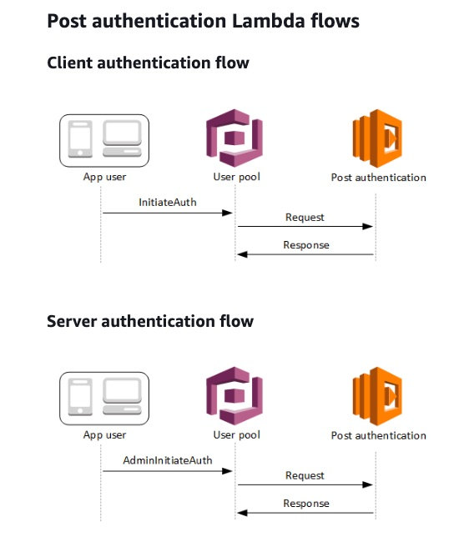 via - <https://docs.aws.amazon.com/cognito/latest/developerguide/user-pool-lambda-post-authentication.html>

Incorrect options:

**Create an AWS Lambda function that uses Amazon Simple Email Service to send an email notification to the concerned security team. Configure this function as Amazon Cognito pre-authentication Lambda trigger** - Pre-authentication Lambda trigger: Amazon Cognito invokes this trigger when a user attempts to sign in so that you can create custom validation that accepts or denies the authentication request. This is not useful for the current use case since we want to track user login activity which happens post-authentication.

**Configure an AWS Lambda function as a trigger to Amazon Cognito identity pools authenticated API operations. Create the Lambda function to utilize the Amazon Simple Email Service to send an email notification to the concerned security team** - This statement is incorrect. Amazon Cognito identity pools (federated identities) enable you to create unique identities for your users and federate them with identity providers. Cognito identity pools are for authorization and not for authentication.

**Configure Amazon Cognito user pools authenticated API operations and MFA API operations to send all login data to Amazon Kinesis Data Streams. Configure an AWS Lambda function to analyze these streams and trigger an SNS notification to the security team based on user access** - This is a made-up option given only as a distractor.

References:

<https://docs.aws.amazon.com/cognito/latest/developerguide/user-pool-lambda-post-authentication.html>

<https://docs.aws.amazon.com/cognito/latest/developerguide/user-pools-API-operations.html>

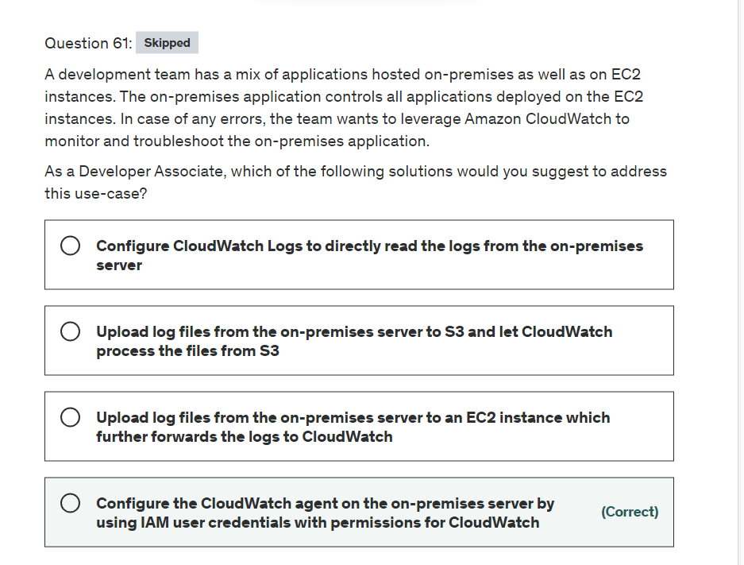

Explanation

Correct option:

**Configure the CloudWatch agent on the on-premises server by using IAM user credentials with permissions for CloudWatch**

The CloudWatch agent enables you to do the following:

Collect system-level metrics from on-premises servers. These can include servers in a hybrid environment as well as servers not managed by AWS.

Collect logs from Amazon EC2 instances and on-premises servers, running either Linux or Windows Server.

To enable the CloudWatch agent to send data from an on-premises server, you must specify the access key and secret key of the IAM user that you created earlier.

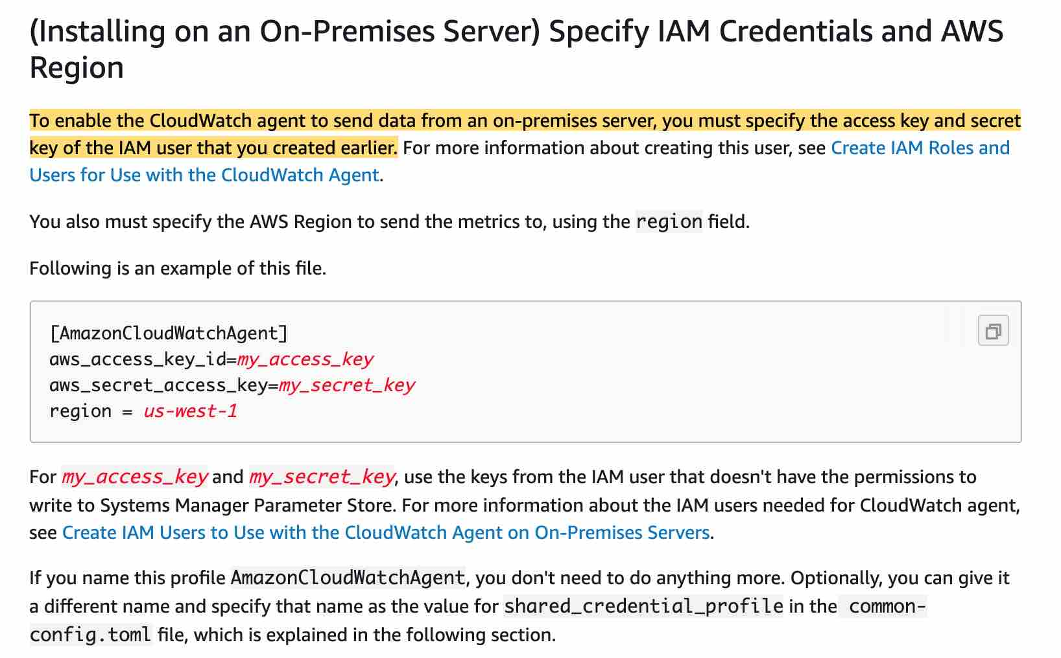 via - <https://docs.aws.amazon.com/AmazonCloudWatch/latest/monitoring/install-CloudWatch-Agent-on-premise.html>

Incorrect options:

**Configure CloudWatch Logs to directly read the logs from the on-premises server** - This is a made-up option as you cannot have CloudWatch Logs directly communicate with the on-premises server. You have to go via the CloudWatch Agent.

**Upload log files from the on-premises server to an EC2 instance which further forwards the logs to CloudWatch**

**Upload log files from the on-premises server to S3 and let CloudWatch process the files from S3**

Both these options require significant customizations and still will not be as neatly integrated with CloudWatch as compared to just using the CloudWatch Agent which is available off-the-shelf.

Reference:

<https://docs.aws.amazon.com/AmazonCloudWatch/latest/monitoring/install-CloudWatch-Agent-on-premise.html>

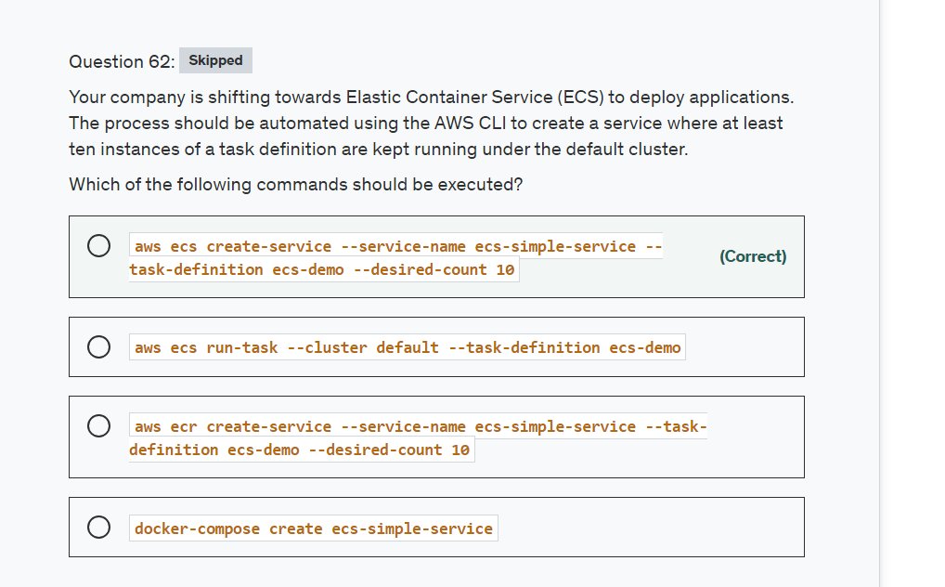

Explanation

Correct option:

**aws ecs create-service --service-name ecs-simple-service --task-definition ecs-demo --desired-count 10**

To create a new service you would use this command which creates a service in your default region called ecs-simple-service. The service uses the ecs-demo task definition and it maintains 10 instantiations of that task.

Incorrect options:

**aws ecr create-service --service-name ecs-simple-service --task-definition ecs-demo --desired-count 10** - This command is referencing a different service called Amazon Elastic Container Registry (ECR) which's is a fully-managed Docker container registry

**docker-compose create ecs-simple-service** - This is a docker command to create containers for a service.

**aws ecs run-task --cluster default --task-definition ecs-demo** - This is a valid command but used for starting a new task using a specified task definition.

Reference:

<https://docs.aws.amazon.com/cli/latest/reference/ecs/create-service.html>

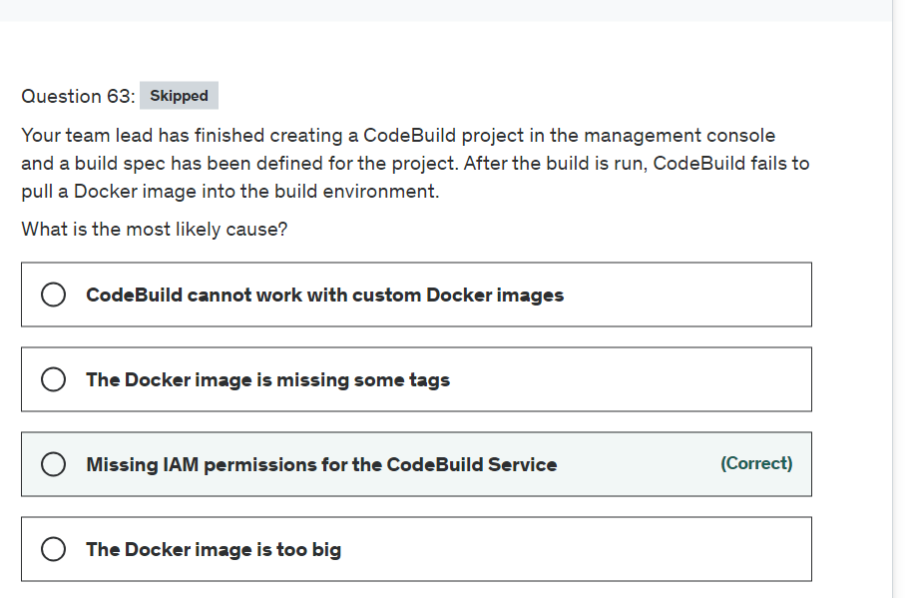

Explanation

Correct option:

**Missing IAM permissions for the CodeBuild Service**

By default, IAM users don't have permission to create or modify Amazon Elastic Container Registry (Amazon ECR) resources or perform tasks using the Amazon ECR API. A user who uses the AWS CodeBuild console must have a minimum set of permissions that allows the user to describe other AWS resources for the AWS account.

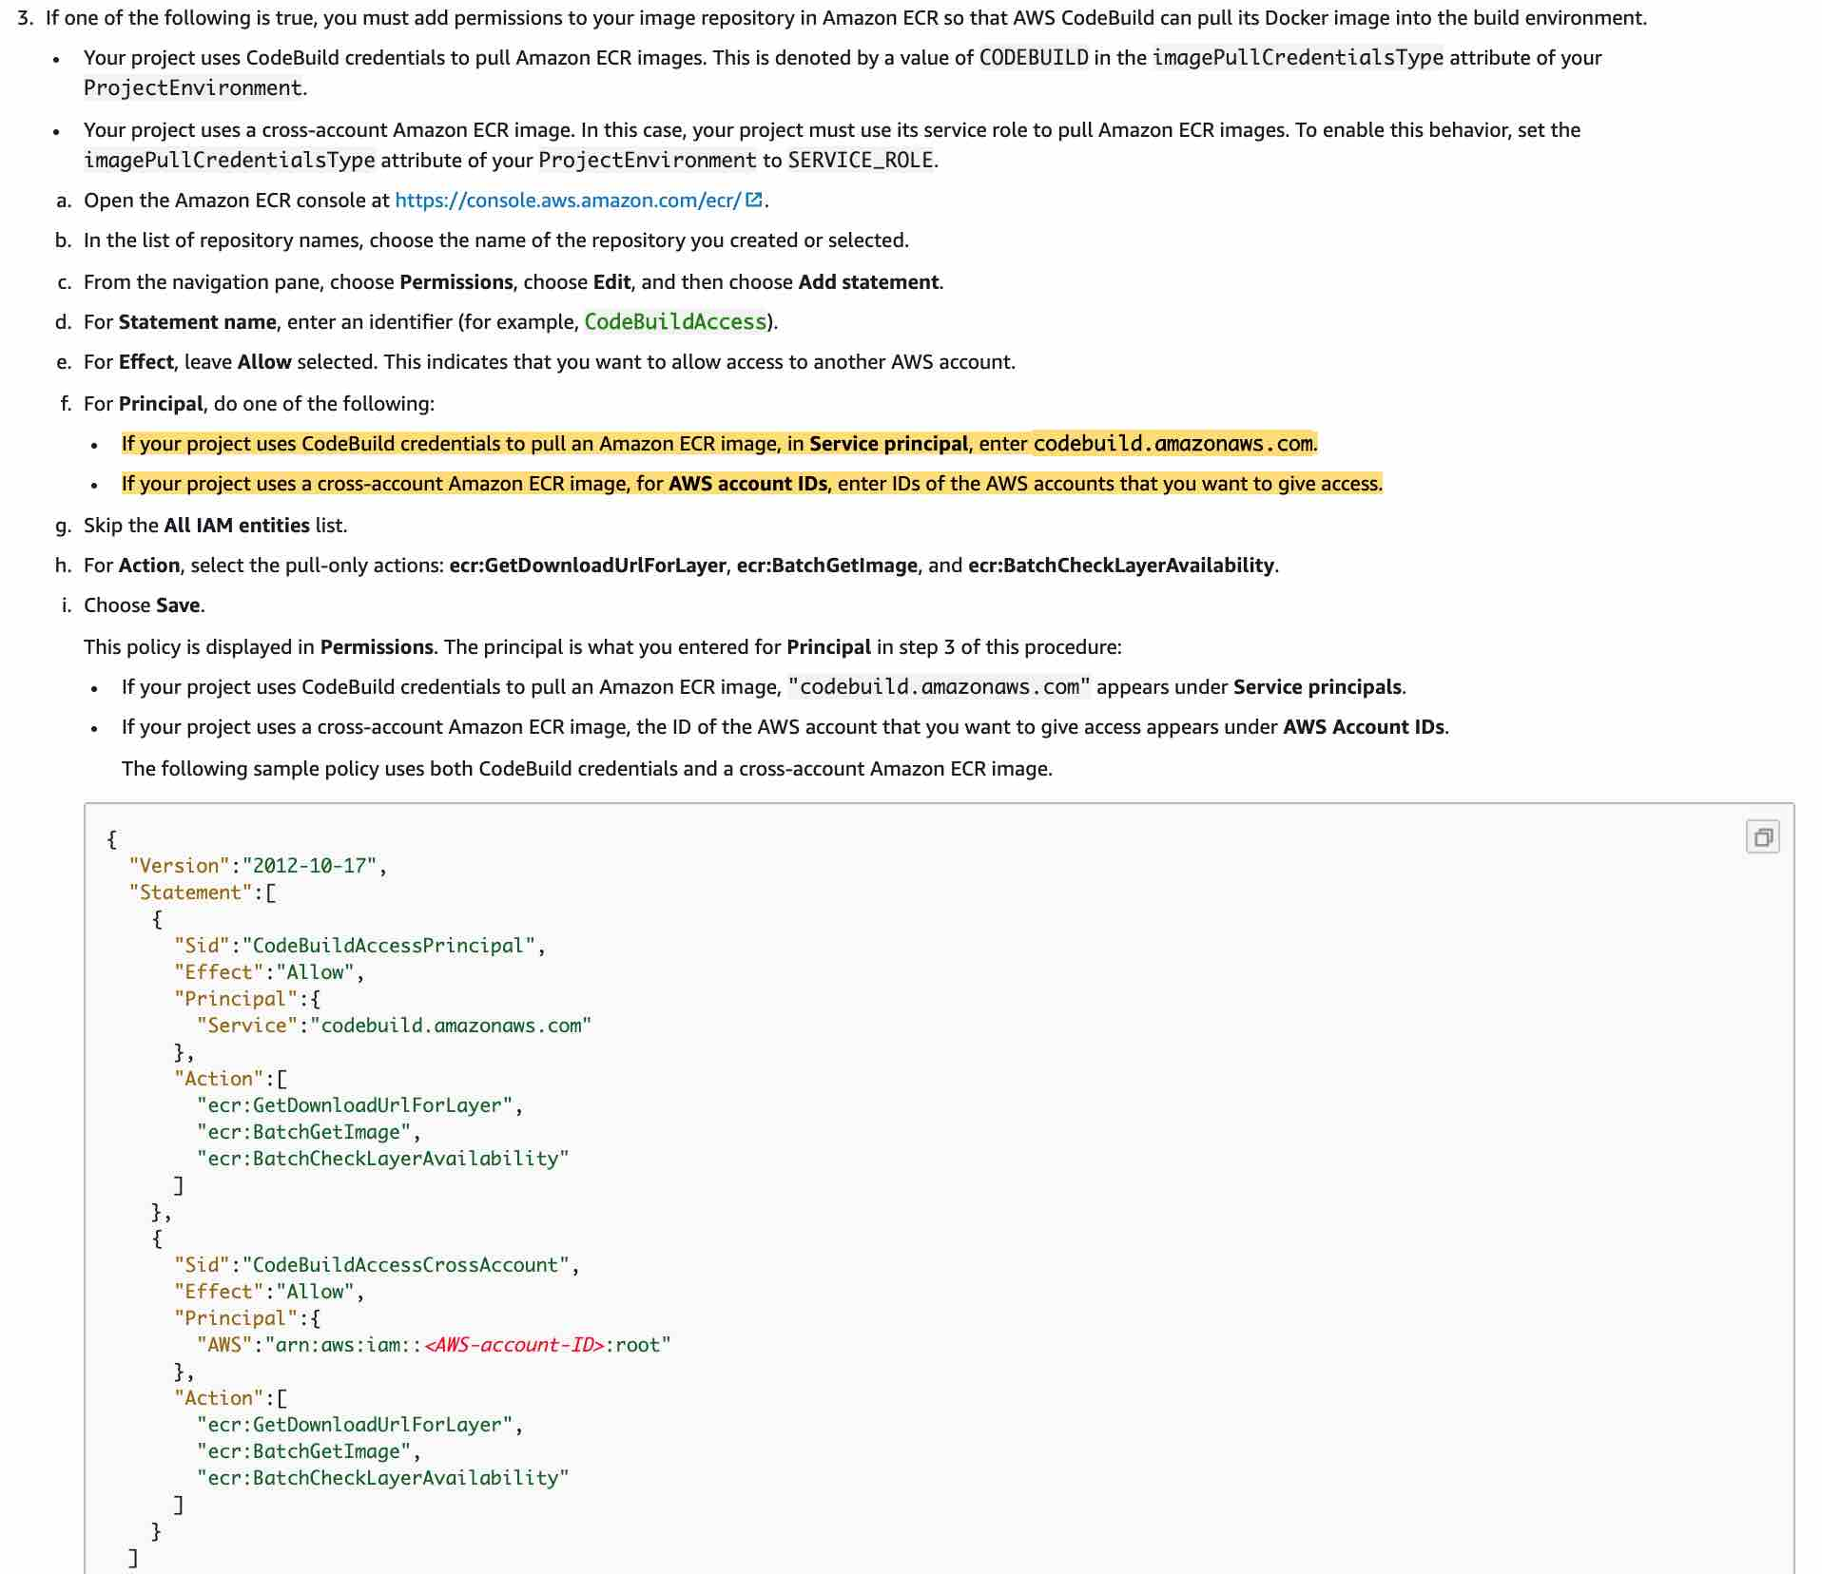 via - <https://docs.aws.amazon.com/codebuild/latest/userguide/sample-ecr.html>

Incorrect options:

**The Docker image is missing some tags** - Tags are optional for naming purposes

**CodeBuild cannot work with custom Docker images** - Custom docker images are supported, so this option is incorrect.

**The Docker image is too big** - It is good to properly design the image but in this case, it does not affect the CodeBuild. You can also look at multi-stage builds, which are a new feature requiring Docker 17.05 or higher on the daemon and client. Multistage builds are useful to anyone who has struggled to optimize Dockerfiles while keeping them easy to read and maintain.

Reference:

<https://docs.aws.amazon.com/codebuild/latest/userguide/sample-ecr.html>

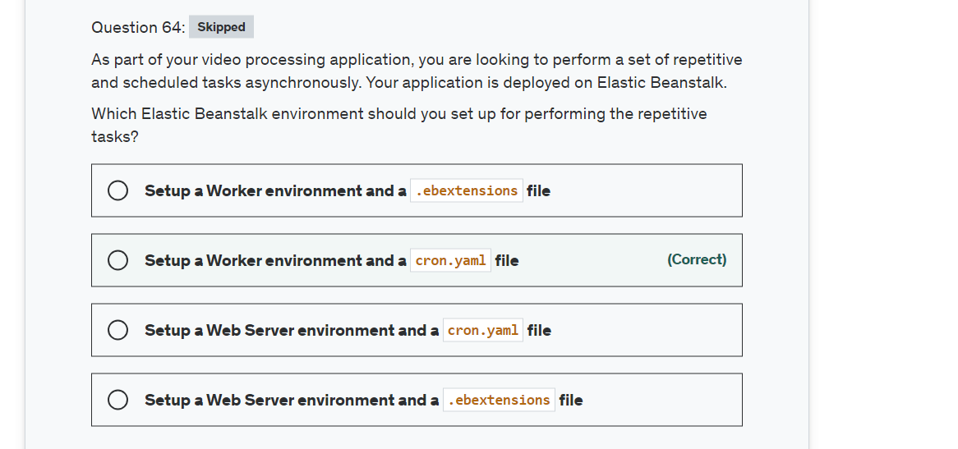

Explanation

Correct option:

With Elastic Beanstalk, you can quickly deploy and manage applications in the AWS Cloud without having to learn about the infrastructure that runs those applications. Elastic Beanstalk reduces management complexity without restricting choice or control. You simply upload your application, and Elastic Beanstalk automatically handles the details of capacity provisioning, load balancing, scaling, and application health monitoring.

Elastic BeanStalk Key Concepts: 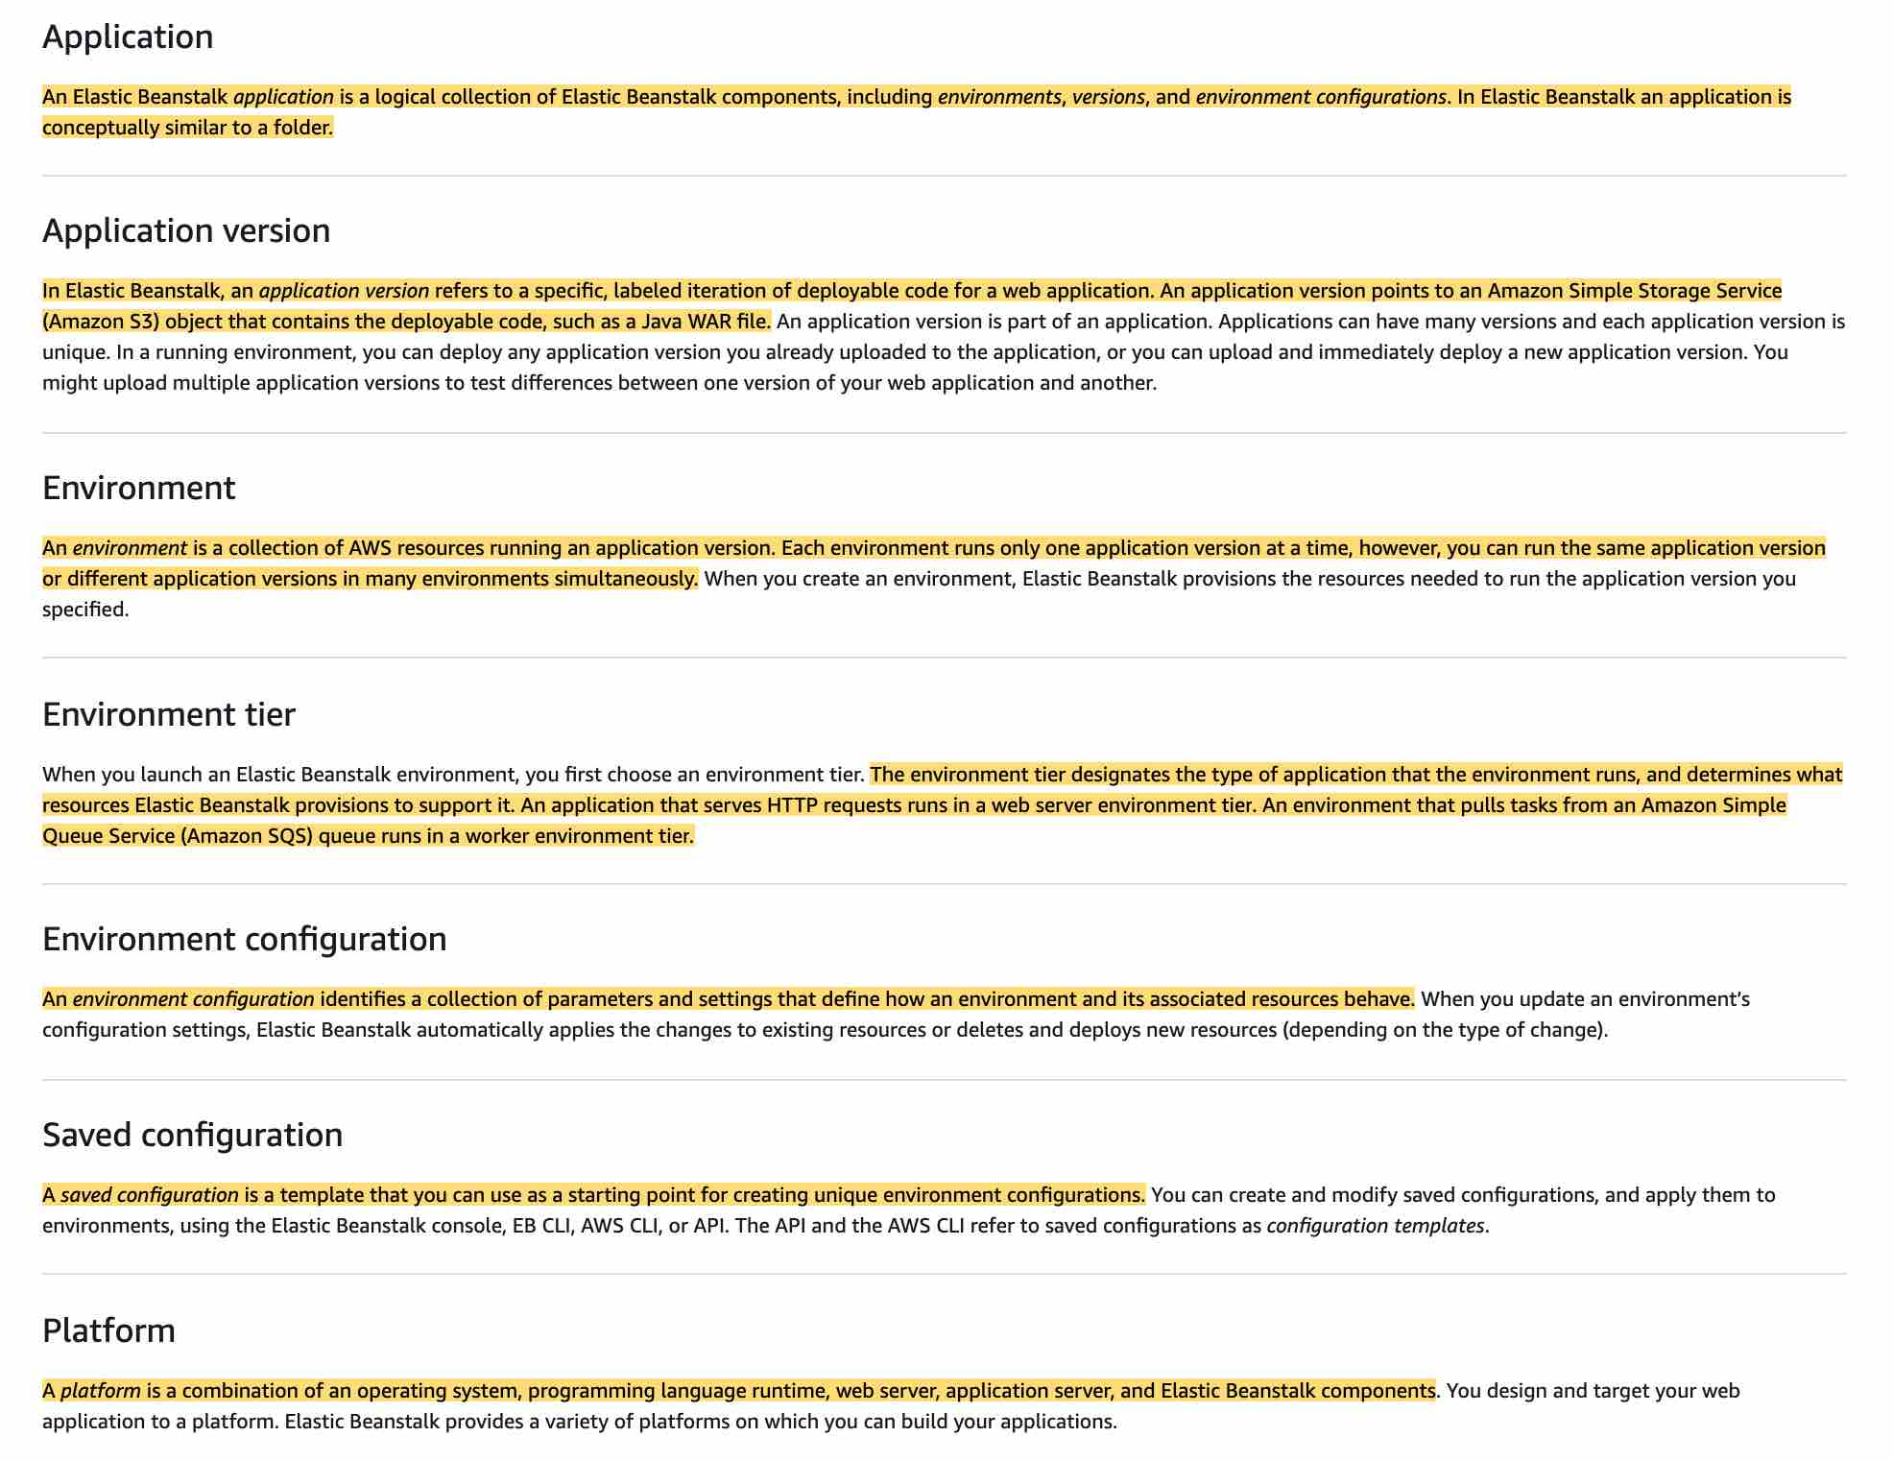 via - <https://docs.aws.amazon.com/elasticbeanstalk/latest/dg/concepts.html>

**Setup a Worker environment and a cron.yaml file**

An environment is a collection of AWS resources running an application version. An environment that pulls tasks from an Amazon Simple Queue Service (Amazon SQS) queue runs in a worker environment tier.

If your AWS Elastic Beanstalk application performs operations or workflows that take a long time to complete, you can offload those tasks to a dedicated worker environment. Decoupling your web application front end from a process that performs blocking operations is a common way to ensure that your application stays responsive under load.

For a worker environment, you need a cron.yaml file to define the cron jobs and do repetitive tasks.

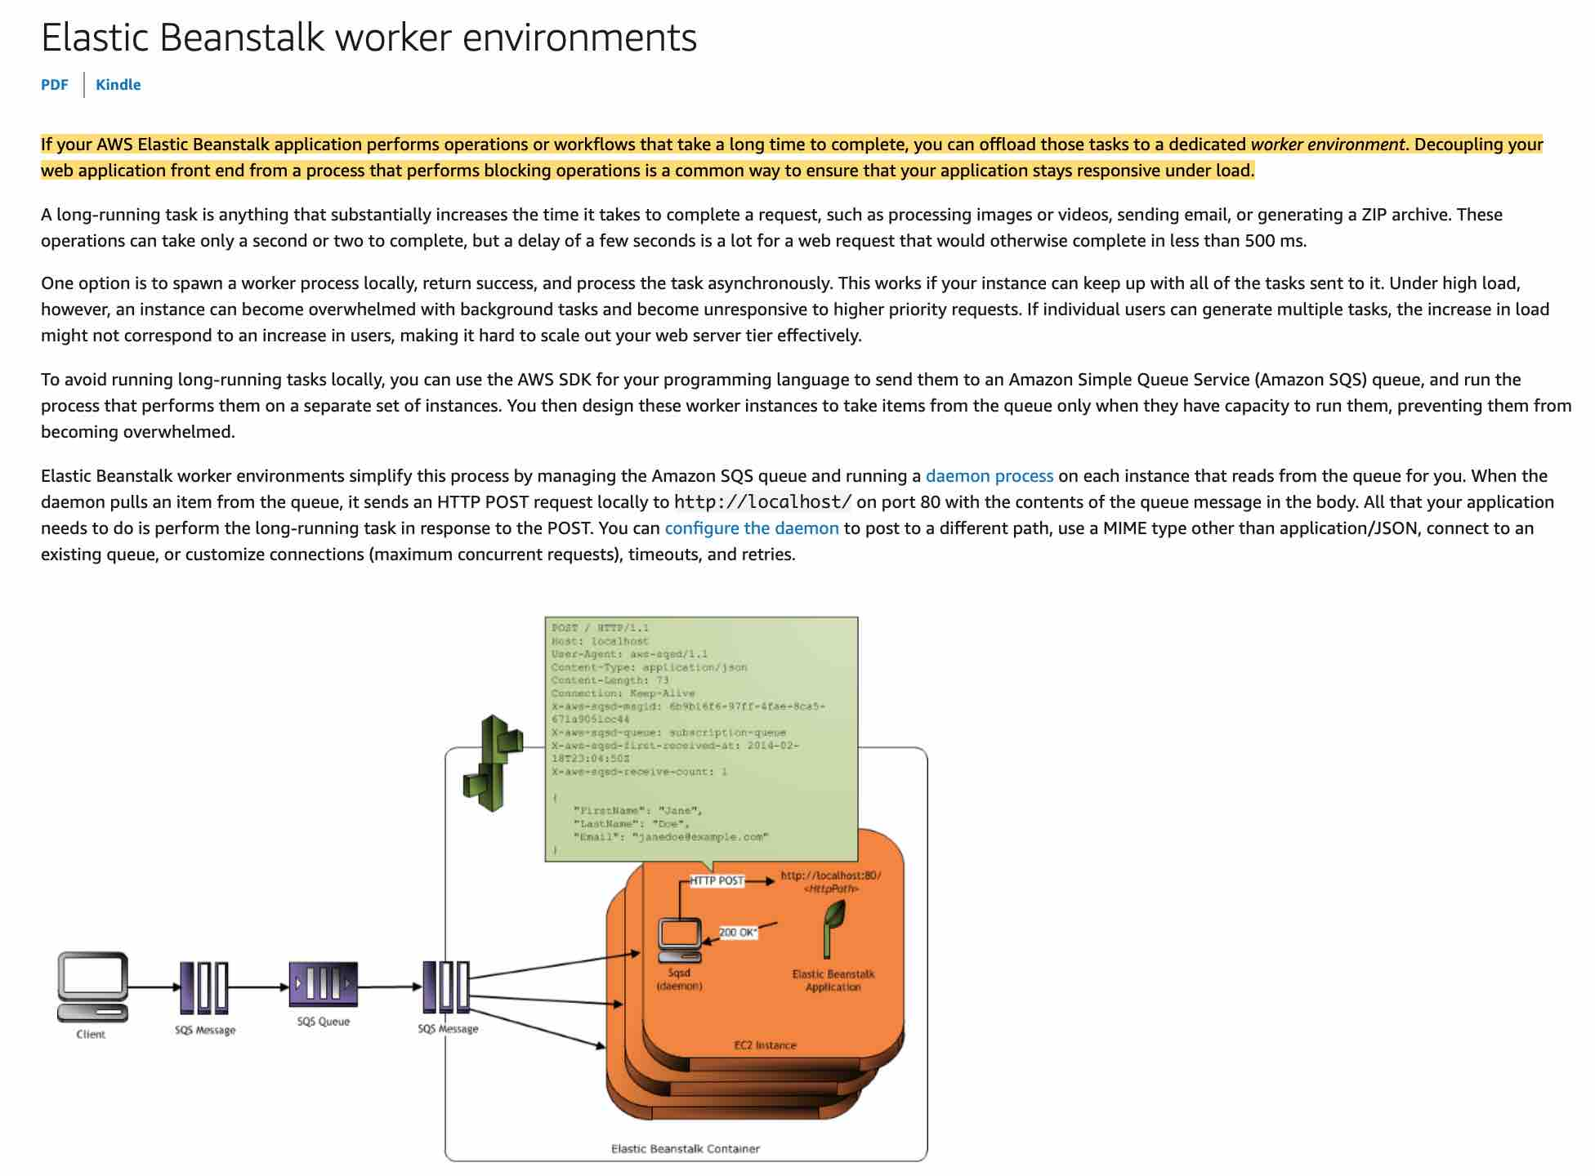 via - <https://docs.aws.amazon.com/elasticbeanstalk/latest/dg/using-features-managing-env-tiers.html>

Incorrect options:

**Setup a Web Server environment and a cron.yaml file**

**Setup a Worker environment and a .ebextensions file**

**Setup a Web Server environment and a .ebextensions file**

.ebextensions/ won't work to define cron jobs, and Web Server environments cannot be set up to perform repetitive and scheduled tasks. So these three options are incorrect.

References:

<https://docs.aws.amazon.com/elasticbeanstalk/latest/dg/concepts.html>

<https://docs.aws.amazon.com/elasticbeanstalk/latest/dg/using-features-managing-env-tiers.html>

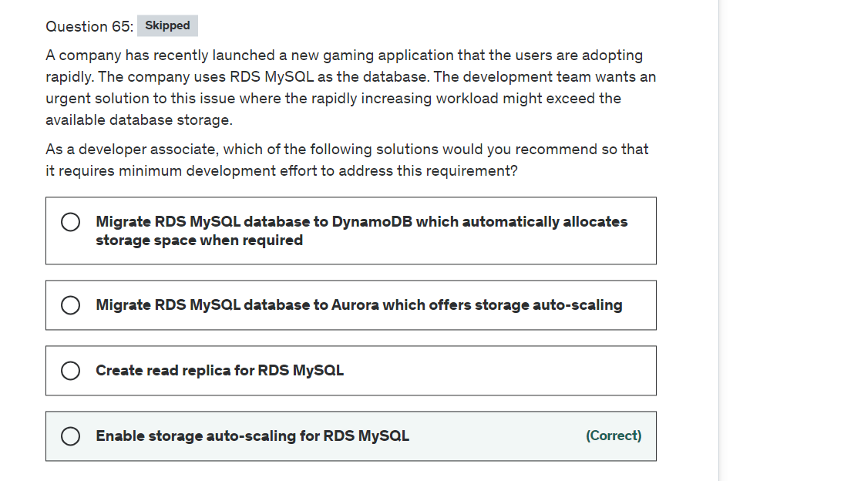

Explanation

Correct option:

**Enable storage auto-scaling for RDS MySQL**

If your workload is unpredictable, you can enable storage autoscaling for an Amazon RDS DB instance. With storage autoscaling enabled, when Amazon RDS detects that you are running out of free database space it automatically scales up your storage. Amazon RDS starts a storage modification for an autoscaling-enabled DB instance when these factors apply:

Free available space is less than 10 percent of the allocated storage.

The low-storage condition lasts at least five minutes.

At least six hours have passed since the last storage modification.

The maximum storage threshold is the limit that you set for autoscaling the DB instance. You can't set the maximum storage threshold for autoscaling-enabled instances to a value greater than the maximum allocated storage.

Incorrect options:

**Migrate RDS MySQL to Aurora which offers storage auto-scaling** - Although Aurora offers automatic storage scaling, this option is ruled out since it involves significant systems administration effort to migrate from RDS MySQL to Aurora. It is much easier to just enable storage auto-scaling for RDS MySQL.

**Migrate RDS MySQL database to DynamoDB which automatically allocates storage space when required** - This option is ruled out since DynamoDB is a NoSQL database which implies significant development effort to change the application logic to connect and query data from the underlying database. It is much easier to just enable storage auto-scaling for RDS MySQL.

**Create read replica for RDS MySQL** - Read replicas make it easy to take advantage of supported engines' built-in replication functionality to elastically scale out beyond the capacity constraints of a single DB instance for read-heavy database workloads. You can create multiple read replicas for a given source DB Instance and distribute your application’s read traffic amongst them. This option acts as a distractor as read replicas cannot help to automatically scale storage for the primary database.

Reference:

<https://docs.aws.amazon.com/AmazonRDS/latest/UserGuide/USER_PIOPS.StorageTypes.html>



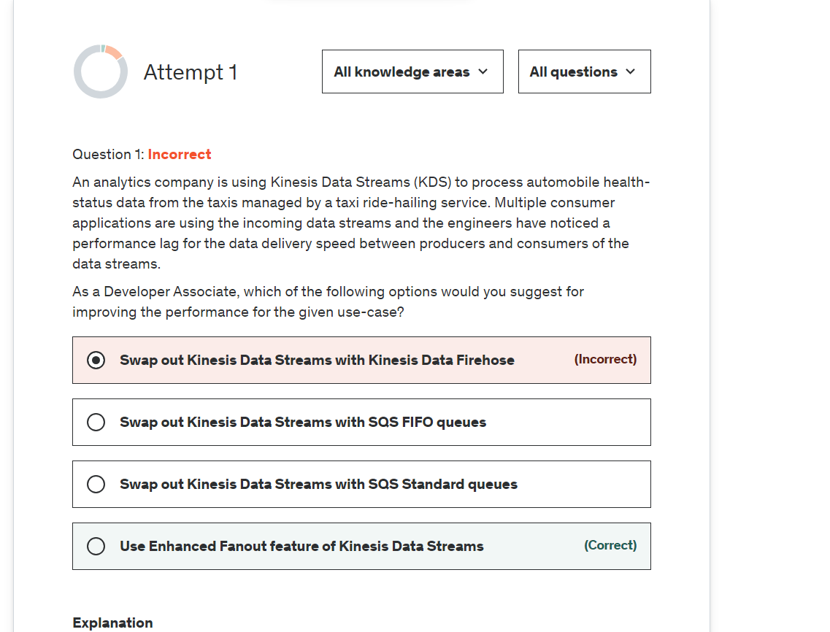

Explanation

Correct option:

**Use Enhanced Fanout feature of Kinesis Data Streams**

Amazon Kinesis Data Streams (KDS) is a massively scalable and durable real-time data streaming service. KDS can continuously capture gigabytes of data per second from hundreds of thousands of sources such as website clickstreams, database event streams, financial transactions, social media feeds, IT logs, and location-tracking events.

By default, the 2MB/second/shard output is shared between all of the applications consuming data from the stream. You should use enhanced fan-out if you have multiple consumers retrieving data from a stream in parallel. With enhanced fan-out developers can register stream consumers to use enhanced fan-out and receive their own 2MB/second pipe of read throughput per shard, and this throughput automatically scales with the number of shards in a stream.

Kinesis Data Streams Fanout 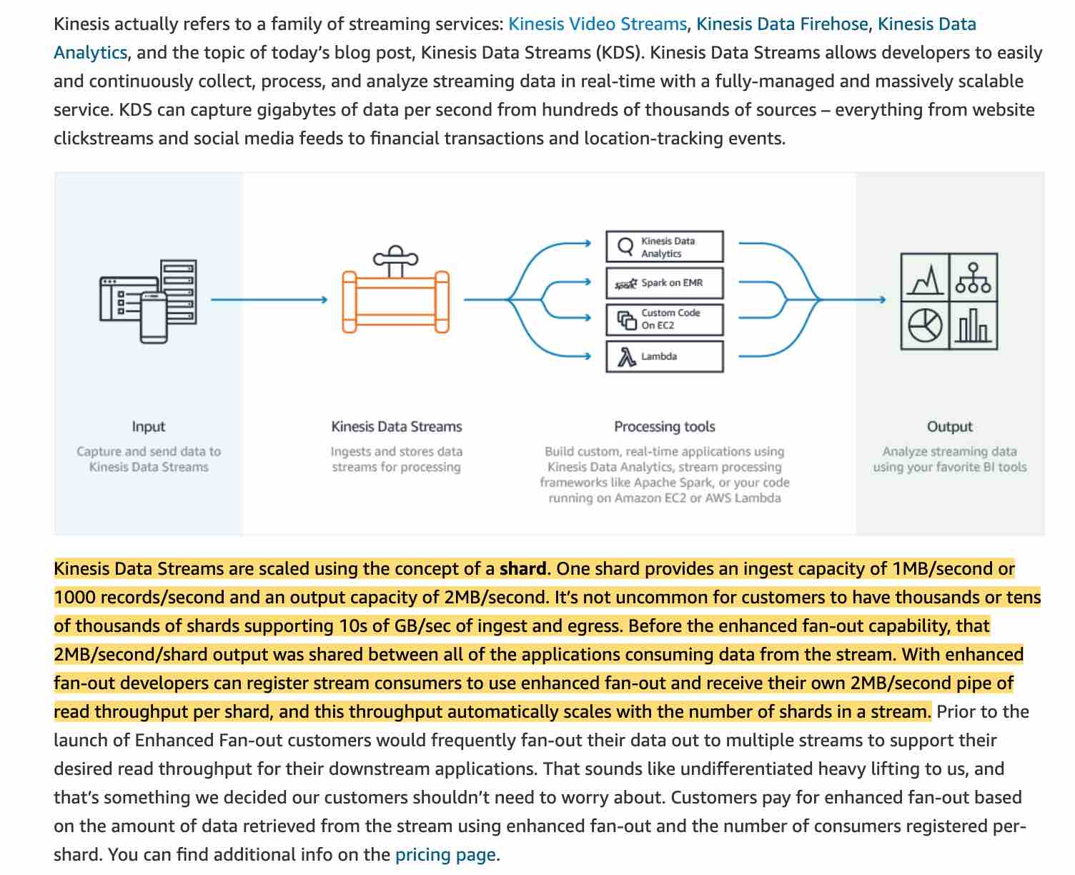 via - <https://aws.amazon.com/blogs/aws/kds-enhanced-fanout/>

Incorrect options:

**Swap out Kinesis Data Streams with Kinesis Data Firehose** - Amazon Kinesis Data Firehose is the easiest way to reliably load streaming data into data lakes, data stores, and analytics tools. It is a fully managed service that automatically scales to match the throughput of your data and requires no ongoing administration. It can also batch, compress, transform, and encrypt the data before loading it, minimizing the amount of storage used at the destination and increasing security. Kinesis Data Firehose can only write to S3, Redshift, Elasticsearch or Splunk. You can't have applications consuming data streams from Kinesis Data Firehose, that's the job of Kinesis Data Streams. Therefore this option is not correct.

**Swap out Kinesis Data Streams with SQS Standard queues**

**Swap out Kinesis Data Streams with SQS FIFO queues**

Amazon Simple Queue Service (SQS) is a fully managed message queuing service that enables you to decouple and scale microservices, distributed systems, and serverless applications. SQS offers two types of message queues. Standard queues offer maximum throughput, best-effort ordering, and at-least-once delivery. SQS FIFO queues are designed to guarantee that messages are processed exactly once, in the exact order that they are sent. As multiple applications are consuming the same stream concurrently, both SQS Standard and SQS FIFO are not the right fit for the given use-case.

Exam Alert:

Please understand the differences between the capabilities of Kinesis Data Streams vs SQS, as you may be asked scenario-based questions on this topic in the exam.

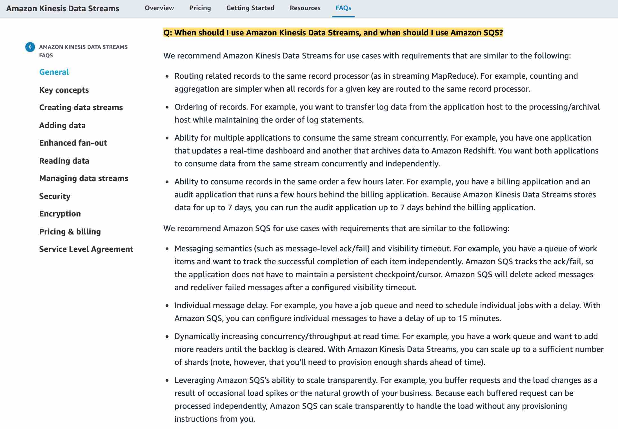 via - <https://aws.amazon.com/kinesis/data-streams/faqs/>

References:

<https://aws.amazon.com/blogs/aws/kds-enhanced-fanout/>

<https://aws.amazon.com/kinesis/data-streams/faqs/>

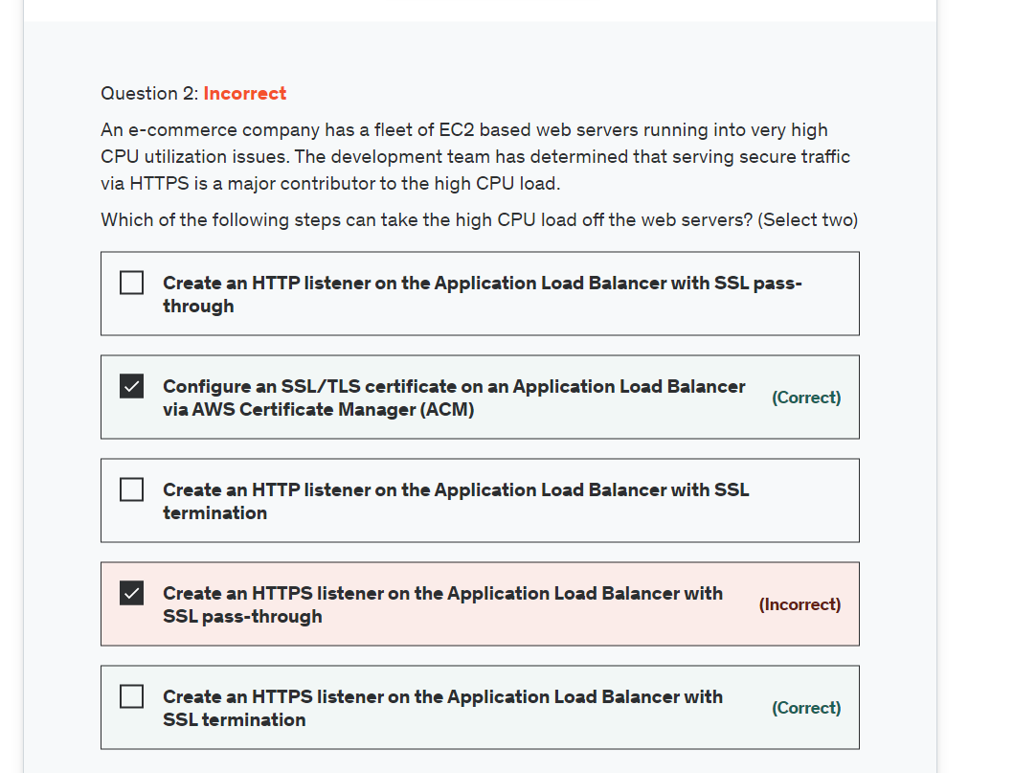

Explanation

Correct option:

"Configure an SSL/TLS certificate on an Application Load Balancer via AWS Certificate Manager (ACM)"

"Create an HTTPS listener on the Application Load Balancer with SSL termination"

An Application load balancer distributes incoming application traffic across multiple targets, such as EC2 instances, in multiple Availability Zones. A listener checks for connection requests from clients, using the protocol and port that you configure. The rules that you define for a listener determine how the load balancer routes requests to its registered targets. Each rule consists of a priority, one or more actions, and one or more conditions.

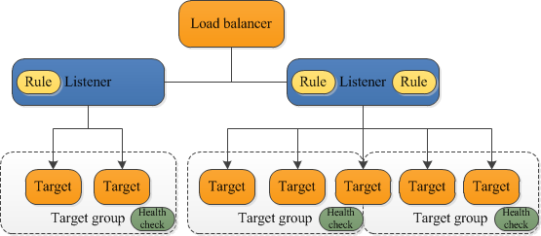 via - <https://docs.aws.amazon.com/elasticloadbalancing/latest/application/introduction.html>

To use an HTTPS listener, you must deploy at least one SSL/TLS server certificate on your load balancer. You can create an HTTPS listener, which uses encrypted connections (also known as SSL offload). This feature enables traffic encryption between your load balancer and the clients that initiate SSL or TLS sessions. As the EC2 instances are under heavy CPU load, the load balancer will use the server certificate to terminate the front-end connection and then decrypt requests from clients before sending them to the EC2 instances.

Please review this resource to understand how to associate an ACM SSL/TLS certificate with an Application Load Balancer: <https://aws.amazon.com/premiumsupport/knowledge-center/associate-acm-certificate-alb-nlb/>

Incorrect options:

"Create an HTTPS listener on the Application Load Balancer with SSL pass-through" - If you use an HTTPS listener with SSL pass-through, then the EC2 instances would continue to be under heavy CPU load as they would still need to decrypt the secure traffic at the instance level. Hence this option is incorrect.

"Create an HTTP listener on the Application Load Balancer with SSL termination"

"Create an HTTP listener on the Application Load Balancer with SSL pass-through"

You cannot have an HTTP listener for an Application Load Balancer to support SSL termination or SSL pass-through, so both these options are incorrect.

References:

<https://docs.aws.amazon.com/elasticloadbalancing/latest/application/introduction.html>

<https://aws.amazon.com/premiumsupport/knowledge-center/associate-acm-certificate-alb-nlb/>

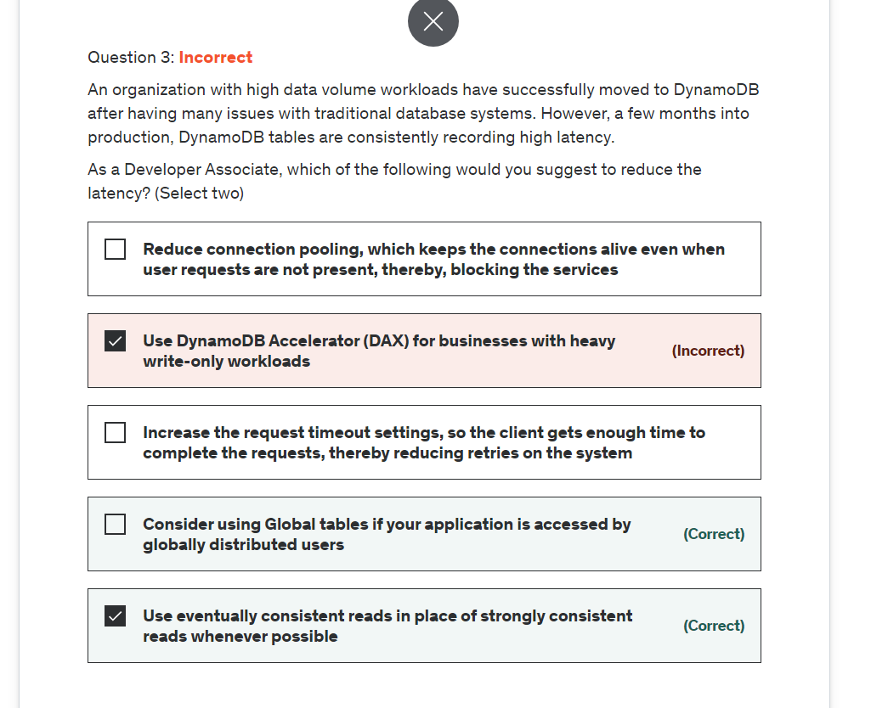

Explanation

Correct option:

Amazon DynamoDB is a key-value and document database that delivers single-digit millisecond performance at any scale. It's a fully managed, multi-Region, multi-master, durable database with built-in security, backup, and restore and in-memory caching for internet-scale applications.

**Consider using Global tables if your application is accessed by globally distributed users** - If you have globally dispersed users, consider using global tables. With global tables, you can specify the AWS Regions where you want the table to be available. This can significantly reduce latency for your users. So, reducing the distance between the client and the DynamoDB endpoint is an important performance fix to be considered.

**Use eventually consistent reads in place of strongly consistent reads whenever possible** - If your application doesn't require strongly consistent reads, consider using eventually consistent reads. Eventually consistent reads are cheaper and are less likely to experience high latency.

Incorrect options:

**Increase the request timeout settings, so the client gets enough time to complete the requests, thereby reducing retries on the system** - This statement is incorrect. The right way is to reduce the request timeout settings. This causes the client to abandon high latency requests after the specified time period and then send a second request that usually completes much faster than the first.

**Reduce connection pooling, which keeps the connections alive even when user requests are not present, thereby, blocking the services** - This is not correct. When you're not making requests, consider having the client send dummy traffic to a DynamoDB table. Alternatively, you can reuse client connections or use connection pooling. All of these techniques keep internal caches warm, which helps keep latency low.

**Use DynamoDB Accelerator (DAX) for businesses with heavy write-only workloads** - This is not correct. If your traffic is read-heavy, consider using a caching service such as DynamoDB Accelerator (DAX). DAX is a fully managed, highly available, in-memory cache for DynamoDB that delivers up to a 10x performance improvement—from milliseconds to microseconds—even at millions of requests per second.

References:

<https://aws.amazon.com/premiumsupport/knowledge-center/dynamodb-high-latency/>

<https://aws.amazon.com/dynamodb/>

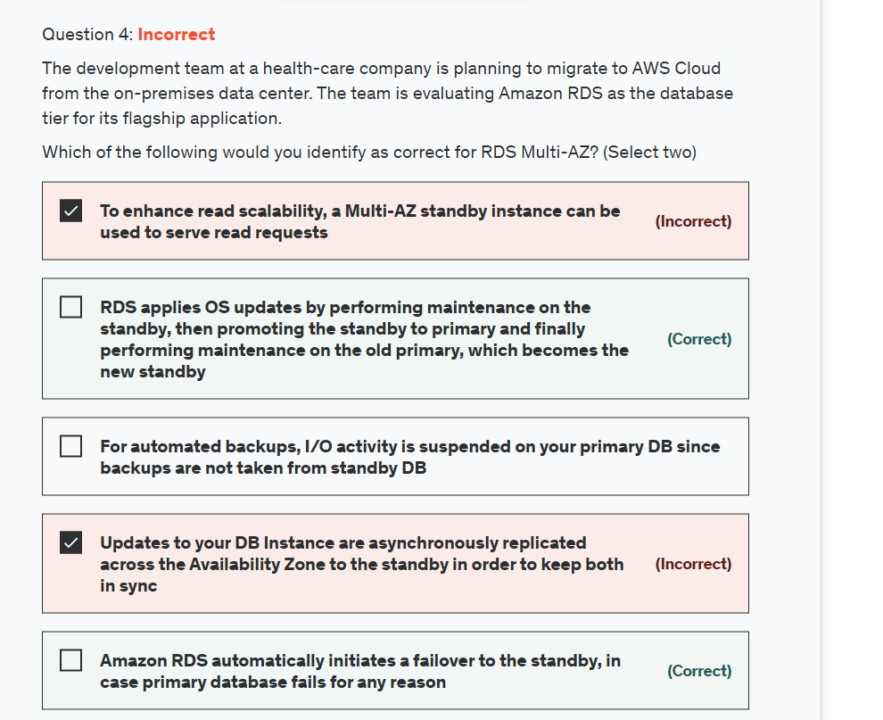

Explanation

Correct options:

**RDS applies OS updates by performing maintenance on the standby, then promoting the standby to primary, and finally performing maintenance on the old primary, which becomes the new standby**

Running a DB instance as a Multi-AZ deployment can further reduce the impact of a maintenance event because Amazon RDS applies operating system updates by following these steps:

Perform maintenance on the standby.

Promote the standby to primary.

Perform maintenance on the old primary, which becomes the new standby.

When you modify the database engine for your DB instance in a Multi-AZ deployment, then Amazon RDS upgrades both the primary and secondary DB instances at the same time. In this case, the database engine for the entire Multi-AZ deployment is shut down during the upgrade.

**Amazon RDS automatically initiates a failover to the standby, in case the primary database fails for any reason** - You also benefit from enhanced database availability when running your DB instance as a Multi-AZ deployment. If an Availability Zone failure or DB instance failure occurs, your availability impact is limited to the time automatic failover takes to complete.

Another implied benefit of running your DB instance as a Multi-AZ deployment is that DB instance failover is automatic and requires no administration. In an Amazon RDS context, this means you are not required to monitor DB instance events and initiate manual DB instance recovery in the event of an Availability Zone failure or DB instance failure.

Incorrect options:

**For automated backups, I/O activity is suspended on your primary DB since backups are not taken from standby DB** - The availability benefits of Multi-AZ also extend to planned maintenance. For example, with automated backups, I/O activity is no longer suspended on your primary during your preferred backup window, since backups are taken from the standby.

**To enhance read scalability, a Multi-AZ standby instance can be used to serve read requests** - A Multi-AZ standby cannot serve read requests. Multi-AZ deployments are designed to provide enhanced database availability and durability, rather than read scaling benefits. As such, the feature uses synchronous replication between primary and standby. AWS implementation makes sure the primary and the standby are constantly in sync, but precludes using the standby for read or write operations.

**Updates to your DB Instance are asynchronously replicated across the Availability Zone to the standby in order to keep both in sync** - When you create your DB instance to run as a Multi-AZ deployment, Amazon RDS automatically provisions and maintains a synchronous “standby” replica in a different Availability Zone. Updates to your DB Instance are synchronously replicated across the Availability Zone to the standby in order to keep both in sync and protect your latest database updates against DB instance failure.

Reference:

<https://aws.amazon.com/rds/faqs/>

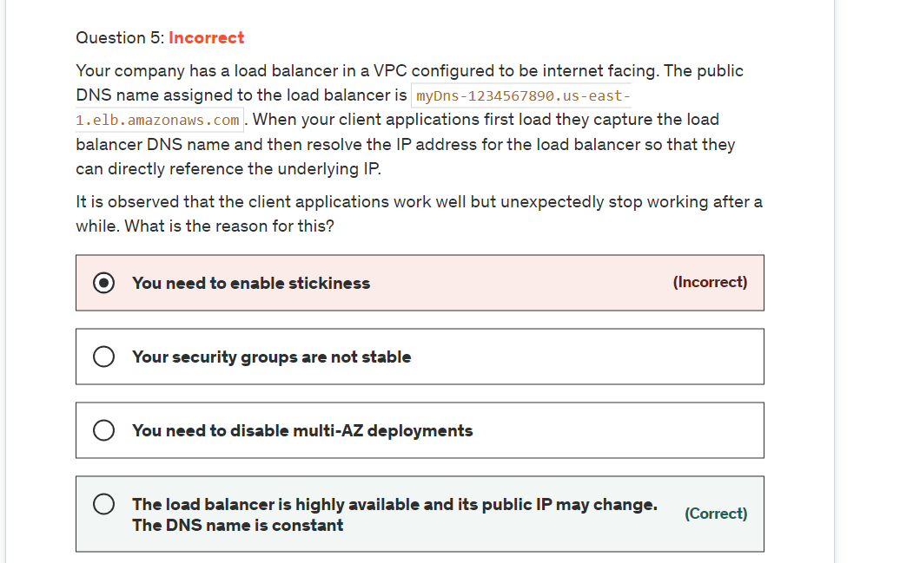

Explanation

Correct option:

**The load balancer is highly available and its public IP may change. The DNS name is constant**

When your load balancer is created, it receives a public DNS name that clients can use to send requests. The DNS servers resolve the DNS name of your load balancer to the public IP addresses of the load balancer nodes for your load balancer. Never resolve the IP of a load balancer as it can change with time. You should always use the DNS name.

Incorrect options:

**Your security groups are not stable** - You security groups to allow your load balancer to work with registered instances. It is stable if set correctly. If your application is working and stops after a while, the issue is not with the security groups.

**You need to enable stickiness** - This enables the load balancer to bind a user's session to a specific instance, so this has no impact on the issue described in the given use-case.

**You need to disable multi-AZ deployments** - This has been added as a distractor and this has no bearing on the use-case. The change is happening with the IP of the load balancer.

Reference:

<https://docs.aws.amazon.com/elasticloadbalancing/latest/classic/elb-internet-facing-load-balancers.html>

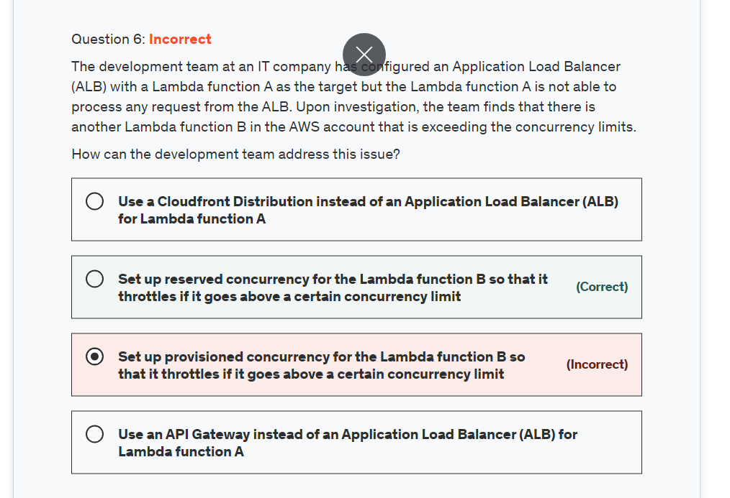

Explanation

Correct option:

**Set up reserved concurrency for the Lambda function B so that it throttles if it goes above a certain concurrency limit**

Concurrency is the number of requests that a Lambda function is serving at any given time. If a Lambda function is invoked again while a request is still being processed, another instance is allocated, which increases the function's concurrency.

To ensure that a function can always reach a certain level of concurrency, you can configure the function with reserved concurrency. When a function has reserved concurrency, no other function can use that concurrency. More importantly, reserved concurrency also limits the maximum concurrency for the function, and applies to the function as a whole, including versions and aliases.

Please review this note to understand how reserved concurrency works:

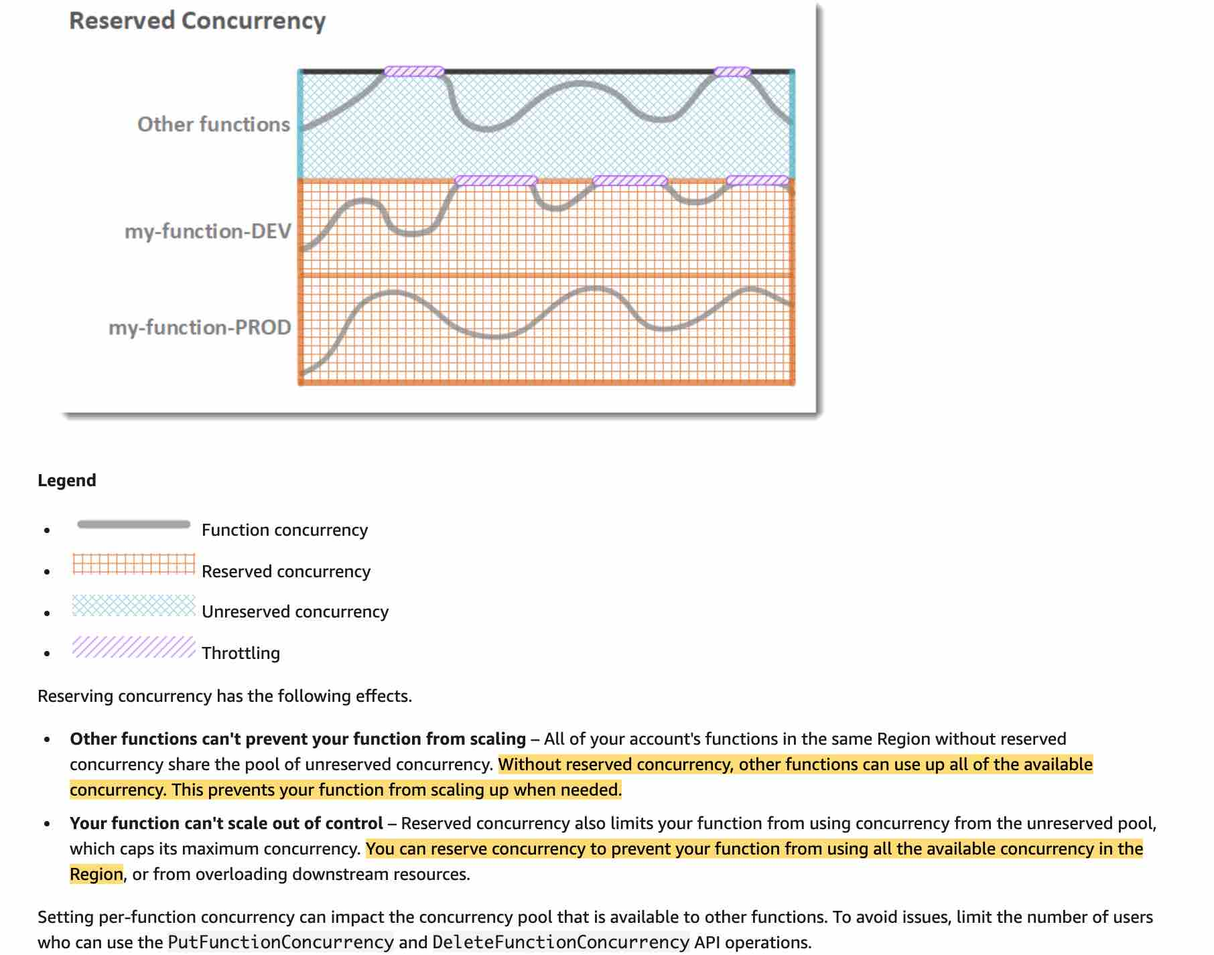 via - <https://docs.aws.amazon.com/lambda/latest/dg/configuration-concurrency.html#configuration-concurrency-reserved>

Therefore using reserved concurrency for Lambda function B would limit its maximum concurrency and allow Lambda function A to execute without getting throttled.

Incorrect options:

**Set up provisioned concurrency for the Lambda function B so that it throttles if it goes above a certain concurrency limit** - You should use provisioned concurrency to enable your function to scale without fluctuations in latency. By allocating provisioned concurrency before an increase in invocations, you can ensure that all requests are served by initialized instances with very low latency. Provisioned concurrency is not used to limit the maximum concurrency for a given Lambda function, so this option is incorrect.

**Use an API Gateway instead of an Application Load Balancer (ALB) for Lambda function A** - This has been added as a distractor as using an API Gateway for Lambda function A has no bearing on limiting the concurrency of Lambda function B, so this option is incorrect.

**Use a Cloudfront Distribution instead of an Application Load Balancer (ALB) for Lambda function A** - When you associate a CloudFront distribution with a Lambda function (known as Lambda@Edge), CloudFront intercepts requests and responses at CloudFront edge locations and runs the function. Again, this has no bearing on limiting the concurrency of Lambda function B, so this option is incorrect.

References:

<https://docs.aws.amazon.com/lambda/latest/dg/configuration-concurrency.html#configuration-concurrency-reserved>

<https://aws.amazon.com/blogs/networking-and-content-delivery/lambda-functions-as-targets-for-application-load-balancers/>

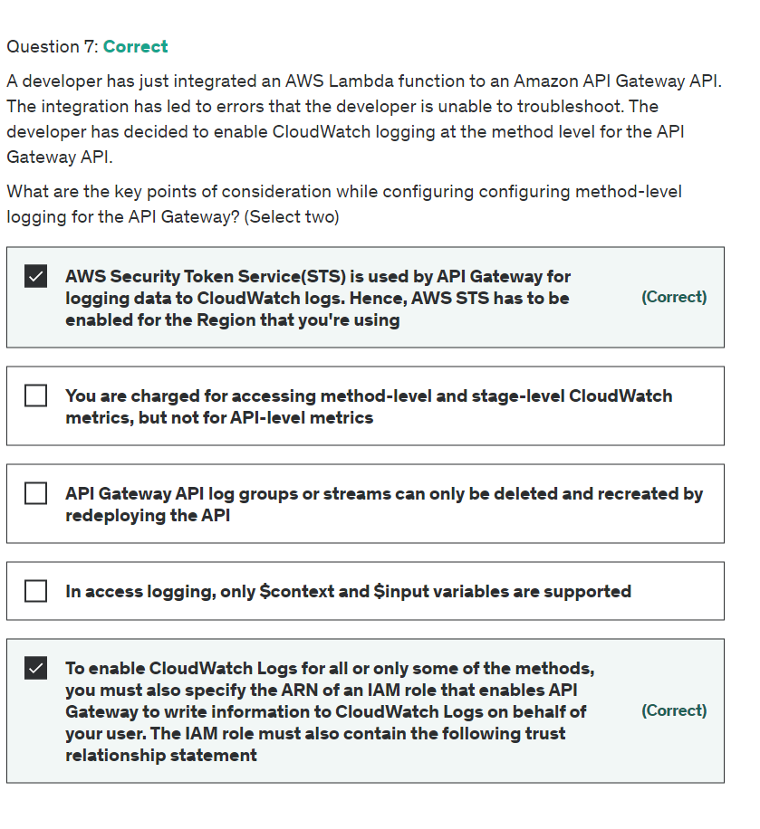

Explanation

Correct options:

**AWS Security Token Service(STS) is used by API Gateway for logging data to CloudWatch logs. Hence, AWS STS has to be enabled for the Region that you're using**

API Gateway calls AWS Security Token Service to assume the IAM role, so make sure that AWS STS is enabled for the Region. If you receive an error when setting the IAM role ARN, check your AWS Security Token Service account settings to make sure that AWS STS is enabled in the Region that you're using.

**To enable CloudWatch Logs for all or only some of the methods, you must also specify the ARN of an IAM role that enables API Gateway to write information to CloudWatch Logs on behalf of your user. The IAM role must also contain the following trust relationship statement**

To enable CloudWatch Logs for all or only some of the methods, you must also specify the ARN of an IAM role that enables API Gateway to write information to CloudWatch Logs on behalf of your user. To do so, choose Settings from the APIs main navigation pane. Then enter the ARN of an IAM role in the CloudWatch log role ARN text field. The IAM role must also contain the trust relationship statement.

Policy of AmazonAPIGatewayPushToCloudWatchLogs for IAM role: 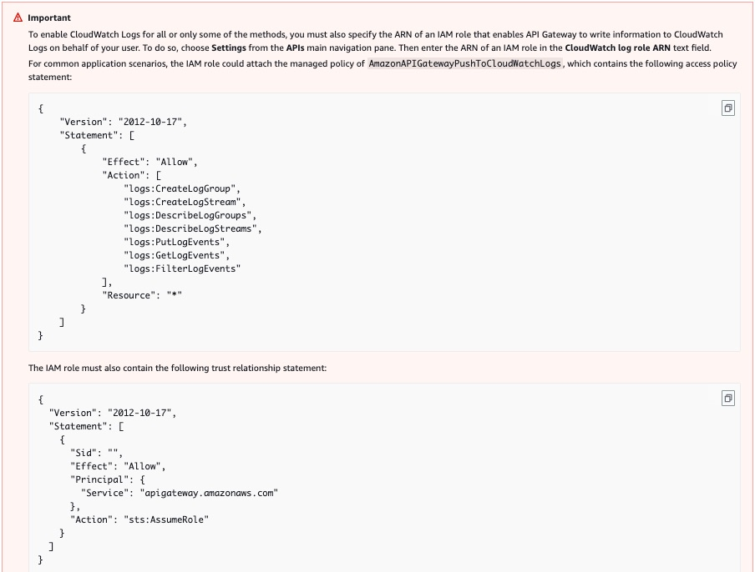 via - <https://docs.aws.amazon.com/apigateway/latest/developerguide/stages.html#how-to-stage-settings-console>

Incorrect options:

**In access logging, only $context and $input variables are supported** - This statement is incorrect. In access logging, you, as an API developer, want to log who has accessed your API and how the caller accessed the API. You can create your own log group or choose an existing log group that could be managed by API Gateway. To specify the access details, you select $context variables and choose a log group as the destination. Only $context variables are supported (not $input, and so on).

**You are charged for accessing method-level and stage-level CloudWatch metrics, but not for API-level metrics** - This statement is incorrect. Your account is charged for accessing method-level CloudWatch metrics, but not the API-level or stage-level metrics.

**API Gateway API log groups or streams can only be deleted and recreated by redeploying the API** - API Gateway API log groups or streams can be deleted from the CloudWatch console. But, it is not recommended.

Do not manually delete API Gateway API log groups or streams; let API Gateway manage these resources. Manually deleting log groups or streams may cause API requests and responses not to be logged. If that happens, you can delete the entire log group for the API and redeploy the API. This is because API Gateway creates log groups or log streams for an API stage at the time when it is deployed.

References:

<https://docs.aws.amazon.com/apigateway/latest/developerguide/stages.html#how-to-stage-settings-console>

<https://docs.aws.amazon.com/apigateway/latest/developerguide/set-up-logging.html#apigateway-cloudwatch-log-formats>

<https://docs.aws.amazon.com/apigateway/latest/developerguide/view-cloudwatch-log-events-in-cloudwatch-console.html>

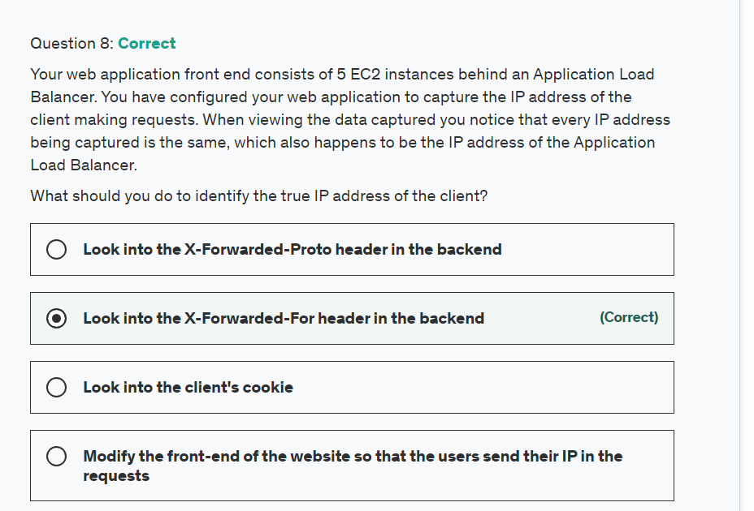

Explanation

Correct option:

**Look into the X-Forwarded-For header in the backend**

The X-Forwarded-For request header helps you identify the IP address of a client when you use an HTTP or HTTPS load balancer. Because load balancers intercept traffic between clients and servers, your server access logs contain only the IP address of the load balancer. To see the IP address of the client, use the X-Forwarded-For request header. Elastic Load Balancing stores the IP address of the client in the X-Forwarded-For request header and passes the header to your server.

Incorrect options:

**Modify the front-end of the website so that the users send their IP in the requests** - When a user makes a request the IP address is sent with the request to the server and the load balancer intercepts it. There is no need to modify the application.

**Look into the X-Forwarded-Proto header in the backend** - The X-Forwarded-Proto request header helps you identify the protocol (HTTP or HTTPS) that a client used to connect to your load balancer.

**Look into the client's cookie** - For this, we would need to modify the client-side logic and server-side logic, which would not be efficient.

Reference:

<https://docs.aws.amazon.com/elasticloadbalancing/latest/classic/x-forwarded-headers.html>

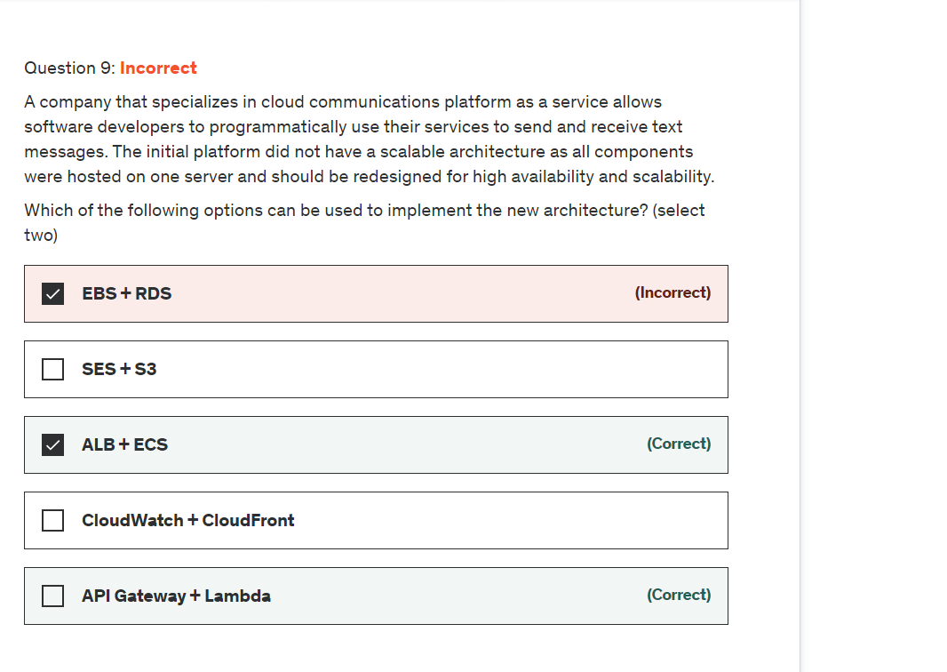

Explanation

Correct options:

**ALB + ECS**

Amazon Elastic Container Service (ECS) is a highly scalable, high-performance container management service that supports Docker containers and allows you to easily run applications on a managed cluster of Amazon EC2 instances.

How ECS Works: 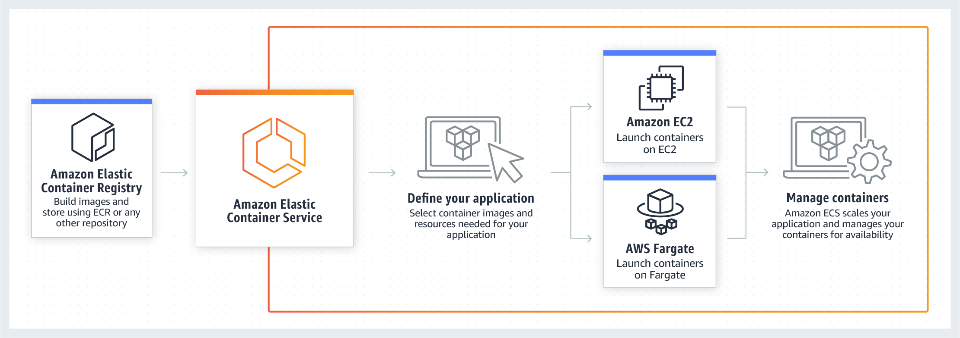 via - <https://aws.amazon.com/ecs/>

Elastic Load Balancing automatically distributes incoming application traffic across multiple targets, such as Amazon EC2 instances, containers, IP addresses, and Lambda functions. It can handle the varying load of your application traffic in a single Availability Zone or across multiple Availability Zones.

When you use ECS with a load balancer such as ALB deployed across multiple Availability Zones, it helps provide a scalable and highly available REST API.

**API Gateway + Lambda**

Amazon API Gateway is a fully managed service that makes it easy for developers to publish, maintain, monitor, and secure APIs at any scale. Using API Gateway, you can create an API that acts as a “front door” for applications to access data, business logic, or functionality from your back-end services, such as EC2 or Lambda functions.

How API Gateway Works:  via - <https://aws.amazon.com/api-gateway/>

AWS Lambda lets you run code without provisioning or managing servers. You pay only for the compute time you consume.

How Lambda function works:  via - <https://aws.amazon.com/lambda/>

API Gateway and Lambda help achieve the same purpose integrating some capabilities such as authentication in a serverless fashion, with fully scalable and highly available architectures.

Incorrect options:

**SES + S3** - The combination of these services only provide email and object storage services.

**CloudWatch + CloudFront** - The combination of these services only provide monitoring and fast content delivery network (CDN) services.

**EBS + RDS** - The combination of these services only provide elastic block storage and database services.

References:

<https://aws.amazon.com/getting-started/projects/build-serverless-web-app-lambda-apigateway-s3-dynamodb-cognito/module-4/>

<https://aws.amazon.com/blogs/compute/microservice-delivery-with-amazon-ecs-and-application-load-balancers/>

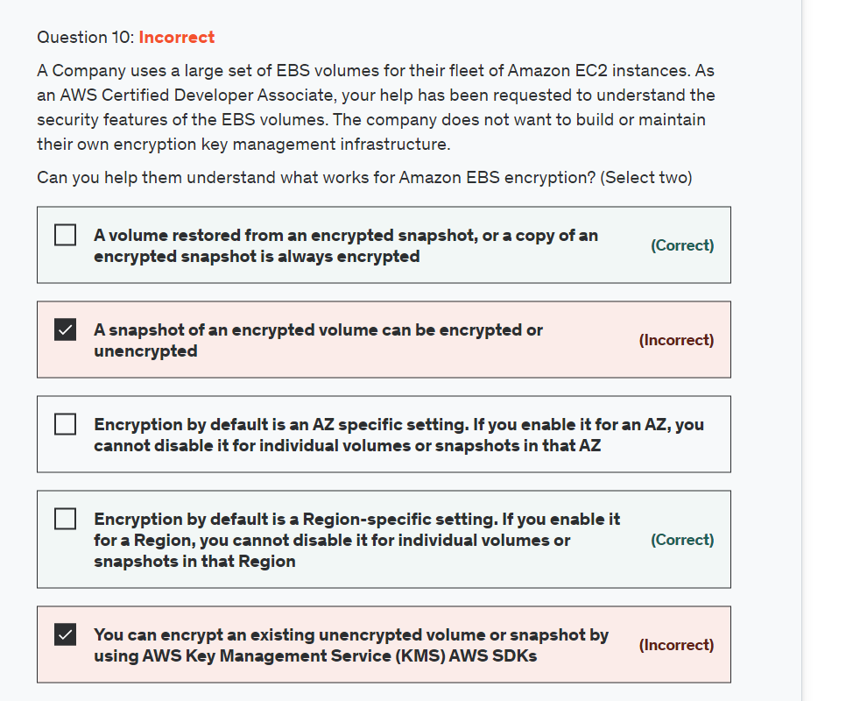

Explanation

Correct option:

**Encryption by default is a Region-specific setting. If you enable it for a Region, you cannot disable it for individual volumes or snapshots in that Region** - You can configure your AWS account to enforce the encryption of the new EBS volumes and snapshot copies that you create. Encryption by default is a Region-specific setting. If you enable it for a Region, you cannot disable it for individual volumes or snapshots in that Region.

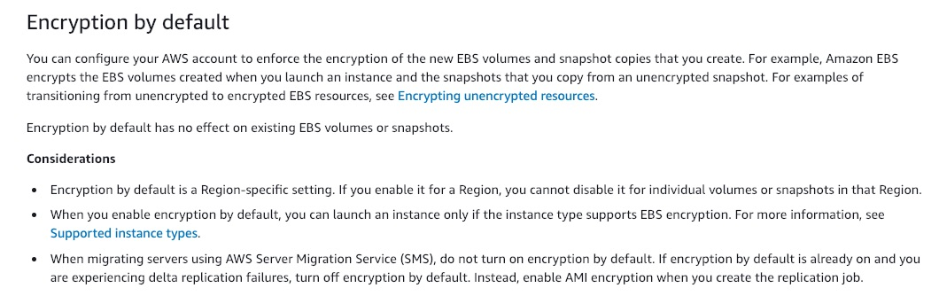 via - <https://docs.aws.amazon.com/AWSEC2/latest/UserGuide/EBSEncryption.html>

**A volume restored from an encrypted snapshot, or a copy of an encrypted snapshot, is always encrypted** - By default, the CMK that you selected when creating a volume encrypts the snapshots that you make from the volume and the volumes that you restore from those encrypted snapshots. You cannot remove encryption from an encrypted volume or snapshot, which means that a volume restored from an encrypted snapshot, or a copy of an encrypted snapshot is always encrypted.

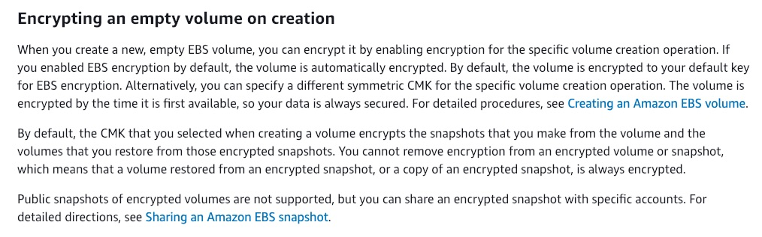 via - <https://docs.aws.amazon.com/AWSEC2/latest/UserGuide/EBSEncryption.html>

Incorrect options:

**You can encrypt an existing unencrypted volume or snapshot by using AWS Key Management Service (KMS) AWS SDKs** - This is an incorrect statement. There is no direct way to encrypt an existing unencrypted volume or snapshot. You can encrypt an unencrypted snapshot by copying and enabling encryption while copying the snapshot. To encrypt an EBS volume, you need to create a snapshot and then encrypt the snapshot as described earlier. From this new encrypted snapshot, you can then create an encrypted volume.

**A snapshot of an encrypted volume can be encrypted or unencrypted** - This is an incorrect statement. You cannot remove encryption from an encrypted volume or snapshot, which means that a volume restored from an encrypted snapshot, or a copy of an encrypted snapshot is always encrypted.

**Encryption by default is an AZ specific setting. If you enable it for an AZ, you cannot disable it for individual volumes or snapshots in that AZ** - This is an incorrect statement. Encryption by default is a Region-specific setting. If you enable it for a Region, you cannot disable it for individual volumes or snapshots in that Region.

References:

<https://docs.aws.amazon.com/AWSEC2/latest/UserGuide/EBSEncryption.html>

<https://docs.aws.amazon.com/AWSEC2/latest/UserGuide/EBSEncryption.html#encrypt-unencrypted>

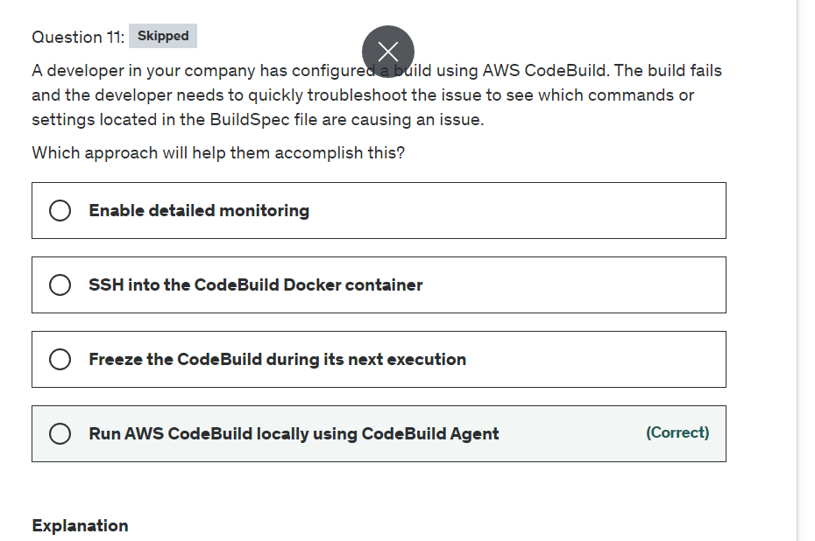

Explanation

Correct option:

**Run AWS CodeBuild locally using CodeBuild Agent**

AWS CodeBuild is a fully managed build service. There are no servers to provision and scale, or software to install, configure, and operate.

With the Local Build support for AWS CodeBuild, you just specify the location of your source code, choose your build settings, and CodeBuild runs build scripts for compiling, testing, and packaging your code. You can use the AWS CodeBuild agent to test and debug builds on a local machine.

By building an application on a local machine you can:

Test the integrity and contents of a buildspec file locally.

Test and build an application locally before committing.

Identify and fix errors quickly from your local development environment.

Incorrect options:

**SSH into the CodeBuild Docker container** - It is not possible to SSH into the CodeBuild Docker container, that's why you should test and fix errors locally.

**Freeze the CodeBuild during its next execution** - You cannot freeze the CodeBuild process but you can stop it. Please see more details on - <https://docs.aws.amazon.com/codebuild/latest/userguide/stop-build.html>

**Enable detailed monitoring** - Detailed monitoring is available for EC2 instances. You do not enable detailed monitoring but you can specify output logs to be captured via CloudTrail.

AWS CodeBuild is integrated with AWS CloudTrail, a service that provides a record of actions taken by a user, role, or an AWS service in CodeBuild. CloudTrail captures all API calls for CodeBuild as events, including calls from the CodeBuild console and from code calls to the CodeBuild APIs. If you create a trail, you can enable continuous delivery of CloudTrail events to an S3 bucket, including events for CodeBuild.

References:

<https://docs.aws.amazon.com/codebuild/latest/userguide/troubleshooting.html>

<https://aws.amazon.com/blogs/devops/announcing-local-build-support-for-aws-codebuild/>

<https://docs.aws.amazon.com/codebuild/latest/userguide/use-codebuild-agent.html>

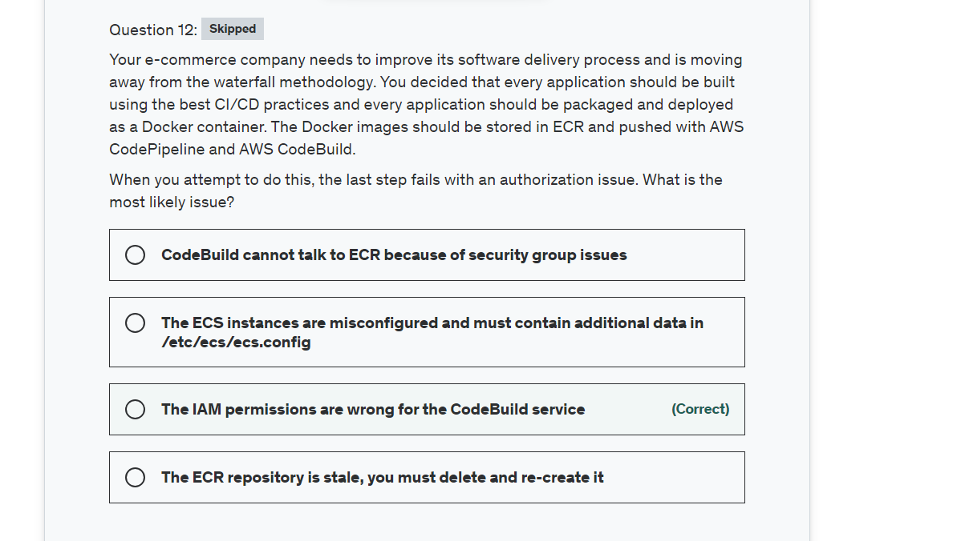

Explanation

Correct option:

**The IAM permissions are wrong for the CodeBuild service**

You can push your Docker or Open Container Initiative (OCI) images to an Amazon ECR repository with the docker push command.

Amazon ECR users require permission to call ecr:GetAuthorizationToken before they can authenticate to a registry and push or pull any images from any Amazon ECR repository. Amazon ECR provides several managed policies to control user access at varying levels

Incorrect options:

**The ECR repository is stale, you must delete and re-create it** - You can delete a repository when you are done using it, stale is not a concept within ECR. This option has been added as a distractor.

**CodeBuild cannot talk to ECR because of security group issues** - A security group acts as a virtual firewall at the instance level and it is not related to pushing Docker images, so this option does not fit the given use-case.

**The ECS instances are misconfigured and must contain additional data in /etc/ecs/ecs.config** - The error Authorization is an indication that there is an access issue, therefore you should not look at your configuration first but rather permissions.

References:

<https://docs.aws.amazon.com/AmazonECR/latest/userguide/docker-push-ecr-image.html>

<https://docs.aws.amazon.com/AmazonECR/latest/userguide/ecr_managed_policies.html>

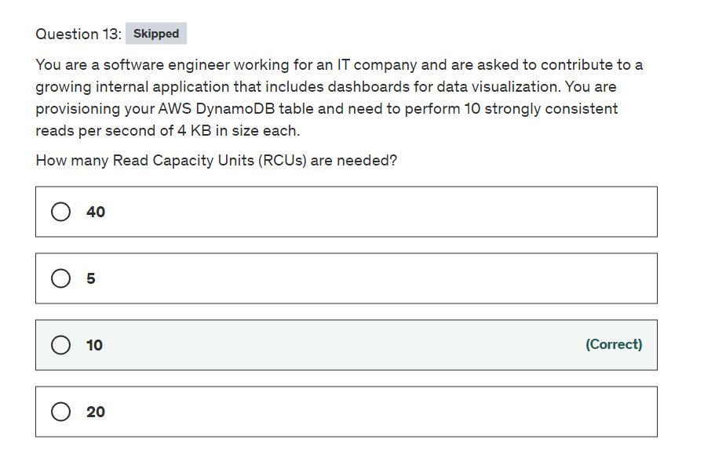

Explanation

Correct option:

Before proceeding with the calculations, please review the following:

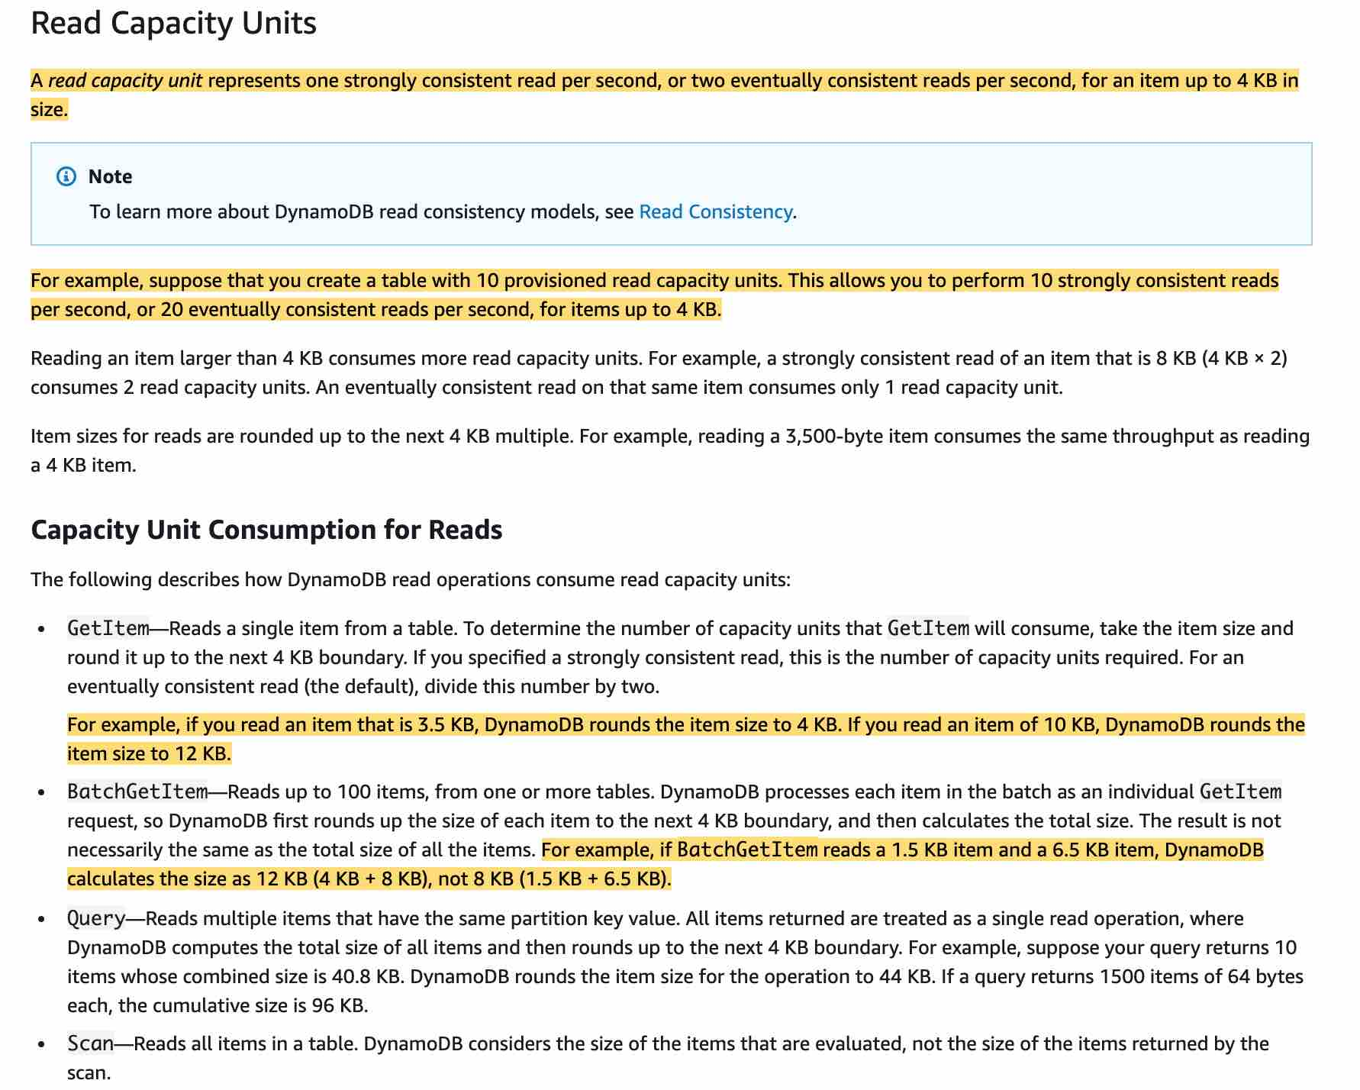

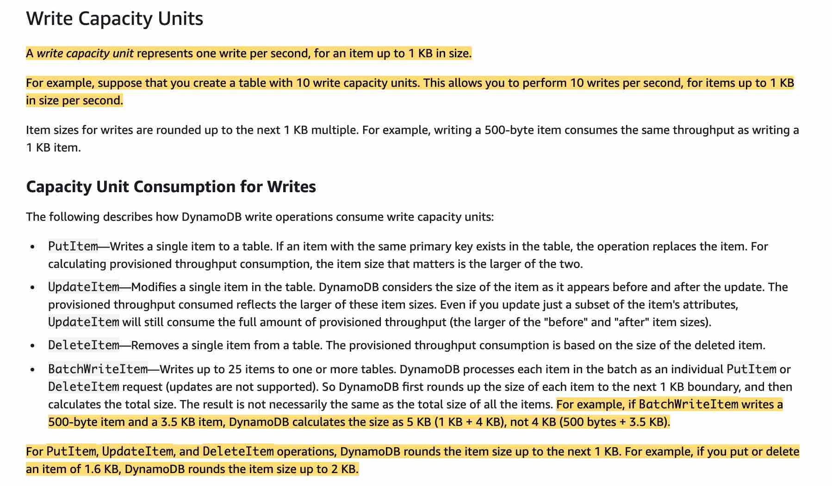

via - <https://docs.aws.amazon.com/amazondynamodb/latest/developerguide/ProvisionedThroughput.html>

**10**

One Read Capacity Unit represents one strongly consistent read per second, or two eventually consistent reads per second, for an item up to 4 KB in size. If you need to read an item that is larger than 4 KB, DynamoDB will need to consume additional read capacity units. The total number of Read Capacity Units required depends on the item size, and whether you want an eventually consistent or strongly consistent read.

1) Item Size / 4KB, rounding to the nearest whole number.

So, in the above case, 4KB / 4 KB = 1 read capacity unit.

2) 1 read capacity unit per item (since strongly consistent read) × No of reads per second

So, in the above case, 1 x 10 = 10 read capacity units.

Incorrect options:

**40**

**20**

**5**

These three options contradict the details provided in the explanation above, so these are incorrect.

Reference:

<https://docs.aws.amazon.com/amazondynamodb/latest/developerguide/ProvisionedThroughput.html>

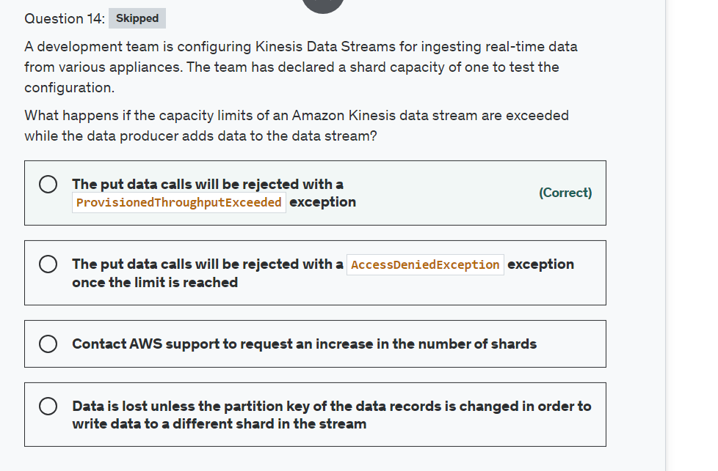

Explanation

Correct option:

**The put data calls will be rejected with a ProvisionedThroughputExceeded exception**

The capacity limits of an Amazon Kinesis data stream are defined by the number of shards within the data stream. The limits can be exceeded by either data throughput or the number of PUT records. While the capacity limits are exceeded, the put data call will be rejected with a ProvisionedThroughputExceeded exception. If this is due to a temporary rise of the data stream’s input data rate, retry by the data producer will eventually lead to completion of the requests. If this is due to a sustained rise of the data stream’s input data rate, you should increase the number of shards within your data stream to provide enough capacity for the put data calls to consistently succeed.

Incorrect options:

**The put data calls will be rejected with a AccessDeniedException exception once the limit is reached** - Access Denied error is thrown when the accessing system does not have enough permissions. Since data was getting ingested into Data Streams before reaching the capacity, this error is not possible.

**Data is lost unless the partition key of the data records is changed in order to write data to a different shard in the stream** - Partition key is used to segregate and route records to different shards of a data stream. A partition key is specified by your data producer while adding data to an Amazon Kinesis data stream. The use case talks about provisioning only one shard. It is not possible to set up more shards by simply changing the partition key. Hence, this choice is incorrect.

**Contact AWS support to request an increase in the number of shards** - This is a made-up option that acts as a distractor.

Reference:

<https://aws.amazon.com/kinesis/data-streams/faqs/>

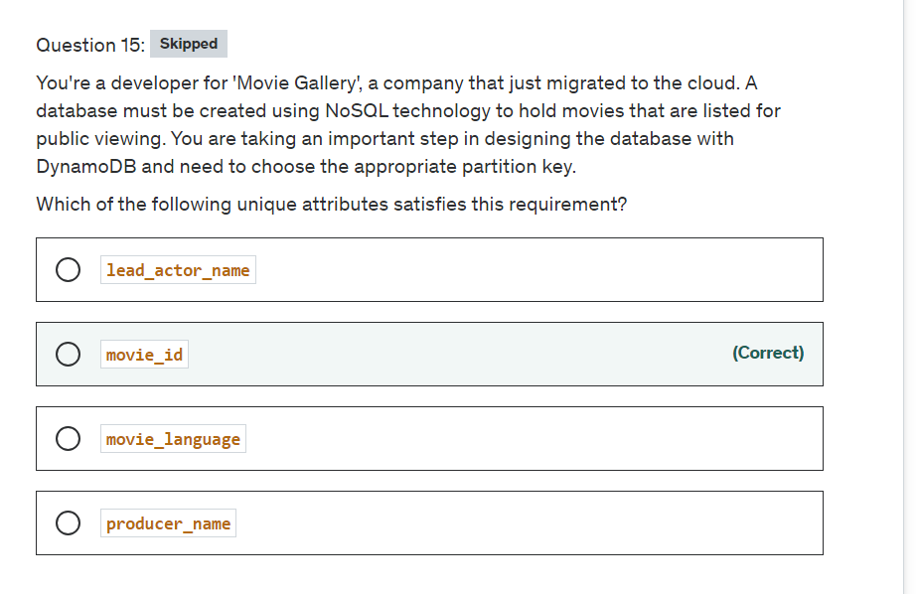

Explanation

Correct option:

DynamoDB stores data as groups of attributes, known as items. Items are similar to rows or records in other database systems. DynamoDB stores and retrieves each item based on the primary key value, which must be unique. Items are distributed across 10-GB storage units, called partitions (physical storage internal to DynamoDB).

DynamoDB uses the partition key’s value as an input to an internal hash function. The output from the hash function determines the partition in which the item is stored. Each item’s location is determined by the hash value of its partition key.

Please see these details for the DynamoDB Partition Keys: 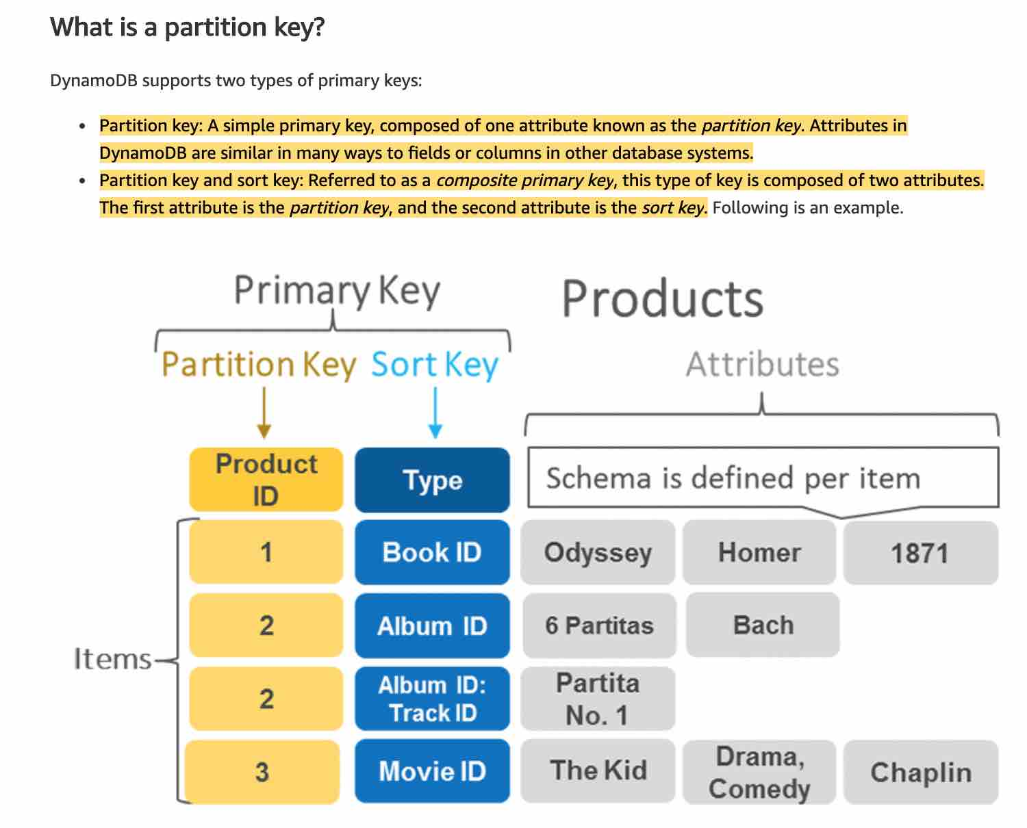 via - <https://aws.amazon.com/blogs/database/choosing-the-right-dynamodb-partition-key/>

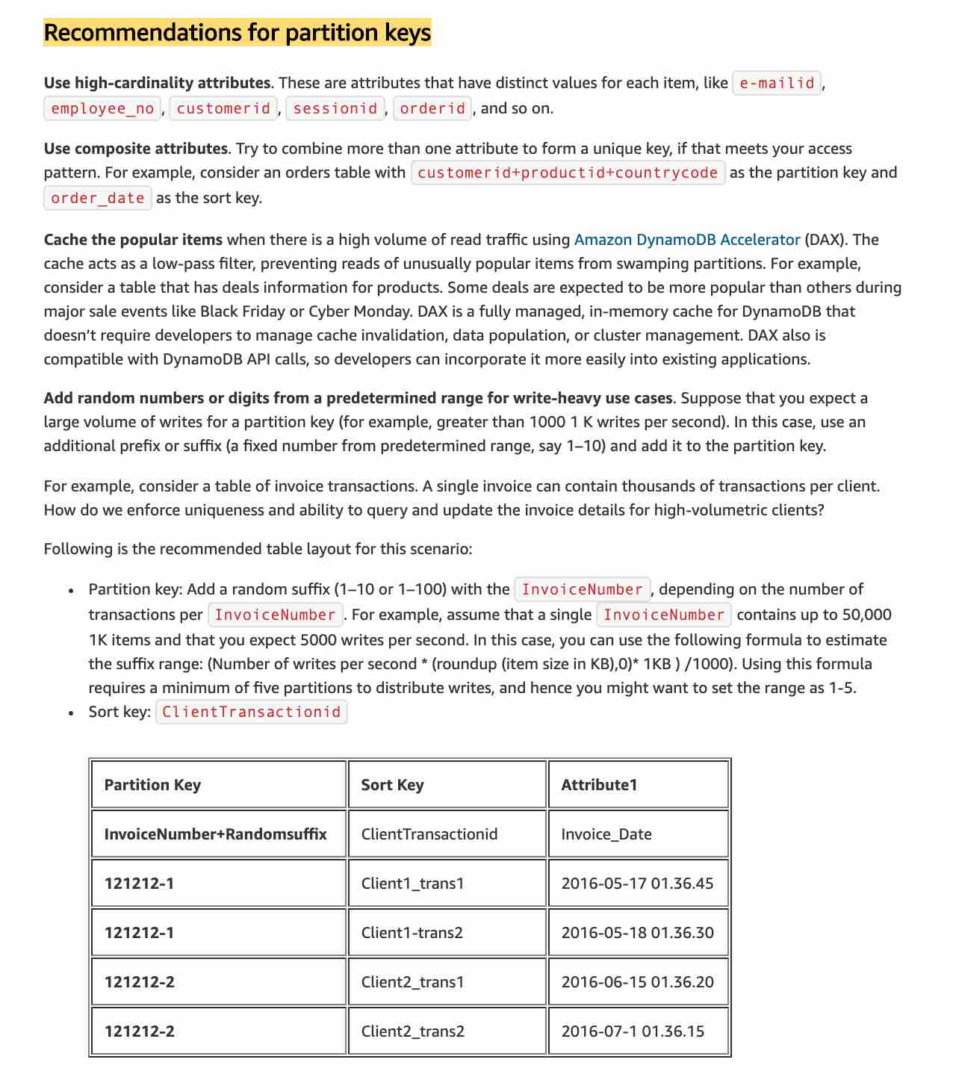 via - <https://aws.amazon.com/blogs/database/choosing-the-right-dynamodb-partition-key/>

**movie_id**

The movie_id attribute has high-cardinality across the entire collection of the movie database, hence it is the most suitable candidate for the partition key in this use case.

Incorrect options:

**producer_name** - Does not qualify because the attribute will have duplicate values (and therefore low cardinality)

**lead_actor_name** - Does not qualify because the attribute will have duplicate values (and therefore low cardinality)

**movie_language** - Does not qualify because the attribute will have duplicate values (and therefore low cardinality)

Reference:

<https://aws.amazon.com/blogs/database/choosing-the-right-dynamodb-partition-key/>

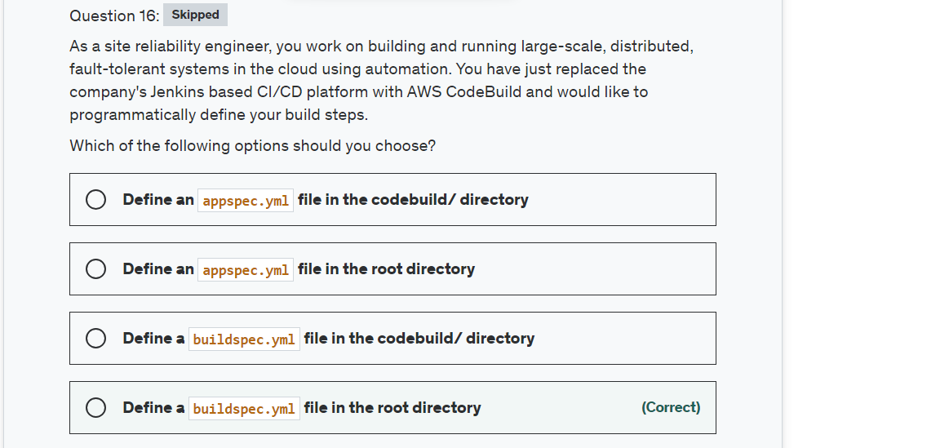

Explanation

Correct option:

**Define a buildspec.yml file in the root directory**

AWS CodeDeploy is a fully managed deployment service that automates software deployments to a variety of compute services such as Amazon EC2, AWS Fargate, AWS Lambda, and your on-premises servers. AWS CodeDeploy makes it easier for you to rapidly release new features, helps you avoid downtime during application deployment, and handles the complexity of updating your applications.

A build spec is a collection of build commands and related settings, in YAML format, that AWS CodeBuild uses to run a build. You can include a build spec as part of the source code or you can define a build spec when you create a build project.

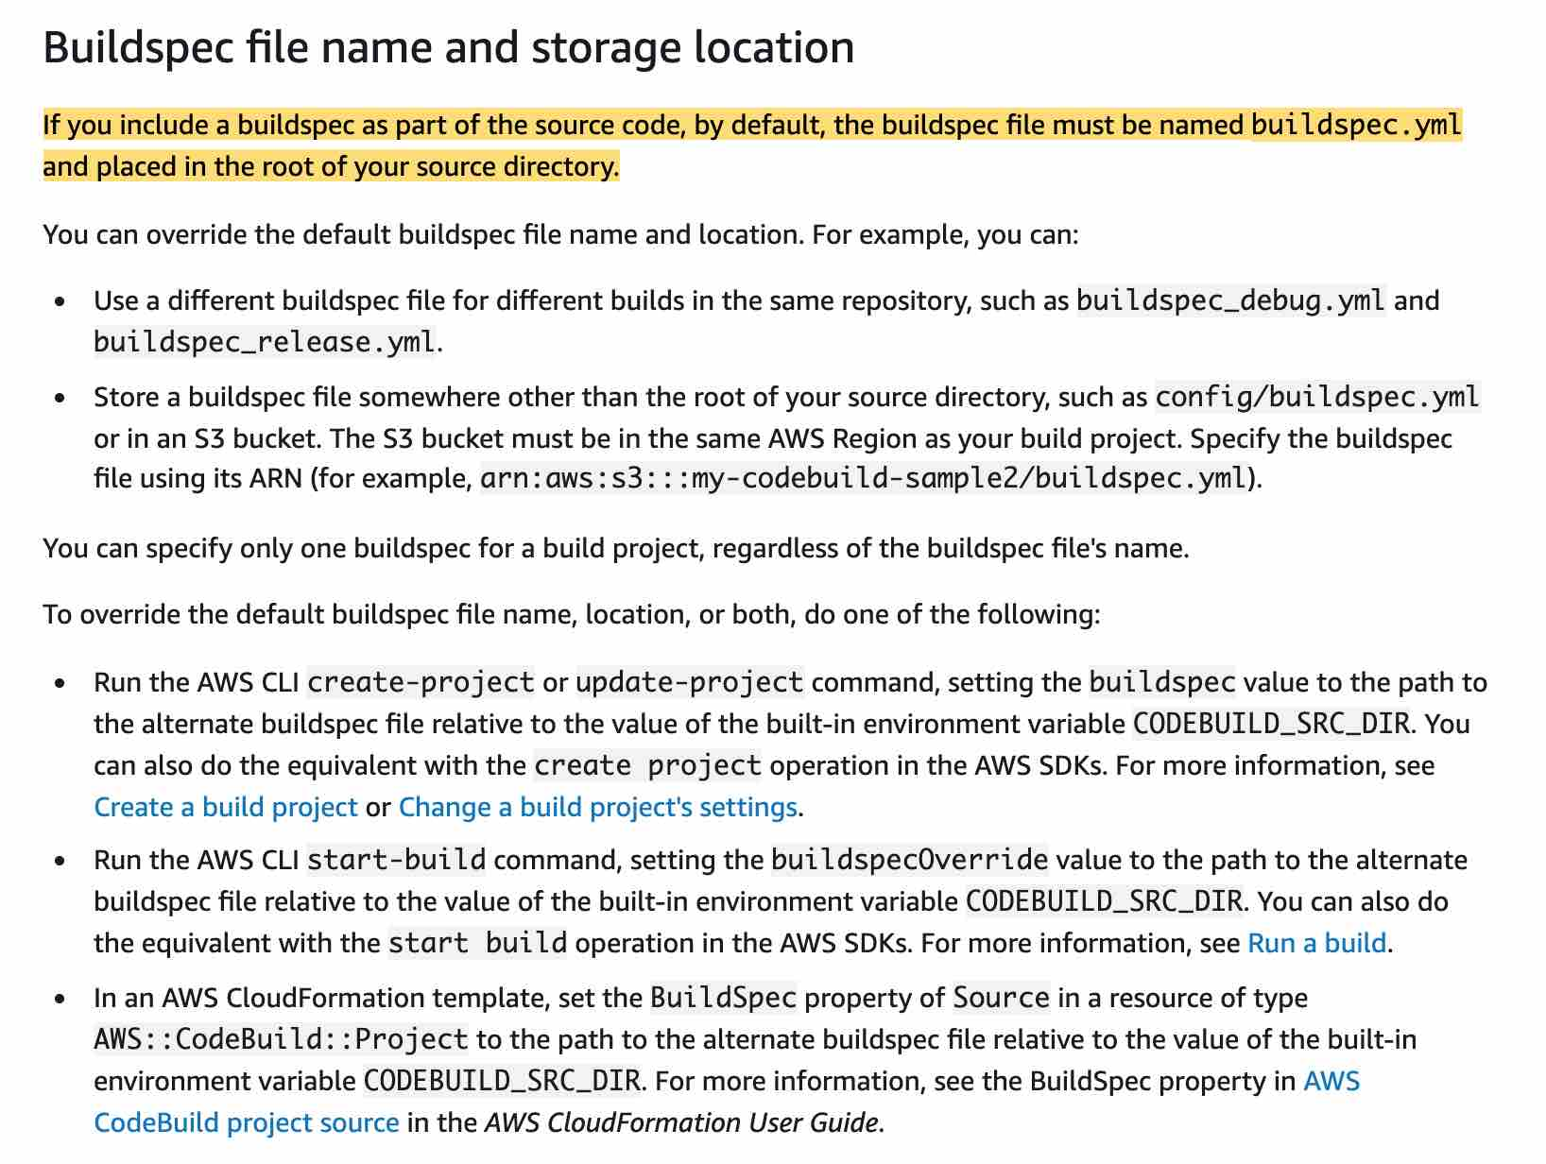 via - <https://docs.aws.amazon.com/codebuild/latest/userguide/build-spec-ref.html>

Incorrect options:

**Define an appspec.yml file in the root directory** - The AppSpec file is used for deployment in the CodeDeploy service.

**Define a buildspec.yml file in the codebuild/ directory** - The file is correct but must be in the root directory.

**Define an appspec.yml file in the codebuild/ directory** - The AppSpec file is used for deployment in the CodeDeploy service.

Reference:

<https://docs.aws.amazon.com/codebuild/latest/userguide/build-spec-ref.html>

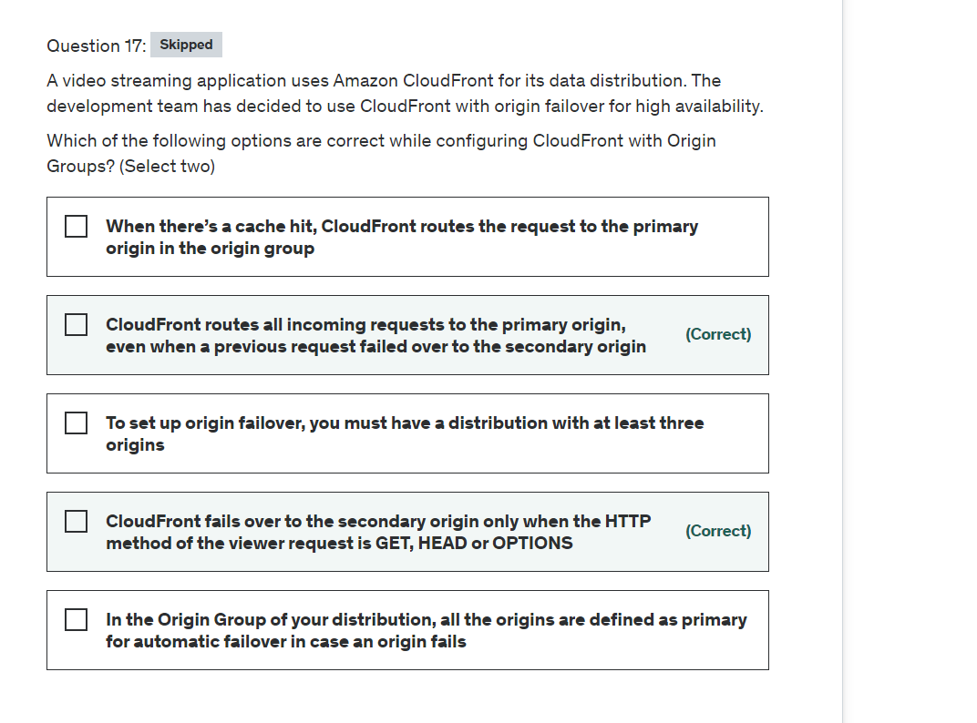

Explanation

Correct options:

**CloudFront routes all incoming requests to the primary origin, even when a previous request failed over to the secondary origin**

CloudFront routes all incoming requests to the primary origin, even when a previous request failed over to the secondary origin. CloudFront only sends requests to the secondary origin after a request to the primary origin fails.

**CloudFront fails over to the secondary origin only when the HTTP method of the viewer request is GET, HEAD or OPTIONS**

CloudFront fails over to the secondary origin only when the HTTP method of the viewer request is GET, HEAD, or OPTIONS. CloudFront does not failover when the viewer sends a different HTTP method (for example POST, PUT, and so on).

How origin failover works: 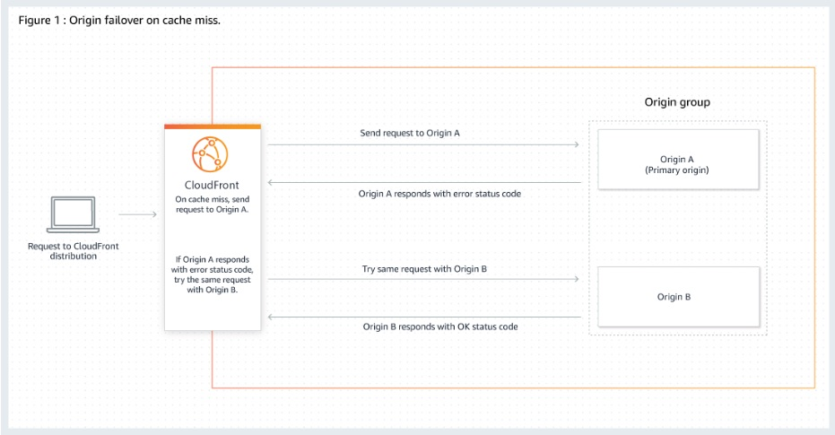 via - <https://docs.aws.amazon.com/AmazonCloudFront/latest/DeveloperGuide/high_availability_origin_failover.html>

Incorrect options:

**When there’s a cache hit, CloudFront routes the request to the primary origin in the origin group** - When there’s a cache miss, CloudFront routes the request to the primary origin in the origin group. When there’s a cache hit, CloudFront returns the requested file.

**To set up origin failover, you must have a distribution with at least three origins** - Two origins are enough to set up an origin failover.

**In the Origin Group of your distribution, all the origins are defined as primary for automatic failover in case an origin fails** - To set up origin failover, you must have a distribution with at least two origins. Next, you create an origin group for your distribution that includes two origins, setting one as the primary. Only one origin can be set as primary.

Reference:

<https://docs.aws.amazon.com/AmazonCloudFront/latest/DeveloperGuide/high_availability_origin_failover.html>

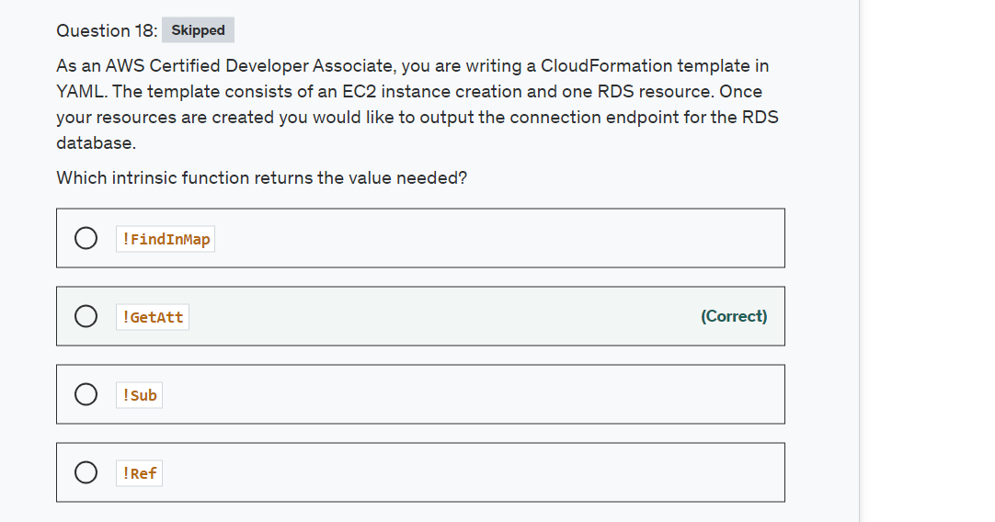

Explanation

Correct option:

AWS CloudFormation provides several built-in functions that help you manage your stacks. Intrinsic functions are used in templates to assign values to properties that are not available until runtime.

**!GetAtt** - The Fn::GetAtt intrinsic function returns the value of an attribute from a resource in the template. This example snippet returns a string containing the DNS name of the load balancer with the logical name myELB - YML : !GetAtt myELB.DNSName JSON : "Fn::GetAtt" : [ "myELB" , "DNSName" ]

Incorrect options:

**!Sub** - The intrinsic function Fn::Sub substitutes variables in an input string with values that you specify. In your templates, you can use this function to construct commands or outputs that include values that aren't available until you create or update a stack.

**!Ref** - The intrinsic function Ref returns the value of the specified parameter or resource.

**!FindInMap** - The intrinsic function Fn::FindInMap returns the value corresponding to keys in a two-level map that is declared in the Mappings section. For example, you can use this in the Mappings section that contains a single map, RegionMap, that associates AMIs with AWS regions.

References:

<https://docs.aws.amazon.com/AWSCloudFormation/latest/UserGuide/intrinsic-function-reference.html>

<https://docs.aws.amazon.com/AWSCloudFormation/latest/UserGuide/intrinsic-function-reference-getatt.html>

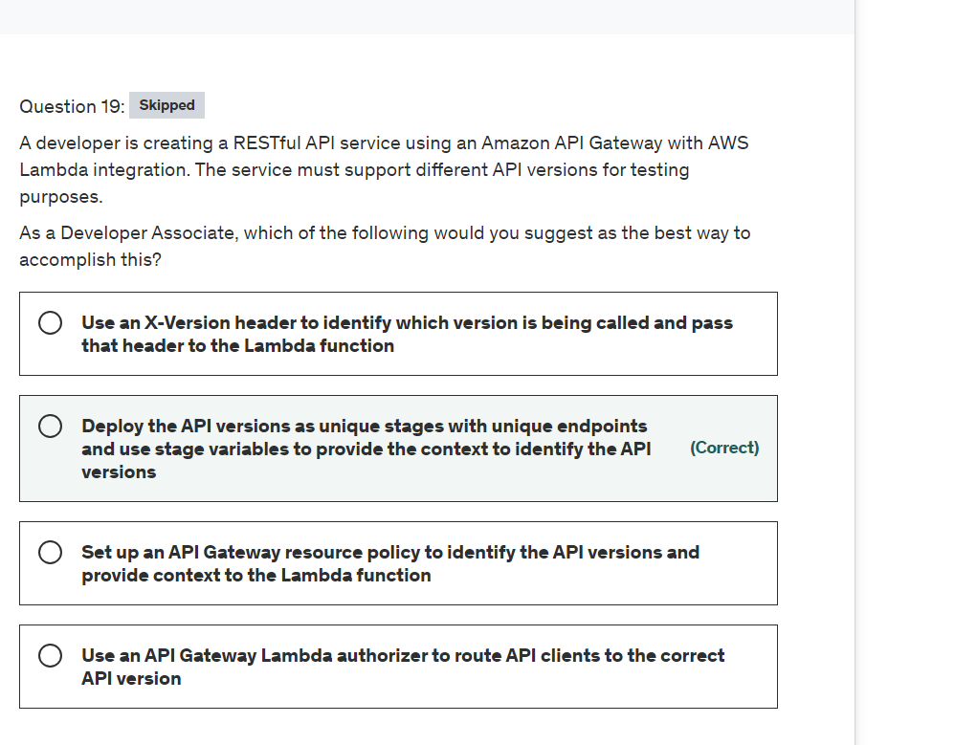

Explanation

Correct option:

**Deploy the API versions as unique stages with unique endpoints and use stage variables to provide the context to identify the API versions** - A stage is a named reference to a deployment, which is a snapshot of the API. You use a stage to manage and optimize a particular deployment. For example, you can configure stage settings to enable caching, customize request throttling, configure logging, define stage variables, or attach a canary release for testing.

Stage variables are name-value pairs that you can define as configuration attributes associated with a deployment stage of a REST API. They act like environment variables and can be used in your API setup and mapping templates.

With deployment stages in API Gateway, you can manage multiple release stages for each API, such as alpha, beta, and production. Using stage variables you can configure an API deployment stage to interact with different backend endpoints.

For example, your API can pass a GET request as an HTTP proxy to the backend web host (for example, http://example.com). In this case, the backend web host is configured in a stage variable so that when developers call your production endpoint, API Gateway calls example.com. When you call your beta endpoint, API Gateway uses the value configured in the stage variable for the beta stage, and calls a different web host (for example, beta.example.com). Similarly, stage variables can be used to specify a different AWS Lambda function name for each stage in your API.

Incorrect options:

**Use an X-Version header to identify which version is being called and pass that header to the Lambda function** - This is an incorrect option and has been added as a distractor.

**Use an API Gateway Lambda authorizer to route API clients to the correct API version** - A Lambda authorizer is an API Gateway feature that uses a Lambda function to control access to your API. A Lambda authorizer is useful if you want to implement a custom authorization scheme that uses a bearer token authentication strategy such as OAuth or SAML, or that uses request parameters to determine the caller's identity.

**Set up an API Gateway resource policy to identify the API versions and provide context to the Lambda function** - Amazon API Gateway resource policies are JSON policy documents that you attach to an API to control whether a specified principal (typically an IAM user or role) can invoke the API. You can use API Gateway resource policies to allow your API to be securely invoked requestors. They are not meant for choosing the version of APIs.

References:

<https://docs.aws.amazon.com/apigateway/latest/developerguide/stage-variables.html>

<https://docs.aws.amazon.com/apigateway/latest/developerguide/apigateway-resource-policies.html>

<https://docs.aws.amazon.com/apigateway/latest/developerguide/apigateway-use-lambda-authorizer.html>

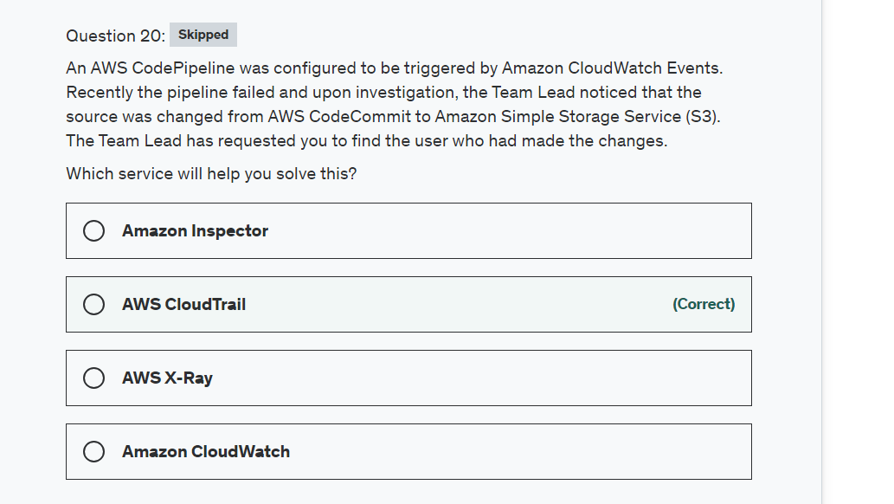

Explanation

Correct option:

**AWS CloudTrail**

AWS CloudTrail is a service that enables governance, compliance, operational auditing, and risk auditing of your AWS account. With CloudTrail, you can log, continuously monitor, and retain account activity related to actions across your AWS infrastructure. CloudTrail provides an event history of your AWS account activity, including actions taken through the AWS Management Console, AWS SDKs, command-line tools, and other AWS services.

AWS CloudTrail increases visibility into your user and resource activity by recording AWS Management Console actions and API calls. You can identify which users and accounts called AWS, the source IP address from which the calls were made, and when the calls occurred.

How CloudTrail works: 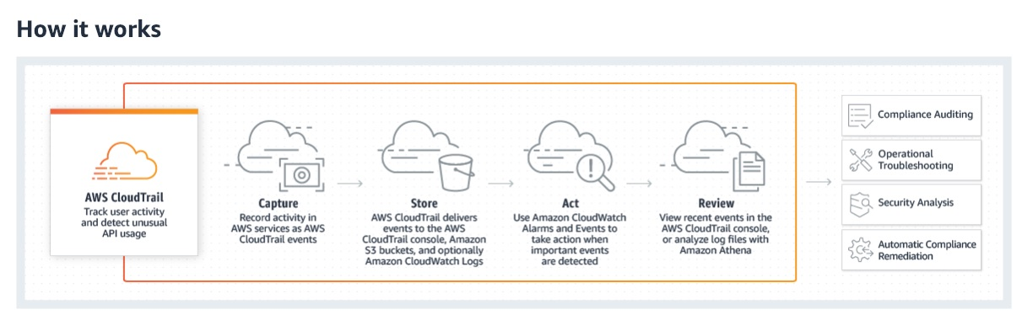 via - <https://aws.amazon.com/cloudtrail/>

Incorrect options:

**Amazon CloudWatch** - Amazon CloudWatch is a monitoring and management service that provides data and actionable insights for AWS, hybrid, and on-premises applications and infrastructure resources. CloudWatch can collect numbers and respond to AWS service-related events, but it does not help in user activity logging.

**AWS X-Ray** - AWS X-Ray helps developers analyze and debug production, distributed applications, such as those built using a microservices architecture. With X-Ray, you can understand how your application and its underlying services are performing to identify and troubleshoot the root cause of performance issues and errors. X-Ray is a very important tool in troubleshooting but is not useful in logging user activity.

**Amazon Inspector** - Amazon Inspector is an automated security assessment service that helps improve the security and compliance of applications deployed on AWS. Amazon Inspector security assessments help you check for unintended network accessibility of your Amazon EC2 instances and for vulnerabilities on those EC2 instances. This does not log User activity at the account level.

References:

<https://aws.amazon.com/xray/>

<https://aws.amazon.com/inspector/>

<https://aws.amazon.com/cloudwatch/>

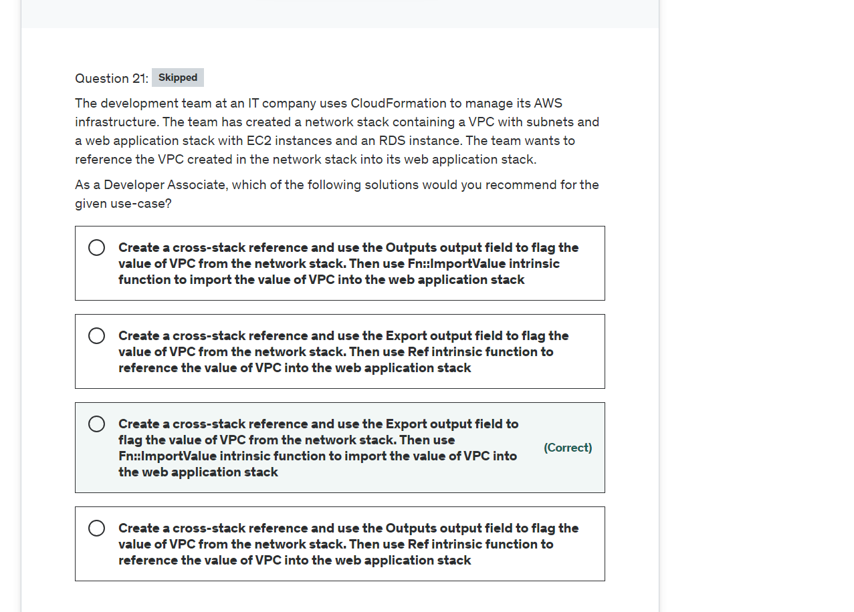

Explanation

Correct option:

**Create a cross-stack reference and use the Export output field to flag the value of VPC from the network stack. Then use Fn::ImportValue intrinsic function to import the value of VPC into the web application stack**

AWS CloudFormation gives developers and businesses an easy way to create a collection of related AWS and third-party resources and provision them in an orderly and predictable fashion.

How CloudFormation Works: 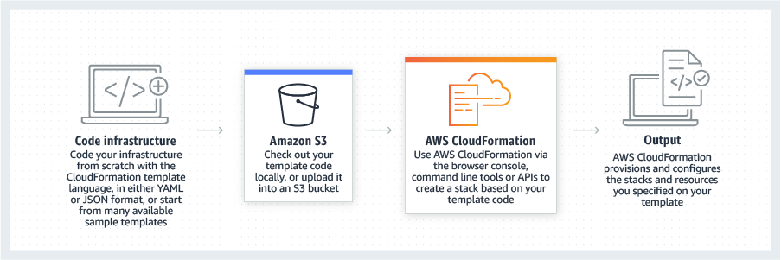 via - <https://aws.amazon.com/cloudformation/>

You can create a cross-stack reference to export resources from one AWS CloudFormation stack to another. For example, you might have a network stack with a VPC and subnets and a separate public web application stack. To use the security group and subnet from the network stack, you can create a cross-stack reference that allows the web application stack to reference resource outputs from the network stack. With a cross-stack reference, owners of the web application stacks don't need to create or maintain networking rules or assets.

To create a cross-stack reference, use the Export output field to flag the value of a resource output for export. Then, use the Fn::ImportValue intrinsic function to import the value.

You cannot use the Ref intrinsic function to import the value.

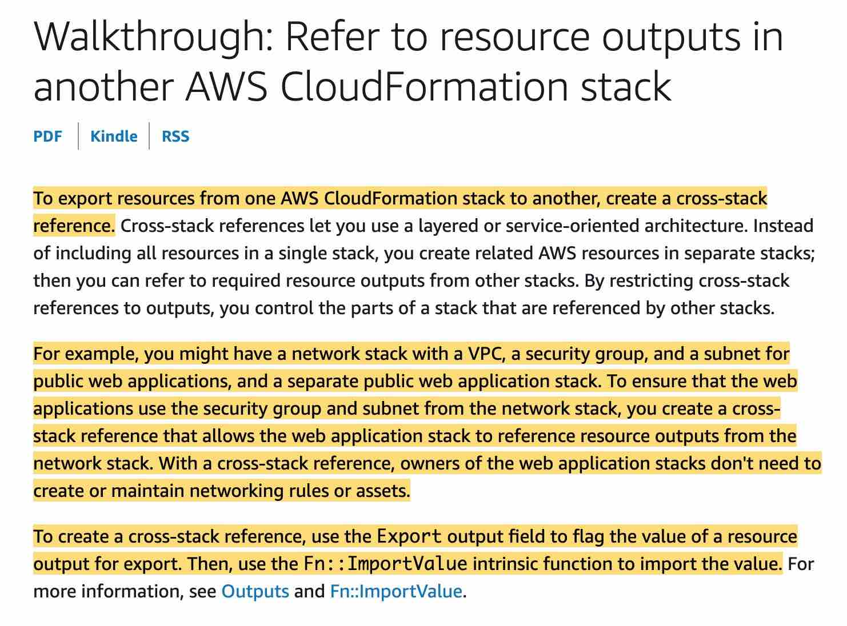 via - <https://docs.aws.amazon.com/AWSCloudFormation/latest/UserGuide/walkthrough-crossstackref.html>

Incorrect options:

**Create a cross-stack reference and use the Outputs output field to flag the value of VPC from the network stack. Then use Fn::ImportValue intrinsic function to import the value of VPC into the web application stack**

**Create a cross-stack reference and use the Outputs output field to flag the value of VPC from the network stack. Then use Ref intrinsic function to reference the value of VPC into the web application stack**

**Create a cross-stack reference and use the Export output field to flag the value of VPC from the network stack. Then use Ref intrinsic function to reference the value of VPC into the web application stack**

These three options contradict the details provided in the explanation above, so these options are not correct.

References:

<https://aws.amazon.com/cloudformation/>

<https://docs.aws.amazon.com/AWSCloudFormation/latest/UserGuide/walkthrough-crossstackref.html>

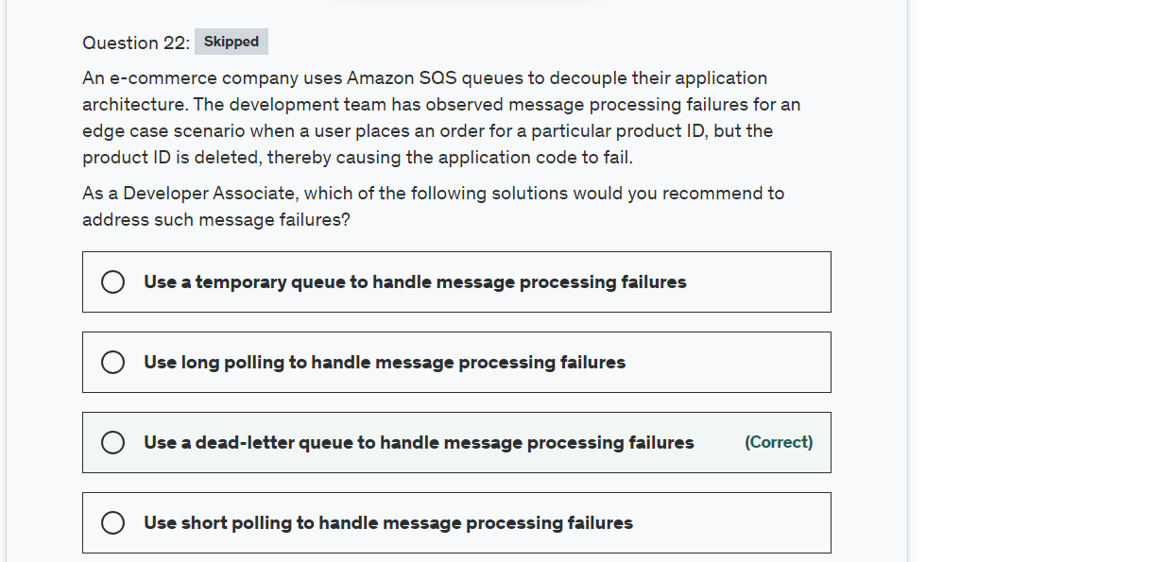

Explanation

Correct option:

**Use a dead-letter queue to handle message processing failures**

Dead-letter queues can be used by other queues (source queues) as a target for messages that can't be processed (consumed) successfully. Dead-letter queues are useful for debugging your application or messaging system because they let you isolate problematic messages to determine why their processing doesn't succeed.

Sometimes, messages can’t be processed because of a variety of possible issues, such as when a user comments on a story but it remains unprocessed because the original story itself is deleted by the author while the comments were being posted. In such a case, the dead-letter queue can be used to handle message processing failures.

How do dead-letter queues work?  via - <https://docs.aws.amazon.com/AWSSimpleQueueService/latest/SQSDeveloperGuide/sqs-dead-letter-queues.html>

Use-cases for dead-letter queues:  via - <https://docs.aws.amazon.com/AWSSimpleQueueService/latest/SQSDeveloperGuide/sqs-dead-letter-queues.html>

Incorrect options:

**Use a temporary queue to handle message processing failures** - The most common use case for temporary queues is the request-response messaging pattern (for example, processing a login request), where a requester creates a temporary queue for receiving each response message. To avoid creating an Amazon SQS queue for each response message, the Temporary Queue Client lets you create and delete multiple temporary queues without making any Amazon SQS API calls. Temporary queues cannot be used to handle message processing failures.

**Use short polling to handle message processing failures**

**Use long polling to handle message processing failures**

Amazon SQS provides short polling and long polling to receive messages from a queue. By default, queues use short polling. With short polling, Amazon SQS sends the response right away, even if the query found no messages. With long polling, Amazon SQS sends a response after it collects at least one available message, up to the maximum number of messages specified in the request. Amazon SQS sends an empty response only if the polling wait time expires. Neither short polling nor long polling can be used to handle message processing failures.

Reference:

<https://docs.aws.amazon.com/AWSSimpleQueueService/latest/SQSDeveloperGuide/sqs-dead-letter-queues.html>

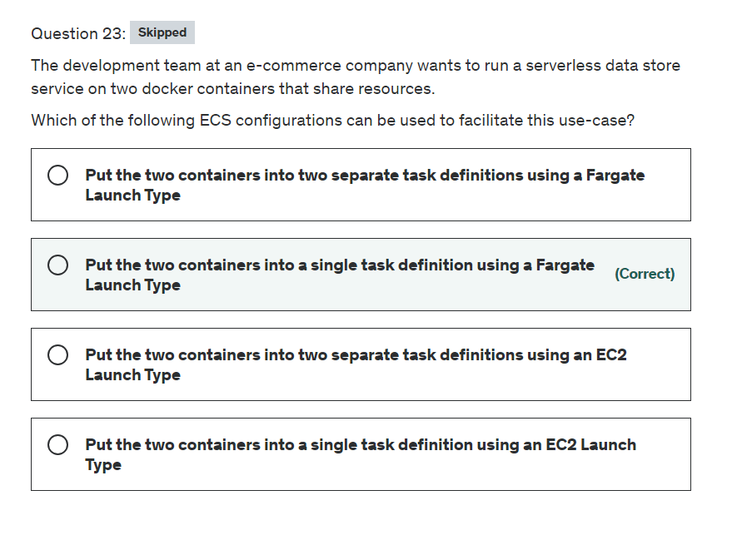

Explanation

Correct option:

**Put the two containers into a single task definition using a Fargate Launch Type**

Amazon Elastic Container Service (Amazon ECS) is a highly scalable, fast, container management service that makes it easy to run, stop, and manage Docker containers on a cluster. You can host your cluster on a serverless infrastructure that is managed by Amazon ECS by launching your services or tasks using the Fargate launch type. For more control over your infrastructure, you can host your tasks on a cluster of Amazon Elastic Compute Cloud (Amazon EC2) instances that you manage by using the EC2 launch type.

 via - <https://aws.amazon.com/ecs/>

As the development team is looking for a serverless data store service, therefore the two containers should be launched into a single task definition using a Fargate Launch Type. Using a single task definition allows the two containers to share resources. Please see these use-cases for Fargate Launch type when you should put multiple containers into the same task definition:

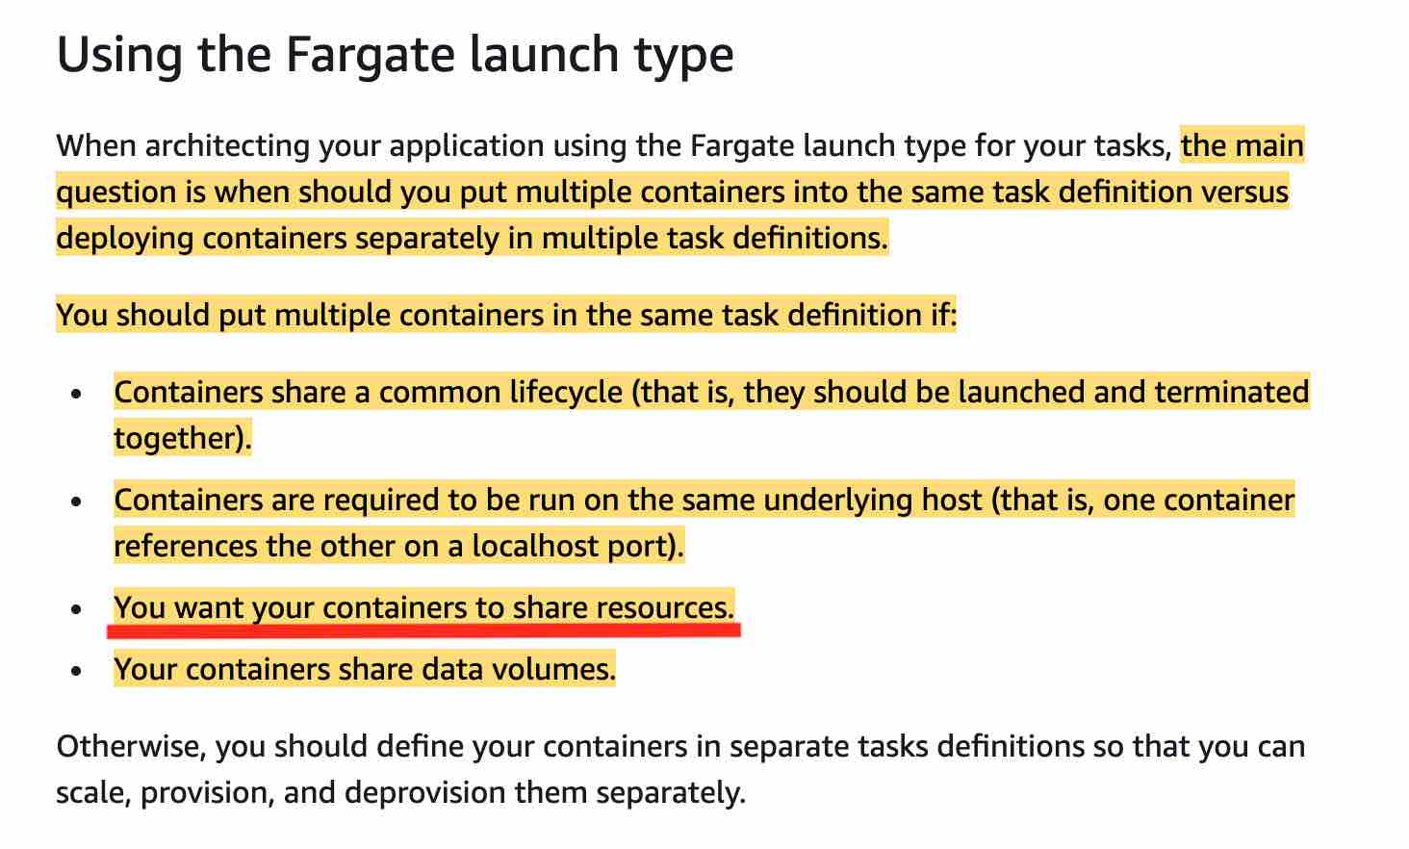 via - <https://docs.aws.amazon.com/AmazonECS/latest/developerguide/application_architecture.html>

For a deep-dive on understanding how Amazon ECS manages CPU and memory resources, please review this excellent blog- <https://aws.amazon.com/blogs/containers/how-amazon-ecs-manages-cpu-and-memory-resources/>

Incorrect options:

**Put the two containers into two separate task definitions using a Fargate Launch Type** - This option contradicts the details provided in the explanation above, so this option is ruled out.

**Put the two containers into two separate task definitions using an EC2 Launch Type**

**Put the two containers into a single task definition using an EC2 Launch Type**

As the development team is looking for a serverless data store service, therefore EC2 Launch Type is ruled out. So both these options are incorrect.

References:

<https://docs.aws.amazon.com/AmazonECS/latest/developerguide/application_architecture.html>

<https://aws.amazon.com/blogs/containers/how-amazon-ecs-manages-cpu-and-memory-resources/>

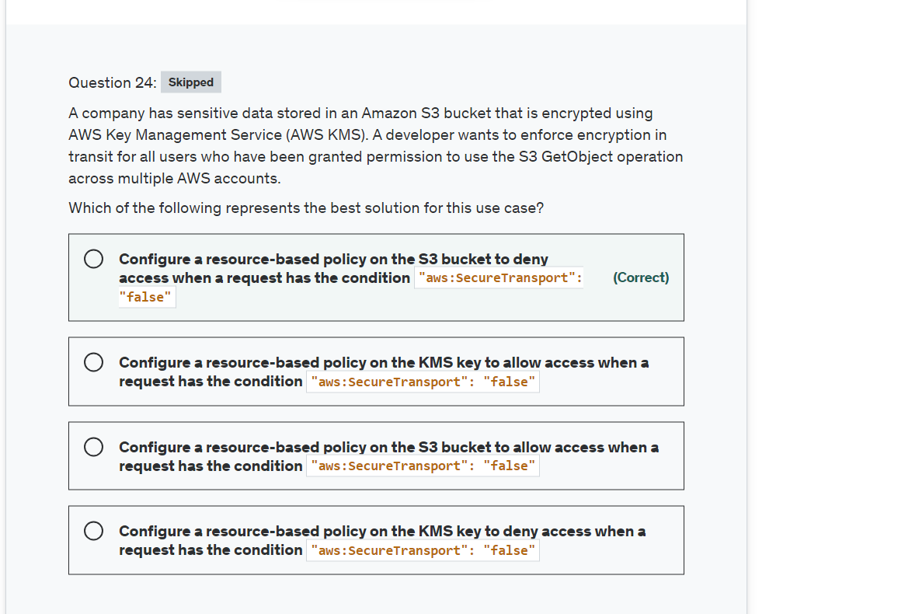

Explanation

Correct option:

**Configure a resource-based policy on the S3 bucket to deny access when a request has the condition "aws:SecureTransport": "false"**

If you want to prevent potential attackers from manipulating network traffic, you can use HTTPS (TLS) to only allow encrypted connections while restricting HTTP requests from accessing your bucket. To determine whether the request is HTTP or HTTPS, use the aws:SecureTransport global condition key in your S3 bucket policy. The aws:SecureTransport condition key checks whether a request was sent by using HTTP.

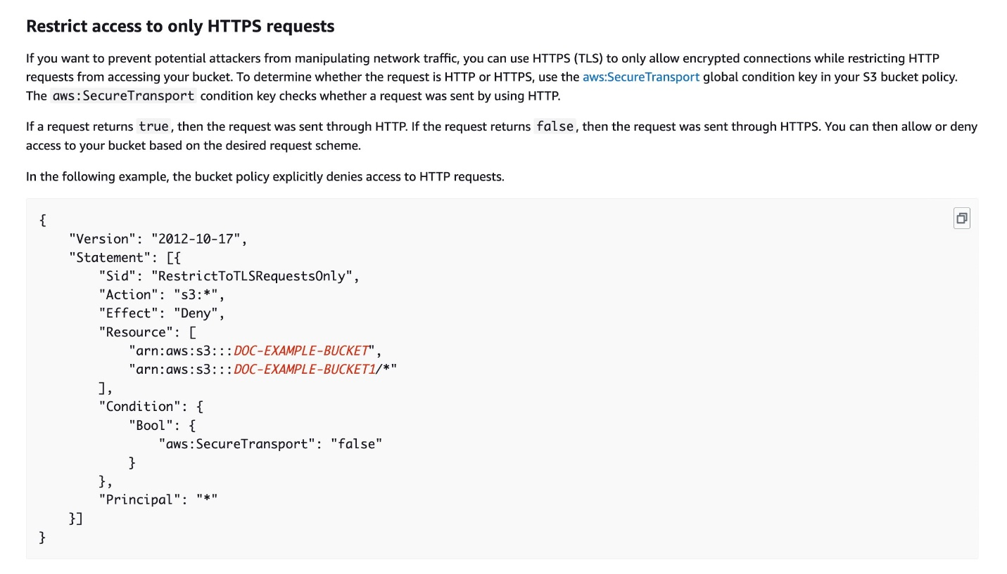 via - <https://docs.aws.amazon.com/AmazonS3/latest/userguide/example-bucket-policies.html>

Incorrect options:

**Configure a resource-based policy on the S3 bucket to allow access when a request has the condition "aws:SecureTransport": "false"** - This option contradicts the explanation provided above.

**Configure a resource-based policy on the KMS key to allow access when a request has the condition "aws:SecureTransport": "false"**

**Configure a resource-based policy on the KMS key to deny access when a request has the condition "aws:SecureTransport": "false"**

Since the use case is about granting permission to use the S3 GetObject operations with encryption in transit, you cannot use a Resource-based policy for KMS. So, both these options are incorrect.

References:

<https://aws.amazon.com/blogs/security/how-to-use-bucket-policies-and-apply-defense-in-depth-to-help-secure-your-amazon-s3-data/>

<https://docs.aws.amazon.com/AmazonS3/latest/userguide/example-bucket-policies.html>

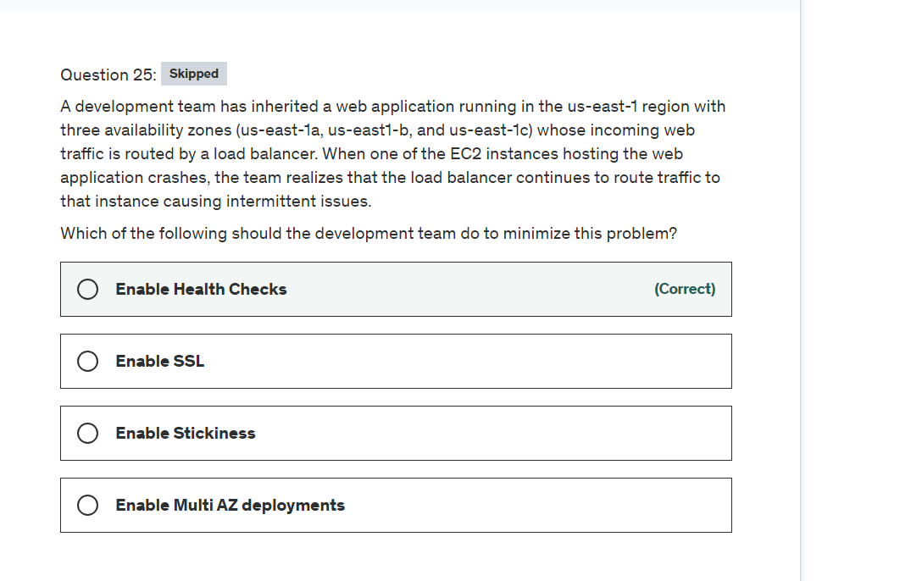

Explanation

Correct option:

**Enable Health Checks**

To discover the availability of your EC2 instances, a load balancer periodically sends pings, attempts connections, or sends requests to test the EC2 instances. These tests are called health checks. The status of the instances that are healthy at the time of the health check is InService. The status of any instances that are unhealthy at the time of the health check is OutOfService.

Load Balancer Health Checks: 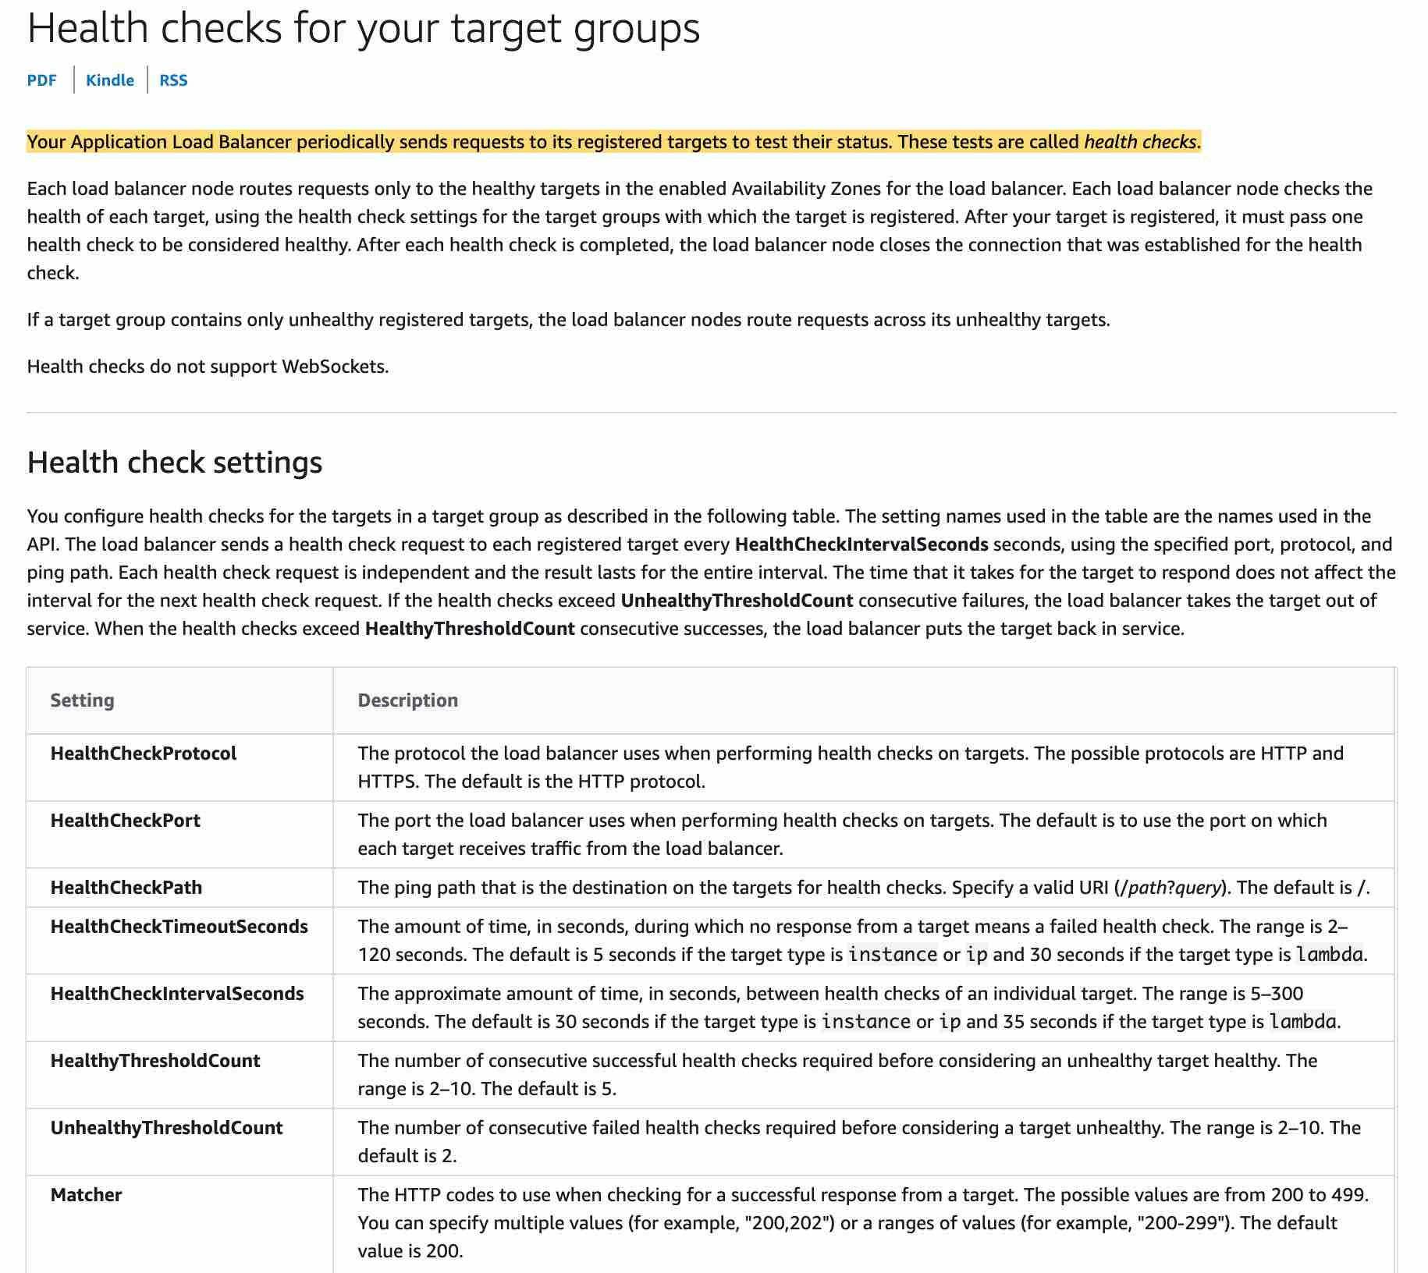 via - <https://docs.aws.amazon.com/elasticloadbalancing/latest/application/target-group-health-checks.html>

Incorrect options:

**Enable Stickiness** - Stickiness enables the load balancer to bind a user's session to a specific instance, it cannot be used for gauging the health of an instance.

**Enable Multi-AZ deployments** - It's a good practice to provision instances in more than one availability zone however you still need a way to check the health status of the instances, so this option is incorrect.

**Enable SSL** - This option has been added as a distractor. SSL encrypts the transmission of data between a web server and a browser.

Reference:

<https://docs.aws.amazon.com/elasticloadbalancing/latest/application/target-group-health-checks.html>

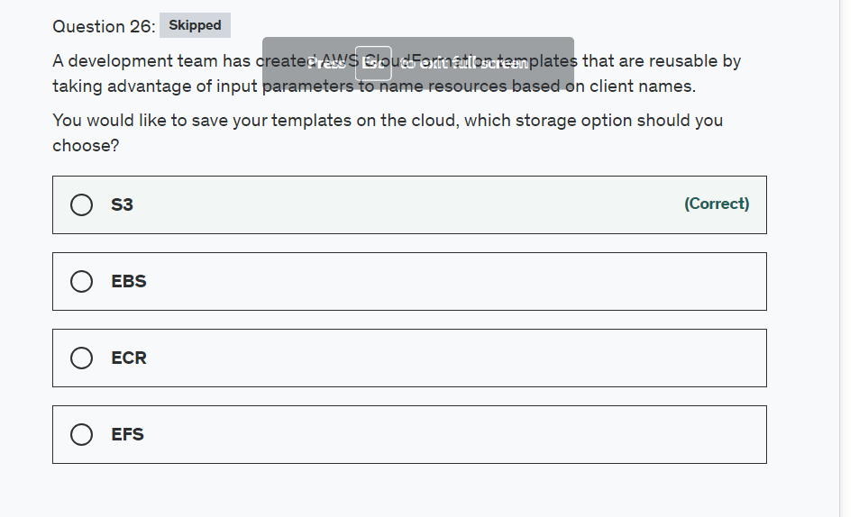

Explanation

Correct option:

**S3**

If you upload a local template file, AWS CloudFormation uploads it to an Amazon Simple Storage Service (Amazon S3) bucket in your AWS account. If you don't already have an S3 bucket that was created by AWS CloudFormation, it creates a unique bucket for each region in which you upload a template file. If you already have an S3 bucket that was created by AWS CloudFormation in your AWS account, AWS CloudFormation adds the template to that bucket.

Selecting a stack template for CloudFormation: 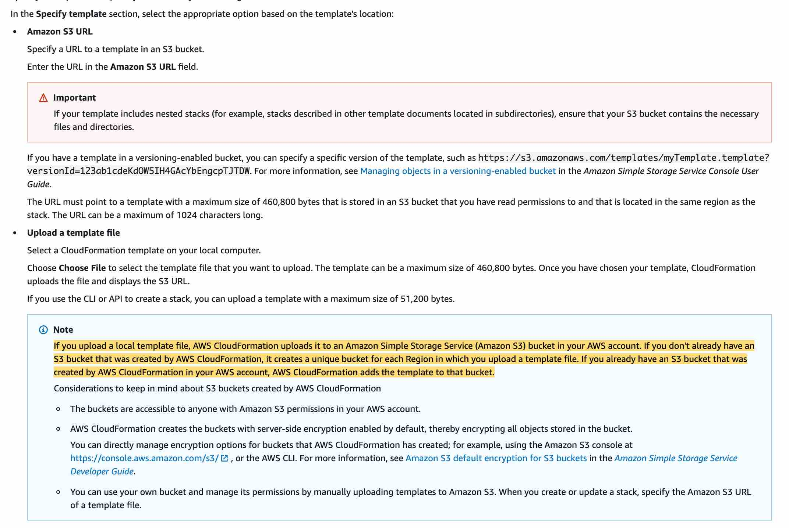 via - <https://docs.aws.amazon.com/AWSCloudFormation/latest/UserGuide/cfn-using-console-create-stack-template.html>

Incorrect options:

**EBS** - An Amazon EBS volume is a durable, block-level storage device that you can attach to your instances. After you attach a volume to an instance, you can use it as you would use a physical hard drive. EBS volumes are flexible. Amazon EBS is a recommended storage option when data must be quickly accessible and requires long-term persistence. EBS cannot be used for selecting a stack template for CloudFormation.

**EFS** - EFS is a file storage service where you mount the file system on an Amazon EC2 Linux-based instance which is not an option for CloudFormation.

**ECR** - Amazon ECR eliminates the need to operate your container repositories or worry about scaling the underlying infrastructure which does not apply to CloudFormation.

Reference:

<https://docs.aws.amazon.com/AWSCloudFormation/latest/UserGuide/cfn-using-console-create-stack-template.html>

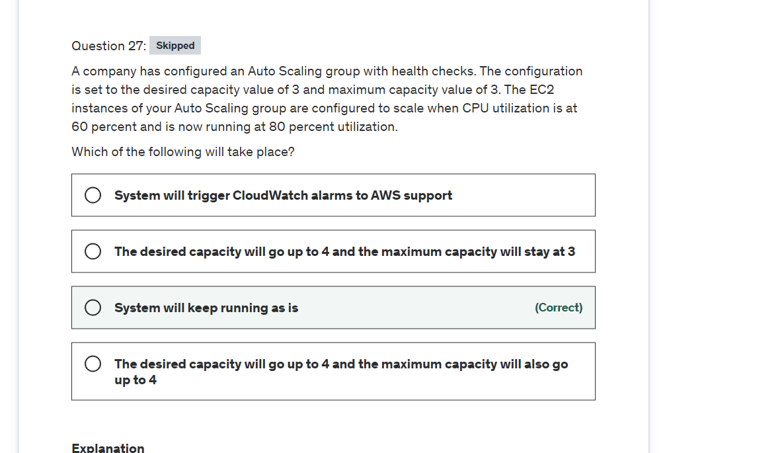

Explanation

Correct option:

**System will keep running as is**

You are already running at max capacity. After you have created your Auto Scaling group, the Auto Scaling group starts by launching enough EC2 instances to meet its minimum capacity (or its desired capacity, if specified). If there are no other scaling conditions attached to the Auto Scaling group, the Auto Scaling group maintains this number of running instances even if an instance becomes unhealthy.

Setting Capacity Limits for Your Auto Scaling Group: 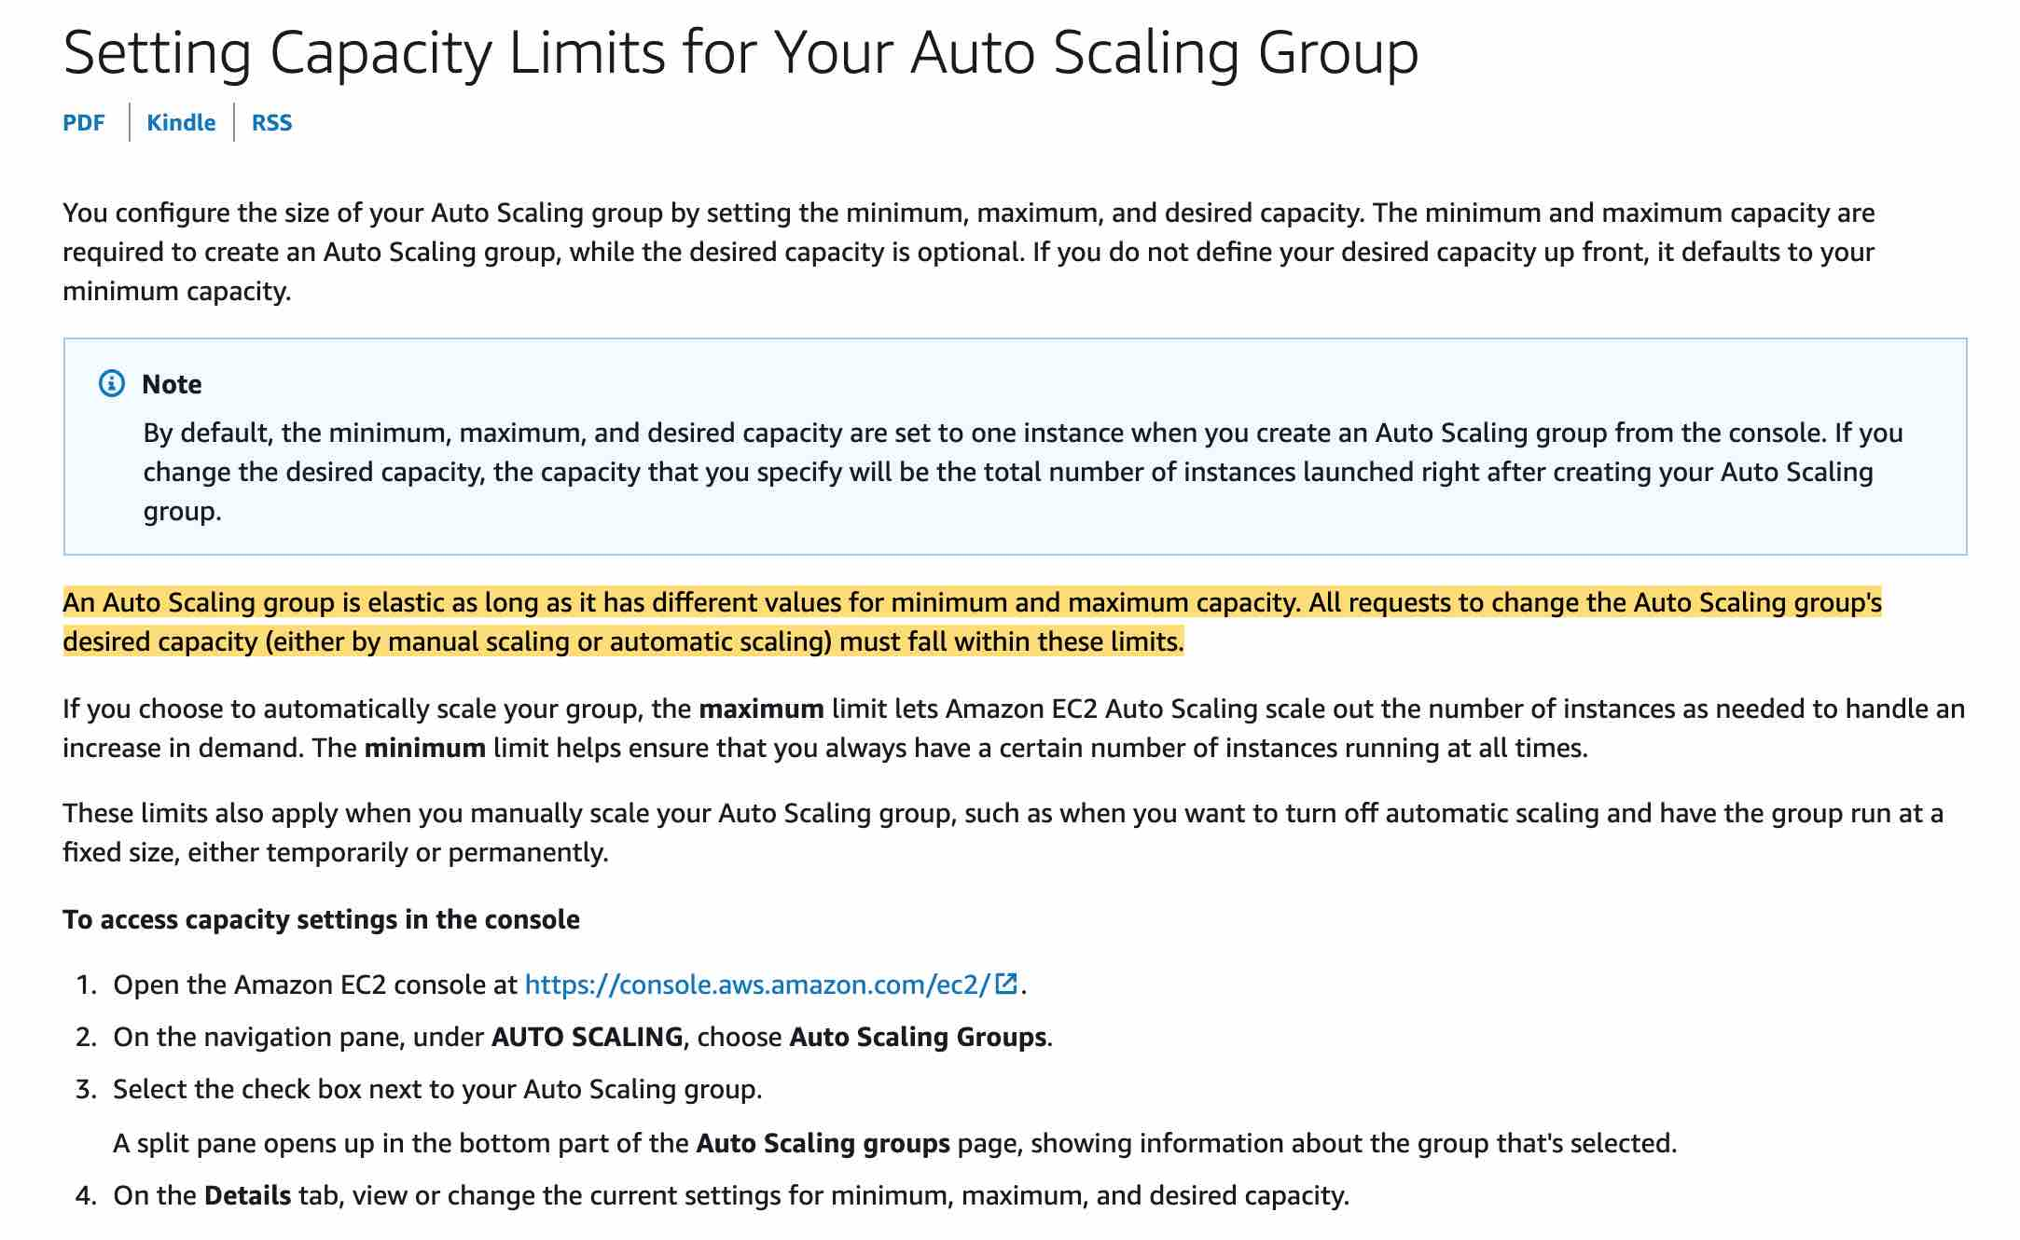 via - <https://docs.aws.amazon.com/autoscaling/ec2/userguide/asg-capacity-limits.html>

Incorrect options:

**The desired capacity will go up to 4 and the maximum capacity will stay at 3** - The desired capacity cannot go over the maximum capacity.

**The desired capacity will go up to 4 and the maximum capacity will also go up to 4** - The maximum capacity cannot change on its own just because the desired capacity has been set to a higher value. You will have to make those changes to the maximum capacity manually.

**System will trigger CloudWatch alarms to AWS support** - This option has been added as a distractor. You already have alarms configured based on rules but AWS support will not intervene for you.

Reference:

<https://docs.aws.amazon.com/autoscaling/ec2/userguide/asg-capacity-limits.html>

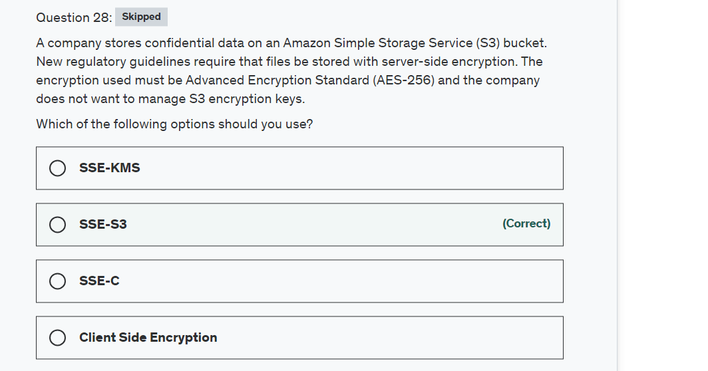

Explanation

Correct option:

**SSE-S3**

Using Server-Side Encryption with Amazon S3-Managed Keys (SSE-S3), each object is encrypted with a unique key employing strong multi-factor encryption. As an additional safeguard, it encrypts the key itself with a master key that it regularly rotates. Amazon S3 server-side encryption uses one of the strongest block ciphers available, 256-bit Advanced Encryption Standard (AES-256), to encrypt your data.

Incorrect options:

**SSE-C** - You manage the encryption keys and Amazon S3 manages the encryption as it writes to disks and decryption when you access your objects.

**Client-Side Encryption** - You can encrypt data client-side and upload the encrypted data to Amazon S3. In this case, you manage the encryption process, the encryption keys, and related tools.

**SSE-KMS** - Similar to SSE-S3 and also provides you with an audit trail of when your key was used and by whom. Additionally, you have the option to create and manage encryption keys yourself.

Reference:

<https://docs.aws.amazon.com/AmazonS3/latest/dev/UsingEncryption.html>

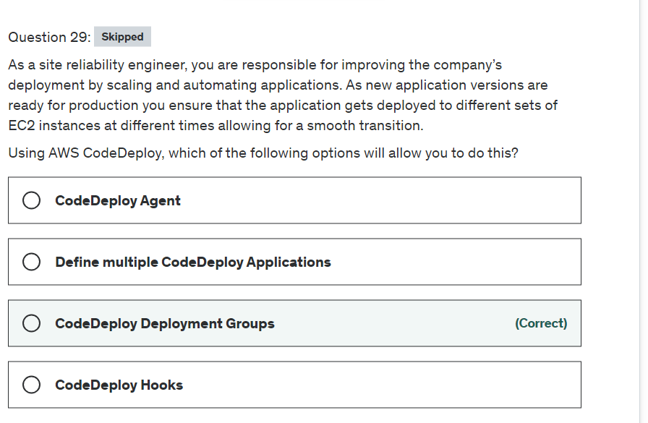

Explanation

Correct option:

**CodeDeploy Deployment Groups**

You can specify one or more deployment groups for a CodeDeploy application. The deployment group contains settings and configurations used during the deployment. Most deployment group settings depend on the compute platform used by your application. Some settings, such as rollbacks, triggers, and alarms can be configured for deployment groups for any compute platform.

In an EC2/On-Premises deployment, a deployment group is a set of individual instances targeted for deployment. A deployment group contains individually tagged instances, Amazon EC2 instances in Amazon EC2 Auto Scaling groups, or both.

Incorrect options:

**CodeDeploy Agent** - The CodeDeploy agent is a software package that, when installed and configured on an instance, makes it possible for that instance to be used in CodeDeploy deployments. The agent connects the EC2 instances to the CodeDeploy service.

**CodeDeploy Hooks** - Hooks are found in the AppSec file used by AWS CodeDeploy to manage deployment. Hooks correspond to lifecycle events such as ApplicationStart, ApplicationStop, etc. to which you can assign a script.

**Define multiple CodeDeploy Applications** - This option has been added as a distractor. Instead, you want to use deployment groups to use the same deployment and maybe separate the times when a group of instances receives the software updates.

Reference:

<https://docs.aws.amazon.com/codedeploy/latest/userguide/deployment-groups.html>

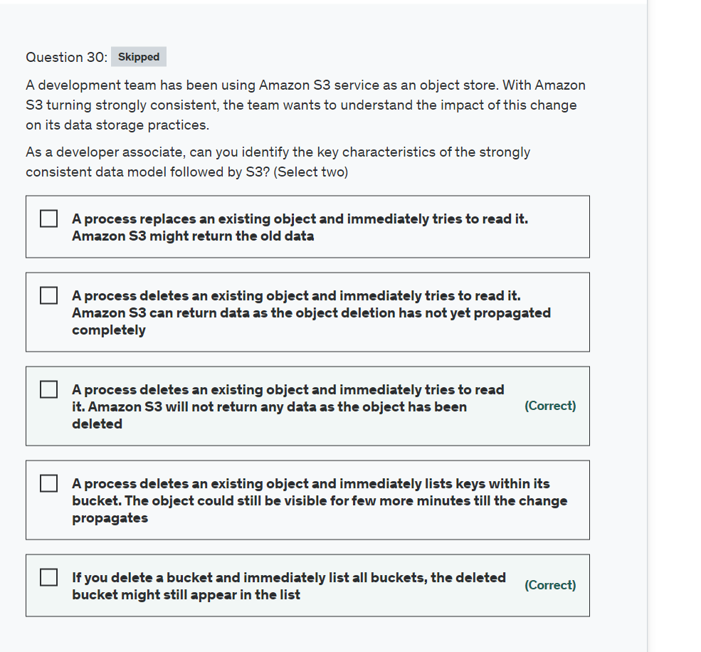

Explanation

Correct options:

**If you delete a bucket and immediately list all buckets, the deleted bucket might still appear in the list** - Bucket configurations have an eventual consistency model. If you delete a bucket and immediately list all buckets, the deleted bucket might still appear in the list.

**A process deletes an existing object and immediately tries to read it. Amazon S3 will not return any data as the object has been deleted** - Amazon S3 provides strong read-after-write consistency for PUTs and DELETEs of objects in your Amazon S3 bucket in all AWS Regions. This applies to both writes to new objects as well as PUTs that overwrite existing objects and DELETEs.

Amazon S3 data consistency model: 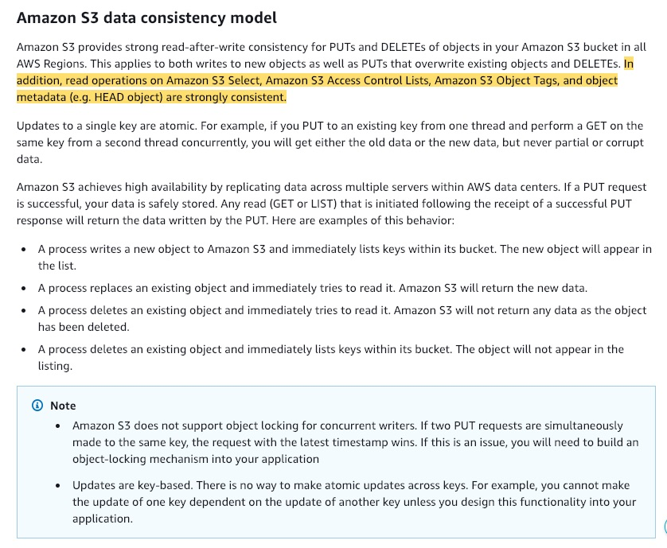 via - <https://docs.aws.amazon.com/AmazonS3/latest/userguide/Welcome.html#ConsistencyModel>

Incorrect options:

**A process deletes an existing object and immediately lists keys within its bucket. The object could still be visible for few more minutes till the change propagates**

**A process deletes an existing object and immediately tries to read it. Amazon S3 can return data as the object deletion has not yet propagated completely** -

These two options highlight an eventually consistent behavior. Amazon S3 is now strongly consistent and will not return any data as the object has been deleted. So both these options are incorrect.

**A process replaces an existing object and immediately tries to read it. Amazon S3 might return the old data** - Amazon S3 will return the new data.

Reference:

<https://docs.aws.amazon.com/AmazonS3/latest/userguide/Welcome.html#ConsistencyModel>

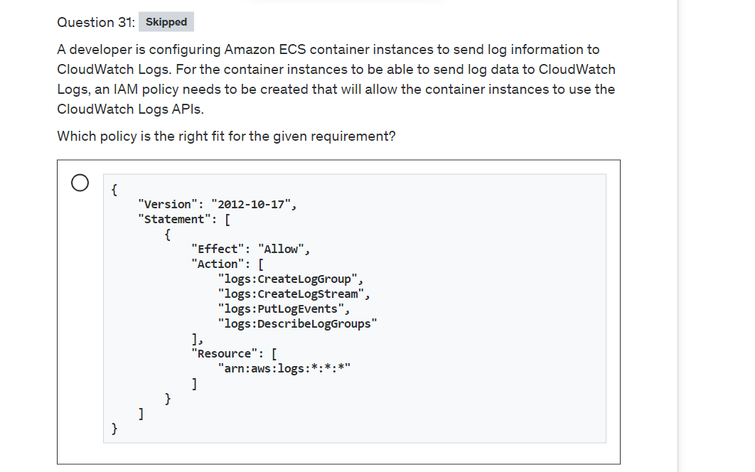

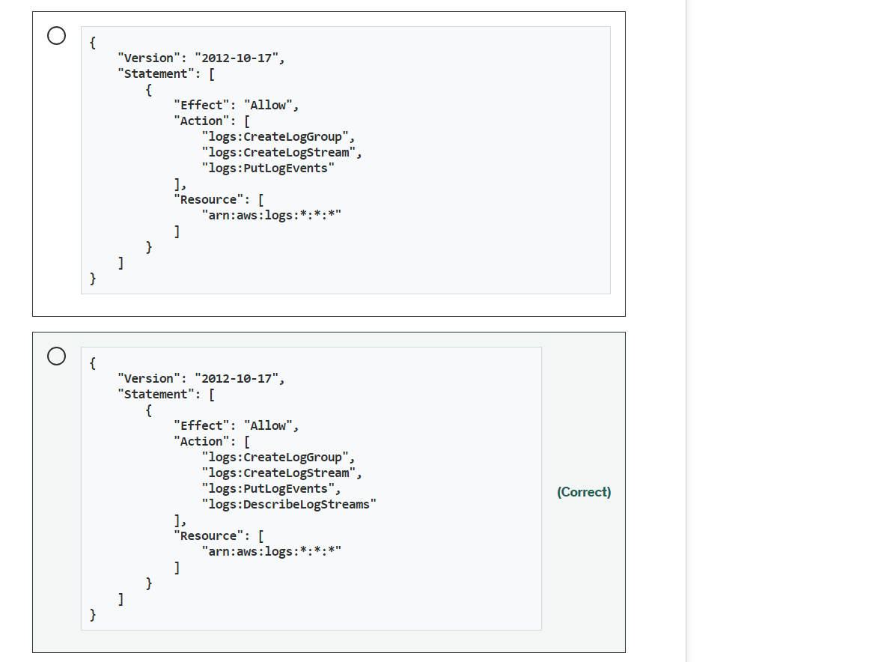

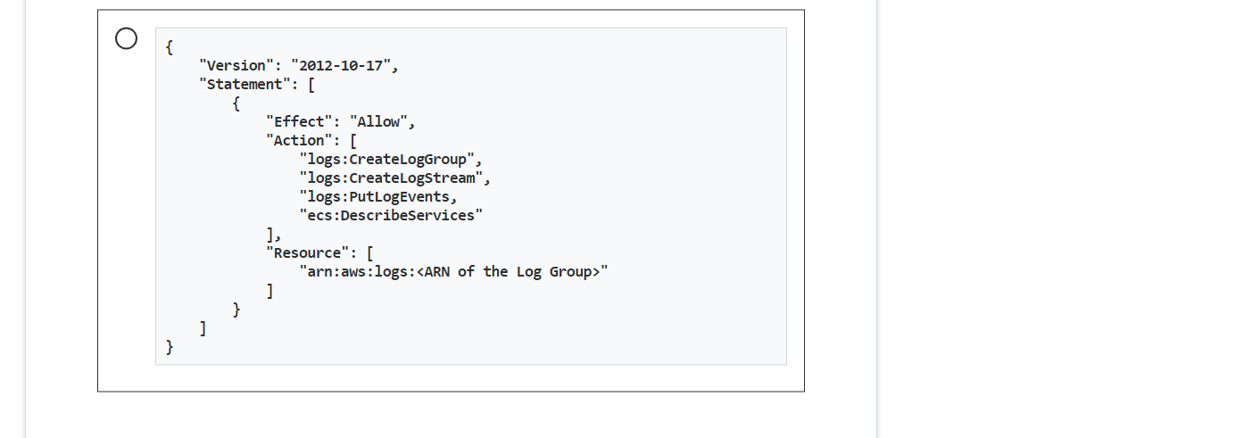

**Explanation**

Correct option:

{

"Version": "2012-10-17",

"Statement": [

{

"Effect": "Allow",

"Action": [

"logs:CreateLogGroup",

"logs:CreateLogStream",

"logs:PutLogEvents",

"logs:DescribeLogStreams"

],

"Resource": [

"arn:aws:logs:*:*:*"

]

}

]

}

Before your container instances can send log data to CloudWatch Logs, you must create an IAM policy to allow your container instances to use the CloudWatch Logs APIs, and then you must attach that policy to ecsInstanceRole.

This policy has one statement that grants permissions to create log groups and log streams, to upload log events to log streams, and to list details about log streams.

The wildcard character (*) at the end of the Resource value means that the statement allows permission for the logs:CreateLogGroup, logs:CreateLogStream, logs:PutLogEvents, and logs:DescribeLogStreams actions on any log group. To limit this permission to a specific log group, replace the wildcard character (*) in the resource ARN with the specific log group ARN

Incorrect options:

{

"Version": "2012-10-17",

"Statement": [

{

"Effect": "Allow",

"Action": [

"logs:CreateLogGroup",

"logs:CreateLogStream",

"logs:PutLogEvents"

],

"Resource": [

"arn:aws:logs:*:*:*"

]

}

]

}

Permission to list details of the log stream needs to be attached to this policy.

{

"Version": "2012-10-17",

"Statement": [

{

"Effect": "Allow",

"Action": [

"logs:CreateLogGroup",

"logs:CreateLogStream",

"logs:PutLogEvents,

"ecs:DescribeServices"

],

"Resource": [

"arn:aws:logs:<ARN of the Log Group>"

]

}

]

}```

- ecs:DescribeServices permission is not needed, but logs:DescribeLogStreams permissions are needed for the policy to perform as expected.

{ "Version": "2012-10-17", "Statement": [ { "Effect": "Allow", "Action": [ "logs:CreateLogGroup", "logs:CreateLogStream", "logs:PutLogEvents", "logs:DescribeLogGroups" ], "Resource": [ "arn:aws:logs:*:*:*" ] } ] } ```

logs:DescribeLogGroups is an erroneous permission here.

References:

<https://docs.aws.amazon.com/AmazonECS/latest/developerguide/using_cloudwatch_logs.html>

<https://docs.aws.amazon.com/AmazonCloudWatch/latest/logs/iam-identity-based-access-control-cwl.html>

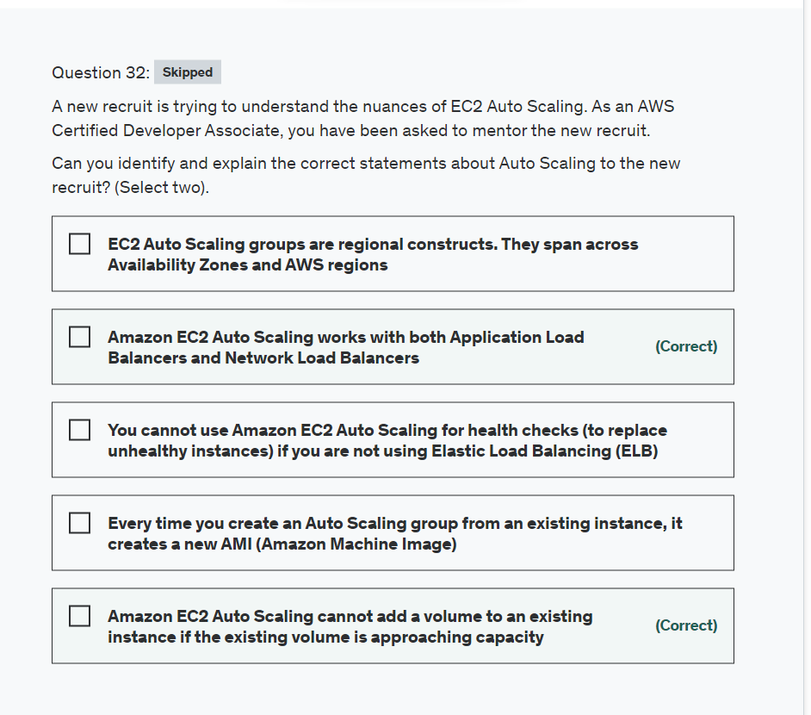

Top of Form

**Explanation**

Correct options:

Amazon EC2 Auto Scaling is a fully managed service designed to launch or terminate Amazon EC2 instances automatically to help ensure you have the correct number of Amazon EC2 instances available to handle the load for your application.

**Amazon EC2 Auto Scaling cannot add a volume to an existing instance if the existing volume is approaching capacity** - A volume is attached to a new instance when it is added. Amazon EC2 Auto Scaling doesn't automatically add a volume when the existing one is approaching capacity. You can use the EC2 API to add a volume to an existing instance.

**Amazon EC2 Auto Scaling works with both Application Load Balancers and Network Load Balancers** - Amazon EC2 Auto Scaling works with Application Load Balancers and Network Load Balancers including their health check feature.

Incorrect options:

**EC2 Auto Scaling groups are regional constructs. They span across Availability Zones and AWS regions** - This is an incorrect statement. EC2 Auto Scaling groups are regional constructs. They can span Availability Zones, but not AWS regions.

**Every time you create an Auto Scaling group from an existing instance, it creates a new AMI (Amazon Machine Image)** - This is an incorrect statement. When you create an Auto Scaling group from an existing instance, it does not create a new AMI.

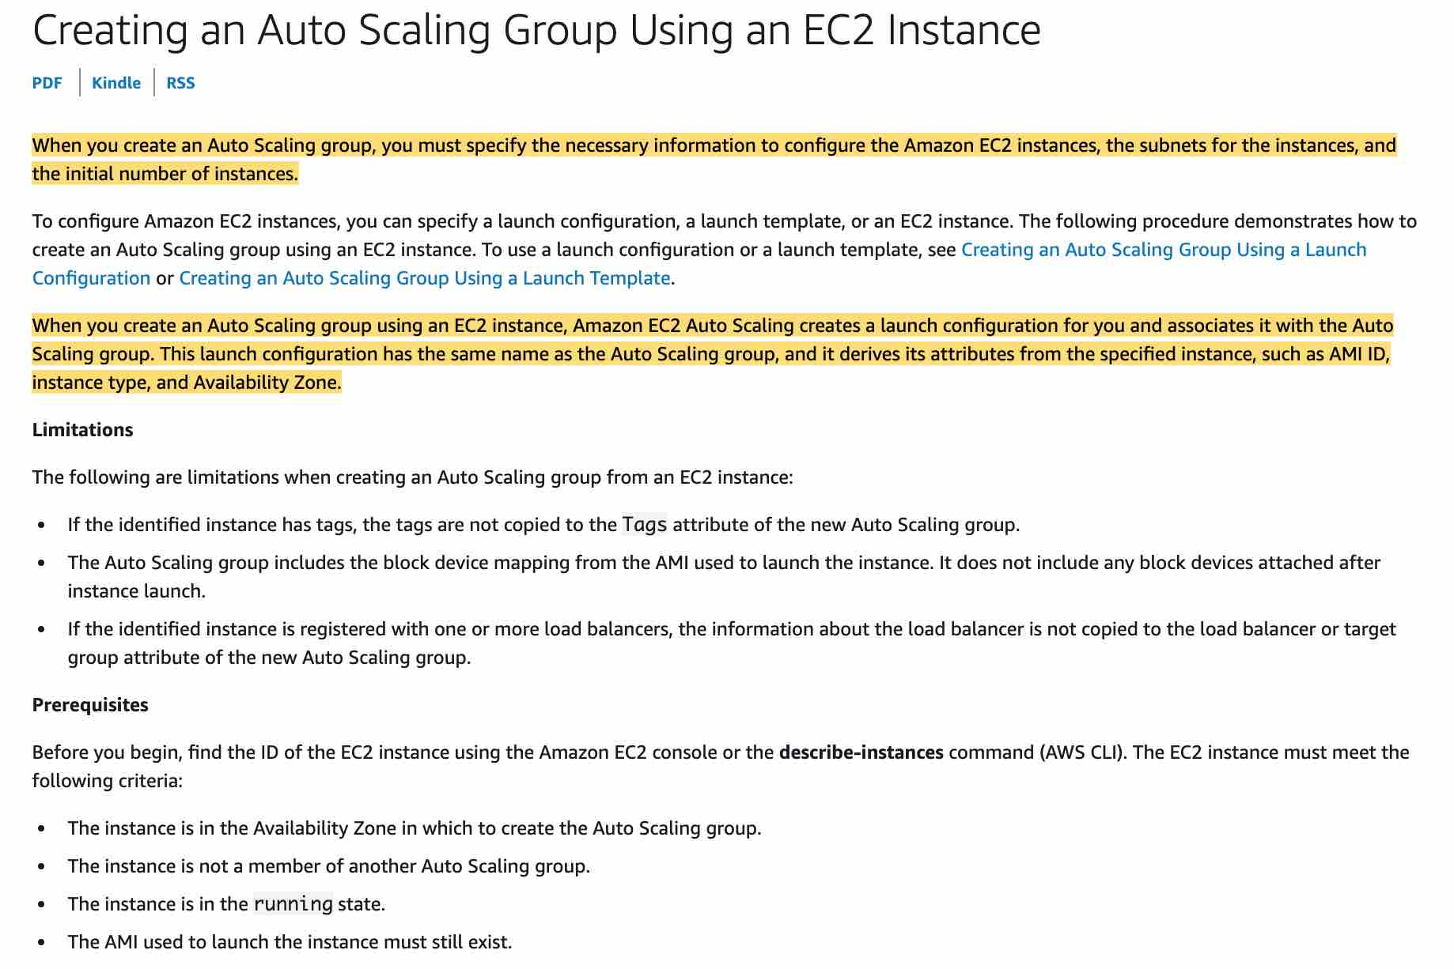 via - <https://docs.aws.amazon.com/autoscaling/ec2/userguide/create-asg-from-instance.html>

**You cannot use Amazon EC2 Auto Scaling for health checks (to replace unhealthy instances) if you are not using Elastic Load Balancing (ELB)** - This is an incorrect statement. You don't have to use ELB to use Auto Scaling. You can use the EC2 health check to identify and replace unhealthy instances.

References:

<https://aws.amazon.com/ec2/autoscaling/faqs/>

<https://docs.aws.amazon.com/autoscaling/ec2/userguide/create-asg-from-instance.html>

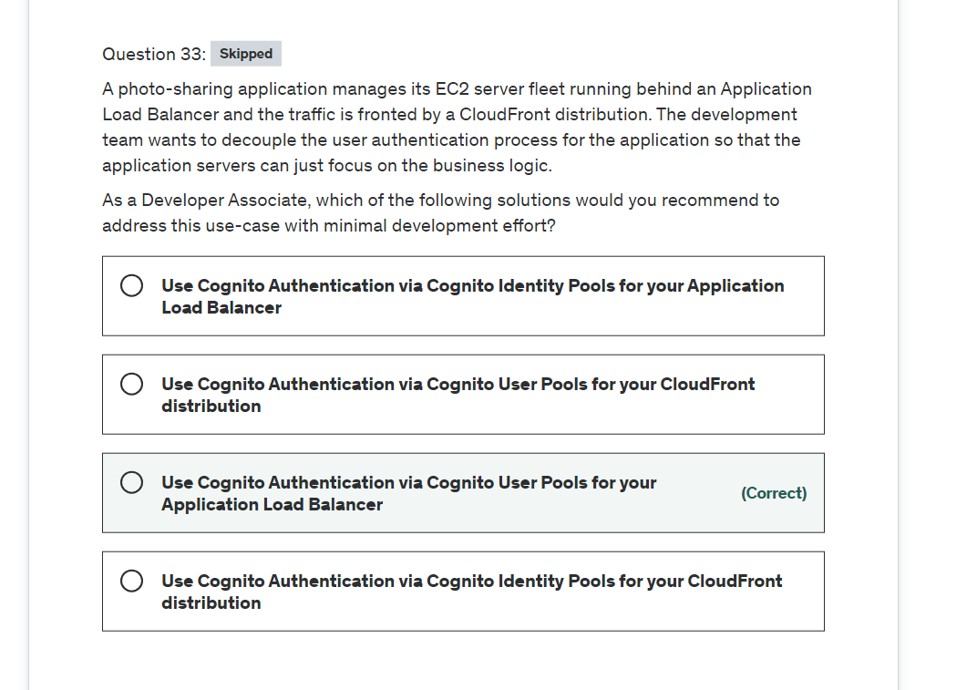

Explanation

Correct option:

**Use Cognito Authentication via Cognito User Pools for your Application Load Balancer**

Application Load Balancer can be used to securely authenticate users for accessing your applications. This enables you to offload the work of authenticating users to your load balancer so that your applications can focus on their business logic. You can use Cognito User Pools to authenticate users through well-known social IdPs, such as Amazon, Facebook, or Google, through the user pools supported by Amazon Cognito or through corporate identities, using SAML, LDAP, or Microsoft AD, through the user pools supported by Amazon Cognito. You configure user authentication by creating an authenticate action for one or more listener rules. The authenticate-cognito and authenticate-oidc action types are supported only with HTTPS listeners.

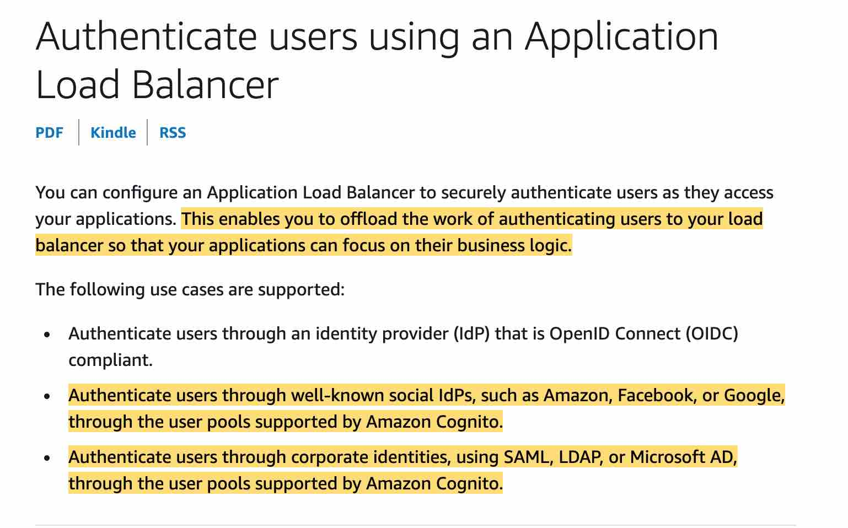 via - <https://docs.aws.amazon.com/elasticloadbalancing/latest/application/listener-authenticate-users.html>

Please make sure that you adhere to the following configurations while using CloudFront distribution in front of your Application Load Balancer: 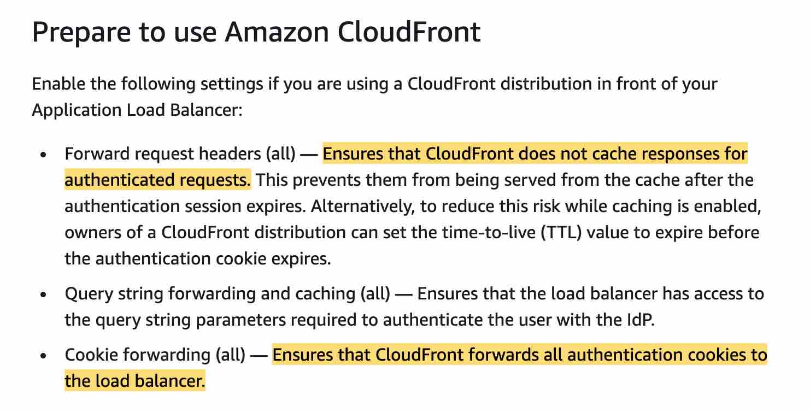 via - <https://docs.aws.amazon.com/elasticloadbalancing/latest/application/listener-authenticate-users.html>

Exam Alert:

Please review the following note to understand the differences between Cognito User Pools and Cognito Identity Pools: 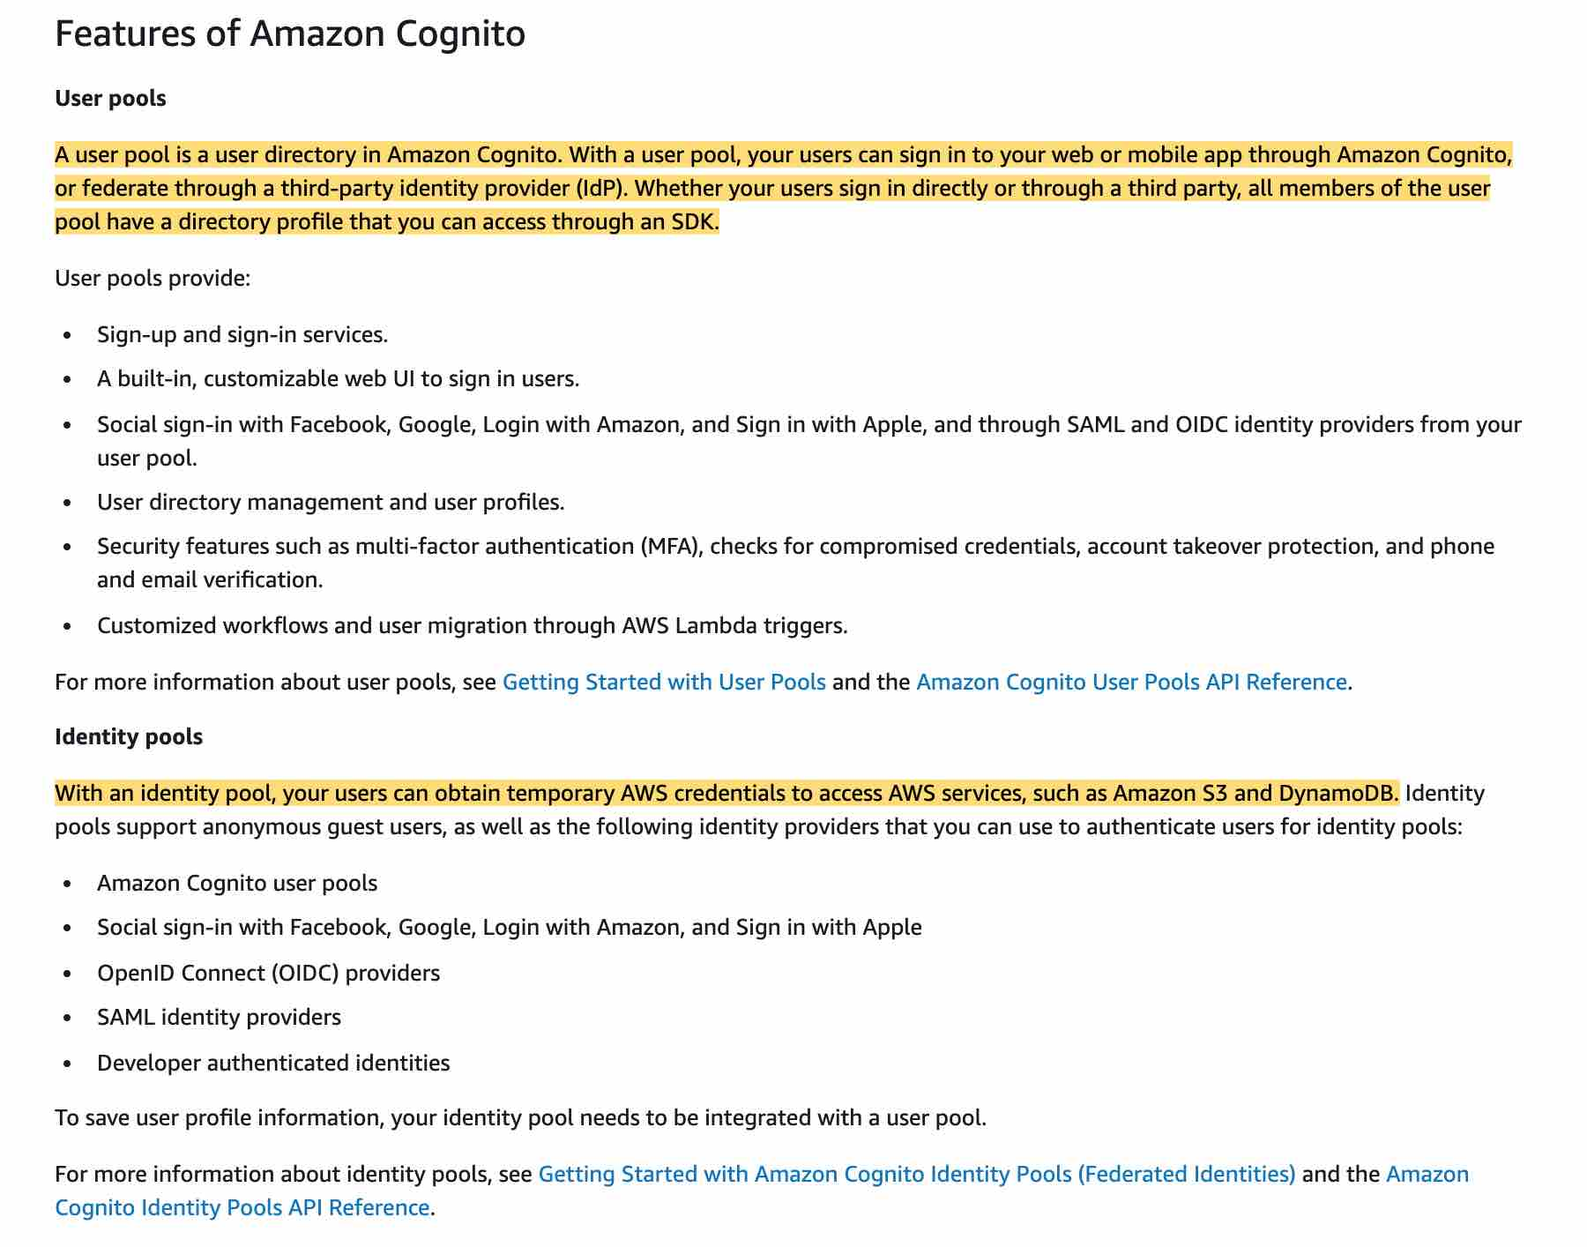 via - <https://docs.aws.amazon.com/cognito/latest/developerguide/what-is-amazon-cognito.html>

Incorrect options:

**Use Cognito Authentication via Cognito Identity Pools for your Application Load Balancer** - There is no such thing as using Cognito Authentication via Cognito Identity Pools for managing user authentication for the application. Application-specific user authentication can be provided via Cognito User Pools. Amazon Cognito identity pools provide temporary AWS credentials for users who are guests (unauthenticated) and for users who have been authenticated and received a token.

**Use Cognito Authentication via Cognito User Pools for your CloudFront distribution** - You cannot directly integrate Cognito User Pools with CloudFront distribution as you have to create a separate Lambda@Edge function to accomplish the authentication via Cognito User Pools. This involves additional development effort, so this option is not the best fit for the given use-case.

**Use Cognito Authentication via Cognito Identity Pools for your CloudFront distribution** - You cannot use Cognito Identity Pools for managing user authentication, so this option is not correct.

References:

<https://docs.aws.amazon.com/elasticloadbalancing/latest/application/listener-authenticate-users.html>

<https://docs.aws.amazon.com/cognito/latest/developerguide/cognito-user-identity-pools.html>

<https://aws.amazon.com/blogs/networking-and-content-delivery/authorizationedge-using-cookies-protect-your-amazon-cloudfront-content-from-being-downloaded-by-unauthenticated-users/>

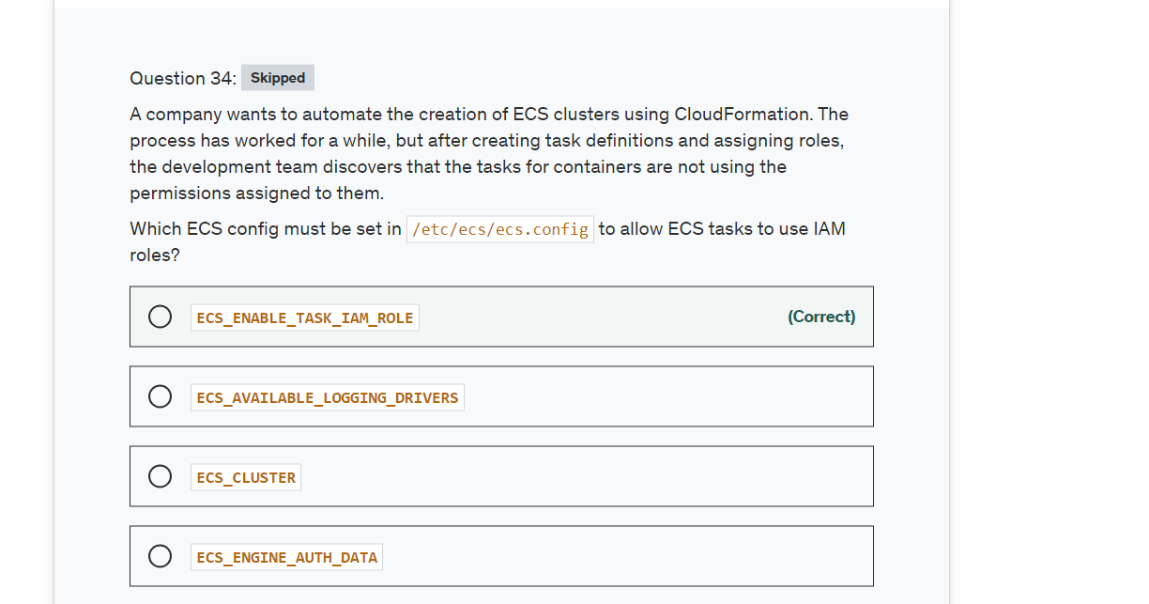

Explanation

Correct option:

**ECS_ENABLE_TASK_IAM_ROLE**

This configuration item is used to enable IAM roles for tasks for containers with the bridge and default network modes.

Incorrect options:

**ECS_ENGINE_AUTH_DATA** - This refers to the authentication data within a Docker configuration file, so this is not the correct option.

**ECS_AVAILABLE_LOGGING_DRIVERS** - The Amazon ECS container agent running on a container instance must register the logging drivers available on that instance with this variable. This configuration item refers to the logging driver.

**ECS_CLUSTER** - This refers to the ECS cluster that the ECS agent should check into. This is passed to the container instance at launch through Amazon EC2 user data.

Reference:

<https://docs.aws.amazon.com/AmazonECS/latest/developerguide/ecs-agent-config.html>

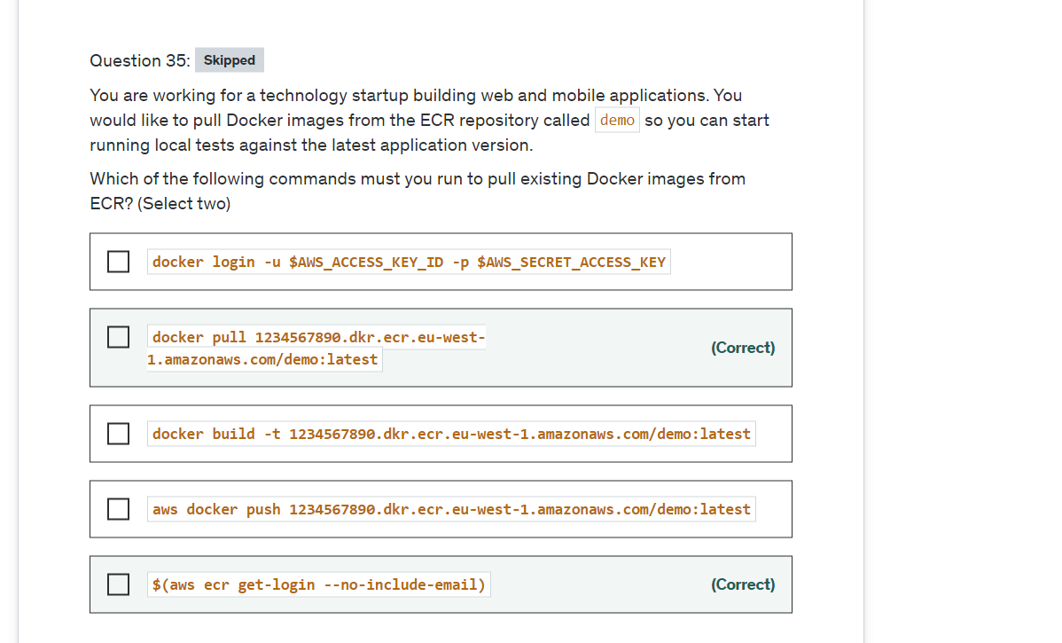

Explanation

Correct options:

**$(aws ecr get-login --no-include-email)**

**docker pull 1234567890.dkr.ecr.eu-west-1.amazonaws.com/demo:latest**

The get-login command retrieves a token that is valid for a specified registry for 12 hours, and then it prints a docker login command with that authorization token. You can execute the printed command to log in to your registry with Docker, or just run it automatically using the $() command wrapper. After you have logged in to an Amazon ECR registry with this command, you can use the Docker CLI to push and pull images from that registry until the token expires. The docker pull command is used to pull an image from the ECR registry.

Incorrect options:

**docker login -u $AWS_ACCESS_KEY_ID -p $AWS_SECRET_ACCESS_KEY** - You cannot login to AWS ECR this way. AWS_ACCESS_KEY_ID and AWS_SECRET_ACCESS_KEY are only used by the CLI and not by docker.

**aws docker push 1234567890.dkr.ecr.eu-west-1.amazonaws.com/demo:latest** - docker push here is the wrong answer, you need to use docker pull.

**docker build -t 1234567890.dkr.ecr.eu-west-1.amazonaws.com/demo:latest** - This is a docker command that is used to build Docker images from a Dockerfile.

Reference:

<https://docs.aws.amazon.com/cli/latest/reference/ecr/get-login.html>

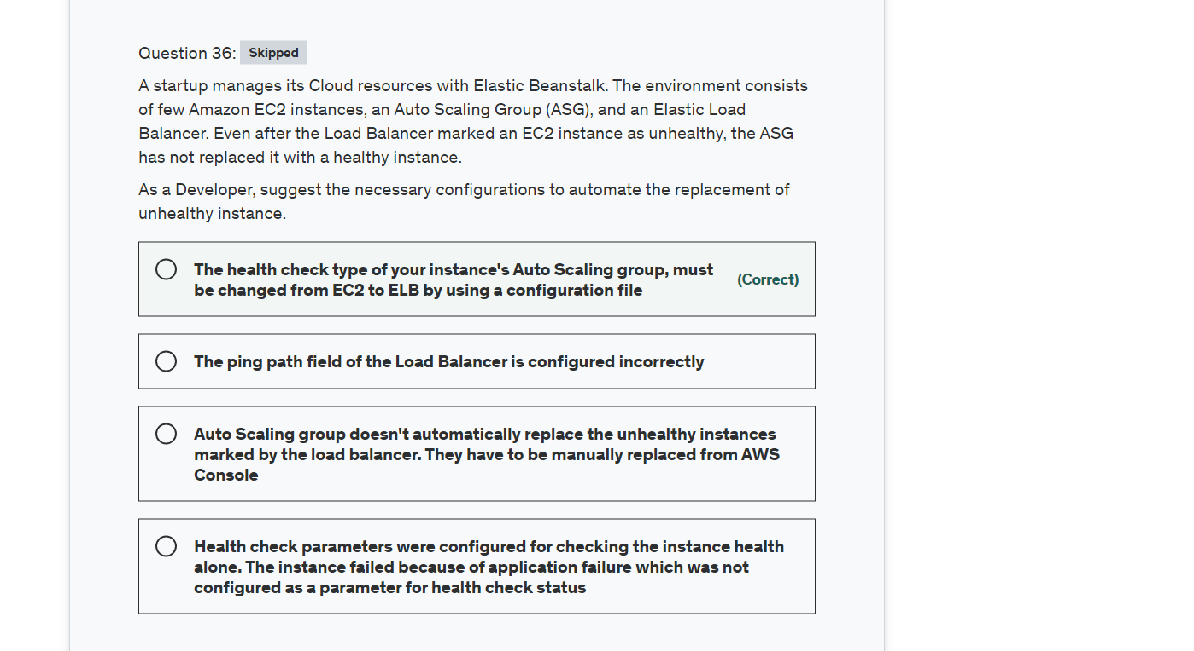

Explanation

Correct option:

**The health check type of your instance's Auto Scaling group, must be changed from EC2 to ELB by using a configuration file** - By default, the health check configuration of your Auto Scaling group is set as an EC2 type that performs a status check of EC2 instances. To automate the replacement of unhealthy EC2 instances, you must change the health check type of your instance's Auto Scaling group from EC2 to ELB by using a configuration file.

Incorrect options:

**Health check parameters were configured for checking the instance health alone. The instance failed because of application failure which was not configured as a parameter for health check status** - This is an incorrect statement. Status checks, by definition, cover only an EC2 instance's health, and not the health of your application, server, or any Docker containers running on the instance.

**Auto Scaling group doesn't automatically replace the unhealthy instances marked by the load balancer. They have to be manually replaced from AWS Console** - Incorrect statement. As discussed above, if the health check type of ASG is changed from EC2 to ELB, Auto Scaling will be able to replace the unhealthy instance.

**The ping path field of the Load Balancer is configured incorrectly** - Ping path is a health check configuration field of Elastic Load Balancer. If the ping path is configured wrong, ELB will not be able to reach the instance and hence will consider the instance unhealthy. However, this would then apply to all instances, not just once instance. So it does not address the issue given in the use-case.

References:

<https://aws.amazon.com/premiumsupport/knowledge-center/elastic-beanstalk-instance-automation/>

<https://docs.aws.amazon.com/elasticloadbalancing/latest/classic/elb-healthchecks.html>

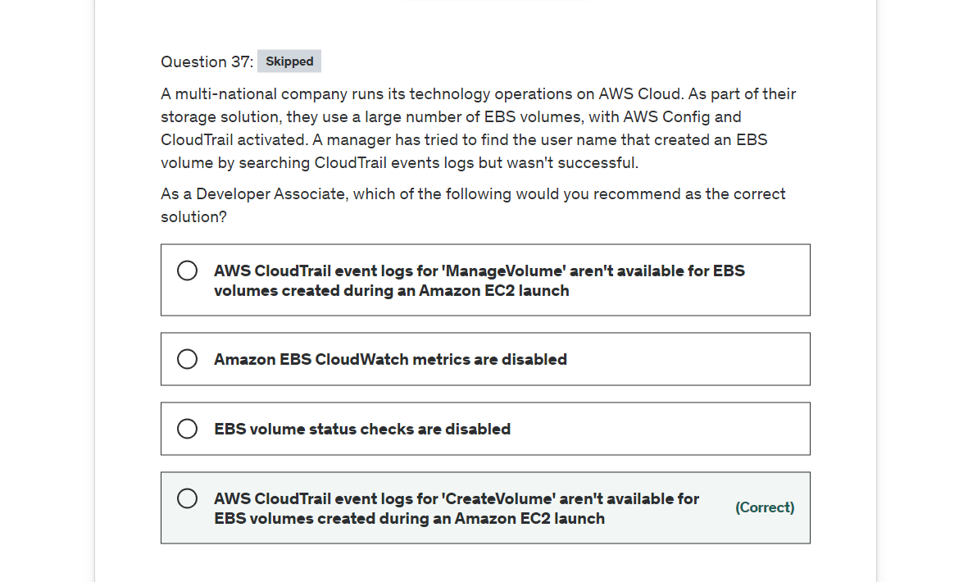

Explanation

Correct option:

**AWS CloudTrail event logs for 'CreateVolume' aren't available for EBS volumes created during an Amazon EC2 launch** - AWS CloudTrail event logs for 'CreateVolume' aren't available for EBS volumes created during an Amazon Elastic Compute Cloud (Amazon EC2) launch.

Incorrect options:

**AWS CloudTrail event logs for 'ManageVolume' aren't available for EBS volumes created during an Amazon EC2 launch** - Event 'ManageVolume' is a made-up option and has been added as a distractor.

**Amazon EBS CloudWatch metrics are disabled** - Amazon Elastic Block Store (Amazon EBS) sends data points to CloudWatch for several metrics. Data is only reported to CloudWatch when the volume is attached to an instance. CloudWatch metrics are useful in tracking the status or life cycle changes of an EBS volume, they are not useful in knowing about the metadata of EBS volumes.

**EBS volume status checks are disabled** - Volume status checks enable you to better understand, track and manage potential inconsistencies in the data on an Amazon EBS volume. They are designed to provide you with the information that you need to determine whether your Amazon EBS volumes are impaired, and to help you control how a potentially inconsistent volume is handled. Our current use case requires us to pull data about EBS volume metadata, which is not possible with this feature.

References:

<https://aws.amazon.com/premiumsupport/knowledge-center/find-ebs-user-config-cloudtrail/>

<https://docs.aws.amazon.com/AWSEC2/latest/UserGuide/using_cloudwatch_ebs.html>

<https://docs.aws.amazon.com/AWSEC2/latest/UserGuide/monitoring-volume-status.html>

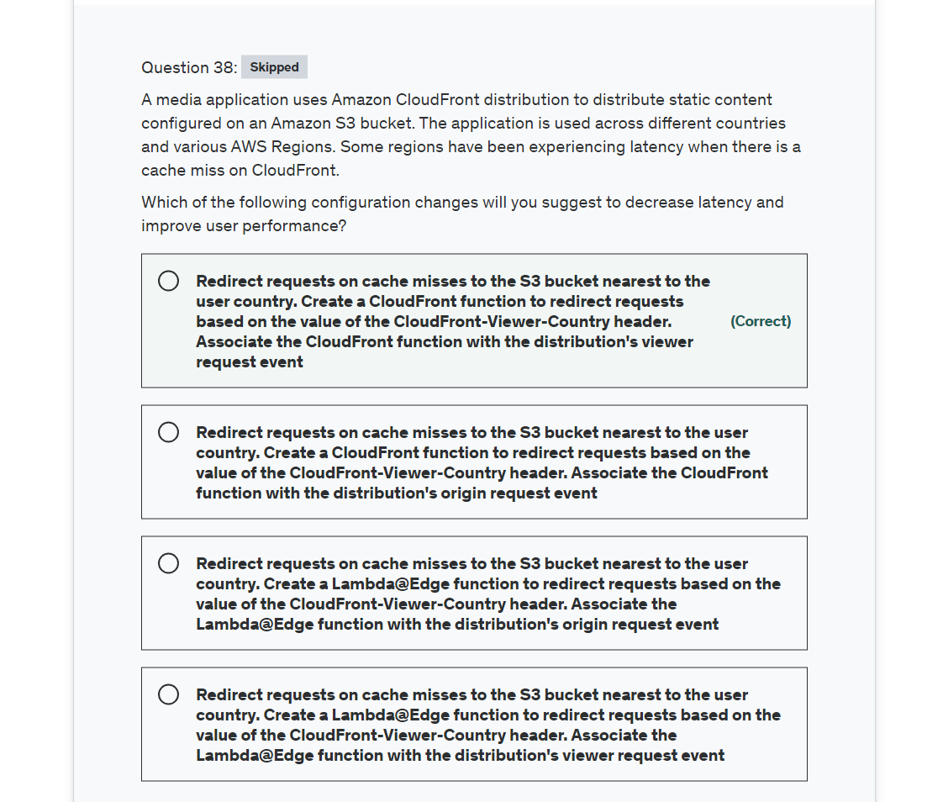

**Explanation**

Correct option:

**Redirect requests on cache misses to the Amazon S3 bucket nearest to the user country. Create a CloudFront function to redirect requests based on the value of the CloudFront-Viewer-Country header. Associate the CloudFront function with the distribution's viewer request event**

With CloudFront Functions in Amazon CloudFront, you can write lightweight functions in JavaScript for high-scale, latency-sensitive CDN customizations. Your functions can manipulate the requests and responses that flow through CloudFront, perform basic authentication and authorization, generate HTTP responses at the edge, and more.

When you associate a CloudFront function with a CloudFront distribution, CloudFront intercepts requests and responses at CloudFront edge locations and passes them to your function. You can invoke CloudFront functions when the following events occur: 1. When CloudFront receives a request from a viewer (viewer request): The function executes when CloudFront receives a request from a viewer before it checks to see whether the requested object is in the CloudFront cache.

Before CloudFront returns the response to the viewer (viewer response): The function executes before returning the requested file to the viewer. Note that the function executes regardless of whether the file is already in the CloudFront cache.

We use the value of the CloudFront-Viewer-Country header to update the S3 bucket domain name to a bucket in a Region that is closer to the viewer. This can be useful in several ways: 1. It reduces latencies when the Region specified is nearer to the viewer's country. 2. It provides data sovereignty by making sure that data is served from an origin that's in the same country that the request came from.

The example below shows how a Lambda handler is used to change response based on user country. A similar CloudFront function can be defined to direct user traffic to the nearest S3 bucket.

Example for redirecting viewer requests to a country-specific URL: 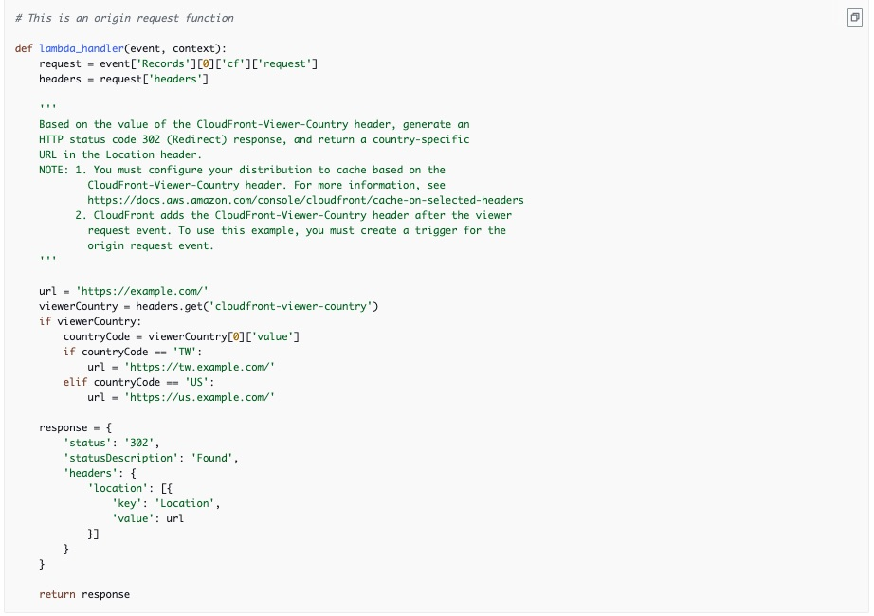 via - <https://docs.aws.amazon.com/AmazonCloudFront/latest/DeveloperGuide/lambda-examples.html#lambda-examples-content-based-S3-origin-request-trigger>

Choosing between CloudFront Functions and Lambda@Edge: 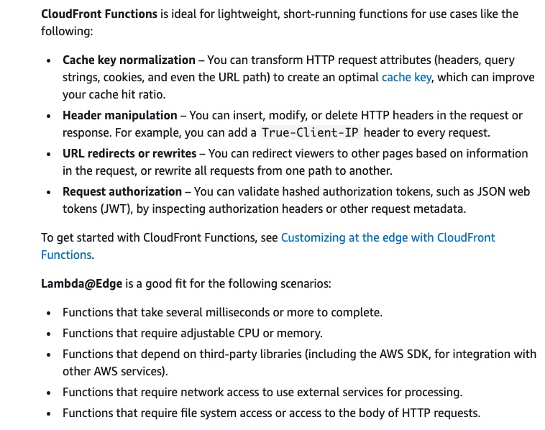 via - <https://docs.aws.amazon.com/AmazonCloudFront/latest/DeveloperGuide/edge-functions.html>

Incorrect options:

**Redirect requests on cache misses to the S3 bucket nearest to the user country. Create a Lambda@Edge function to redirect requests based on the value of the CloudFront-Viewer-Country header. Associate the Lambda@Edge function with the distribution's origin request event**

**Redirect requests on cache misses to the S3 bucket nearest to the user country. Create a Lambda@Edge function to redirect requests based on the value of the CloudFront-Viewer-Country header. Associate the Lambda@Edge function with the distribution's viewer request event** -

As discussed above, CloudFront Function is a better choice than Lambda@Edge function for this use case. Also, the Viewer request event is better suited for this requirement than the Origin request event to trigger the function.

Viewer request event: The function executes when CloudFront receives a request from a viewer before it checks to see whether the requested object is in the CloudFront cache.

Origin request event: The function executes only when CloudFront forwards a request to your origin. When the requested object is in the CloudFront cache, the function doesn't execute.

**Redirect requests on cache misses to the S3 bucket nearest to the user country. Create a CloudFront function to redirect requests based on the value of the CloudFront-Viewer-Country header. Associate the CloudFront function with the distribution's origin request event** - This option is incorrect. You can invoke CloudFront functions for only two events: When CloudFront receives a request from a viewer (viewer request) and Before CloudFront returns the response to the viewer (viewer response). Origin request and Origin response events are not supported for the CloudFront function.

References:

<https://docs.aws.amazon.com/AmazonCloudFront/latest/DeveloperGuide/lambda-examples.html#lambda-examples-redirecting-examples>

<https://docs.aws.amazon.com/AmazonCloudFront/latest/DeveloperGuide/edge-functions.html>

<https://docs.aws.amazon.com/AmazonCloudFront/latest/DeveloperGuide/lambda-cloudfront-trigger-events.html>

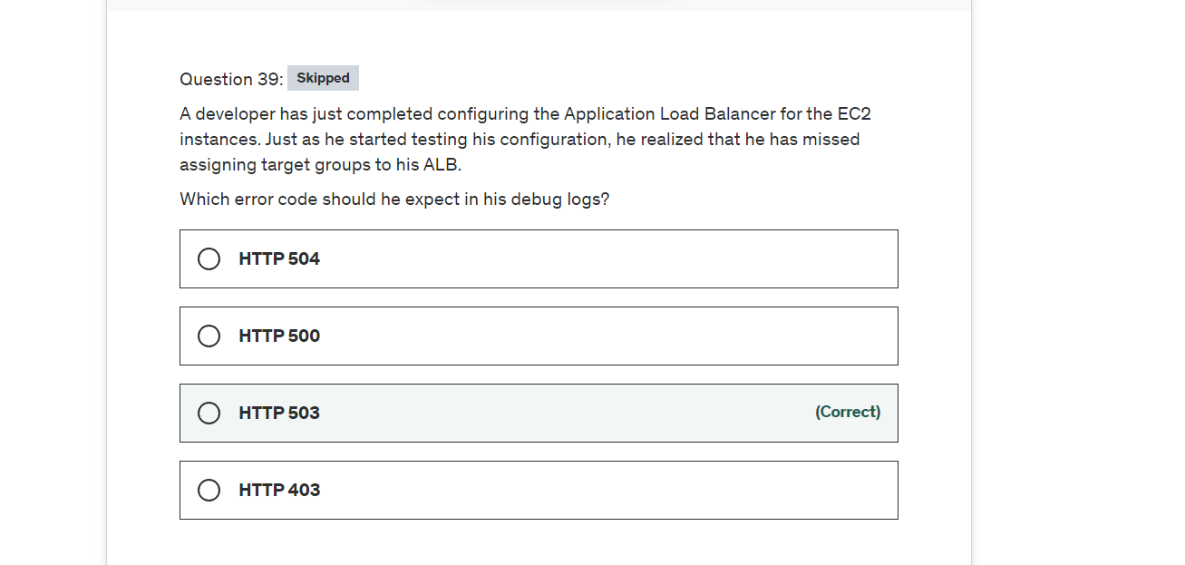

Explanation

Correct option:

**HTTP 503** - HTTP 503 indicates 'Service unavailable' error. This error in ALB is an indicator of the target groups for the load balancer having no registered targets.

Incorrect options:

**HTTP 500** - HTTP 500 indicates 'Internal server' error. There are several reasons for their error: A client submitted a request without an HTTP protocol, and the load balancer was unable to generate a redirect URL, there was an error executing the web ACL rules.

**HTTP 504** - HTTP 504 is 'Gateway timeout' error. Several reasons for this error, to quote a few: The load balancer failed to establish a connection to the target before the connection timeout expired, The load balancer established a connection to the target but the target did not respond before the idle timeout period elapsed.

**HTTP 403** - HTTP 403 is 'Forbidden' error. You configured an AWS WAF web access control list (web ACL) to monitor requests to your Application Load Balancer and it blocked a request.

Reference:

<https://docs.aws.amazon.com/elasticloadbalancing/latest/application/load-balancer-troubleshooting.html>

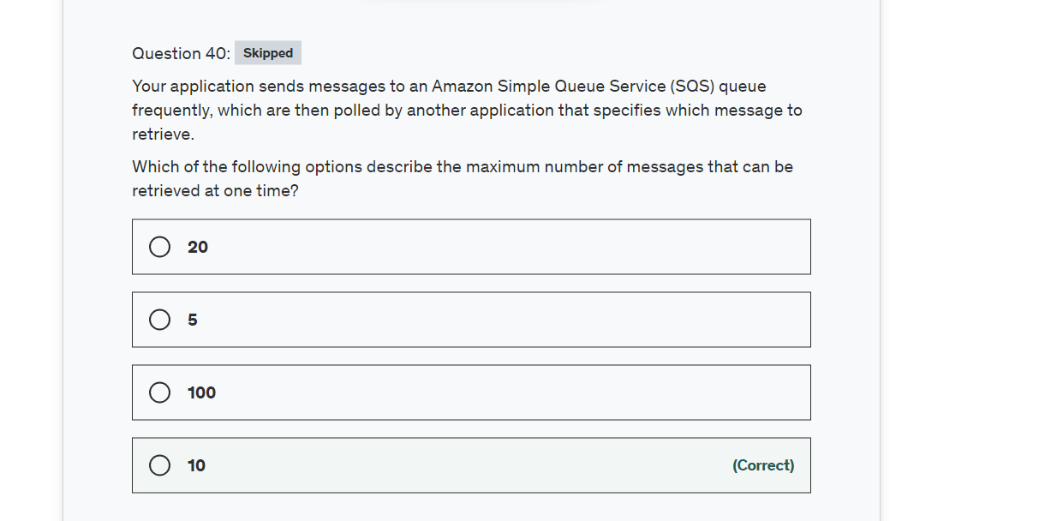

Explanation

Correct option:

**10**

After you send messages to a queue, you can receive and delete them. When you request messages from a queue, you can't specify which messages to retrieve. Instead, you specify the maximum number of messages (up to 10) that you want to retrieve.

Incorrect options:

**5**

**20**

**100**

Reference:

<https://docs.aws.amazon.com/AWSSimpleQueueService/latest/SQSDeveloperGuide/sqs-using-receive-delete-message.html>

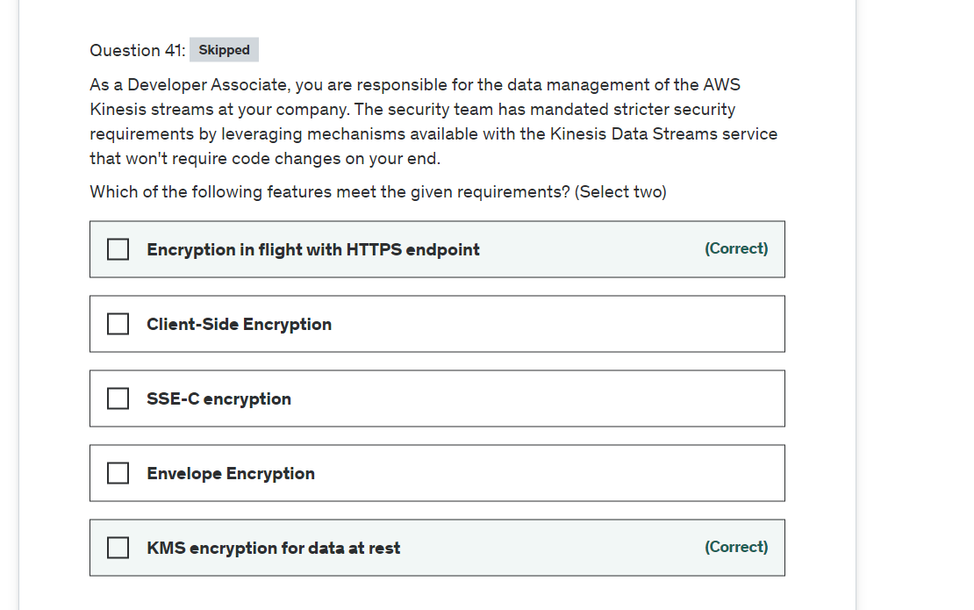

Explanation

Correct options:

**KMS encryption for data at rest**

**Encryption in flight with HTTPS endpoint**

Server-side encryption is a feature in Amazon Kinesis Data Streams that automatically encrypts data before it's at rest by using an AWS KMS customer master key (CMK) you specify. Data is encrypted before it's written to the Kinesis stream storage layer and decrypted after it's retrieved from storage. As a result, your data is encrypted at rest within the Kinesis Data Streams service. Also, the HTTPS protocol ensures that data inflight is encrypted as well.

Incorrect options:

**SSE-C encryption** - SSE-C is functionality in Amazon S3 where S3 encrypts your data, on your behalf, using keys that you provide. This does not apply for the given use-case.

**Client-Side Encryption** - This involves code changes, so the option is incorrect.

**Envelope Encryption** - This involves code changes, so the option is incorrect.

Reference:

<https://docs.aws.amazon.com/streams/latest/dev/what-is-sse.html>

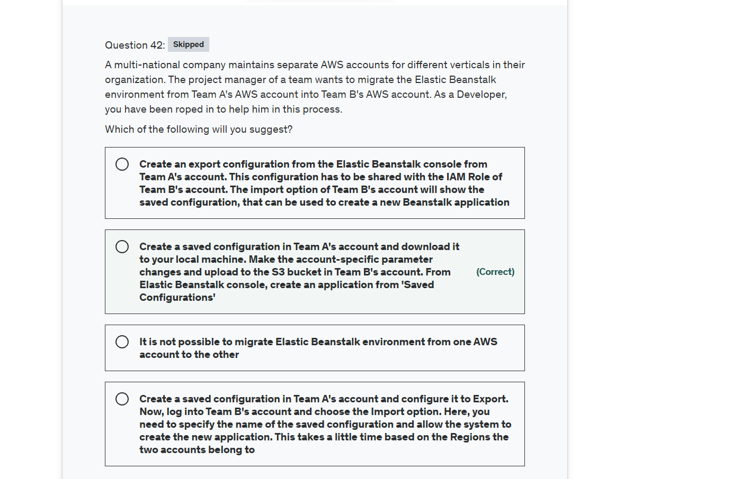

Explanation

Correct option:

**Create a saved configuration in Team A's account and download it to your local machine. Make the account-specific parameter changes and upload to the S3 bucket in Team B's account. From Elastic Beanstalk console, create an application from 'Saved Configurations** - You must use saved configurations to migrate an Elastic Beanstalk environment between AWS accounts. You can save your environment's configuration as an object in Amazon Simple Storage Service (Amazon S3) that can be applied to other environments during environment creation, or applied to a running environment. Saved configurations are YAML formatted templates that define an environment's platform version, tier, configuration option settings, and tags.

Download the saved configuration to your local machine. Change your account-specific parameters in the downloaded configuration file, and then save the changes. For example, change the key pair name, subnet ID, or application name (such as application-b-name). Upload the saved configuration from your local machine to an S3 bucket in Team B's account. From this account, create a new Beanstalk application by choosing 'Saved Configurations' from the navigation panel.

Incorrect options:

**Create a saved configuration in Team A's account and configure it to Export. Now, log into Team B's account and choose the Import option. Here, you need to specify the name of the saved configuration and allow the system to create the new application. This takes a little time based on the Regions the two accounts belong to** - There is no direct Export and Import option for migrating Elastic Beanstalk configurations.

**It is not possible to migrate Elastic Beanstalk environment from one AWS account to the other** - This is an incorrect statement.

**Create an export configuration from the Elastic Beanstalk console from Team A's account. This configuration has to be shared with the IAM Role of Team B's account. The import option of the Team B's account will show the saved configuration, that can be used to create a new Beanstalk application** - This contradicts the explanation provided earlier.

References:

<https://aws.amazon.com/premiumsupport/knowledge-center/elastic-beanstalk-migration-accounts/>

<https://docs.aws.amazon.com/elasticbeanstalk/latest/dg/environment-configuration-savedconfig.html>

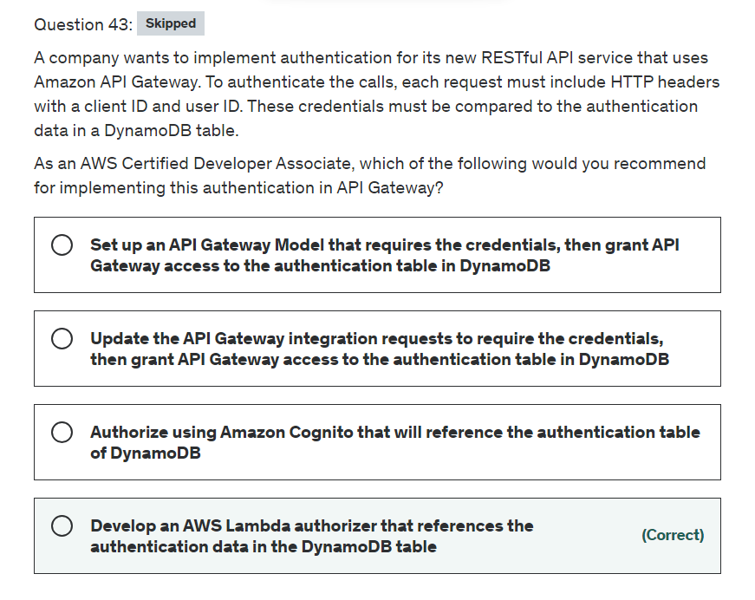

Explanation

Correct option:

**Develop an AWS Lambda authorizer that references the DynamoDB authentication table** - A Lambda authorizer is an API Gateway feature that uses a Lambda function to control access to your API.

A Lambda authorizer is useful if you want to implement a custom authorization scheme that uses a bearer token authentication strategy such as OAuth or SAML, or that uses request parameters to determine the caller's identity.

When a client makes a request to one of your API's methods, API Gateway calls your Lambda authorizer, which takes the caller's identity as input and returns an IAM policy as output.

There are two types of Lambda authorizers:

A token-based Lambda authorizer (also called a TOKEN authorizer) receives the caller's identity in a bearer token, such as a JSON Web Token (JWT) or an OAuth token.

A request parameter-based Lambda authorizer (also called a REQUEST authorizer) receives the caller's identity in a combination of headers, query string parameters, state variables, and $context variables.

API Gateway Lambda authorization workflow: 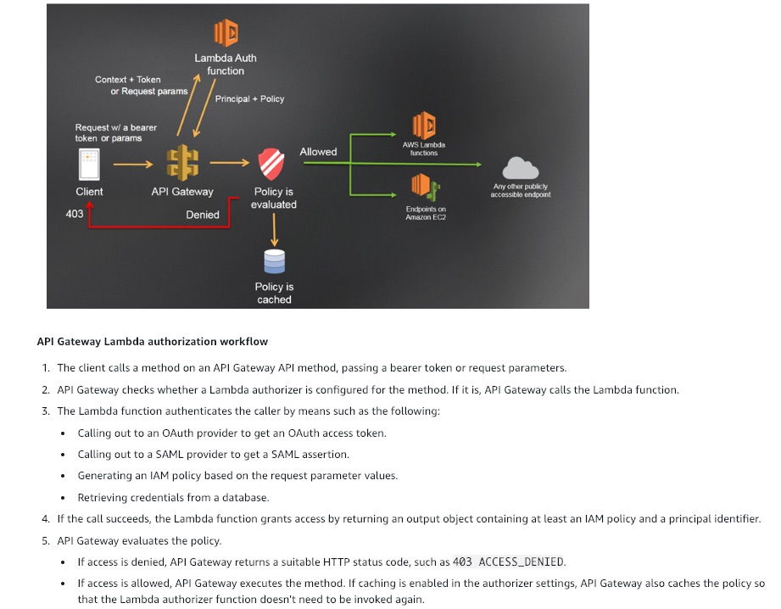 via - <https://docs.aws.amazon.com/apigateway/latest/developerguide/apigateway-use-lambda-authorizer.html>

Incorrect options:

**Set up an API Gateway Model that requires the credentials, then grant API Gateway access to the authentication table in DynamoDB** - In API Gateway, a model defines the data structure of a payload. In API Gateway models are defined using the JSON schema draft 4. Models are not mandatory.

**Update the API Gateway integration requests to require the credentials, then grant API Gateway access to the authentication table in DynamoDB** - After setting up an API method, you must integrate it with an endpoint in the backend. A backend endpoint is also referred to as an integration endpoint and can be a Lambda function, an HTTP webpage, or an AWS service action.

An integration request is an HTTP request that API Gateway submits to the backend, passing along the client-submitted request data, and transforming the data, if necessary. The HTTP method (or verb) and URI of the integration request are dictated by the backend (that is, the integration endpoint). They can be the same as or different from the method request's HTTP method and URI, respectively.

**Authorize using Amazon Cognito that will reference the authentication table of DynamoDB** - As an alternative to using IAM roles and policies or Lambda authorizers (formerly known as custom authorizers), you can use an Amazon Cognito user pool to control who can access your API in Amazon API Gateway.

To use an Amazon Cognito user pool with your API, you must first create an authorizer of the COGNITO_USER_POOLS type and then configure an API method to use that authorizer. After the API is deployed, the client must first sign the user in to the user pool, obtain an identity or access token for the user, and then call the API method with one of the tokens, which are typically set to the request's Authorization header. The API call succeeds only if the required token is supplied and the supplied token is valid, otherwise, the client isn't authorized to make the call because the client did not have credentials that could be authorized.

References:

<https://docs.aws.amazon.com/apigateway/latest/developerguide/apigateway-use-lambda-authorizer.html>

<https://docs.aws.amazon.com/apigateway/latest/developerguide/apigateway-integrate-with-cognito.html>

<https://docs.aws.amazon.com/apigateway/latest/developerguide/how-to-integration-settings.html>

<https://docs.aws.amazon.com/apigateway/latest/developerguide/models-mappings.html>

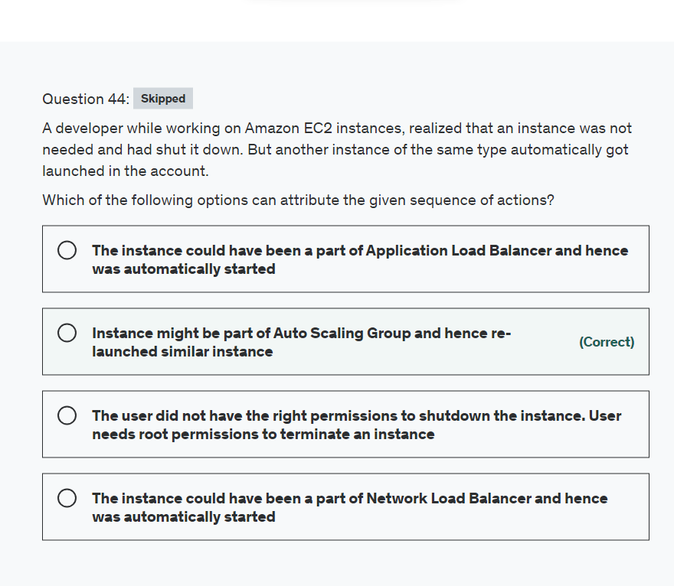

Explanation

Correct option:

**Instance might be part of Auto Scaling Group and hence re-launched similar instance** - Auto Scaling groups can be configured to launch an instance to replace an instance that is undergoing maintenance. This could have been the reason why an instance of the same type got launched automatically. The size of an Auto Scaling group depends on the number of instances that you set as the desired capacity. If you wish to terminate an instance that is part of Auto Scaling Group, the configuration of the group should be changed to a reduced number of instances, so the automatic launch of instances does not happen when an unwanted instance is terminated.

Incorrect options:

**The user did not have the right permissions to shutdown the instance. User needs root permissions to terminate an instance** - This is an incorrect statement. If the user does not have enough permissions, then the action itself is unavailable for him. A user does not need root permissions to terminate an EC2 instance.

**The instance could have been a part of the Application Load Balancer and hence was automatically started** - Application Load Balancer is used to balance the incoming traffic requests equally among the available EC2 instances so keep the performance and availability at its best. ALBs are configured with Auto Scaling Groups, but this is not specified in the use-case. In the absence of Auto Scaling Group, ALB cannot launch instances by itself.

**The instance could have been a part of Network Load Balancer and hence was automatically started** - As explained above for ALB, a Network Load Balancer is not capable of launching instances by itself if it's not configured with an Auto Scaling Group.

References:

<https://docs.aws.amazon.com/autoscaling/ec2/userguide/AutoScalingGroup.html>

<https://docs.aws.amazon.com/autoscaling/ec2/userguide/detach-instance-asg.html>

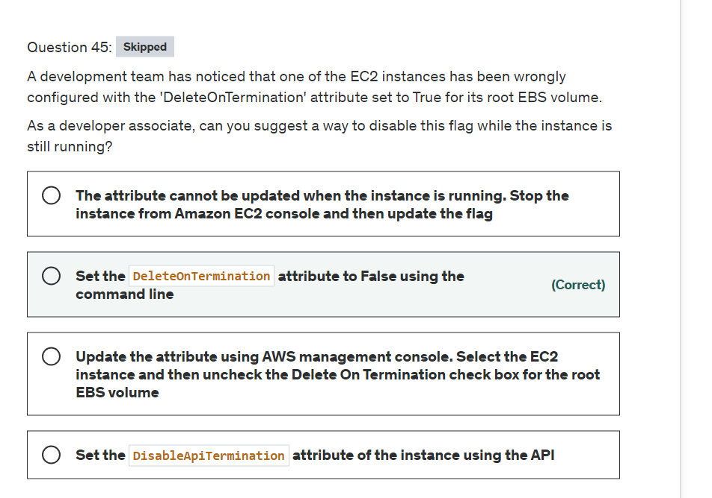

Explanation

Correct option:

When an instance terminates, the value of the DeleteOnTermination attribute for each attached EBS volume determines whether to preserve or delete the volume. By default, the DeleteOnTermination attribute is set to True for the root volume and is set to False for all other volume types.

**Set the DeleteOnTermination attribute to False using the command line** - If the instance is already running, you can set DeleteOnTermination to False using the command line.

Incorrect options:

**Update the attribute using AWS management console. Select the EC2 instance and then uncheck the Delete On Termination check box for the root EBS volume** - You can set the DeleteOnTermination attribute to False when you launch a new instance. It is not possible to update this attribute of a running instance from the AWS console.

**Set the DisableApiTermination attribute of the instance using the API** - By default, you can terminate your instance using the Amazon EC2 console, command-line interface, or API. To prevent your instance from being accidentally terminated using Amazon EC2, you can enable termination protection for the instance. The DisableApiTermination attribute controls whether the instance can be terminated using the console, CLI, or API. This option cannot be used to control the delete status for the EBS volume when the instance terminates.

**The attribute cannot be updated when the instance is running. Stop the instance from Amazon EC2 console and then update the flag** - This statement is wrong and given only as a distractor.

References:

<https://aws.amazon.com/premiumsupport/knowledge-center/deleteontermination-ebs/>

<https://docs.aws.amazon.com/AWSEC2/latest/UserGuide/terminating-instances.html#delete-on-termination-running-instance>

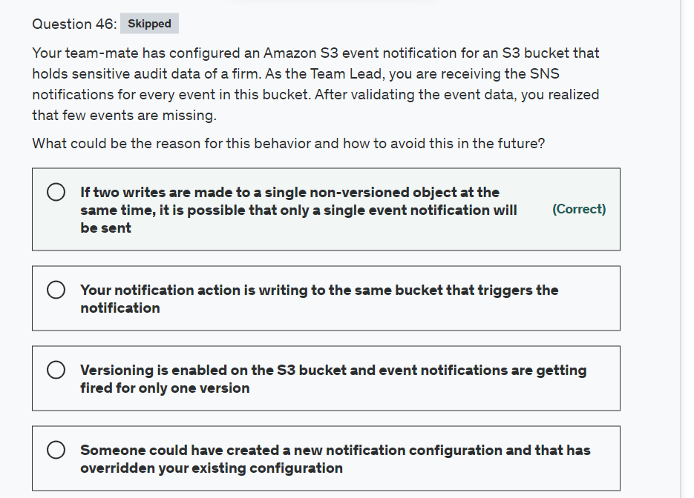

Explanation

Correct option:

**If two writes are made to a single non-versioned object at the same time, it is possible that only a single event notification will be sent** - Amazon S3 event notifications are designed to be delivered at least once. Typically, event notifications are delivered in seconds but can sometimes take a minute or longer.

If two writes are made to a single non-versioned object at the same time, it is possible that only a single event notification will be sent. If you want to ensure that an event notification is sent for every successful write, you can enable versioning on your bucket. With versioning, every successful write will create a new version of your object and will also send event notification.

Incorrect options:

**Someone could have created a new notification configuration and that has overridden your existing configuration** - It is possible that the configuration can be overridden. But, in the current scenario, the team lead is receiving notifications for most of the events, which nullifies the claim that the configuration is overridden.

**Versioning is enabled on the S3 bucket and event notifications are getting fired for only one version** - This is an incorrect statement. If you want to ensure that an event notification is sent for every successful write, you should enable versioning on your bucket. With versioning, every successful write will create a new version of your object and will also send event notification.

**Your notification action is writing to the same bucket that triggers the notification** - If your notification ends up writing to the bucket that triggers the notification, this could cause an execution loop. But it will not result in missing events.

Reference:

<https://docs.aws.amazon.com/AmazonS3/latest/dev/NotificationHowTo.html>

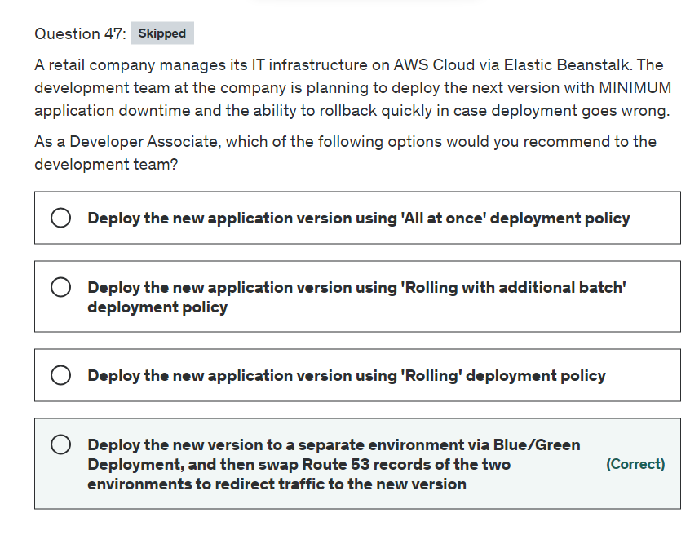

Explanation

Correct option:

**Deploy the new version to a separate environment via Blue/Green Deployment, and then swap Route 53 records of the two environments to redirect traffic to the new version**

With deployment policies such as 'All at once', AWS Elastic Beanstalk performs an in-place update when you update your application versions and your application can become unavailable to users for a short period of time. You can avoid this downtime by performing a blue/green deployment, where you deploy the new version to a separate environment, and then swap CNAMEs (via Route 53) of the two environments to redirect traffic to the new version instantly. In case of any deployment issues, the rollback process is very quick via swapping the URLs for the two environments.

Overview of Elastic Beanstalk Deployment Policies: 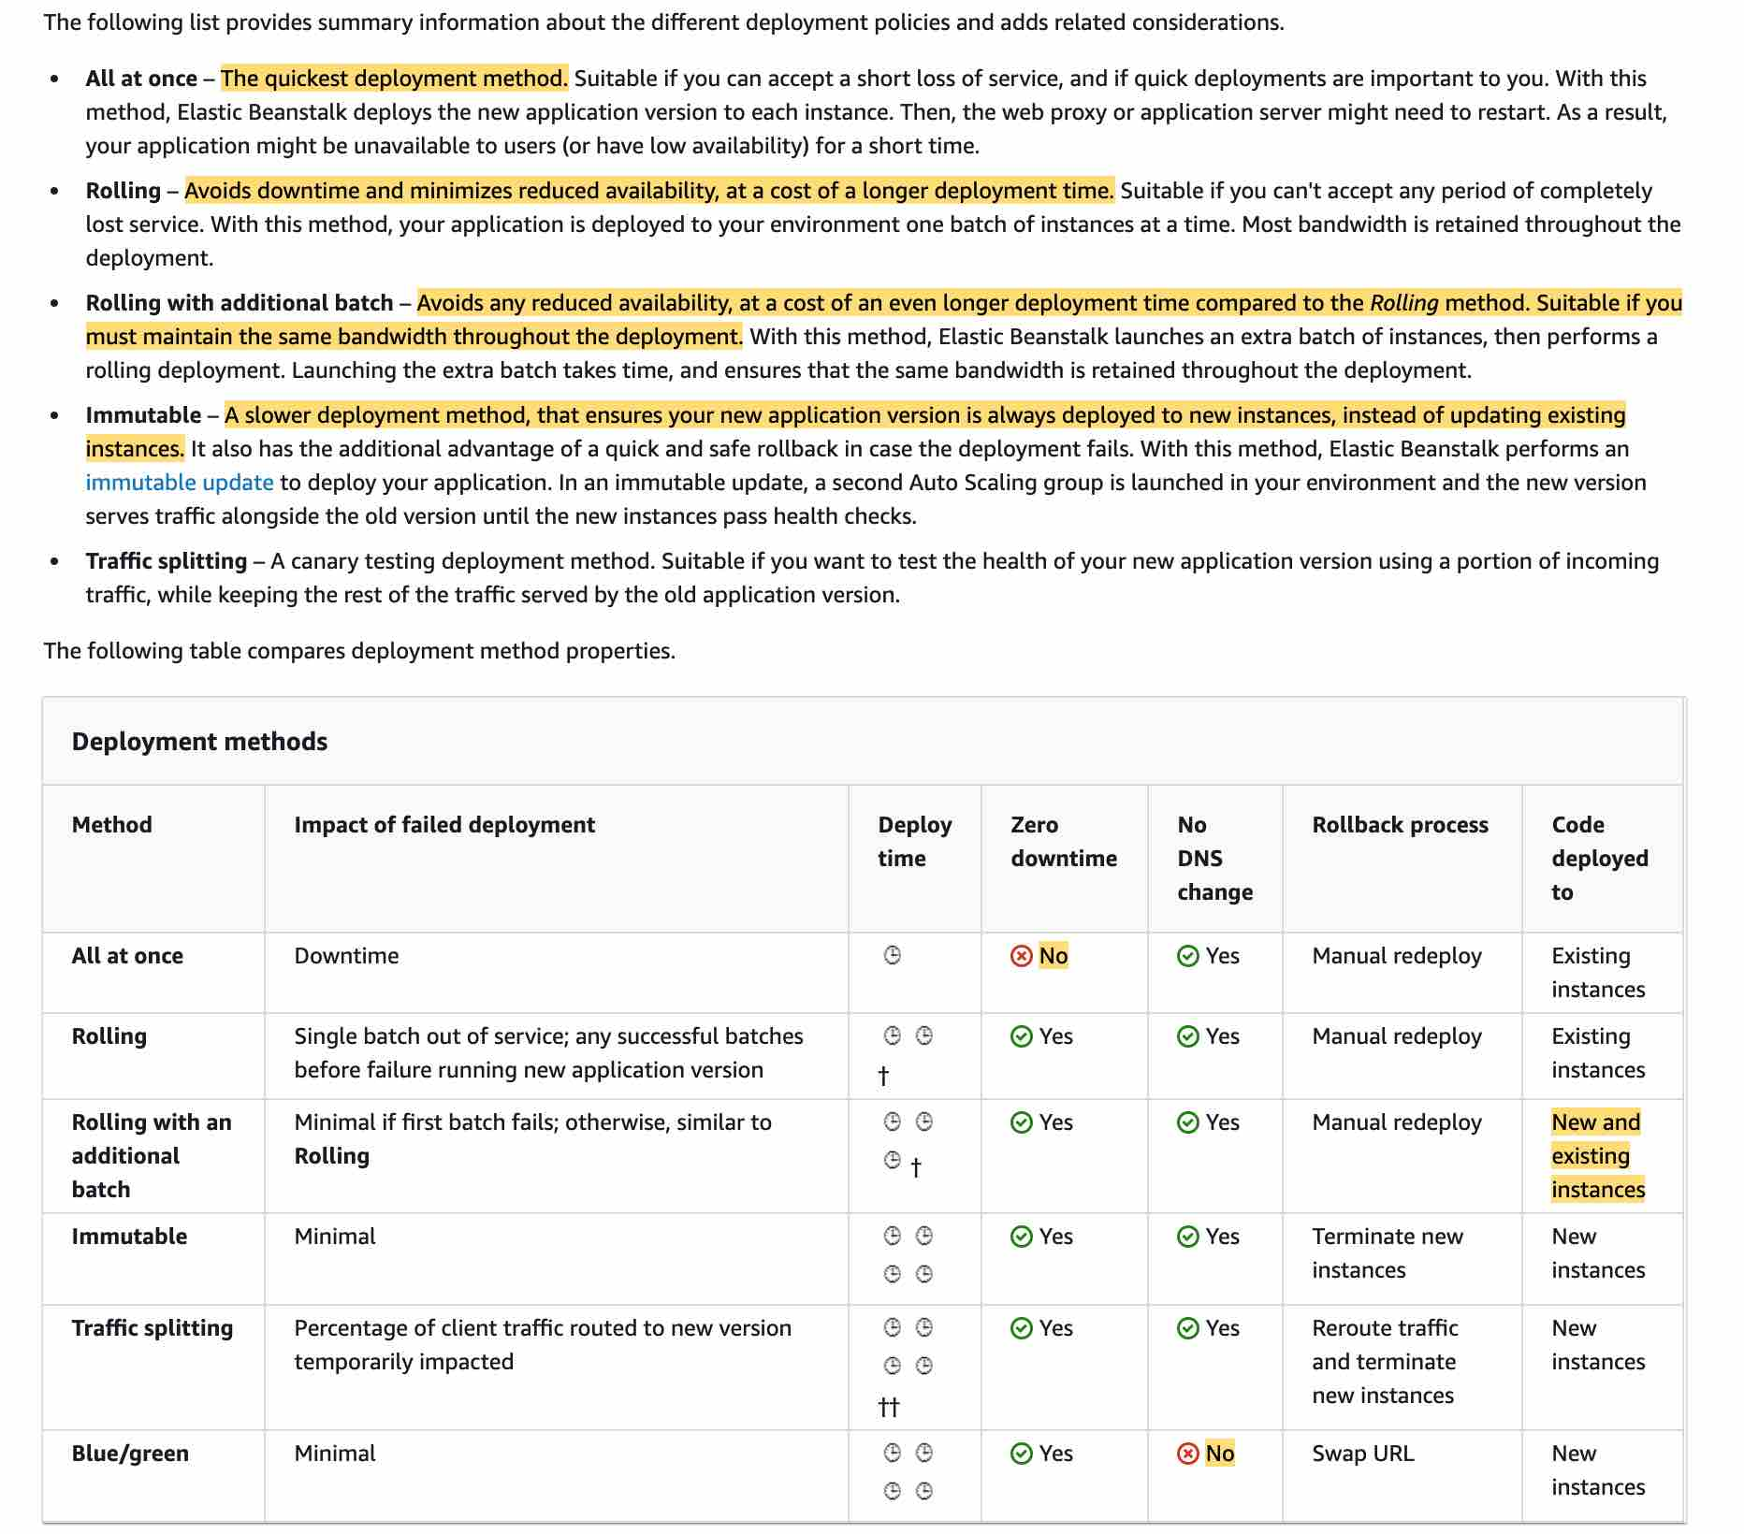 via - <https://docs.aws.amazon.com/elasticbeanstalk/latest/dg/using-features.deploy-existing-version.html>

Incorrect options:

**Deploy the new application version using 'All at once' deployment policy** - Although 'All at once' is the quickest deployment method, but the application may become unavailable to users (or have low availability) for a short time. So this option is not correct.

**Deploy the new application version using 'Rolling' deployment policy** - This policy avoids downtime and minimizes reduced availability, at a cost of a longer deployment time. However rollback process is via manual redeploy, so it's not as quick as the Blue/Green deployment.

**Deploy the new application version using 'Rolling with additional batch' deployment policy** - This policy avoids any reduced availability, at a cost of an even longer deployment time compared to the Rolling method. Suitable if you must maintain the same bandwidth throughout the deployment. However rollback process is via manual redeploy, so it's not as quick as the Blue/Green deployment.

Reference:

<https://docs.aws.amazon.com/elasticbeanstalk/latest/dg/using-features.deploy-existing-version.html>

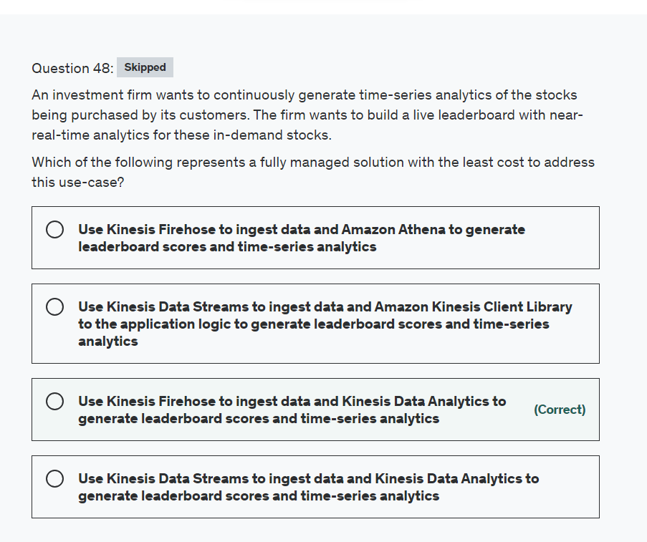

Explanation

Correct option:

**Use Kinesis Firehose to ingest data and Kinesis Data Analytics to generate leaderboard scores and time-series analytics**

Amazon Kinesis Data Firehose is the easiest way to reliably load streaming data into data lakes, data stores, and analytics services. It can capture, transform, and deliver streaming data to Amazon S3, Amazon Redshift, Amazon Elasticsearch Service, generic HTTP endpoints, and service providers like Datadog, New Relic, MongoDB, and Splunk. It is a fully managed service that automatically scales to match the throughput of your data and requires no ongoing administration. It can also batch, compress, transform, and encrypt your data streams before loading, minimizing the amount of storage used and increasing security.

Amazon Kinesis Data Analytics is the easiest way to transform and analyze streaming data in real-time with Apache Flink. Apache Flink is an open source framework and engine for processing data streams. Amazon Kinesis Data Analytics reduces the complexity of building, managing, and integrating Apache Flink applications with other AWS services.

Amazon Kinesis Data Analytics provides built-in functions to filter, aggregate, and transform streaming data for advanced analytics. It processes streaming data with sub-second latencies, enabling you to analyze and respond to incoming data and events in real-time.

Amazon Kinesis Data Analytics is serverless; there are no servers to manage. It runs your streaming applications without requiring you to provision or manage any infrastructure. Amazon Kinesis Data Analytics automatically scales the infrastructure up and down as required to process incoming data.

Incorrect options:

**Use Kinesis Data Streams to ingest data and Kinesis Data Analytics to generate leaderboard scores and time-series analytics** - Amazon Kinesis Data Streams (KDS) is a massively scalable and durable real-time data streaming service. KDS can continuously capture gigabytes of data per second from hundreds of thousands of sources such as website clickstreams, database event streams, financial transactions, social media feeds, IT logs, and location-tracking events. The data collected is available in milliseconds to enable real-time analytics use cases such as real-time dashboards, real-time anomaly detection, dynamic pricing, and more.

Although Kinesis Data Streams supports on-demand provisioning of shards, however, the data ingestion cost along with the per hour shards cost would be more than the corresponding cost incurred while using Firehose. The use-case clearly states that the company wants a fully managed solution with the least cost, so Kinesis Firehose is a better solution.

**Use Kinesis Data Streams to ingest data and Amazon Kinesis Client Library to the application logic to generate leaderboard scores and time-series analytics** - The Amazon Kinesis Client Library (KCL) is a pre-built library that helps you build consumer applications for reading and processing data from an Amazon Kinesis data stream. The KCL handles complex issues such as adapting to changes in data stream volume, load balancing streaming data, coordinating distributed services, and processing data with fault-tolerance. The KCL enables you to focus on business logic while building applications.

If you want a fully managed solution and you want to use SQL to process the data from your data stream, you should use Kinesis Data Analytics. Use KCL if you need to build a custom processing solution whose requirements are not met by Kinesis Data Analytics, and you can manage the resulting consumer application.

**Use Kinesis Firehose to ingest data and Amazon Athena to generate leaderboard scores and time-series analytics** - Amazon Athena is an interactive query service that makes it easy to analyze data in Amazon S3 using standard SQL. Athena is serverless, so there is no infrastructure to manage, and you pay only for the queries that you run. Athena is used for running analytics on S3 based data. For running analytics on real-time streaming data, Kinesis Data Analytics is the right fit.

References:

<https://docs.aws.amazon.com/firehose/latest/dev/data-analysis.html>

<https://aws.amazon.com/kinesis/data-analytics/faqs/>

<https://aws.amazon.com/kinesis/data-firehose/pricing/>

<https://aws.amazon.com/kinesis/data-streams/pricing/>

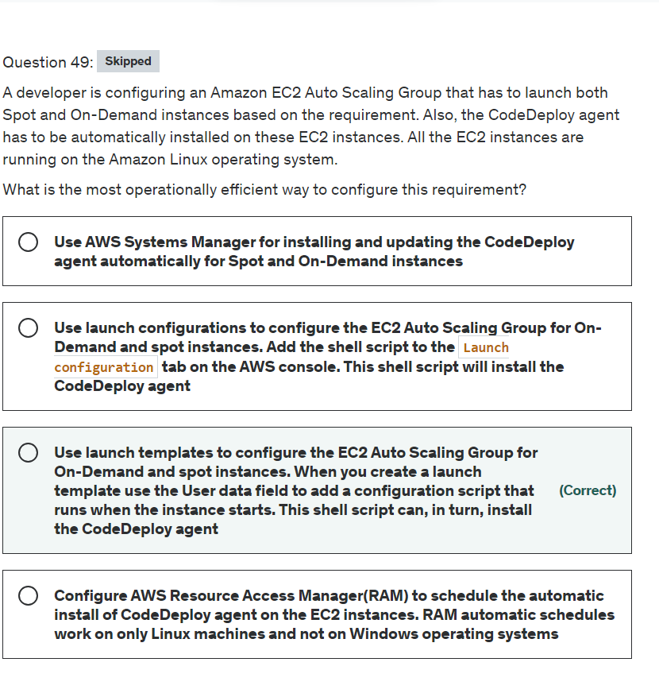

Explanation

Correct option:

**Use launch templates to configure the EC2 Auto Scaling Group for On-Demand and spot instances. When you create a launch template use the User data field to add a configuration script that runs when the instance starts. This shell script can, in turn, install the CodeDeploy agent**

A launch template specifies instance configuration information that includes the ID of the Amazon Machine Image (AMI), the instance type, a key pair, security groups, and other parameters used to launch EC2 instances. Defining a launch template instead of a launch configuration allows you to have multiple versions of a launch template.

When you create a launch template, you can use the User data field to add a configuration script that runs when the instance starts. This shell script installs the CodeDeploy agent for all AWS Regions and supported Amazon Linux and Ubuntu distributions. You can configure CodeDeploy to auto-update on boot by setting the AUTOUPDATE variable to true.

Incorrect options:

**Use launch configurations to configure the EC2 Auto Scaling Group for On-Demand and spot instances. Add the shell script to the Launch configuration tab on the AWS console. This shell script will install the CodeDeploy agent** - This statement is incorrect. Not all Amazon EC2 Auto Scaling features are available when you use launch configurations. For example, you cannot create an Auto Scaling group that launches both Spot and On-Demand Instances or that specifies multiple instance types. You must use a launch template to configure these features. AWS strongly recommends not using launch configurations anymore.

**Use AWS Systems Manager for installing and updating the CodeDeploy agent automatically for Spot and On-Demand instances** - AWS Systems Manager also uses launch templates to automatically deploy CodeDeploy agent. However, for this use case, SSM is not operationally efficient since SSM agent needs to be installed first on all EC2 instances and then you can install the CodeDeploy agent.

**Configure AWS Resource Access Manager(RAM) to schedule the automatic installation of CodeDeploy agent on the EC2 instances. RAM automatic schedules work on only Linux machines and not on Windows operating systems** - AWS RAM helps you securely share your resources across AWS accounts, within your organization or organizational units (OUs), and with IAM roles and users for supported resource types. You can use AWS RAM to share resources with other AWS accounts. This eliminates the need to provision and manage resources in every account. RAM cannot be used to install the CodeDeploy agent, so this option is incorrect.

References:

<https://docs.aws.amazon.com/autoscaling/ec2/userguide/launch-templates.html>

<https://aws.amazon.com/premiumsupport/knowledge-center/codedeploy-agent-launch-template/>

<https://docs.aws.amazon.com/autoscaling/ec2/userguide/launch-configurations.html>

<https://docs.aws.amazon.com/codedeploy/latest/userguide/codedeploy-agent-operations-install-ssm.html>

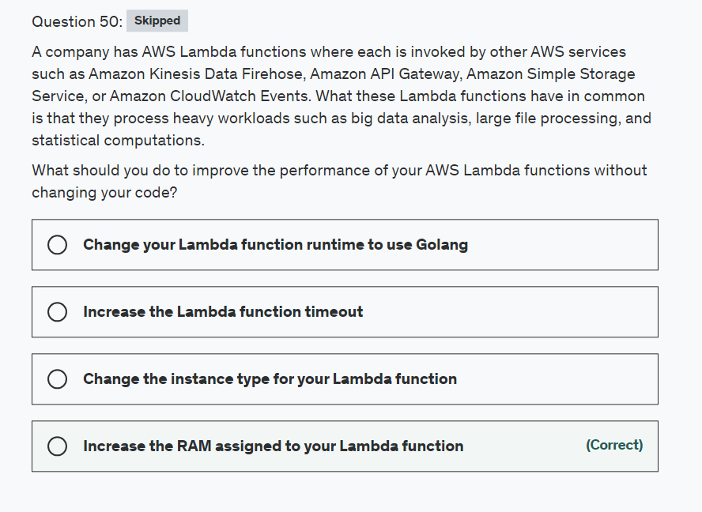

Explanation

Correct option:

**Increase the RAM assigned to your Lambda function**

AWS Lambda lets you run code without provisioning or managing servers. You pay only for the compute time you consume.

In the AWS Lambda resource model, you choose the amount of memory you want for your function which allocates proportional CPU power and other resources. This means you will have access to more compute power when you choose one of the new larger settings. To configure the memory for your function, set a value between 128 MB and 10,240 MB in 1-MB increments. At 1,769 MB, a function has the equivalent of one vCPU (one vCPU-second of credits per second). You access these settings when you create a function or update its configuration. The settings are available using the AWS Management Console, AWS CLI, or SDKs.

Therefore, by increasing the amount of memory available to the Lambda functions, you can run the compute-heavy workflows.

Incorrect options:

**Change the instance type for your Lambda function** - Instance types apply to the EC2 service and not to Lambda function as its a serverless service.

**Change your Lambda function runtime to use Golang** - This changes programming language which requires code changes, so this option is not correct. Besides, changing the runtime may not even address the performance issues.

**Increase the Lambda function timeout** - This option would increase the amount of time for which the Lambda function executes, which may help in case you have some heavy processing, but won't help with the actual performance of your Lambda function.

Reference:

<https://docs.aws.amazon.com/lambda/latest/dg/configuration-console.html>

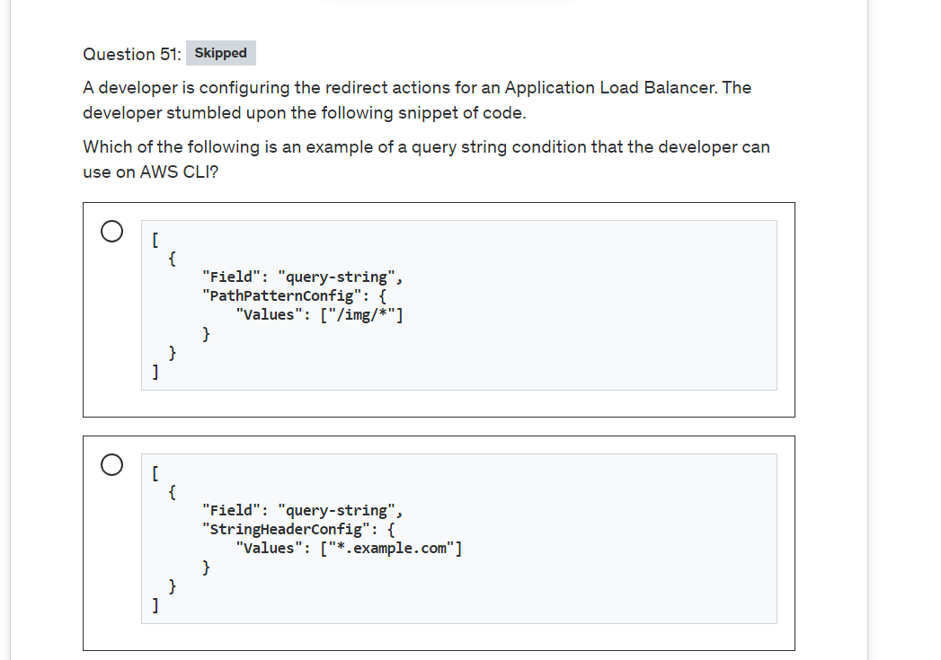

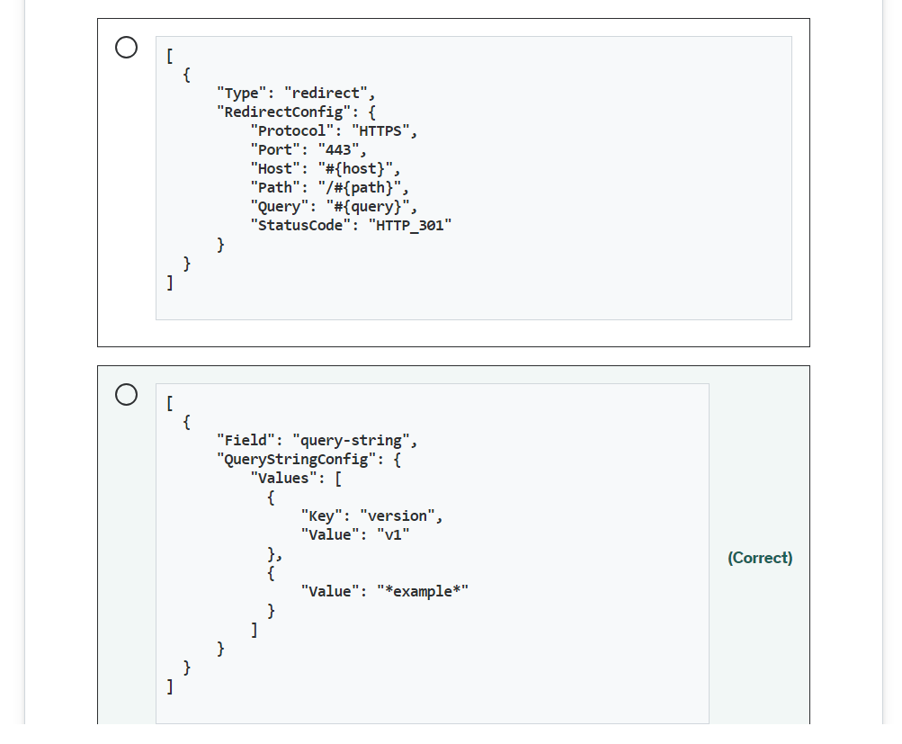

Explanation

Correct option:

**

[

{

"Field": "query-string",

"QueryStringConfig": {

"Values": [

{

"Key": "version",

"Value": "v1"

},

{

"Value": "*example*"

}

]

}

}

]

**

You can use query string conditions to configure rules that route requests based on key/value pairs or values in the query string. The match evaluation is not case-sensitive. The following wildcard characters are supported: * (matches 0 or more characters) and ? (matches exactly 1 character). You can specify conditions when you create or modify a rule.

Query parameters are often used along with the path component of the URL for applying a special logic to the resource being fetched.

The query string component starts after the first "?" in a URI. Typically query strings contain key-value pairs separated by a delimiter "&". Example: http://example.com/path/to/page?version=A&gender=female

The example condition given in the question is satisfied by requests with a query string that includes either a key/value pair of "version=v1" or any key set to "example".

Incorrect options:

**

[

{

"Field": "query-string",

"PathPatternConfig": {

"Values": ["/img/*"]

}

}

]

**

**

[

{

"Field": "query-string",

"StringHeaderConfig": {

"Values": ["*.example.com"]

}

}

]

**

These two options are malformed and are incorrect.

**

[

{

"Type": "redirect",

"RedirectConfig": {

"Protocol": "HTTPS",

"Port": "443",

"Host": "#{host}",

"Path": "/#{path}",

"Query": "#{query}",

"StatusCode": "HTTP_301"

}

}

]

** - This action redirects an HTTP request to an HTTPS request on port 443, with the same hostname, path, and query string as the HTTP request.

Reference:

<https://docs.aws.amazon.com/elasticloadbalancing/latest/application/load-balancer-listeners.html#query-string-conditions>

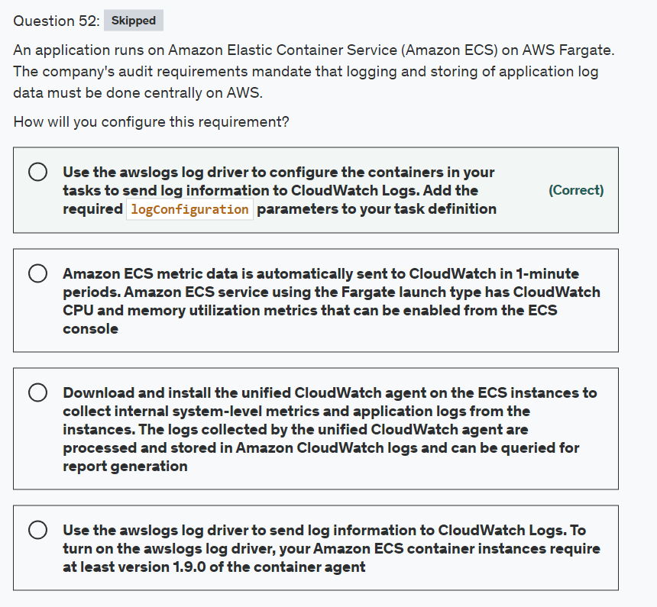

Explanation

Correct option:

**Use the awslogs log driver to configure the containers in your tasks to send log information to CloudWatch Logs. Add the required logConfiguration parameters to your task definition**

Using the awslogs log driver you can configure the containers in your tasks to send log information to CloudWatch Logs. If you're using the Fargate launch type for your tasks, you need to add the required logConfiguration parameters to your task definition to turn on the awslogs log driver.

Before your containers can send logs to CloudWatch, you must specify the awslogs log driver for containers in your task definition. The example task definition JSON that follows has a logConfiguration object specified for each container. One is for the WordPress container that sends logs to a log group called awslogs-wordpress. The other is for a MySQL container that sends logs to a log group that's called awslogs-mysql. Both containers use the awslogs-example log stream. prefix.

Specifying a log configuration in your task definition: 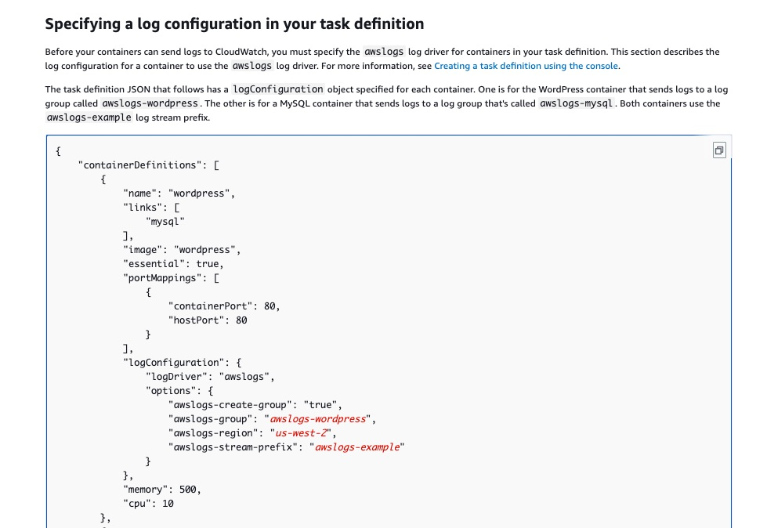 via - <https://docs.aws.amazon.com/AmazonECS/latest/developerguide/using_awslogs.html#specify-log-config>

Incorrect options:

**Use the awslogs log driver to send log information to CloudWatch Logs. To turn on the awslogs log driver, your Amazon ECS container instances require at least version 1.9.0 of the container agent** - This statement is incorrect. If you're using the EC2 launch type (and not Fargate) for your tasks and want to turn on the awslogs log driver, your Amazon ECS container instances require at least version 1.9.0 of the container agent.

**Amazon ECS metric data is automatically sent to CloudWatch in 1-minute periods. Amazon ECS service using the Fargate launch type has CloudWatch CPU and memory utilization metrics that can be enabled from the ECS console** - Indeed, Amazon ECS metric data is automatically sent to CloudWatch in 1-minute periods. Also, any Amazon ECS service using the Fargate launch type has CloudWatch CPU and memory utilization metrics automatically, so you don't need to take any manual steps. But, these are system logs and not the application logs as is needed in the current use case.

**Download and install the unified CloudWatch agent on the ECS instances to collect internal system-level metrics and application logs from the instances. The logs collected by the unified CloudWatch agent are processed and stored in Amazon CloudWatch logs and can be queried for report generation** - This statement is incorrect and given only as a distractor. ECS Fargate is serverless and hence the scope of downloading and installing software on the instance does not arise.

References:

<https://docs.aws.amazon.com/AmazonECS/latest/developerguide/using_awslogs.html>

<https://docs.aws.amazon.com/AmazonECS/latest/userguide/cloudwatch-metrics.html#available_cloudwatch_metrics>

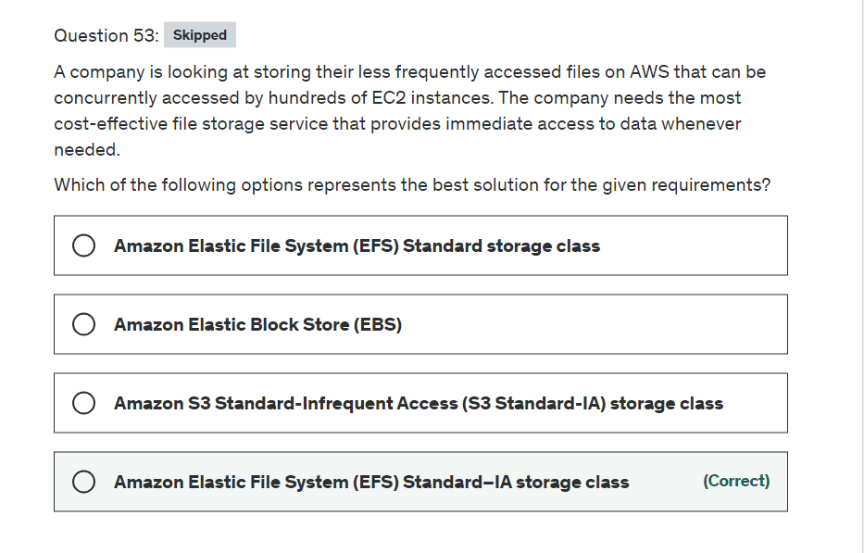

Explanation

Correct option:

**Amazon Elastic File System (EFS) Standard–IA storage class** - Amazon EFS is a file storage service for use with Amazon compute (EC2, containers, serverless) and on-premises servers. Amazon EFS provides a file system interface, file system access semantics (such as strong consistency and file locking), and concurrently accessible storage for up to thousands of Amazon EC2 instances.

The Standard–IA storage class reduces storage costs for files that are not accessed every day. It does this without sacrificing the high availability, high durability, elasticity, and POSIX file system access that Amazon EFS provides. AWS recommends Standard-IA storage if you need your full dataset to be readily accessible and want to automatically save on storage costs for files that are less frequently accessed.

Incorrect options:

**Amazon S3 Standard-Infrequent Access (S3 Standard-IA) storage class** - Amazon S3 is an object storage service. Amazon S3 makes data available through an Internet API that can be accessed anywhere. It is not a file storage service, as is needed in the use case.

**Amazon Elastic File System (EFS) Standard storage class** - Amazon EFS Standard storage classes are ideal for workloads that require the highest levels of durability and availability. The EFS Standard storage class is used for frequently accessed files. It is the storage class to which customer data is initially written for Standard storage classes. The company is also looking at cutting costs by optimally storing the infrequently accessed data. Hence, EFS standard storage class is not the right solution for the given use case.

**Amazon Elastic Block Store (EBS)** - Amazon EBS is a block-level storage service for use with Amazon EC2. Amazon EBS can deliver performance for workloads that require the lowest latency access to data from a single EC2 instance. EBS volume cannot be accessed by hundreds of EC2 instances concurrently. It is not a file storage service, as is needed in the use case.

Reference:

<https://docs.aws.amazon.com/efs/latest/ug/storage-classes.html>

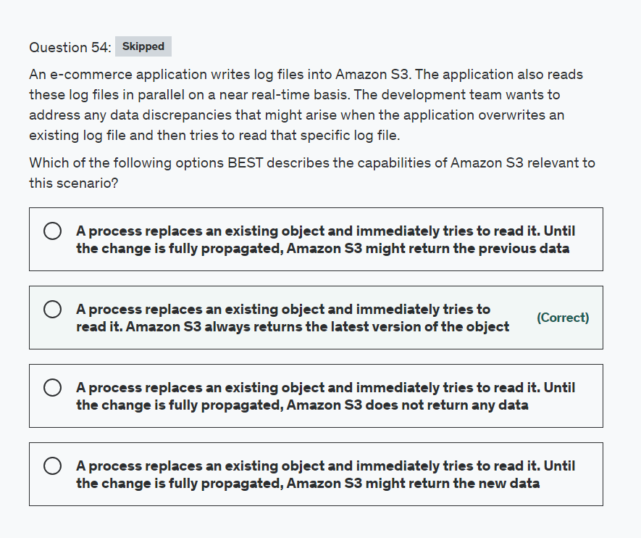

Explanation

Correct option:

**A process replaces an existing object and immediately tries to read it. Amazon S3 always returns the latest version of the object**

Amazon S3 delivers strong read-after-write consistency automatically, without changes to performance or availability, without sacrificing regional isolation for applications, and at no additional cost.

After a successful write of a new object or an overwrite of an existing object, any subsequent read request immediately receives the latest version of the object. S3 also provides strong consistency for list operations, so after a write, you can immediately perform a listing of the objects in a bucket with any changes reflected.

Strong read-after-write consistency helps when you need to immediately read an object after a write. For example, strong read-after-write consistency when you often read and list immediately after writing objects.

To summarize, all S3 GET, PUT, and LIST operations, as well as operations that change object tags, ACLs, or metadata, are strongly consistent. What you write is what you will read, and the results of a LIST will be an accurate reflection of what’s in the bucket.

Incorrect options:

**A process replaces an existing object and immediately tries to read it. Until the change is fully propagated, Amazon S3 might return the previous data**

**A process replaces an existing object and immediately tries to read it. Until the change is fully propagated, Amazon S3 does not return any data**

**A process replaces an existing object and immediately tries to read it. Until the change is fully propagated, Amazon S3 might return the new data**

These three options contradict the earlier details provided in the explanation.

References:

<https://docs.aws.amazon.com/AmazonS3/latest/dev/Introduction.html#ConsistencyModel>

<https://aws.amazon.com/s3/faqs/>

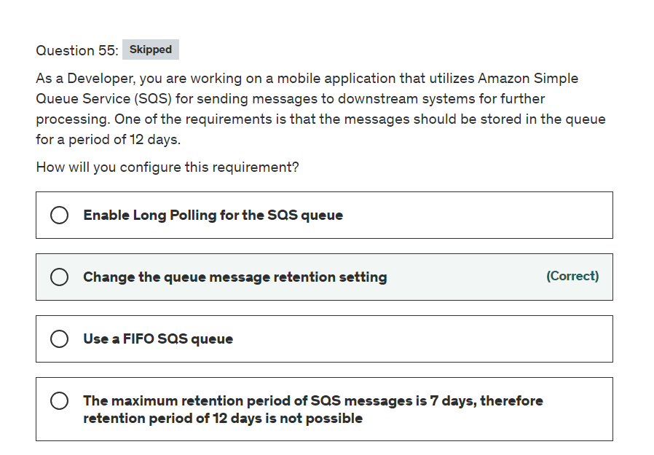

Explanation

Correct option:

**Change the queue message retention setting** - Amazon SQS automatically deletes messages that have been in a queue for more than the maximum message retention period. The default message retention period is 4 days. However, you can set the message retention period to a value from 60 seconds to 1,209,600 seconds (14 days) using the SetQueueAttributes action.

More info here: 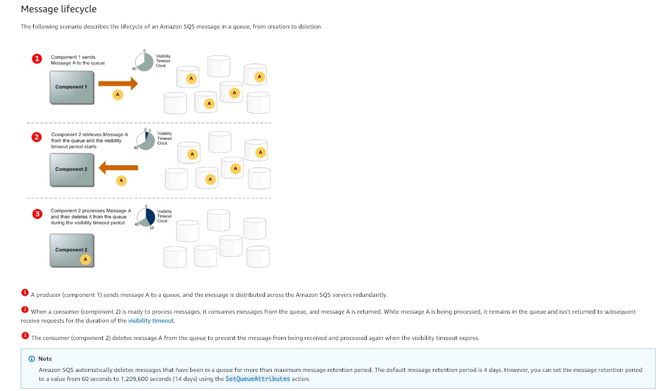 via - <https://docs.aws.amazon.com/AWSSimpleQueueService/latest/SQSDeveloperGuide/sqs-basic-architecture.html>

Incorrect options:

**Enable Long Polling for the SQS queue** - Amazon SQS provides short polling and long polling to receive messages from a queue. By default, queues use short polling. When the wait time for the ReceiveMessage API action is greater than 0, long polling is in effect. The maximum long polling wait time is 20 seconds. Long polling helps reduce the cost of using Amazon SQS by eliminating the number of empty responses (when there are no messages available for a ReceiveMessage request) and false empty responses (when messages are available but aren't included in a response). This feature is not useful for the current use case.

**The maximum retention period of SQS messages is 7 days, therefore retention period of 12 days is not possible** - This is an incorrect statement. Retention period of up to 14 days is possible.

**Use a FIFO SQS queue** - FIFO (First-In-First-Out) queues are designed to enhance messaging between applications when the order of operations and events is critical, or where duplicates can't be tolerated. This is not useful for the current scenario.

References:

<https://docs.aws.amazon.com/AWSSimpleQueueService/latest/SQSDeveloperGuide/sqs-basic-architecture.html>

<https://docs.aws.amazon.com/AWSSimpleQueueService/latest/SQSDeveloperGuide/sqs-short-and-long-polling.html>

<https://docs.aws.amazon.com/AWSSimpleQueueService/latest/SQSDeveloperGuide/FIFO-queues.html>

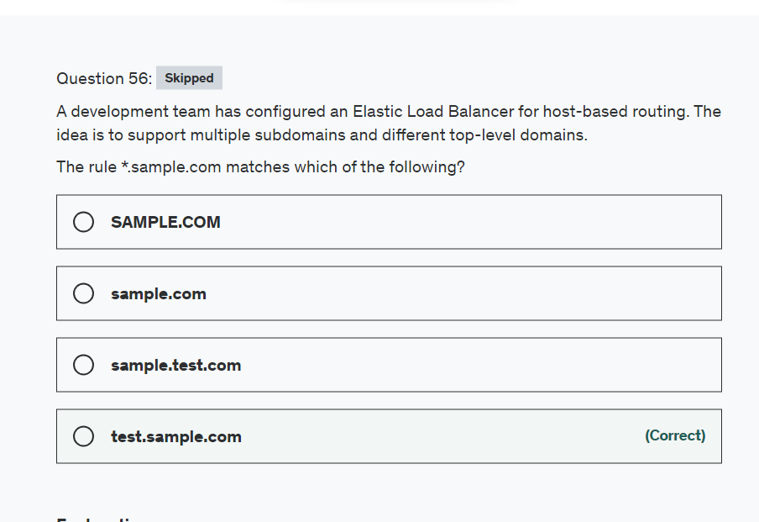

Explanation

Correct option:

**test.sample.com** - You can use host conditions to define rules that route requests based on the hostname in the host header (also known as host-based routing). This enables you to support multiple subdomains and different top-level domains using a single load balancer.

A hostname is not case-sensitive, can be up to 128 characters in length, and can contain any of the following characters: 1. A–Z, a–z, 0–9 2. - . 3. * (matches 0 or more characters) 4. ? (matches exactly 1 character)

You must include at least one "." character. You can include only alphabetical characters after the final "." character.

The rule *.sample.com matches test.sample.com but doesn't match sample.com.

Incorrect options:

**sample.com**

**sample.test.com**

**SAMPLE.COM**

These three options contradict the explanation provided above, so these options are incorrect.

Reference:

<https://docs.aws.amazon.com/elasticloadbalancing/latest/application/load-balancer-listeners.html>

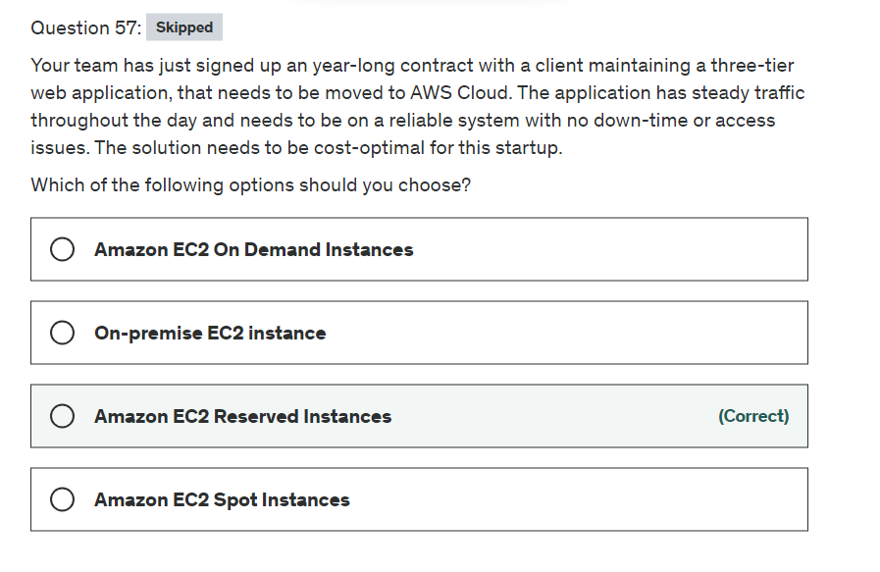

Explanation

Correct option:

**Amazon EC2 Reserved Instances** - Reserved instances can provide a capacity reservation, offering additional confidence in your ability to launch the number of instances you have reserved when you need them. You save money going with Reserved instances vs on-demand especially in a year's worth of time.

Reserved Instances are not physical instances, but rather a billing discount applied to the use of On-Demand Instances in your account. These On-Demand Instances must match certain attributes, such as instance type and Region, to benefit from the billing discount. So, there is no performance difference between an On-Demand instance or a Reserved instance.

How RIs work: 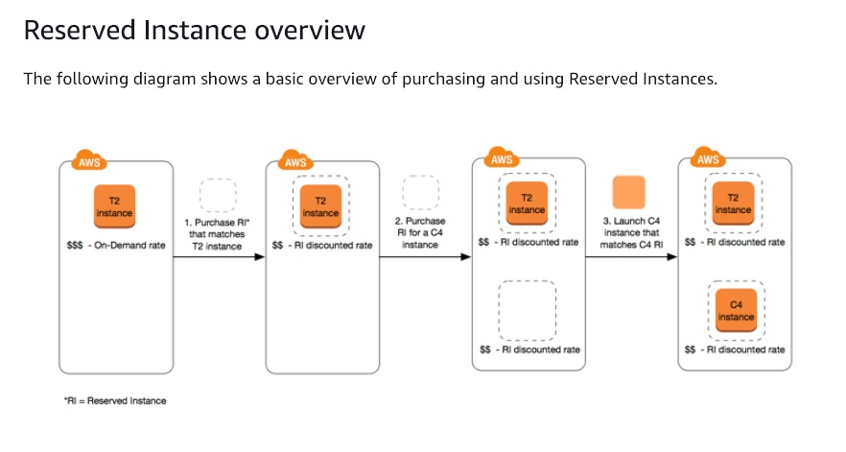 via - <https://docs.aws.amazon.com/AWSEC2/latest/UserGuide/ec2-reserved-instances.html>

Incorrect options:

**Amazon EC2 Spot Instances** - A Spot Instance is an unused EC2 instance that is available for less than the On-Demand price. Because Spot Instances enable you to request unused EC2 instances at steep discounts, you can lower your Amazon EC2 costs significantly. Spot instances are useful if your applications can be interrupted, like data analysis, batch jobs, background processing, and optional tasks. Spot instances can be pulled down anytime without prior notice. Hence, not the right choice for the current scenario.

**Amazon EC2 On-Demand Instances** - With On-Demand Instances, you pay for compute capacity by the second with no long-term commitments. You have full control over its lifecycle—you decide when to launch, stop, hibernate, start, reboot, or terminate it. But, On-Demand instances cost a lot more than Reserved instances. Here, in our use case, we already know that the systems are required for a complete year, so making use of Reserved Instances discount makes a lot more sense.

**On-premise EC2 instance** - On-premise implies the client has to maintain the physical machines, their capacity provisioning and maintenance. Not an option when the client is planning to move to AWS Cloud.

References:

<https://aws.amazon.com/ec2/pricing/reserved-instances/>

<https://docs.aws.amazon.com/AWSEC2/latest/UserGuide/ec2-reserved-instances.html>

<https://docs.aws.amazon.com/AWSEC2/latest/UserGuide/using-spot-instances.html>

<https://docs.aws.amazon.com/AWSEC2/latest/UserGuide/ec2-on-demand-instances.html>

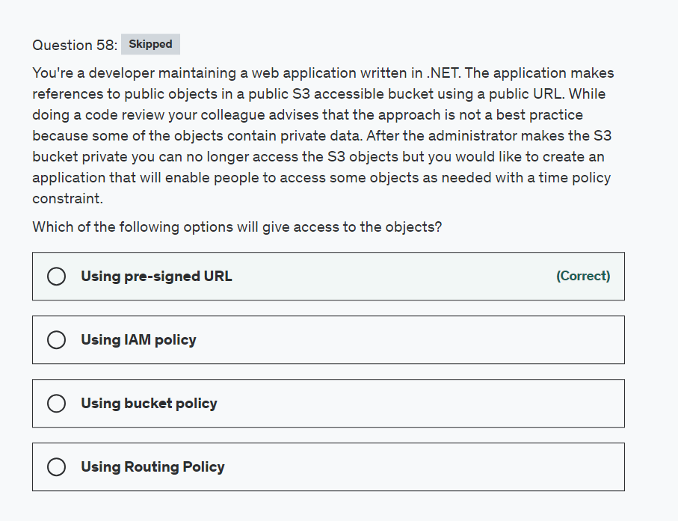

Explanation

Correct option:

"Using pre-signed URL"

All objects by default are private, with object owner having permission to access the objects. However, the object owner can optionally share objects with others by creating a pre-signed URL, using their own security credentials, to grant time-limited permission to download the objects. When you create a pre-signed URL for your object, you must provide your security credentials, specify a bucket name, an object key, specify the HTTP method (GET to download the object) and expiration date and time. The pre-signed URLs are valid only for the specified duration.

Please see this note for more details: 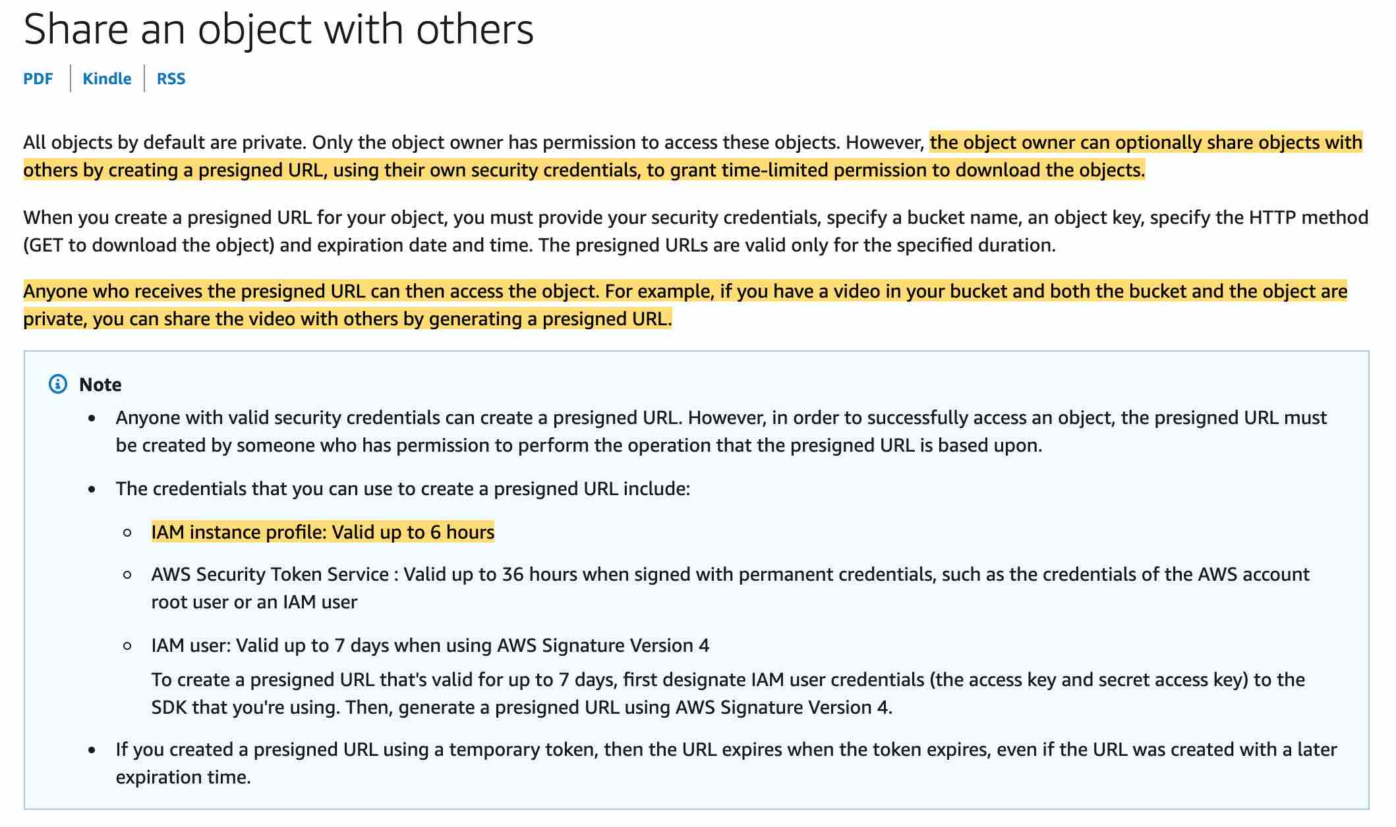 via - <https://docs.aws.amazon.com/AmazonS3/latest/dev/ShareObjectPreSignedURL.html>

Incorrect:

"Using bucket policy" - You can use this policy to limit users from a source IP address however for time-based constraints you are better off using a pre-signed URL.

"Using Routing Policy" - This concept applies to DNS in Route 53, so this option is ruled out.

"Using IAM policy" - You can use IAM policy to grant access toa specific bucket however for time-based constraints you are better off using a pre-signed URL.

Reference:

<https://docs.aws.amazon.com/AmazonS3/latest/dev/ShareObjectPreSignedURL.html>

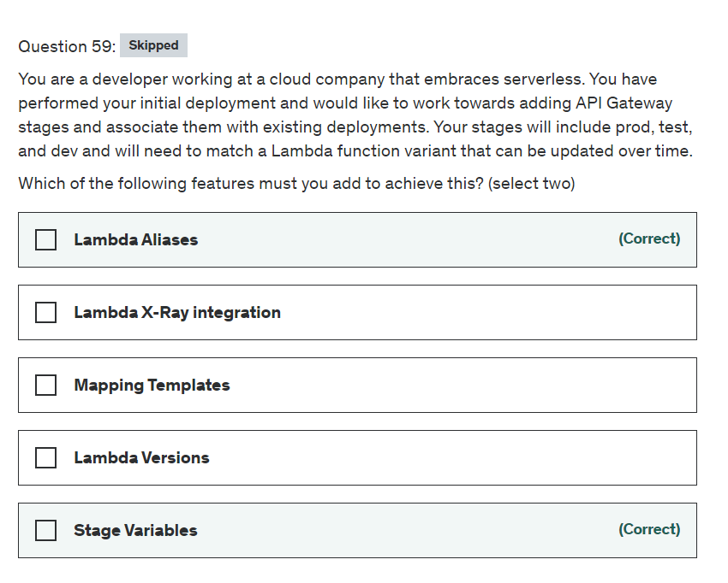

Explanation

Correct options:

**Stage Variables**

Stage variables are name-value pairs that you can define as configuration attributes associated with a deployment stage of an API. They act like environment variables and can be used in your API setup and mapping templates. With deployment stages in API Gateway, you can manage multiple release stages for each API, such as alpha, beta, and production. Using stage variables you can configure an API deployment stage to interact with different backend endpoints.

For example, your API can pass a GET request as an HTTP proxy to the backend web host (for example, http://example.com). In this case, the backend web host is configured in a stage variable so that when developers call your production endpoint, API Gateway calls example.com. When you call your beta endpoint, API Gateway uses the value configured in the stage variable for the beta stage and calls a different web host (for example, beta.example.com).

**Lambda Aliases**

A Lambda alias is like a pointer to a specific Lambda function version. Users can access the function version using the alias ARN.

Lambda Aliases allow you to create a "mutable" Lambda version that points to whatever version you want in the backend. This allows you to have a "dev", "test", prod" Lambda alias that can remain stable over time.

Incorrect options:

**Lambda Versions** - Versions are immutable and cannot be updated over time. So this option is not correct.

**Lambda X-Ray integration** - This is good for tracing and debugging requests so it can be looked at as a good option for troubleshooting issues in the future. This is not the right fit for the given use-case.

**Mapping Templates** - Mapping template overrides provides you with the flexibility to perform many-to-one parameter mappings; override parameters after standard API Gateway mappings have been applied; conditionally map parameters based on body content or other parameter values; programmatically create new parameters on the fly, and override status codes returned by your integration endpoint. This is not the right fit for the given use-case.

References:

<https://docs.aws.amazon.com/apigateway/latest/developerguide/stage-variables.html>

<https://docs.aws.amazon.com/lambda/latest/dg/configuration-aliases.html>

<https://docs.aws.amazon.com/apigateway/latest/developerguide/apigateway-override-request-response-parameters.html>

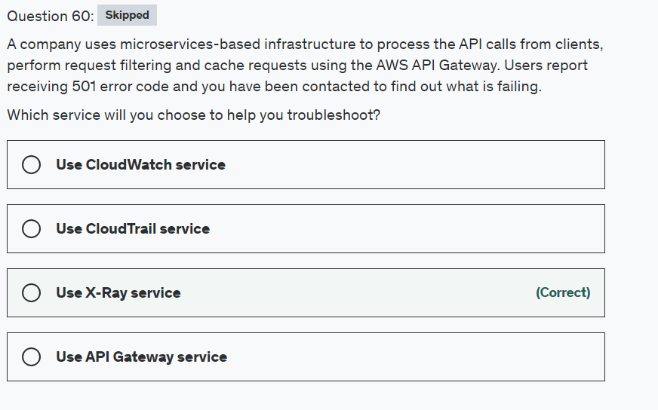

Explanation

Correct option:

**Use X-Ray service** - AWS X-Ray helps developers analyze and debug production, distributed applications, such as those built using a microservices architecture. With X-Ray, you can understand how your application and its underlying services are performing to identify and troubleshoot the root cause of performance issues and errors. X-Ray provides an end-to-end view of requests as they travel through your application, and shows a map of your application’s underlying components. You can use X-Ray to analyze both applications in development and in production, from simple three-tier applications to complex microservices applications consisting of thousands of services.

X-Ray Overview: 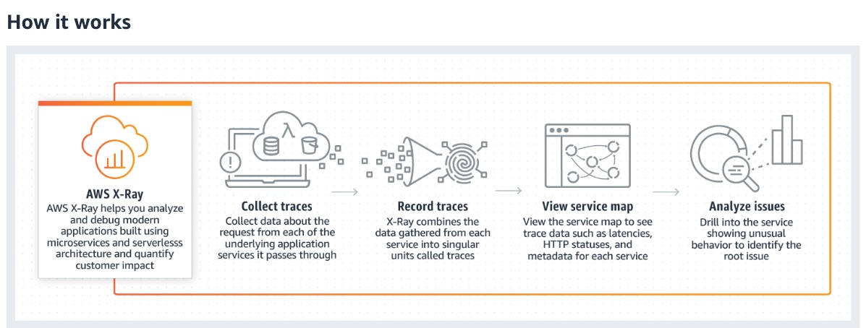 via - <https://aws.amazon.com/xray/>

AWS X-Ray creates a map of services used by your application with trace data that you can use to drill into specific services or issues. This provides a view of connections between services in your application and aggregated data for each service, including average latency and failure rates. You can create dependency trees, perform cross-availability zone or region call detections, and more.

X-Ray Service maps: 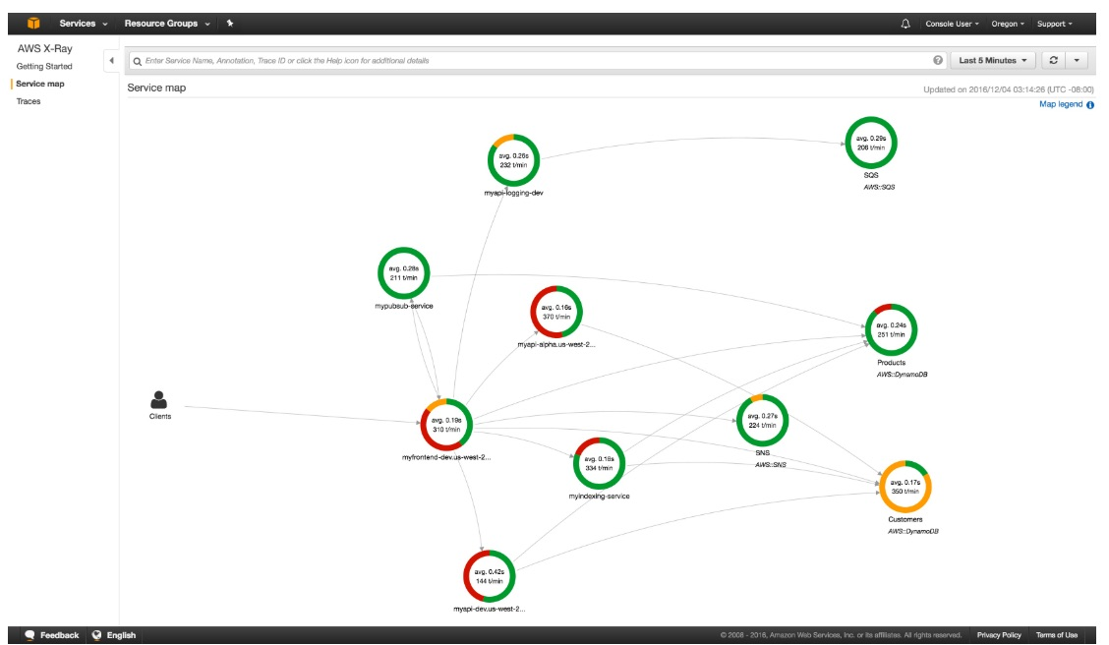 via - <https://aws.amazon.com/xray/features/>

X-Ray Traces: 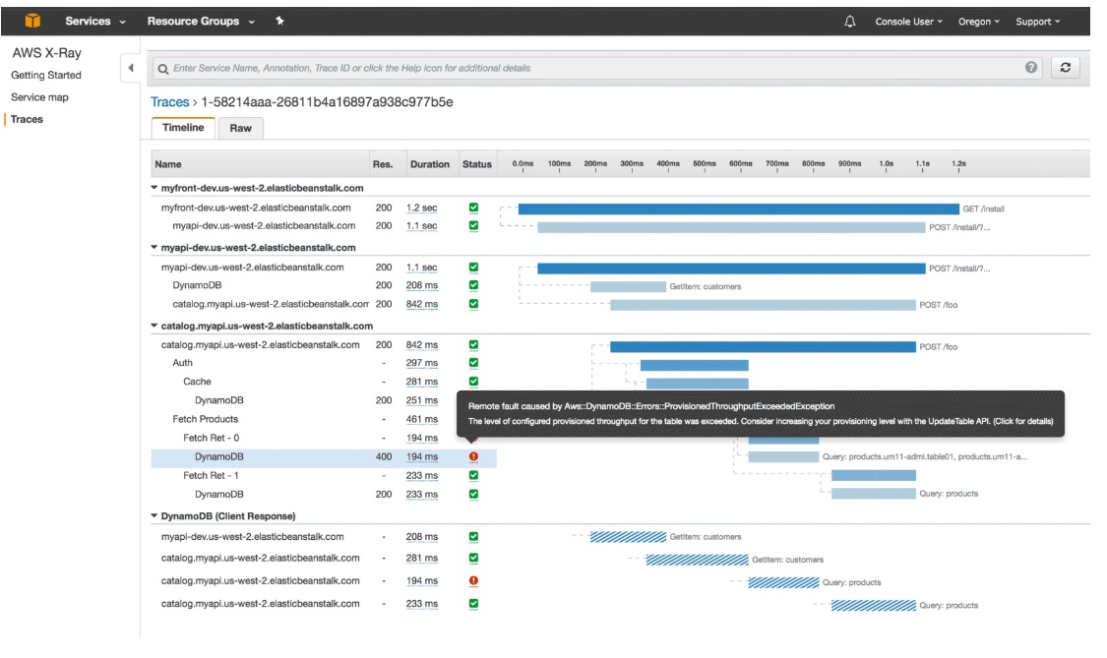 via - <https://aws.amazon.com/xray/features/>

Incorrect options:

**Use CloudTrail service** - With CloudTrail, you can get a history of AWS API calls for your account - including API calls made via the AWS Management Console, AWS SDKs, command-line tools, and higher-level AWS services (such as AWS CloudFormation). This is a very useful service for general monitoring and tracking. But, it will not give a detailed analysis of the outcome of microservices or drill into specific issues. For the current use case, X-Ray offers a better solution.

**Use API Gateway service** - Amazon API Gateway is an AWS service for creating, publishing, maintaining, monitoring, and securing REST, HTTP, and WebSocket APIs at any scale. API Gateway will not be able to drill into the flow between different microservices or their issues.

**Use CloudWatch service** - Amazon CloudWatch is a monitoring and management service that provides data and actionable insights for AWS, hybrid, and on-premises applications and infrastructure resources. CloudWatch can collect numbers and respond to AWS service-related events, but it can't help you debug microservices specific issues on AWS.

References:

<https://aws.amazon.com/cloudtrail/>

<https://aws.amazon.com/api-gateway/>

<https://aws.amazon.com/cloudwatch/features/>

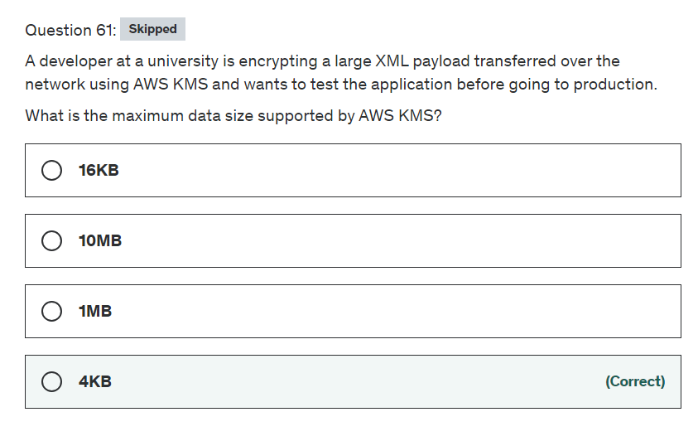

Explanation

Correct option:

**4 KB**

You can encrypt up to 4 kilobytes (4096 bytes) of arbitrary data such as an RSA key, a database password, or other sensitive information.

While AWS KMS does support sending data up to 4 KB to be encrypted directly, envelope encryption can offer significant performance benefits. When you encrypt data directly with AWS KMS it must be transferred over the network. Envelope encryption reduces the network load since only the request and delivery of the much smaller data key go over the network. The data key is used locally in your application or encrypting AWS service, avoiding the need to send the entire block of data to AWS KMS and suffer network latency.

Incorrect options:

**1MB** - For anything over 4 KB, you may want to look at envelope encryption

**10MB** - For anything over 4 KB, you may want to look at envelope encryption

**16KB** - For anything over 4 KB, you may want to look at envelope encryption

Reference:

<https://aws.amazon.com/kms/faqs/>

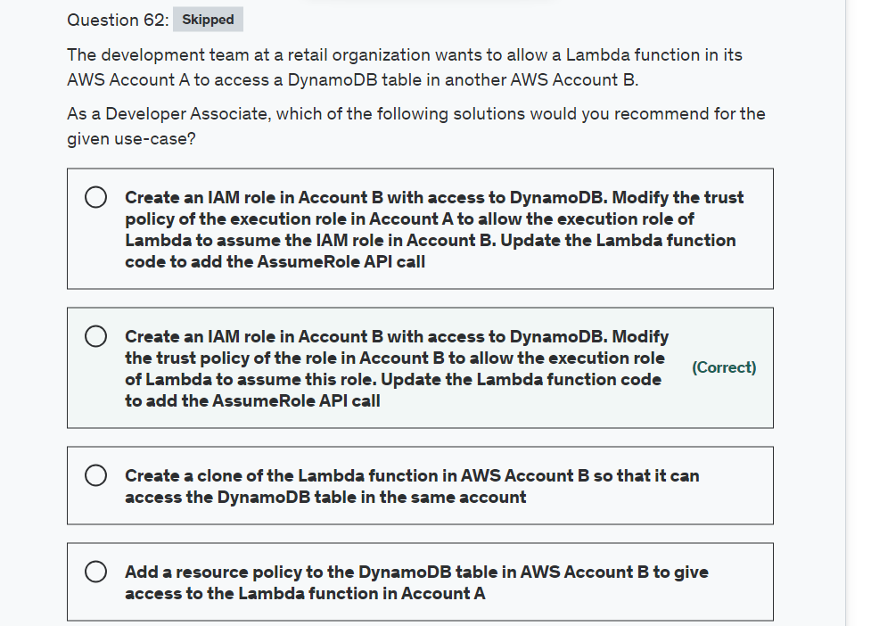

Explanation

Correct option:

**Create an IAM role in account B with access to DynamoDB. Modify the trust policy of the role in Account B to allow the execution role of Lambda to assume this role. Update the Lambda function code to add the AssumeRole API call**

You can give a Lambda function created in one account ("account A") permissions to assume a role from another account ("account B") to access resources such as DynamoDB or S3 bucket. You need to create an execution role in Account A that gives the Lambda function permission to do its work. Then you need to create a role in account B that the Lambda function in account A assumes to gain access to the cross-account DynamoDB table. Make sure that you modify the trust policy of the role in Account B to allow the execution role of Lambda to assume this role. Finally, update the Lambda function code to add the AssumeRole API call.

Sample use-case to configure a Lambda function to assume a role from another AWS account: 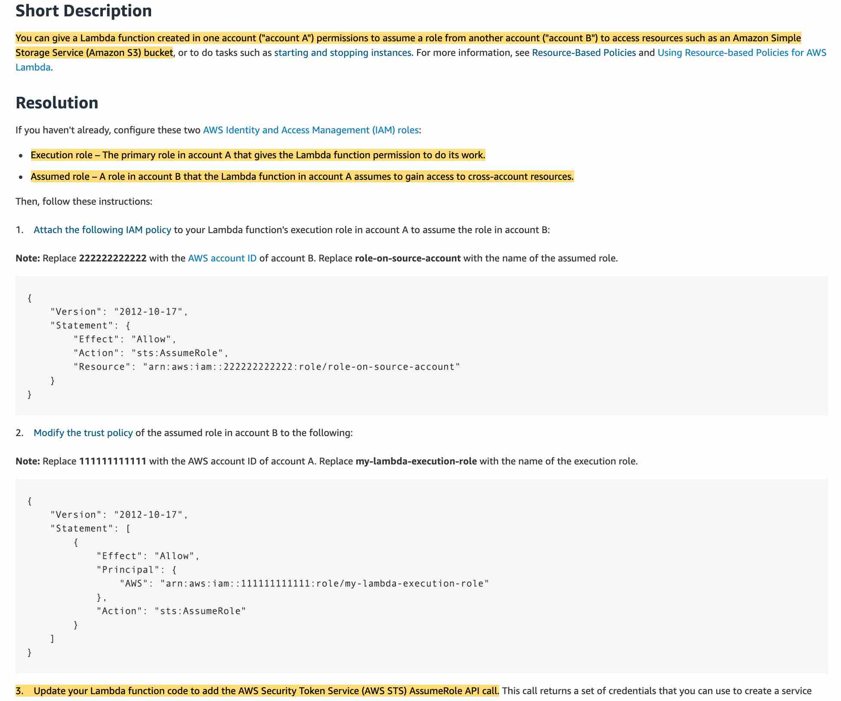 via - <https://aws.amazon.com/premiumsupport/knowledge-center/lambda-function-assume-iam-role/>

Incorrect options:

**Create a clone of the Lambda function in AWS Account B so that it can access the DynamoDB table in the same account** - Creating a clone of the Lambda function is a distractor as this does not solve the use-case outlined in the problem statement.

**Add a resource policy to the DynamoDB table in AWS Account B to give access to the Lambda function in Account A** - You cannot attach a resource policy to a DynamoDB table, so this option is incorrect.

**Create an IAM role in Account B with access to DynamoDB. Modify the trust policy of the execution role in Account A to allow the execution role of Lambda to assume the IAM role in Account B. Update the Lambda function code to add the AssumeRole API call** - As mentioned in the explanation above, you need to modify the trust policy of the IAM role in Account B so that it allows the execution role of Lambda function in account A to assume the IAM role in Account B.

Reference: <https://aws.amazon.com/premiumsupport/knowledge-center/lambda-function-assume-iam-role/>

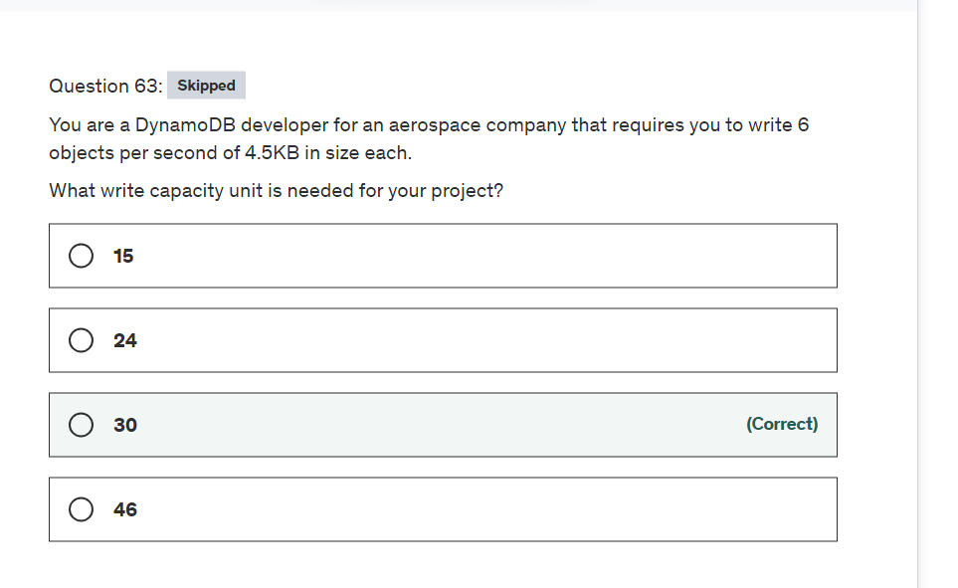

Explanation

Correct option:

Before proceeding with the calculations, please review the following:





via - <https://docs.aws.amazon.com/amazondynamodb/latest/developerguide/ProvisionedThroughput.html>

**30**

A write capacity unit represents one write per second, for an item up to 1 KB in size.

Item sizes for writes are rounded up to the next 1 KB multiple. For example, writing a 500-byte item consumes the same throughput as writing a 1 KB item. So, for the given use-case, each object is of size 4.5 KB, which will be rounded up to 5KB.

Therefore, for 6 objects, you need 6x5 = 30 WCUs.

Incorrect options:

**24**

**15**

**46**

These three options contradict the details provided in the explanation above, so these are incorrect.

Reference:

<https://docs.aws.amazon.com/amazondynamodb/latest/developerguide/ProvisionedThroughput.html>

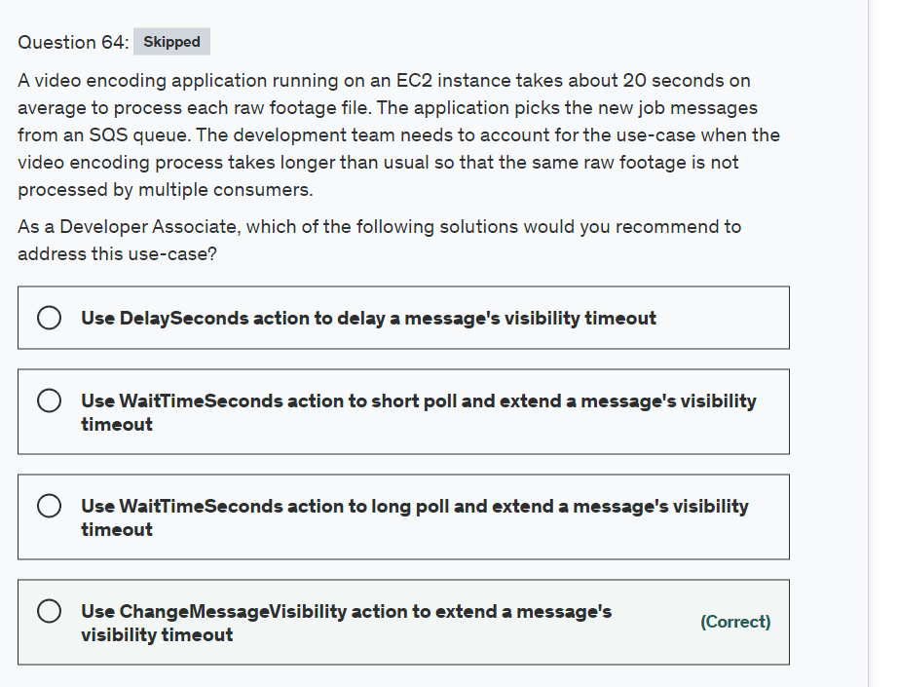

Explanation

Correct option:

**Use ChangeMessageVisibility action to extend a message's visibility timeout**

Amazon SQS uses a visibility timeout to prevent other consumers from receiving and processing the same message. The default visibility timeout for a message is 30 seconds. The minimum is 0 seconds. The maximum is 12 hours.

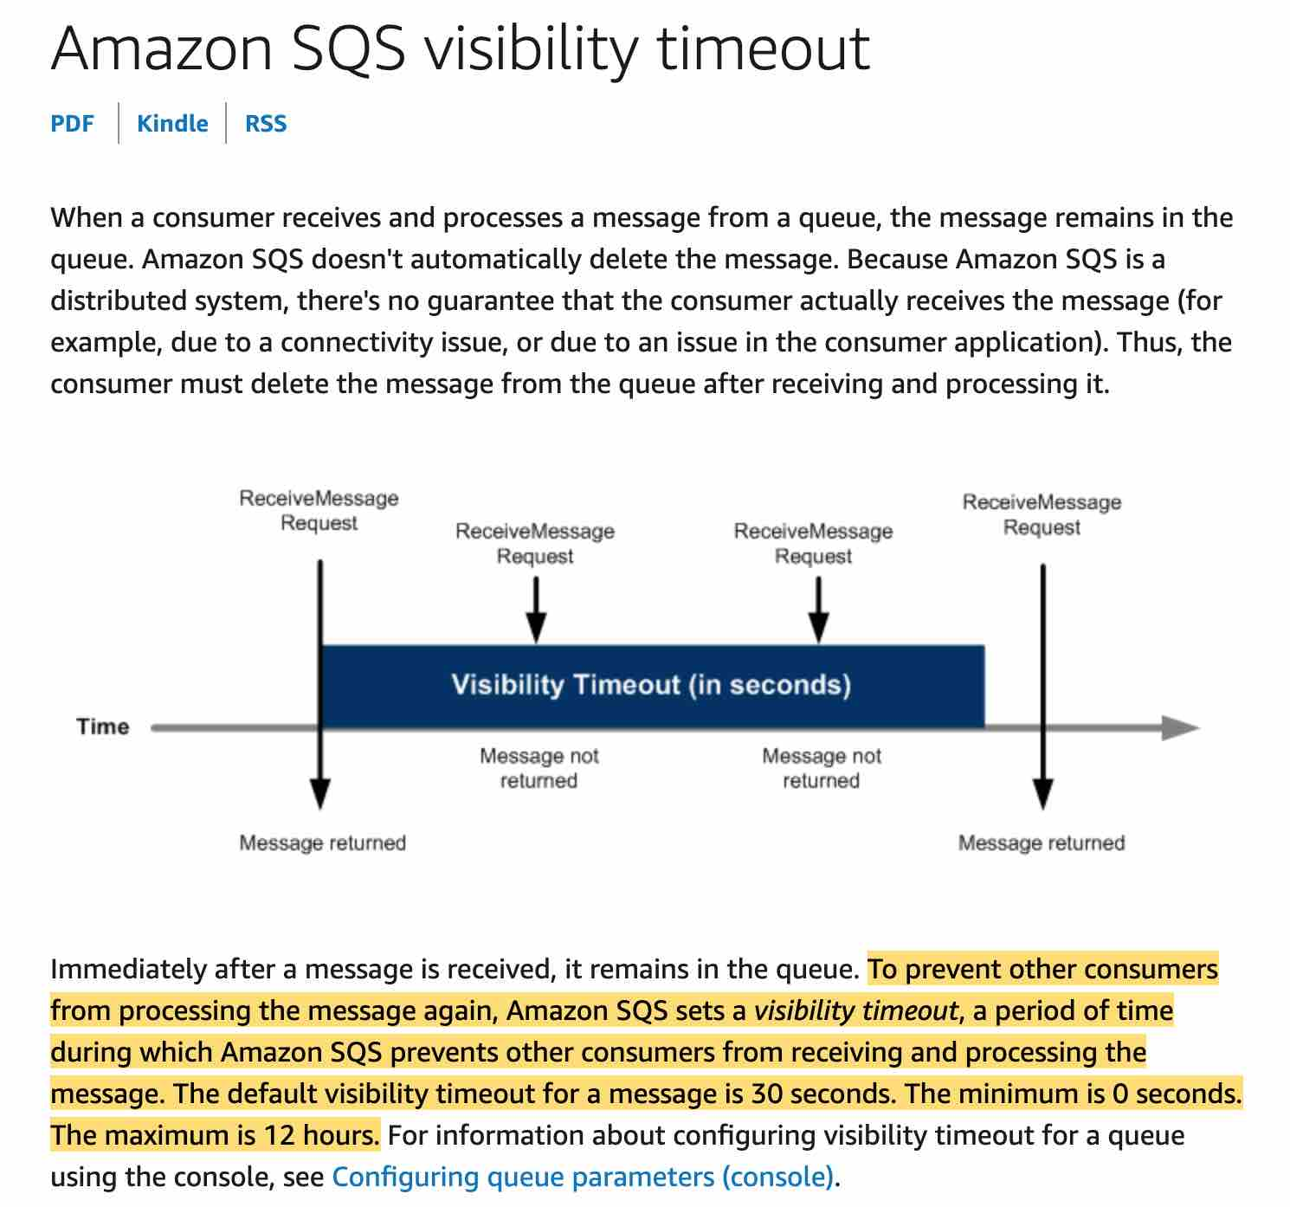 via - <https://docs.aws.amazon.com/AWSSimpleQueueService/latest/SQSDeveloperGuide/sqs-visibility-timeout.html>

For example, you have a message with a visibility timeout of 5 minutes. After 3 minutes, you call ChangeMessageVisibility with a timeout of 10 minutes. You can continue to call ChangeMessageVisibility to extend the visibility timeout to the maximum allowed time. If you try to extend the visibility timeout beyond the maximum, your request is rejected. So, for the given use-case, the application can set the initial visibility timeout to 1 minute and then continue to update the ChangeMessageVisibility value if required.

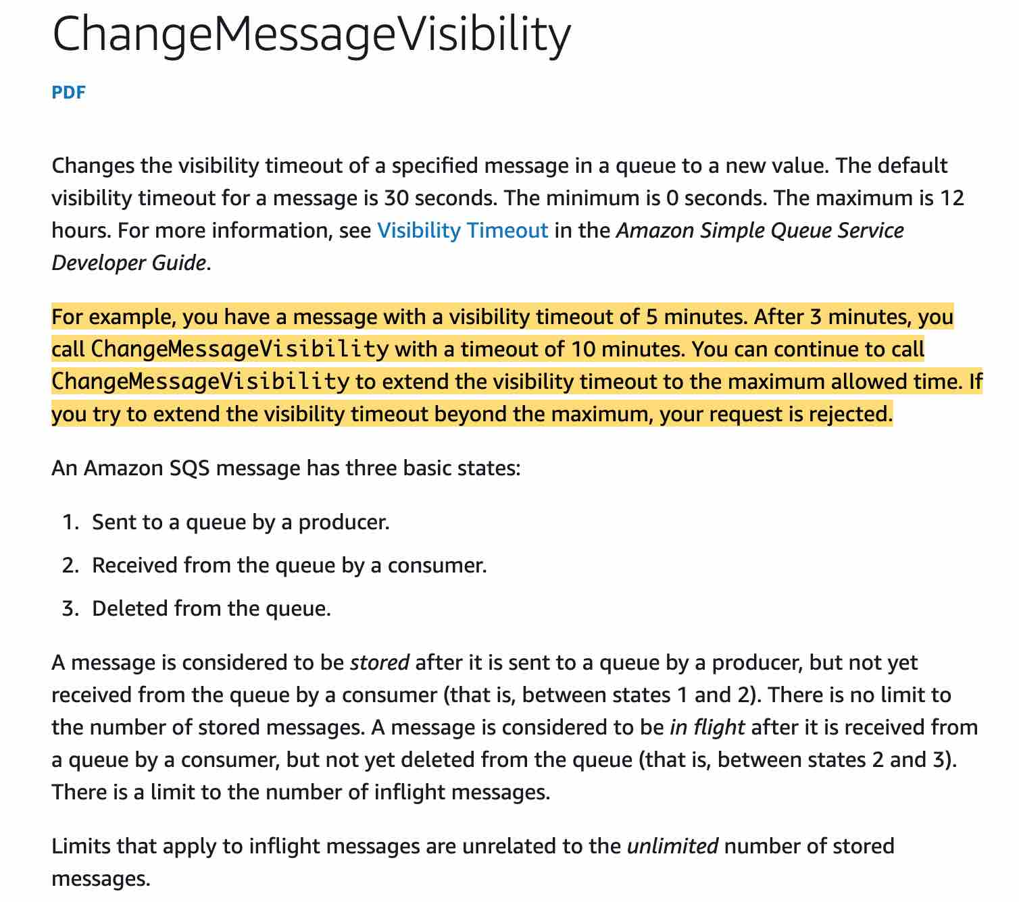 via - <https://docs.aws.amazon.com/AWSSimpleQueueService/latest/SQSDeveloperGuide/sqs-visibility-timeout.html>

Incorrect options:

**Use DelaySeconds action to delay a message's visibility timeout** - Delay queues let you postpone the delivery of new messages to a queue for a number of seconds. To set delay seconds on individual messages, rather than on an entire queue, use message timers to allow Amazon SQS to use the message timer's DelaySeconds value instead of the delay queue's DelaySeconds value. You cannot use DelaySeconds to alter the visibility of a message which has been picked for processing.

**Use WaitTimeSeconds action to short poll and extend a message's visibility timeout**

**Use WaitTimeSeconds action to long poll and extend a message's visibility timeout**

Amazon SQS provides short polling and long polling to receive messages from a queue. Both these options have been added as distractors as WaitTimeSeconds (via short polling or long polling) cannot be used to influence the message's visibility.

References:

<https://docs.aws.amazon.com/AWSSimpleQueueService/latest/SQSDeveloperGuide/sqs-visibility-timeout.html>

<https://docs.aws.amazon.com/AWSSimpleQueueService/latest/APIReference/API_ChangeMessageVisibility.html>

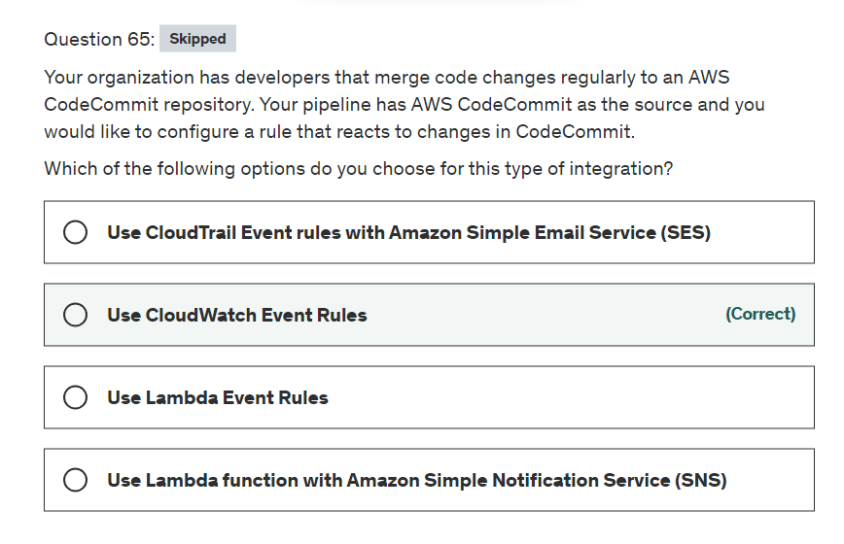

Explanation

Correct option:

**Use CloudWatch Event Rules**

Amazon CloudWatch Events is a web service that monitors your AWS resources and the applications you run on AWS. You can use Amazon CloudWatch Events to detect and react to changes in the state of a pipeline, stage, or action. Then, based on rules you create, CloudWatch Events invokes one or more target actions when a pipeline, stage, or action enters the state you specify in a rule. Examples of Amazon CloudWatch Events rules and targets:

A rule that sends a notification when the instance state changes, where an EC2 instance is the event source, and Amazon SNS is the event target.

A rule that sends a notification when the build phase changes, where a CodeBuild configuration is the event source, and Amazon SNS is the event target.

A rule that detects pipeline changes and invokes an AWS Lambda function.

Incorrect options:

**Use CloudTrail Event rules with Amazon Simple Email Service (SES)** - This is an incorrect statement. There is no such thing as CloudTrail Event Rule.

**Use Lambda function with Amazon Simple Notification Service (SNS)** - Lambda functions can be triggered by the use of CloudWatch Event Rules as discussed above. AWS CodePipeline does not trigger Lambda functions directly.

**Use Lambda Event Rules** - This is an incorrect statement. There is no such thing as Lambda Event Rule.

Reference:

<https://docs.aws.amazon.com/codepipeline/latest/userguide/detect-state-changes-cloudwatch-events.html>